Exercise 1. A group of students was asked whether they have a dog or a cat at home.
The chart shows the results of this survey.
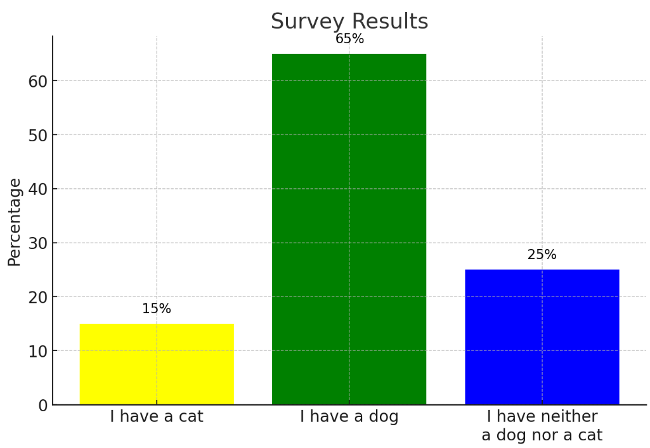
Determine what percentage of the respondents:
a) do not have a dog
b) have both a cat and a dog
c) have a cat and do not have a dog
d) have a dog and do not have a cat.
Exercise 2. The students could enroll in language courses: Polish, German, and Russian.
11 students enrolled in the Polish course.
8 students enrolled in the German course.
6 students enrolled in the Russian course.
5 students enrolled in both the Polish and German courses.
4 students enrolled in both the Polish and Russian courses.
3 students enrolled in both the German and Russian courses.
2 students enrolled in all three courses.
How many students in total enrolled in the courses?
Exercise 3. In a school with 100 students, the students could enroll in language courses (they had to enroll in at least one of them):
Italian, Spanish, and Portuguese.
72 students enrolled in the Italian course.
50 students enrolled in the Spanish course.
38 students enrolled in the Portuguese course.
30 students enrolled in both the Italian and Spanish courses.
18 students enrolled in both the Italian and Portuguese courses.
19 students enrolled in both the Spanish and Portuguese courses.
How many students enrolled in all three courses?
Exercise 4. In the new banking app, the bank has stated that each customer must choose a four-digit PIN, but PINs that contain three consecutive identical digits are considered invalid. How many valid PINs can customers create?

