Lung nodule simulation was based on previous work carried out by Samei, Flynn and Eyler (1997). Given a collection of confirmed subtle lung nodule cases from a database of chest radiographs, the authors developed a model for constructing nodule simulation phantoms. The model was used to produce actual physical objects that may be attached to chest phantoms, producing realistic looking subtle lung nodules when radiographically imaged. The objects were designed to be circularly symmetric along their central axis with a flat surface on one side. Thickness profiles for the objects are defined as

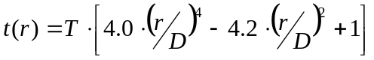, (1)

where D is the effective diameter, T is the maximum thickness at the center of the object and r is the radial distance along the central axis. Note that the profile has the zero r = 0.604D, which we take as the support of the object, i.e. the object has a physical extent of 1.208D.

The model described in the previous paragraph was used to design a digital simulation algorithm under the following assumptions:

- No hardening of x-ray beam as it passes through model object
- No geometric distortions (parallel x-ray beam)
- No additional x-ray scattering due to model object
- The model object is attached to the chest phantom on same side as x-ray detector.
- The flat side of the model object is parallel to the imaging plane.

To implement the nodule simulation, we begin with a raw digitized radiographic image I(x,y) of a chest phantom. The code values describing the image pixel values are assumed directly proportional to incident x-ray exposure. With the above assumptions, the simulation image I’(x,y) is easily constructed using Beer’s law of absorption:

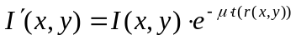, (2)

where t(r) is the thickness profile given by eq. (1), μ is the effective linear attenuation coefficient of the model object, and r(x,y) is the radial distance in the image plane from the projected center of the model object. Note that the nodule contrast is specified by the product of thickness T and effective linear attenuation coefficient μ.

When constructing examples of simulated nodules as explained above via eq. (2), we found that some cases exhibited too sharp of margins. This is perhaps due to the assumption 2) and 3) where, in practice, scattering and geometric distortions will serve to soften the margins. To help alleviate this problem, we integrated a smoothing feature into the algorithm. In this case, the simulation image is constructed according to

, (3)

where denotes two-dimensional convolution, and 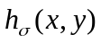is the (normalized) smoothing kernel defined as

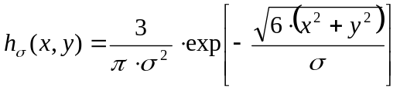, (4)

The parameter σ controls the amount of smoothing, or feathering. Increasing σ will soften the margins further. In the limit 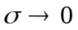, eq. (4) reduces to eq. (2).

References

Samei E, Flynn MJ, Eyler WR, “Simulation of Subtle Lung Nodules in Projection Chest Radiography,” Radiology; 202:pp.17-124 (1997).

