Python setup in PC steps

1. Download from official python website   
   (V 3.9.0)
2. Visual Studio Code
3. Ctrl+, settings Enable
4. Python version check from info bar
5. Debug launcher Json configuration

***"configurations": [***

***{***

***"name": "Python: Current File",***

***"type": "python",***

***"request": "launch",***

***"program": "${file}",***

***"console": "integratedTerminal",***

***"cwd": "${fileDirname}",***

***"stopOnEntry":true***

***}***

1. Save all the files and Installation part is done

***Scikit Leran :***

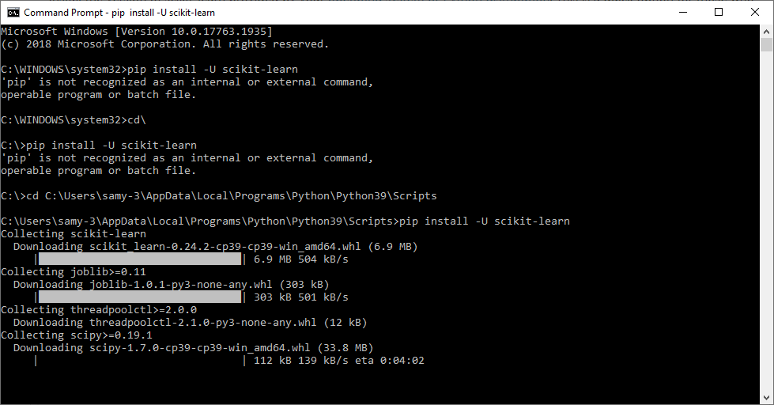

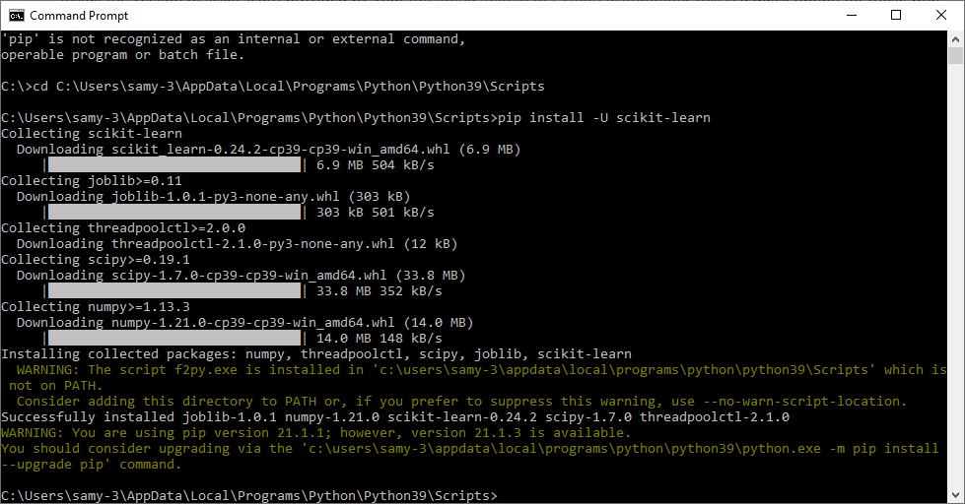

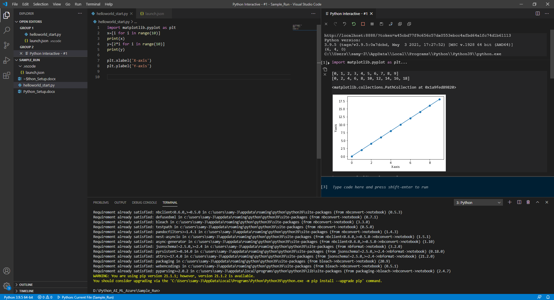

Useful Links:

<https://www.youtube.com/watch?v=kqtD5dpn9C8>

<https://www.youtube.com/watch?v=WGJJIrtnfpk>