Project Mobile Application

App “Money Keeper”

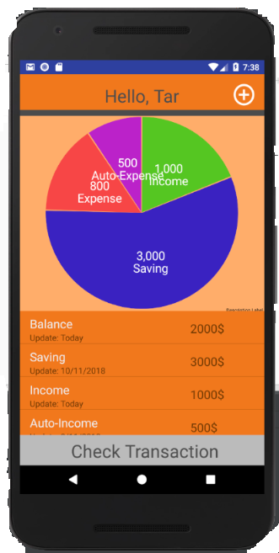

Prepared by

1.5904062660191 Mr.NOPPAWEE DEEJUNGWIPHAT

2.5904062663123 Mr.PANNAWAT NIYOMRAT

Function of Application

-Money Keeper this Application use for about save money in everyday life.

-Note title about income, expense ,auto-expense and saving

How to use Application

-In the first page, there will be ‘Next’ button. When you click on it, it will lead you to log in page.

-Log in page ,there have fill box name and money. After that it appear “Do you want to have pin code”. If click on yes it will lead you to go Pin code page.

-After fill Pin code finish. It will lead you to show Transaction page.

-When click on button ‘+’. It will lead you to add new transaction page.

-When click on button ‘Check Transaction’ it will show the list of transaction.

UI of Application

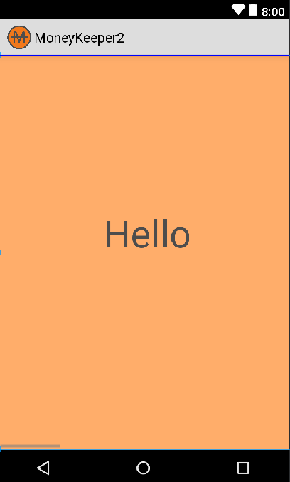

-First page when open application

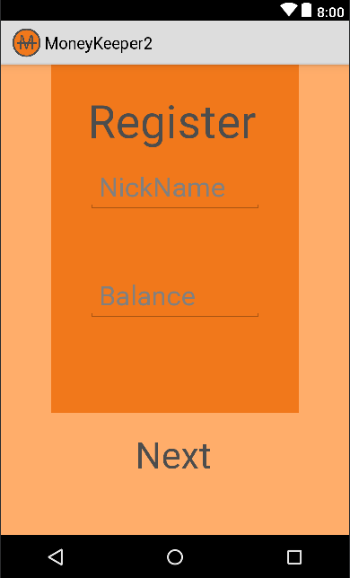

-Register for new user

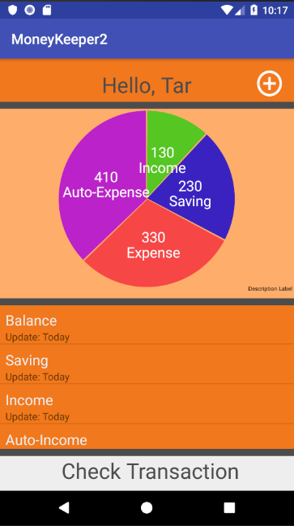

-After register and fill name and balance, this main page for see transaction.

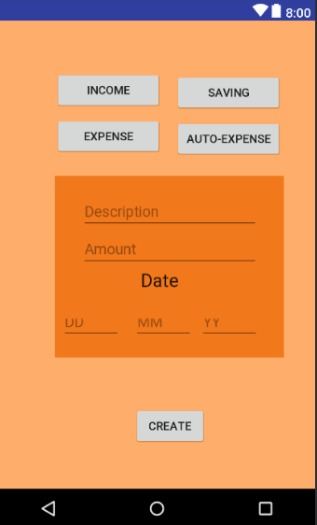

-After click on button’+’ you lead to this page. This page use for update transaction for today.

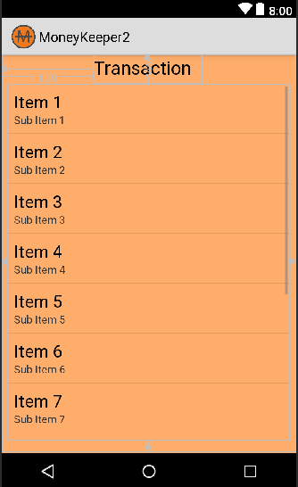

-This page for view history of transaction.