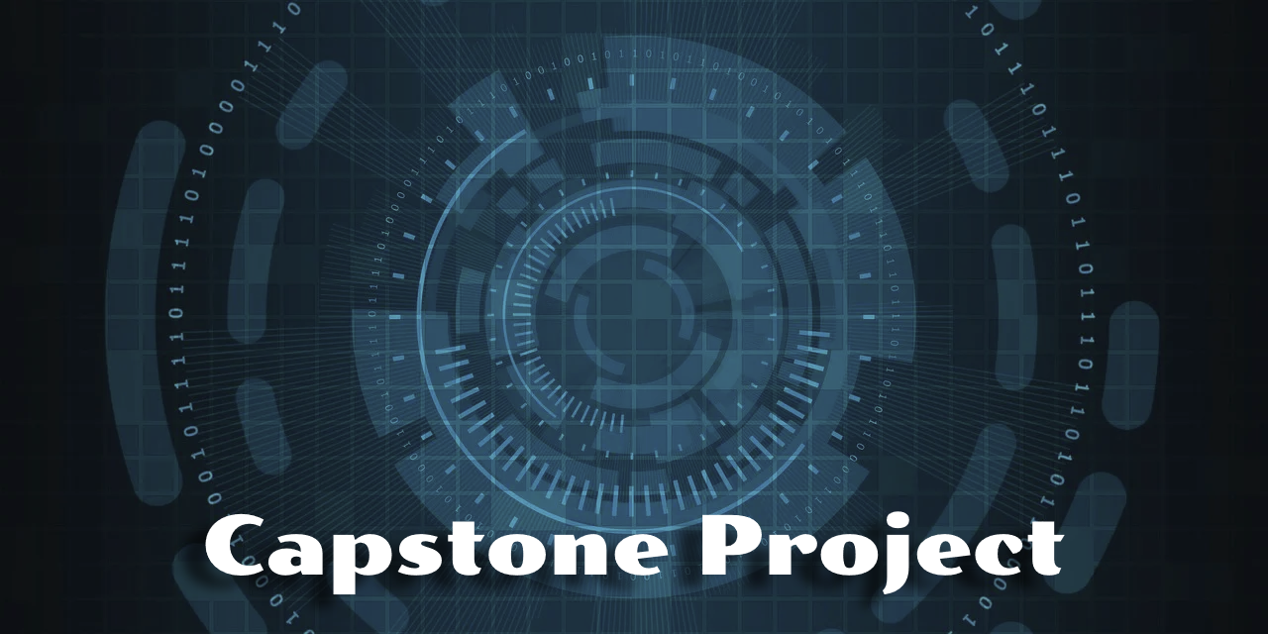

AllPlay Incident Intelligence Console

UniversalGaming Entertainment

Proposal prepared by | Brian Summers
Contact email | briansummers@student.purdueglobal.edu
Preparation date | April 7th, 2026

Executive Summary

The AllPlay Incident Intelligence Dashboard project will provide a central, AI-powered monitoring and response platform that is designed for cloud gaming environments. Companies like UniversalGaming Entertainment frequently utilize distributed infrastructure with changing demand levels, where real-time visibility and immediate incident response is critical. AllPlay provides consolidated telemetry from streaming servers, matchmaking services, and network performance tools into a single interface, which allows for more immediate recognition of incidents and resolution of interruptions. AI-powered insights assist in prioritizing issues, reducing downtime, and improving player experience. AllPlay will allow for UniversalGaming to gain a scalable, cost-effective tool for increasing reliability, growth, and stability of the cloud gaming platform.

Qualifications

I chose the Project Manager role because it most closely aligns with my background in leading complex technical programs and cross-functional teams in the Navy, as well as my current transition into Technical Program Management in the commercial industry. Cloud gaming requires coordination, communication, and a strong understanding of systems. Each of these areas align with my professional background, as well as my background in Information Technology/Data Analytics in my M.S. program. This combination of experience and education enhances my ability to plan, document, and oversee technology projects. I am well positioned to manage scope, risks, and stakeholders throughout the AllPlay project.

Purpose

Cloud gaming platforms require low latency, stabile infrastructure, and rapid incident response to ensure an uninterrupted gaming experience. Companies like UniversalGaming Entertainment rely on many monitoring tools and manual processes, which makes it cumbersome to readily identify and resolve service interruptions. The purpose of the AllPlay Incident Intelligence Dashboard is to create a centralized for system health, automated alerting, and AI-powered recommendations. Implementing this solution will allow UniversalGaming to reduce outages, improve player experience, and allow for greater scalability. Without AllPlay, UniversalGaming Entertainment risks continued inefficiencies, increased costs, and player attrition rates.

Stakeholders

- Executive Sponsor: Approves funding, sets major priorities, and ensures project alignment with UniversalGaming’s cloud gaming roadmap.
- Cloud Infrastructure/IT Operations Team: Responsible for monitoring servers, streaming nodes, and incident response.
- Data/Analytics Team: Data ingestion, telemetry mapping, and AI model configuration.
- Player/Support Teams: Benefit from reduced downtime and improved reliability for users.
- Project Manager: Oversight of planning, documentation, scheduling, and stakeholder communication during the project lifecycle.

Resources and Cost Estimate

Schedule Overview

Milestone | Estimated Duration
Project Charter, Scope Definition, and Stakeholder Alignment | 1 Week
Requirements Gathering | 1 Week
System Architecture, Data Flow Design, and Planning | 1 Week
Dashboard Mockup, Wireframes, and Telemetry Mapping | 1-2 Weeks
Backend and API Design | 2 Weeks
Frontend Development | 2 Weeks
AI/ML Integrations | 1-2 Weeks
Testing and QA | 1 Week
Final Documentation and Presentation | 1 Week

Feasibility Comments

- Technical Feasibility:
  - AllPlay leverages cloud-native services, scalable telemetry ingestion, and AI/ML APIs that work fluidly with UniversalGaming’s existing infrastructure. It requires Azure compute, logging tools, and anomaly-detection models. These are all mature and compatible with the current infrastructure.
- Operational Feasibility:
  - The project will enhance the existing monitoring and incident-response instead of simply replacing them, making adoption more accessible for a small operations team. It consolidates tools and reduces manual labor, which creates added efficiency without need massive organizational change.
- Economic Feasibility:
  - The project is estimated to cost $32,340.00 and is a realistic cost for a mid-sized organization. It creates long-term savings for UniversalGaming Entertainment from reduced downtime, increased user satisfaction, and decreased disruptons.
- Legal Feasibility:
  - Compliance risks are mitigated based on AllPlay relying on operation telemetry instead of personal data. This ensures that standard data-handling and privacy requirements are easily met.

