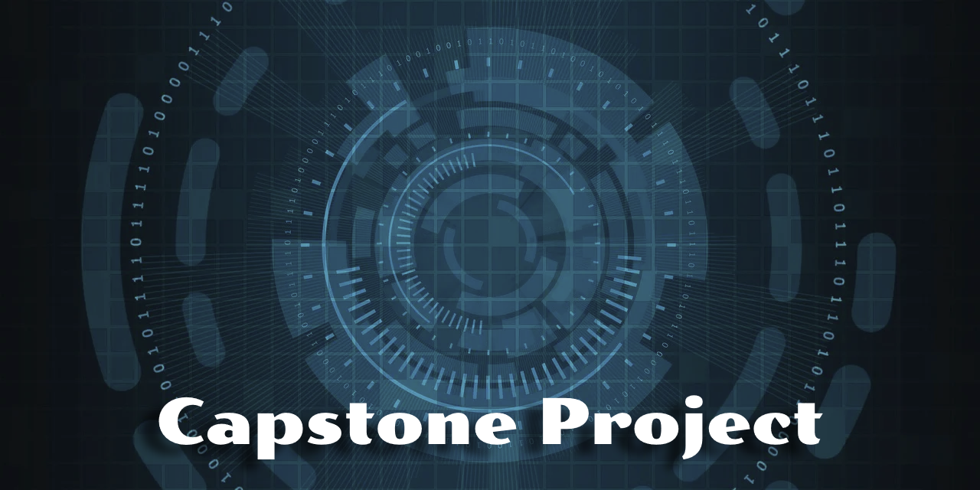

AllPlay Incident Intelligence Dashboard
Implementation Plan

UniversalGaming Entertainment

Proposal prepared by | Brian Summers
Contact email | brianedwsummers@gmail.com
Preparation date | April 21st, 2026

Project Overview and Requirements

The AllPlay Incident Intelligence Dashboard project will provide a central, AI-powered monitoring and response platform that is designed for cloud gaming environments. Companies like UniversalGaming Entertainment frequently utilize distributed infrastructure with changing demand levels, where real-time visibility and immediate incident response is critical. AllPlay provides consolidated telemetry from streaming servers, matchmaking services, and network performance tools into a single interface, which allows for more immediate recognition of incidents and resolution of interruptions. AI-powered insights assist in prioritizing issues, reducing downtime, and improving player experience. AllPlay will allow for UniversalGaming to gain a scalable, cost-effective tool for increasing reliability, growth, and stability of the cloud gaming platform.

The AllPlay platform must integrate multiple telemetry sources, including server health data, network latency indicators, and service-level logs from streaming and matchmaking systems. The dashboard must also utilize real-time data, automated alerts, and AI-powered anomaly detection using cloud-based models. Required features are customizable visualizations, incident timelines, severity ratings, and automating troubleshooting recommendations. It must authenticate users in a secure manner, where role-based access controls are used and data is always encrypted. Additionally, it must integrate with current operational workflows, be compatible with Azure cloud services, and must scale based on demand. The final deliverable should include a functional prototype, documentation, and a roadmap for production level deployment.

Resources and Costs

Building and implementing the dashboard requires several categories of labor from project management, analytics, cloud architecture, frontend and backend developers, and AI/ML engineers. Additionally, it will require Azure compute resources, monitoring tool, AI API usage, testing, and SME consulting. Costs are derived from hourly rates for specific roles, Azure pricing models, and an additional 10% contingency for unexpected expenses.

Schedule

Reference included MS Project file.

Performance Measures and Quality Plan

Performance will be measured using input, output, and outcome metrics. Input will be measured by task completion rate, resource burndown, and compliance with the schedule. Output will be measured by ensuring the dashboard meets functional criteria, like real-time telemetry usage, alert accuracy, and AI-generated troubleshooting recommendations. Data security will be validated through encryption verification, access-control auditing, and compliance with internal and external polices.

Cost performance will be determined by using Return on Investment (ROI). If the dashboard can reduce downtime by 20 hours per year, where each hour results in a loss of $1,000 in productivity, then the annual savings would be $20,000. The estimated project cost is $32,340, ROI is calculated as ROI = (20,000 – 32,340) / 32,340 = -38%, It is negative at first, but the long-term savings and reduced incidences are expected to create a positive ROI in follow-on years. Quality will be determined by stakeholder reviews, acceptance testing, and alignment with initial expectations.

Risk Management Plan

Risk | Description | Mitigation | Risk Level
Scope, Schedule, or Cost Diversion | Changes in the requirements or schedule issues could increase cost or delay production. | Maintain change-control processes and review impacts before implementation. | Medium
Data Security Risk | Unauthorized access to telemetry or logs could leak sensitive data. | Utilize RBAC, encryption, and monitoring. Conduct security audit prior to deployment. | High
Integration Complexity | Multiple telemetry sources may require more effort. | Conduct API testing early and ensure constant communication with IT operations. | Medium
AI Model Accuracy | AI Anomaly detection could create false alarms or miss real events. | Perform model testing, tuning, monitor functionality, and maintain manual review processes at the ready. | Low

The primary risk is changes in the Triple Constraint, where issues with scope or production could increase the cost or delay deployment. It will be mitigated using change-control processes and regular stakeholder reviews. Data security presents a risk as well and will be controlled through RBAC, encryption, and security assessments.

The dashboard will utilize data from multiple systems, in different formats, and must be mitigated with early API testing and communication with the IT operations team. Additionally, AI models may provide inaccurate information for incident notification and resolution recommendations. The models will be continuously monitored, tuned, and a fallback plan will be in place to ensure functionality of the dashboard. Utilizing these strategies should provide a smooth implementation and allow UniversalGaming to reap the benefits of an AI-powered incident management console.

