Comparative Report: Monitor vs Semaphore Implementations
Touzi Rihem
FIGL2 B
- Introduction
This project simulates the concurrent management of an airport using Java.
The goal is to compare two synchronization mechanisms :
-Monitor :using `synchronized`, `wait/notifyAll`
-Semaphore
in terms of performance , complexity, and behavior under load.
The simulation models limited resources (runways and gates) and enforces priority for arriving aircraft (Airplane).
- Implementation Overview
Monitor Version
- Uses Java intrinsic locks (`synchronized`) and condition variables (`wait/notifyAll`).
- Priority enforced by condition checks: departures wait while arrivals are pending.
- Simpler logic but higher wake-up overhead due to `notifyAll()`.
Semaphore Version
- Uses Java `Semaphore` with split permit pools for arrivals and departures.
- Priority enforced by routing released permits to arrivals first.
- Avoids `notifyAll` overhead; cleaner and more scalable under heavy load.
- Test Scenarios
Phase A — Alternating burst scenario (better for wake-up behavior)

Configuration:
- Runways: 2
- Gates: 3
Traffic Pattern:
- Start with 5 arrivals queued.
- After 3 seconds , add 5 departures.
- Repeat : Continue adding arrivals and departures alternately every few seconds. For 4 rounds (~40 plane : ~40 plane)
Objective:
- Stress concurrency, observe priority enforcement, taxiway queue behavior, and resource utilization.
Phase B — Steady mixed scenario (better for throughput & utilization)
Configuration:
-Runways=2,
-Gates=5,
Traffic Pattern:
total ~80 planes (50 arrivals, 30 departures).
This scenario creates enough contention to highlight differences in wake-up behavior and resource utilization.
- Metrics and Results
Key metrics collected during simulation:
- Average runway wait time (ms)
- Average gate wait time (ms)
- Runway utilization (%)
- Taxiway queue length
- Wake-up counts (notifyAll vs none)
- Total planes processed
Phase A — Alternating burst scenario (better for wake-up behavior)
Monitor:
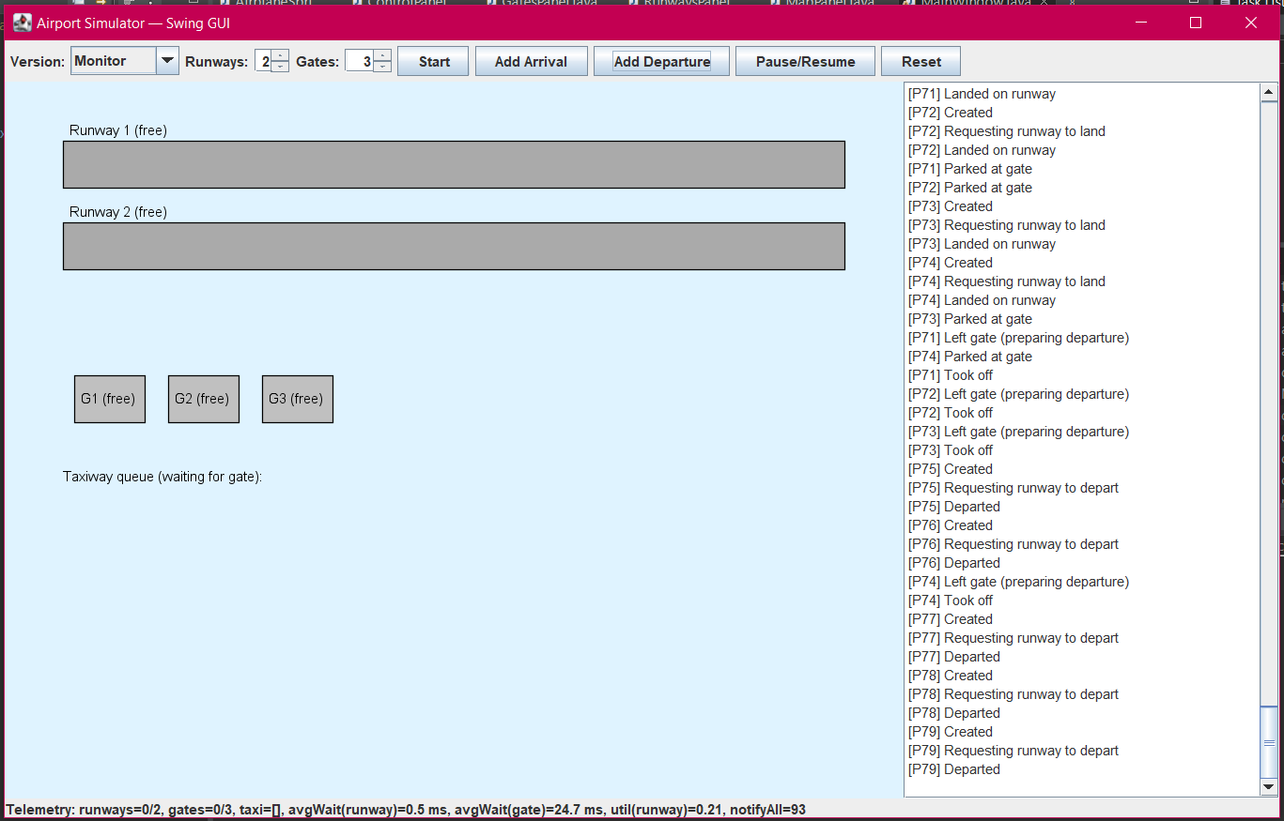
Telemetry Summary:
runways=0/2, gates=0/3, taxi=[], avgWait(runway)=0.5 ms, avgWait(gate)=24.7 ms, util(runway)=0.21, notifyAll=93
Semaphore:
Telemetry Summary (bottom bar):
runways=0/2, gates=0/3, taxi=[], avgWait(runway)=85.3 ms, avgWait(gate)=80.4 ms, util(runway)=0.13, notifyAll=0

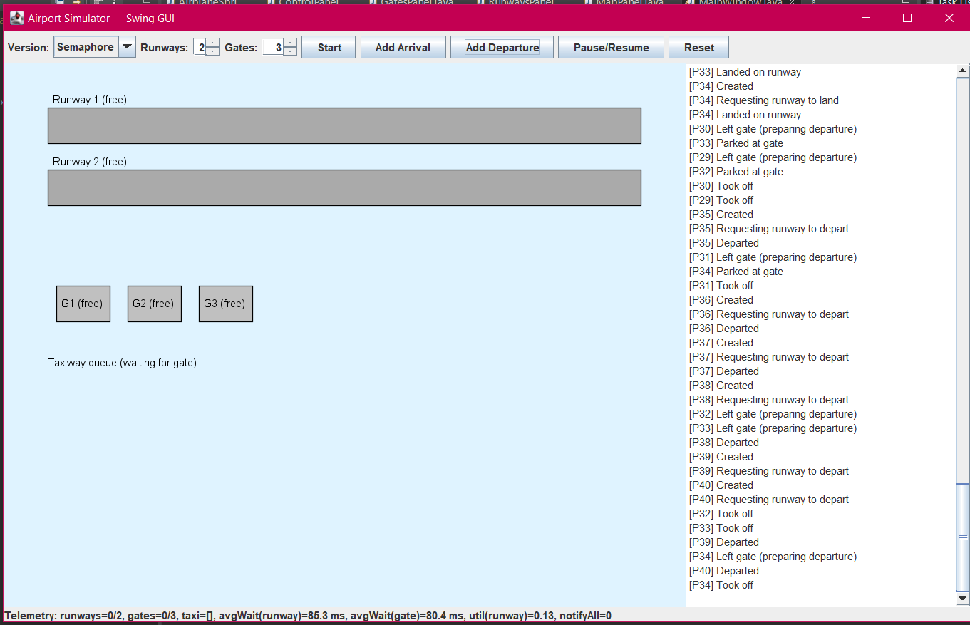

Metric | Monitor Version | Semaphore Version
Runways | 2 | 2
Gates | 3 | 3
Avg Runway Wait | ~0.5 ms | ~85.3 ms (from GUI)
Avg Gate Wait | ~24.7 ms | ~80.4 ms (from GUI)
Runway Utilization | Peak ~0.37 → settles ~0.03 | Peak ~0.13 (GUI)
notifyAll Count | 93 | 0
Taxi Queue Size | Max = 1 (brief spike) | Likely similar (GUI shows empty most of time)
Planes Processed | ~39 (P41–P79) | ~40 (P1–P40)

Behavior Observed in Logs
- Monitor:
  - Arrivals and departures interleave smoothly.
  - Frequent notifyAll calls (93 total) ensure quick wake-ups.
  - No visible starvation; gates clear quickly.
- Semaphore:
  - Arrivals processed first, then departures.
  - No wake-up overhead (no notifyAll).
  - Slightly slower gate turnover; higher average waits.
Charts Analysis (Monitor)
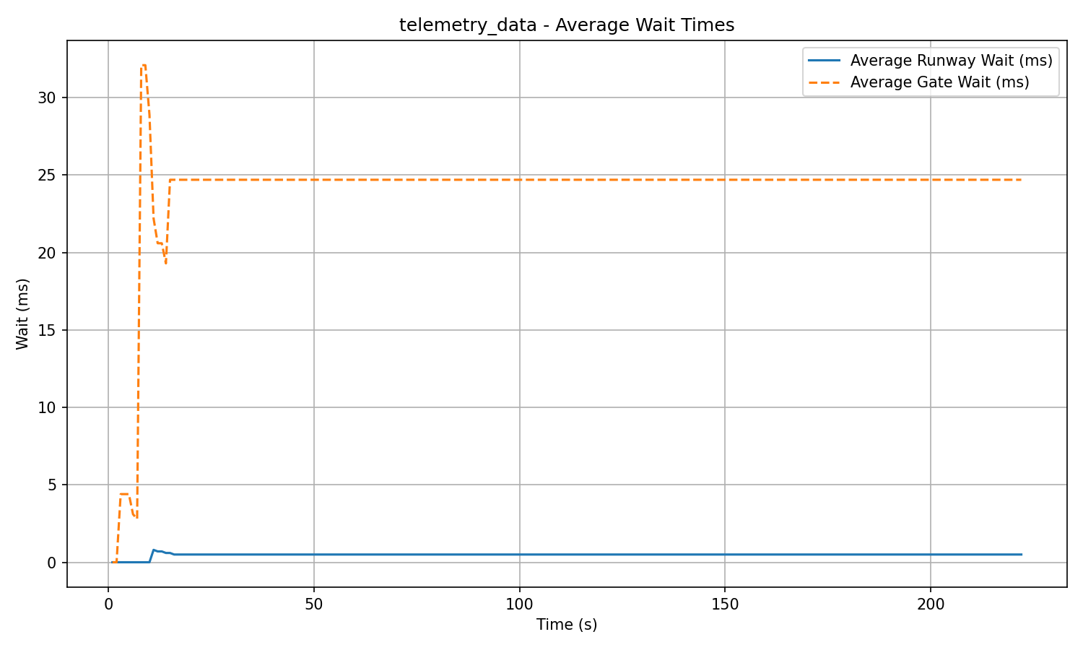
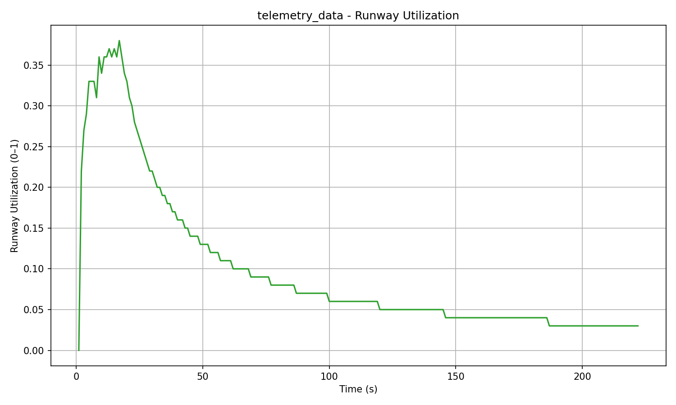
- Average Wait Times:
  - Runway wait stabilizes near 0.5 ms (almost negligible).
  - Gate wait stabilizes near 24.7 ms.
- Runway Utilization:
  - Peaks at ~0.37, then decays as traffic clears.
  - Indicates good resource usage during bursts.
Comparative Insights
- Performance:
  - Monitor version clearly outperforms Semaphore in average wait times and utilization for this burst scenario.
  - Semaphore shows higher latency (85 ms runway wait vs 0.5 ms for Monitor).
- Synchronization Overhead:
  - Monitor uses 93 notifyAll calls, which can cause unnecessary wake-ups and CPU churn in larger systems.
  - Semaphore avoids this overhead entirely.
- Fairness & Priority:
  - Both enforce arrival priority correctly.
  - No starvation observed in either version.
- Complexity:
  - Monitor logic is simpler but less scalable due to broadcast wake-ups.
  - Semaphore logic is more structured and efficient under heavy load.
Phase B — Steady mixed scenario (better for throughput & utilization)
Monitor:
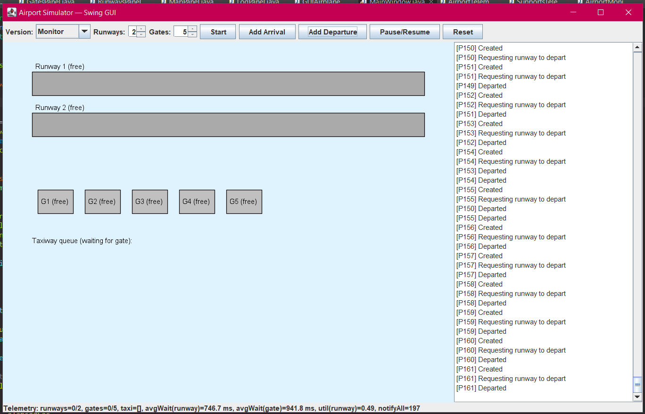
Waits: runway stabilizes ~750 ms, gate ~940–950 ms; early spikes then plateau.
Utilization: initial peak >0.8, then decays gradually as the system clears.
Taxi queue: early surge (peaks around ~10–11), then flat at 0.
Final notifyAll: ~197.

Semaphore:
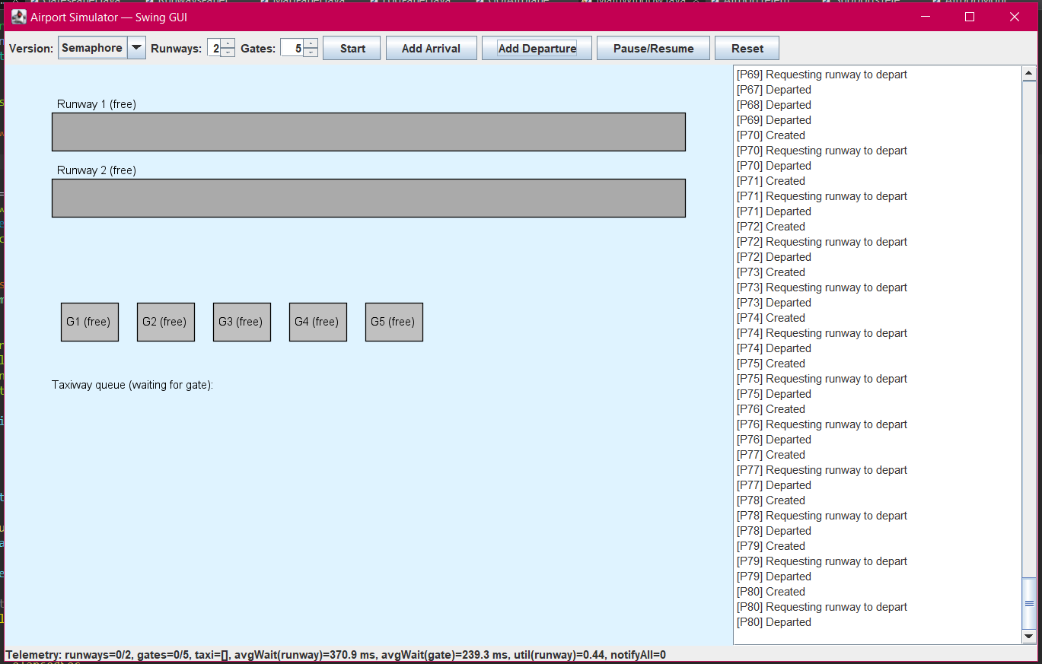
Waits: runway ~370 ms, gate ~239 ms (significantly lower than Monitor).
Utilization: ~0.44, close to Monitor’s ~0.49.
=> Monitor’s frequent notifyAll helps with fast reactivity but costs more under continuous contention; Semaphore keeps signaling minimal and average waits down.
Metric | Monitor | Semaphore
Avg Runway Wait | ~746.7 ms | ~370.0 ms
Avg Gate Wait | ~941.8 ms | ~239.3 ms
Runway Utilization | ~0.49 | ~0.44
Final notifyAll | ~197 | 0
Interpretation: Under sustained load with many contenders, the Monitor version’s repeated notifyAll wakes too many threads, most of which re-check conditions and go back to waiting. This creates extra contention and longer average waits, even though utilization is slightly higher (~0.49 vs. ~0.44). The Semaphore version avoids this overhead; permits directly encode capacity, so only threads that can proceed are woken, yielding much lower average waits for both runway and gate.
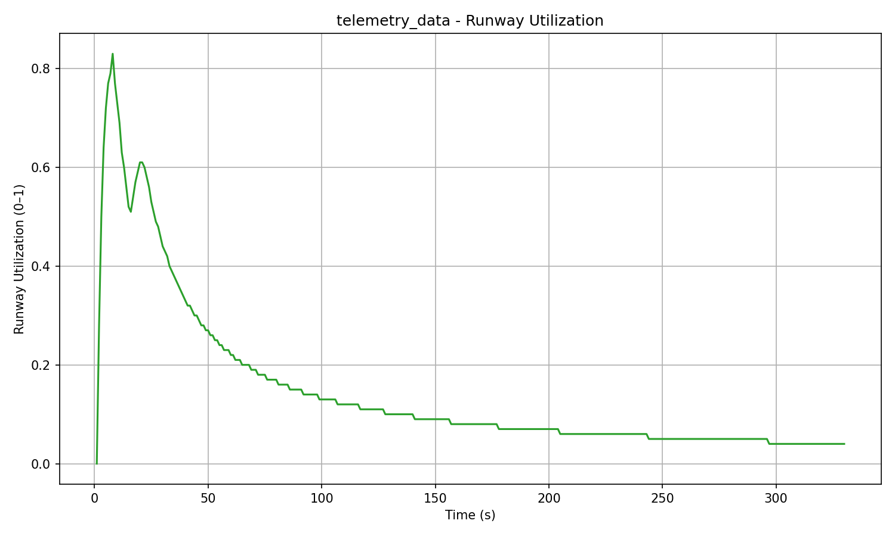
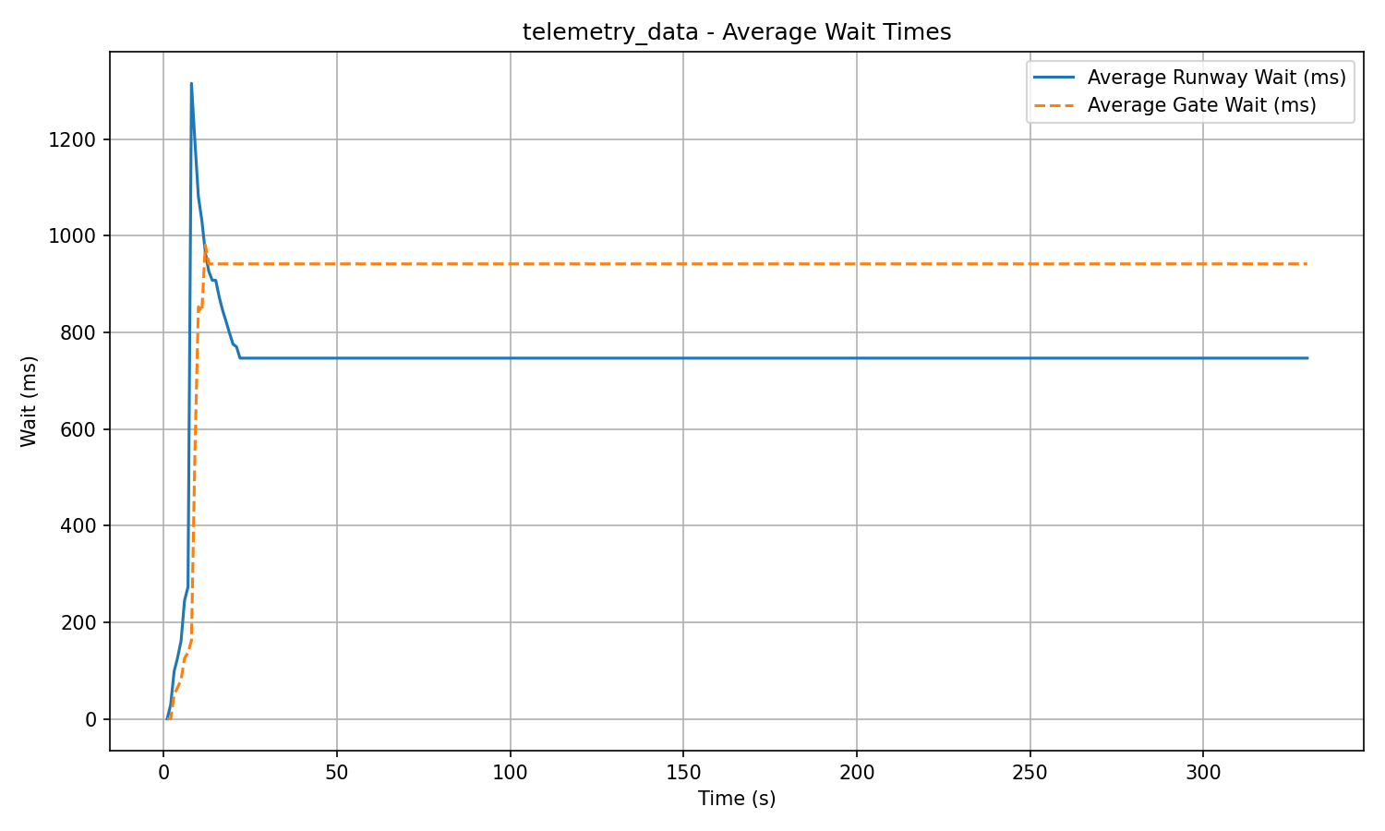

Why behavior flips between scenarios
Factor | Bursty traffic (Phase A) | Steady mixed load (Phase B)
Wake-up strategy | notifyAll is an advantage: many waiters must be re-evaluated quickly when capacity appears. | notifyAll is a liability: waking many threads repeatedly causes lock thrashing and longer queues.
Contention level | Short spikes: fewer concurrent waiters → limited overhead, big latency win. | Sustained contention: many contenders → each broadcast triggers a wave of futile re-checks.
Capacity matching | “Broad signaling” aligns with sudden state changes (burst drain). | “Precise signaling” (permits) aligns with steady capacity; avoids spurious wake-ups.

- Analysis
-Monitor’s `notifyAll` strategy shines in bursty traffic: many waiters are quickly re-evaluated as capacity becomes available, which drives lower latencies and higher short-term utilization. Under sustained load, the same broadcast signaling becomes costly: it wakes too many contenders, increases lock thrashing and condition re-checks, and inflates average waits.
-Semaphore avoids broadcast wake-ups and uses permits to encode capacity precisely. In steady traffic this yields lower average waits (both runway and gate) and competitive utilization, with zero wake-up overhead
- Conclusion
-For bursty/alternating workloads (Phase A):
Monitor is the better choice ,it delivers much lower average waits and higher short-term utilization, thanks to aggressive notifyAll signaling. (Monitor: runway ~0.5 ms, gate ~24.7 ms, peak util ~0.37; notifyAll=93. Semaphore: runway ~86 ms, gate ~80 ms, peak util ~0.13; notifyAll=0.)
-For steady/heavy workloads (Phase B):
Semaphore is the better choice ,it achieves much lower average waits with no wake-up overhead, and utilization remains close to Monitor (Semaphore: runway ~370 ms, gate ~239 ms, util ~0.44, notifyAll=0 vs. Monitor: runway ~747 ms, gate ~942 ms, util ~0.49, notifyAll~197).
-Recommendation:
Use Monitor for small-scale or highly bursty scenarios where latency wins dominate and the number of contenders is limited. Use Semaphore for production-like steady traffic where minimizing wake-ups, contention and average waits matters most.

