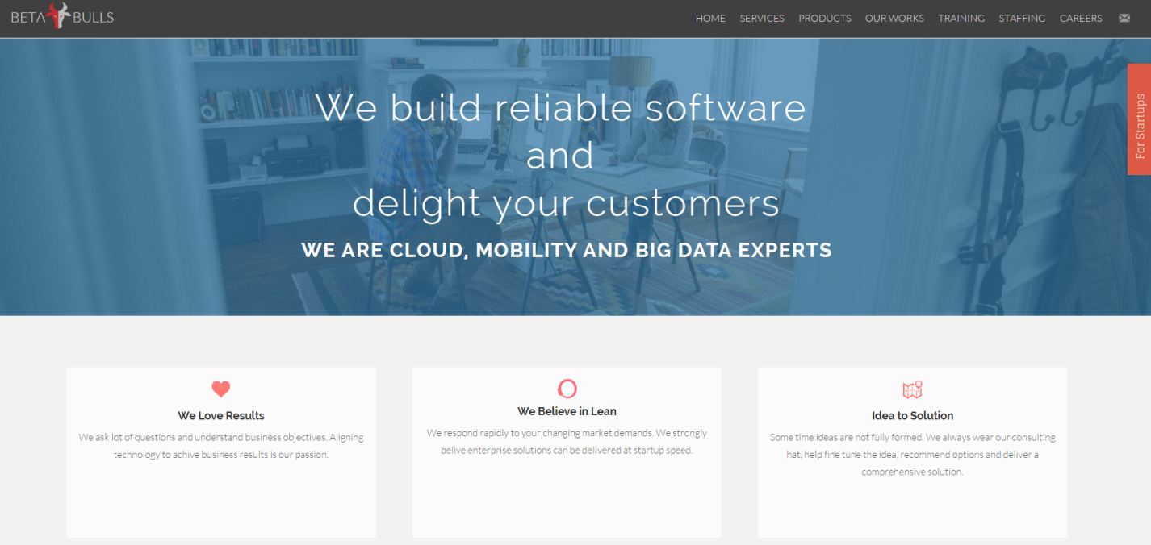

Its exact same thing. But we introduce a new block between the image and we love results section.

Section heading is “What We Do”

**Application Support and Maintenance**

We support your applications 24x7 and keep the Lights On (KTLO)

**Custom Software Development**

We develop reliable web and Mobile software that matters to you

**Mobile Enablement**

We Extend Legacy Applications to Smartphones and Tablets

**Cloud Enablement**

We optimize your apps for the cloud.

**Search and information discovery**

We build powerful search driven apps and text analytics

**Big Data Analytics**

We help you make smarter decisions with analytics