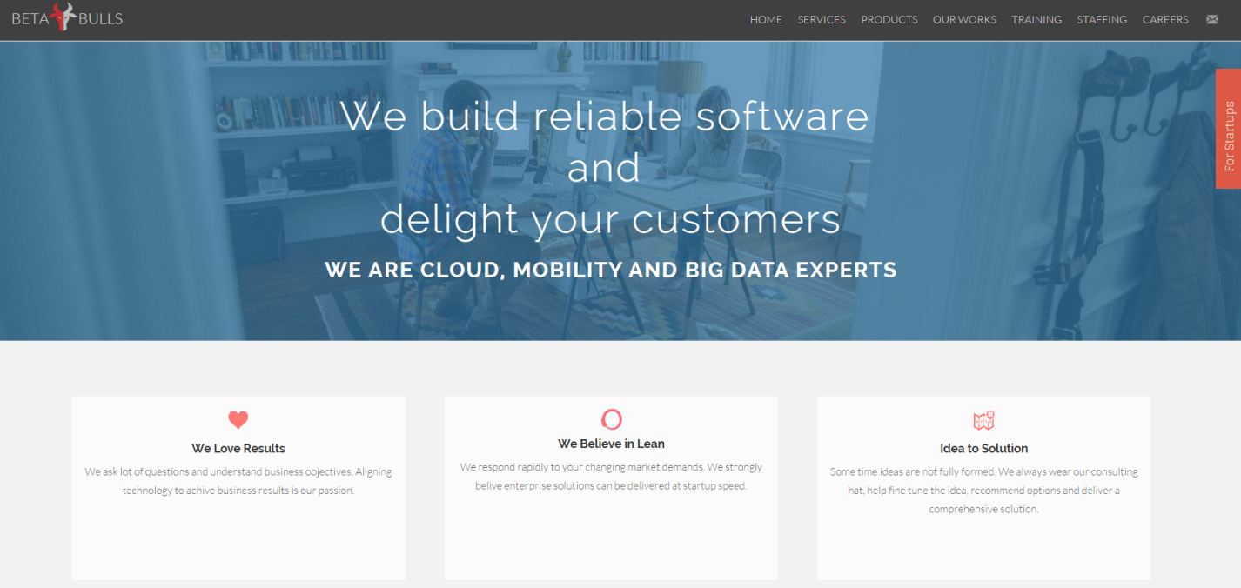

Its exact same thing. But we introduce a new block between the image and we love results section.

Section heading is “What We Do”

Application Support and Maintenance

We support your applications 24x7 and keep the Lights On (KTLO)

Custom Software Development

We develop reliable web and Mobile software that matters to you

Mobile Enablement

We Extend Legacy Applications to Smartphones and Tablets

Cloud Enablement

We optimize your apps for the cloud.

Search and information discovery

We build powerful search driven apps and text analytics

Big Data Analytics

We help you make smarter decisions with analytics