Date of publication xxxx 00, 0000, date of current version xxxx 00, 0000.
Digital Object Identifier 10.1109/ACCESS.2026.Doi Number
Command-Layer Resilience and Relay Over-Allocation Trade-Offs in Heterogeneous Multi-Robot Teams Under Delayed Hazard Information
Bong-Keun Song
Friedrich-Alexander-Universität Erlangen-Nürnberg (FAU), Erlangen, Germany
Corresponding author: Bong-Keun Song (e-mail: bongkeun.song@fau.de).
ABSTRACT Multi-robot teams operating under delayed hazard information must balance communication latency, physical exposure, and command-layer intervention. This paper evaluates that balance in heterogeneous teams with standard, scout, relay, and payload roles. We test a conservative claim: command-layer resilience is environment dependent, whereas relay over-allocation creates a latency-safety trade-off. The study uses a continuous two-dimensional simulator, relay-count ablations, parameter robustness sweeps, an independent grid-world transfer environment, and a Webots R2025a differential-drive physics validation. In the continuous confirmatory panel, crowd-vector command improves degraded-regime safe delivery by 0.0875 and operational score by 2.3276 relative to autonomous control, with confidence intervals excluding zero for both metrics. Severe-regime command effects are positive for operational score but weaker for safe delivery. In contrast, relay-heavy teams consistently lower effective map delay while degrading safety-aware outcomes. In Webots, relay-rich allocation cuts effective delay by 12 steps in degraded stress and by 22 steps in severe stress, but decreases safe delivery by 0.3333 and 0.6250, respectively, while increasing attrition. Grid-world transfer further shows that command aggregation does not generalize blindly. These results support a design principle for multi-robot systems: additional relay capacity can improve information freshness without improving, and sometimes while harming, task safety.
INDEX TERMS Heterogeneous multi-robot systems, human-swarm interaction, delayed information, relay allocation, robot simulation, swarm robotics, Webots.

- INTRODUCTION
Multi-robot teams are often deployed in settings where global information is stale, local observations are partial, and communication resources are themselves embodied in robots that must move through the same hazardous environment as the rest of the team. In such settings, improving information freshness is not free: relay robots can reduce map delay, but they also change team composition, consume physical space, and may increase exposure or attrition.
This paper studies a narrow but robotics-relevant question. When hazard information is delayed, should a heterogeneous team rely on a command layer, allocate more relay robots, or preserve autonomous local navigation? The answer is not assumed to be universal. Instead, we test which effects survive across multiple simulation layers and which effects should be treated as boundary conditions.
The work is positioned at the interface between multi-robot coordination, human-swarm-inspired command aggregation, and communication-constrained autonomy. Unlike a new low-level planner paper, the contribution is a design trade-off characterization. The central result is that relay over-allocation robustly reduces delay but can harm safety-aware task completion. Command aggregation can help in selected continuous regimes, but it does not transfer blindly across environment representations.
The contributions are as follows. First, we provide a continuous delayed-hazard simulator for heterogeneous teams with autonomous, crowd-vector, consensus-gated, and stale command policies. Second, we run relay-count ablations and robustness sweeps that separate latency reduction from safe task completion. Third, we test transfer in an independent grid-world environment. Fourth, we add a Webots R2025a physics validation with 12 differential-drive robots. Finally, we state only those claims that are supported by cross-environment evidence.
RELATED WORK
- A. MULTI-ROBOT COORDINATION AND ALLOCATION
Multi-robot systems research has long studied task allocation, coordination, and distributed control under limited sensing and communication [1]-[4]. Prior work shows that role allocation and communication structure can strongly affect emergent team behavior. The present study follows that line but focuses on a delayed-hazard setting where relay robots are both information resources and physical agents.
Consensus and networked-control studies provide a formal background for cooperation under communication constraints [5], [6]. However, the present question differs from pure consensus: the relay layer reduces map delay but also modifies the moving team and its exposure to hazards.
- B. HUMAN-SWARM AND COMMAND-LAYER INTERACTION
Human-swarm interaction research has examined how operators, supervisors, or command abstractions influence large robot teams [7], [8]. This paper does not run a human-subject study. Instead, it uses a synthetic command layer as a controlled model of delayed, noisy, quantized command aggregation.
The command layer is therefore not claimed to represent human behavior in general. It is a testable intervention: does a global command vector improve safety-aware outcomes when local hazard maps are delayed?
- C. SIMULATION-BASED ROBOTICS VALIDATION
Robotics simulation is commonly used for controlled evaluation before hardware deployment [9]-[13]. The risk is that a result can be an artifact of a single simulator. To reduce that risk, this paper uses continuous simulation, grid-world transfer, parameter sweeps, and a Webots physics validation rather than relying on one environment.
The Webots layer is included to test whether the strongest effect, relay over-allocation, remains visible when robots are represented as differential-drive rigid bodies with physical contacts and wheel actuation.
PROBLEM SETTING AND CLAIM BOUNDARIES
The team contains 12 robots assigned to standard, scout, relay, and payload roles. Payload delivery is the mission objective; scouts improve local hazard sensing; relay robots reduce effective shared-map delay; standard robots provide baseline mobility. Stress regimes manipulate map delay, command delay, packet loss, command noise, and role dropout.
A hazard field changes over time. Robots use local target-seeking, hazard avoidance, separation, and optional command-vector terms. The command layer produces quantized aggregate directions, optionally gated by perceived risk. Relay allocation changes effective map delay but also changes the role mix and exposes relay robots to attrition.
The paper deliberately avoids three stronger claims. It does not claim that command aggregation is generally superior across environments, that relay-rich teams are superior, or that the Webots validation establishes physical-deployment effect sizes. The claim is limited to the observed simulation stack: relay over-allocation creates a repeatable latency-safety trade-off, and command-layer benefits are conditional.
The relay mechanism is intentionally simple. Relay robots reduce the effective delay of the shared hazard map and reduce packet-loss exposure, but they do not create payload capacity and they do not remove the need for local hazard avoidance. This makes the relay variable interpretable as a communication-allocation intervention rather than as a hidden planner change.
The safety endpoints are deliberately stricter than mission completion. A team can deliver payload while losing robots, accumulating hazard exposure, or requiring long recovery. Such cases are counted differently from safe delivery because the paper studies whether better information freshness improves mission safety, not only whether it improves nominal progress.
The main counterfactual throughout the paper is therefore not whether relays reduce delay; that is expected by construction. The question is whether the delay reduction remains beneficial when the physical and compositional costs of the relay allocation are included in the same evaluation.
EXPERIMENTAL DESIGN
TABLE I
Experimental layers and manuscript role.
Layer | Runs | Role in claim
Continuous confirmatory panel | 3,840 | Core command-layer and relay contrasts under degraded/severe stress
Full continuous Q2 panel | 9,024 | Delay-grid and auxiliary diagnostic analysis
Relay-count sweep | 4,800 | Tests whether more relay capacity monotonically improves outcomes
Robustness sweep | 1,152 | Checks sign stability across delay, noise, packet-loss, and dropout variants
Grid-world transfer | 2,304 | Independent environment and boundary condition for command aggregation
Webots physics validation | 192 | Differential-drive physics validation of relay trade-off

- A. METRICS
The primary metrics are safe delivery, operational score, degraded outcome, attrition rate, payload delivery, mean hazard exposure, and mean effective map delay. Safe delivery is stricter than binary mission success; it requires task completion without meaningful attrition or excessive hazard exposure.
Operational score is a bounded composite score combining payload delivery, progress, survival, and exposure. It is used because binary success saturates in easy regimes and fails to distinguish unsafe delivery from safe delivery.
Contrasts are reported as mean differences with nonparametric bootstrap 95% confidence intervals. The analysis emphasizes effect direction, interval width, and cross-environment replication rather than isolated p-values.
The bootstrap summaries are computed from saved seed-level outputs rather than from post-hoc hand-entered values. This matters because the manuscript contains several layers with different run counts and different outcome distributions. The same contrast convention is used throughout: positive values indicate that the left-hand policy or team has a larger mean for the reported metric, and negative values indicate a smaller mean.
For safety metrics, the sign of an effect is interpreted together with the metric definition. A positive change in safe delivery is beneficial, but a positive change in attrition or degraded outcome is harmful. A negative change in effective delay is beneficial only if it is not accompanied by unacceptable safety loss. This sign convention is why the relay result is described as a trade-off rather than as a simple performance gain.
Operational score is used as a secondary continuous endpoint, not as the sole basis for the claim. The core relay conclusion is evaluated against safe delivery, attrition, degraded outcome, and effective delay because those metrics expose different failure modes. This prevents a score gain in one component from masking safety degradation in another.
The diagnostic AUROC analysis has a different role. It asks whether early signals such as command geometry, map uncertainty, exposure, and early attrition are informative about later failure. The diagnostics are not used to define the relay trade-off; they are included to show whether the failure modes are observable early enough to support monitoring or future intervention.
- B. POLICIES AND ABLATIONS
Command policies include autonomous control, crowd-vector command, consensus-gated command, and stale-hold command. Team allocations include no-relay heterogeneity, sparse relay, balanced relay, and relay-rich configurations.
The ablations are designed to separate information freshness from mission safety. If relay-rich allocation only reduced delay, it would support a communication benefit. If it reduced delay while degrading safe delivery or increasing attrition, it would support the latency-safety trade-off.
The continuous confirmatory panel is intentionally not the only evidence layer. It provides statistical power and controlled variation, but it may share assumptions with the simulator that generated the hypothesis. The relay-count sweep then tests whether the trade-off changes monotonically with relay count rather than appearing only at a single arbitrary team composition.
The robustness sweep perturbs delay, command noise, packet loss, and dropout parameters around degraded and severe regimes. It is used as a sign-stability check rather than as a separate claim. The grid-world environment changes the motion and hazard abstraction, and Webots changes the embodiment model. These layers are included to expose where an effect transfers and where it should be bounded.
TABLE II
Robot roles and experimental interpretation.
Role | Nominal function | Interpretation in this study
Standard | Baseline mobile agent | Provides ordinary target progress and local avoidance
Scout | Higher sensing and avoidance | Improves local hazard awareness but is not a communication relay
Relay | Reduces effective shared-map delay | Improves information freshness while changing team composition
Payload | Task-critical delivery agent | Determines whether the team achieves the delivery objective

TABLE III
Stress regimes and ablation logic.
Regime or ablation | Perturbation | Purpose
Degraded | Moderate delay, noise, packet loss, and dropout | Tests whether command and relay effects appear before collapse
Severe | Higher delay, noise, packet loss, and dropout | Tests stress sensitivity and failure modes
Relay-count sweep | Relay count varied from zero to four | Separates delay reduction from safe task completion
Grid-world transfer | Independent discrete navigation abstraction | Checks whether command benefits are simulator-specific
Webots validation | Differential-drive rigid-body robots | Checks whether the relay trade-off survives physics simulation

The experimental design is intentionally layered. The continuous simulator provides the broadest controlled panel and permits a dense delay grid. The relay-count sweep isolates the allocation variable that is most directly tied to the paper's central claim. The grid-world transfer environment changes the representation of space, hazard evaluation, and motion update, so it is used as a boundary-condition test rather than as a replicate with identical assumptions. Webots then adds wheel-level actuation, contacts, and rigid-body dynamics.
This layered design also prevents over-interpretation. A result is treated as central only when it is visible across more than one environment or when the environment-specific boundary is explicitly stated. Therefore, command-layer results are written as conditional, while relay-rich over-allocation is written as the stronger cross-environment trade-off.
RESULTS
- A. COMMAND-LAYER EFFECTS ARE CONDITIONAL
In the continuous confirmatory panel, crowd-vector command improves degraded-regime safe delivery by 0.0875, 95% CI [0.0250, 0.1521], and operational score by 2.3276, 95% CI [1.6203, 3.0459], relative to autonomous control. Degraded outcome decreases by 0.1479, 95% CI [-0.2021, -0.0917].
In severe stress, the operational-score effect remains positive at 1.7986, 95% CI [1.0508, 2.5393], and degraded outcome decreases by 0.1083, 95% CI [-0.1583, -0.0563]. The safe-delivery difference is positive but weaker: 0.0583, 95% CI [-0.0021, 0.1187].
The independent grid-world transfer does not support a universal command benefit. In degraded grid-world conditions, crowd-vector command reduces safe delivery by 0.0764, 95% CI [-0.1111, -0.0451], relative to autonomous control. This result is treated as a boundary condition rather than an anomaly.
Webots gives an intermediate result. In degraded stress, crowd-vector safe delivery increases by 0.1562, but the confidence interval crosses zero, 95% CI [-0.0625, 0.3914]. Consensus-gated command improves operational score by 7.0581, 95% CI [0.1282, 14.3766]. Severe command safe-delivery contrasts are weak. Therefore, command aggregation is a conditional effect, not the main transferable claim.

TABLE IV
Command-layer contrasts across validation layers.
Layer / stress | Contrast and metric | Observed effect
Continuous degraded | Crowd-vector vs autonomous, safe delivery | +0.0875, CI [0.0250, 0.1521]
Continuous degraded | Crowd-vector vs autonomous, operational score | +2.3276, CI [1.6203, 3.0459]
Continuous severe | Crowd-vector vs autonomous, safe delivery | +0.0583, CI [-0.0021, 0.1187]
Continuous severe | Crowd-vector vs autonomous, operational score | +1.7986, CI [1.0508, 2.5393]
Grid-world degraded | Crowd-vector vs autonomous, safe delivery | -0.0764, CI [-0.1111, -0.0451]
Grid-world degraded | Crowd-vector vs autonomous, operational score | -2.7921, CI [-3.9046, -1.6338]
Webots degraded | Crowd-vector vs autonomous, safe delivery | +0.1562, CI [-0.0625, 0.3914]
Webots degraded | Consensus-gated vs autonomous, operational score | +7.0581, CI [0.1282, 14.3766]

Table IV is included to make the command-layer boundary explicit. The continuous simulator supports a beneficial command effect in degraded stress and a weaker effect in severe stress. The grid-world result moves in the opposite direction, and Webots gives partial support only under degraded stress. This pattern is not consistent with an unconditional command-layer superiority claim, but it is consistent with an environment-dependent command-layer resilience claim.
The negative grid-world contrast is not removed from the argument. It is used to define the scope of the result: command aggregation is useful when its global direction is compatible with local hazard geometry and risk gating, but it can be harmful when a global vector encourages locally unsafe motion.
This is why the paper does not frame command aggregation as the main transferable result. The continuous and Webots layers show that command information can help under some dynamics, but the grid-world result shows that the same abstraction can overrule useful local avoidance. In engineering terms, the command layer is a design option that requires validation against the environment representation and risk geometry.
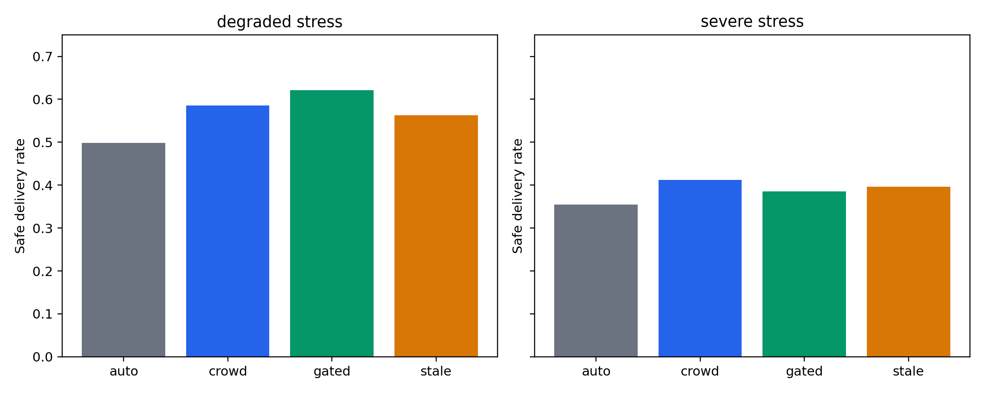
- Continuous simulator command-layer safe-delivery outcomes. Crowd-vector command improves the degraded continuous setting but is not interpreted as a universal control law.
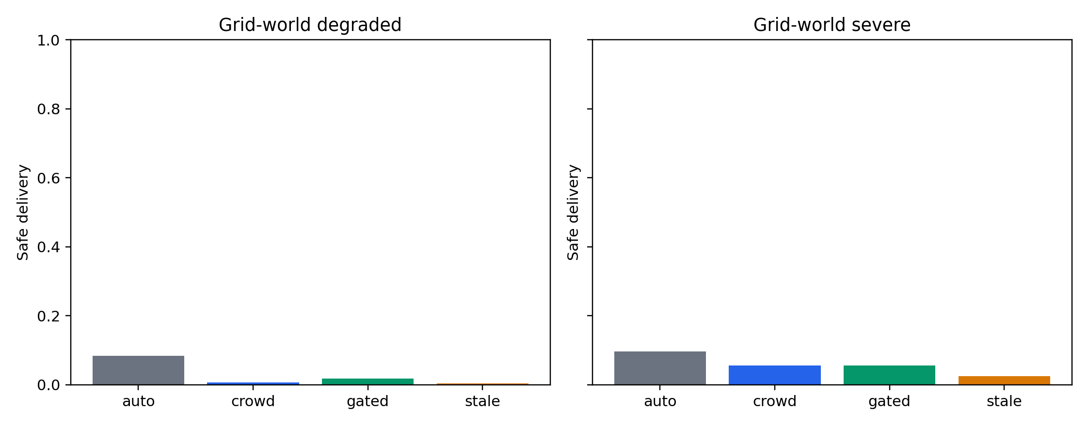
- Grid-world command transfer. The negative transfer result motivates the paper's boundary-condition framing for command aggregation.
- B. RELAY OVER-ALLOCATION PRODUCES A LATENCY-SAFETY TRADE-OFF
Relay-rich allocation consistently reduces effective map delay. In the continuous confirmatory panel, relay-rich teams reduce mean effective map delay by 11.2616, 95% CI [-11.7138, -10.7799], relative to no-relay heterogeneous teams. However, the same contrast decreases safe delivery by 0.1667, 95% CI [-0.2174, -0.1172], decreases operational score by 1.5353, 95% CI [-2.1302, -0.9027], and increases attrition by 0.0250, 95% CI [0.0182, 0.0314].
The relay-count sweep supports the same interpretation. In severe stress, moving from no relays to four relays reduces delay from 24.000 to 9.231 but decreases safe delivery from 0.442 to 0.285 and increases attrition from 0.055 to 0.086. The one-relay condition is not reliably superior; the robust finding is that relay-rich over-allocation is harmful.
The grid-world severe regime also reproduces the trade-off. The relay-rich team lowers effective delay from 12 to 5 while decreasing safe delivery by 0.0382, 95% CI [-0.0729, -0.0069], and increasing attrition by 0.0266, 95% CI [0.0133, 0.0399].
The Webots physics validation provides the strongest robotics-facing replication. In degraded stress, relay-rich allocation shortens effective delay by 12 but decreases safe delivery by 0.3333, 95% CI [-0.6052, -0.0833], increases degraded outcome by 0.3333, 95% CI [0.0833, 0.5833], and increases attrition by 0.1146, 95% CI [0.0799, 0.1493]. In severe stress, effective delay decreases by 22, while safe delivery decreases by 0.6250, 95% CI [-0.7917, -0.4167], degraded outcome increases by 0.6250, 95% CI [0.4167, 0.8333], and attrition increases by 0.1493, 95% CI [0.1232, 0.1771].

TABLE V
Relay-count sweep raw means.
Stress | Relay count | Safe delivery | Attrition | Effective delay
Degraded | 0 | 0.617 | 0.033 | 12.000
Degraded | 1 | 0.592 | 0.036 | 10.068
Degraded | 2 | 0.558 | 0.044 | 8.157
Degraded | 4 | 0.490 | 0.051 | 4.311
Severe | 0 | 0.442 | 0.055 | 24.000
Severe | 1 | 0.444 | 0.060 | 20.222
Severe | 2 | 0.356 | 0.073 | 16.546
Severe | 4 | 0.285 | 0.086 | 9.231

TABLE VI
Grid-world transfer contrasts.
Stress | Contrast and metric | Observed effect
Degraded | Crowd-vector vs autonomous, safe delivery | -0.0764, CI [-0.1111, -0.0451]
Degraded | Crowd-vector vs autonomous, operational score | -2.7921, CI [-3.9046, -1.6338]
Severe | Relay-rich vs no-relay, safe delivery | -0.0382, CI [-0.0729, -0.0069]
Severe | Relay-rich vs no-relay, attrition | +0.0266, CI [0.0133, 0.0399]
Severe | Relay-rich vs no-relay, effective delay | -7.0000, CI [-7.0000, -7.0000]

Table V shows why the relay result is not merely a delay result. The effective delay decreases monotonically as relays are added, but safe delivery also declines and attrition rises. The design implication is not that relays should be avoided; it is that relay capacity should be evaluated jointly with payload, scout, and survival constraints.
Table VI shows the second reason for conservative phrasing. The independent grid-world environment preserves the severe relay trade-off but does not preserve the degraded command benefit. This split is useful because it separates the cross-environment allocation claim from the conditional command-layer claim.
A reviewer could reasonably ask whether the relay-rich result is only a composition artifact, because adding relays also changes the number of other roles. For that reason the relay claim is not stated as a pure causal law about a single robot type. It is stated as an allocation trade-off: in the tested heterogeneous teams, allocating too much team capacity to relay service improves map freshness while degrading safety-aware delivery.
Post-hoc reviewer-defense diagnostics further support this interpretation. A matched-composition diagnostic with 1,536 additional continuous-simulator runs preserved the severe delayed-map relay trade-off when scout count was matched and when relay dynamics were standardized. These diagnostics reduce the likelihood that the result is solely a missing-scout or slow-relay artifact, although they do not replace physical deployment testing.
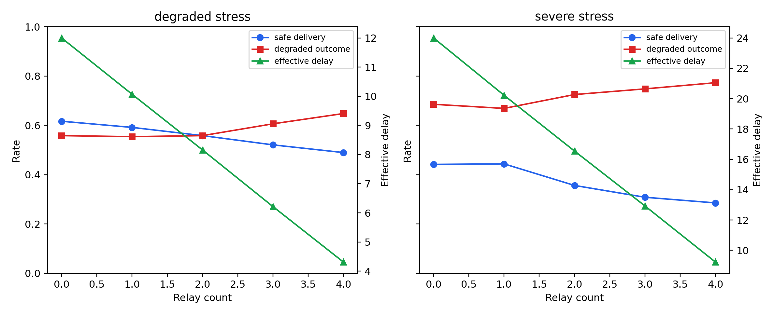
- Continuous relay trade-off. The relay-rich team gains fresher maps while degrading safety-aware outcomes.
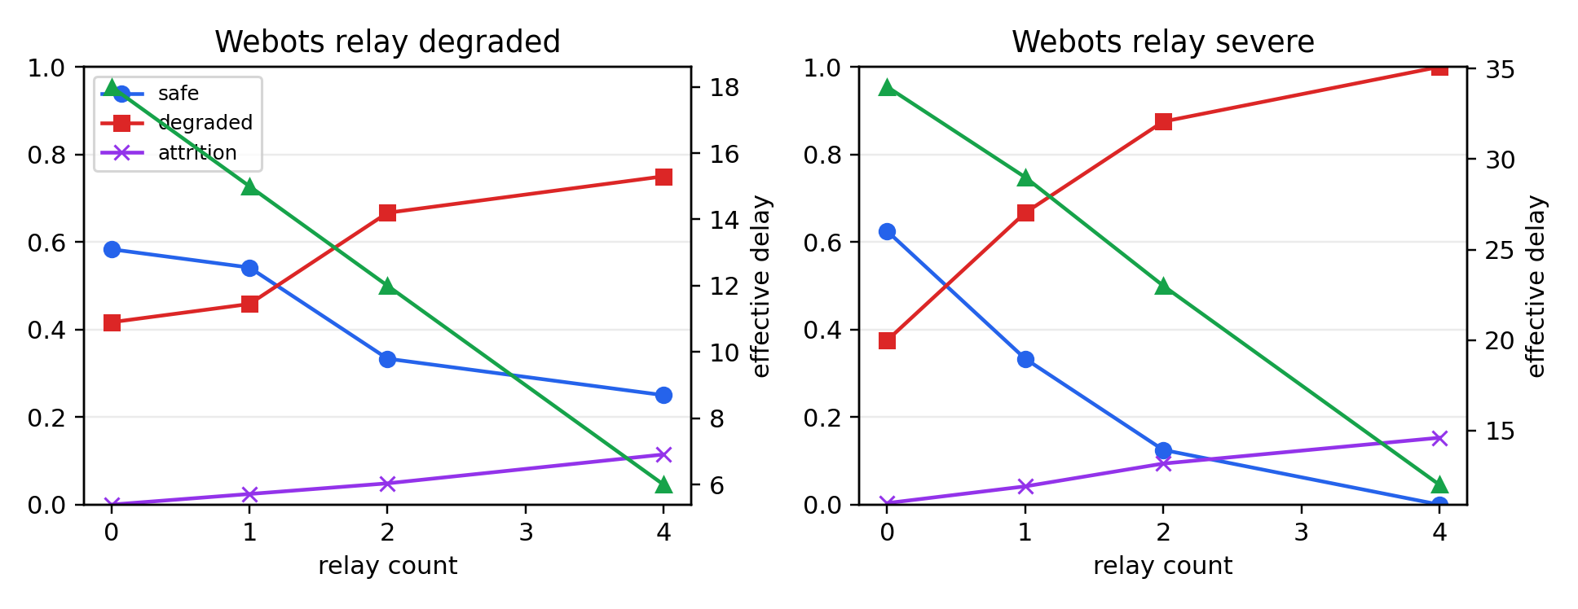
- Webots physics validation. As relay count increases, effective delay falls, but safe delivery decreases and degraded outcomes/attrition increase, especially under severe stress.

TABLE VII
Main Webots relay contrasts.
Stress | Metric | Relay-rich minus no-relay
Degraded | Safe delivery | -0.3333, CI [-0.6052, -0.0833]
Degraded | Degraded outcome | +0.3333, CI [0.0833, 0.5833]
Degraded | Attrition | +0.1146, CI [0.0799, 0.1493]
Degraded | Effective delay | -12.0000, CI [-12.0000, -12.0000]
Severe | Safe delivery | -0.6250, CI [-0.7917, -0.4167]
Severe | Degraded outcome | +0.6250, CI [0.4167, 0.8333]
Severe | Attrition | +0.1493, CI [0.1232, 0.1771]
Severe | Effective delay | -22.0000, CI [-22.0000, -22.0000]

The Webots panel is deliberately interpreted as validation rather than as a standalone deployment study. It uses differential-drive robots, contacts, and wheel-level control, but it still shares the same high-level task abstraction and uses 192 trials. Therefore, the strongest Webots statement is that the severe relay trade-off survives a physics layer; the paper does not claim that the numerical effect size will transfer unchanged to hardware.
Permutation tests on the existing Webots runs support this cautious reading. The severe relay-rich versus no-relay contrasts for safe delivery, degraded outcome, attrition, and effective delay remain strong under nonparametric permutation testing, whereas command-layer Webots effects are weaker. This reinforces the decision to keep relay allocation as the primary claim and command aggregation as conditional evidence.
- C. DIAGNOSTICS ARE AUXILIARY
Diagnostic signals are useful for interpretation but are not the central contribution. In the confirmatory panel, command geometry alone reaches AUROC 0.582 for failure prediction, while map uncertainty reaches 0.575 and early exposure reaches 0.624. A combined non-attrition diagnostic reaches AUROC 0.654.
When the broader delay grid is included, combined diagnostics improve to AUROC 0.716 without attrition and 0.833 with early attrition. These values justify keeping diagnostics as secondary analysis, but they do not replace the main relay-allocation claim.
TABLE VIII
Diagnostic AUROC summary.
Predictor | Confirmatory AUROC | All-Q2 AUROC
Command geometry | 0.5823 | 0.6420
Map uncertainty | 0.5752 | 0.6140
Early exposure | 0.6244 | 0.6426
Combined, no attrition | 0.6541 | 0.7157
Early attrition only | 0.8262 | 0.8537
Combined with attrition | 0.7663 | 0.8326

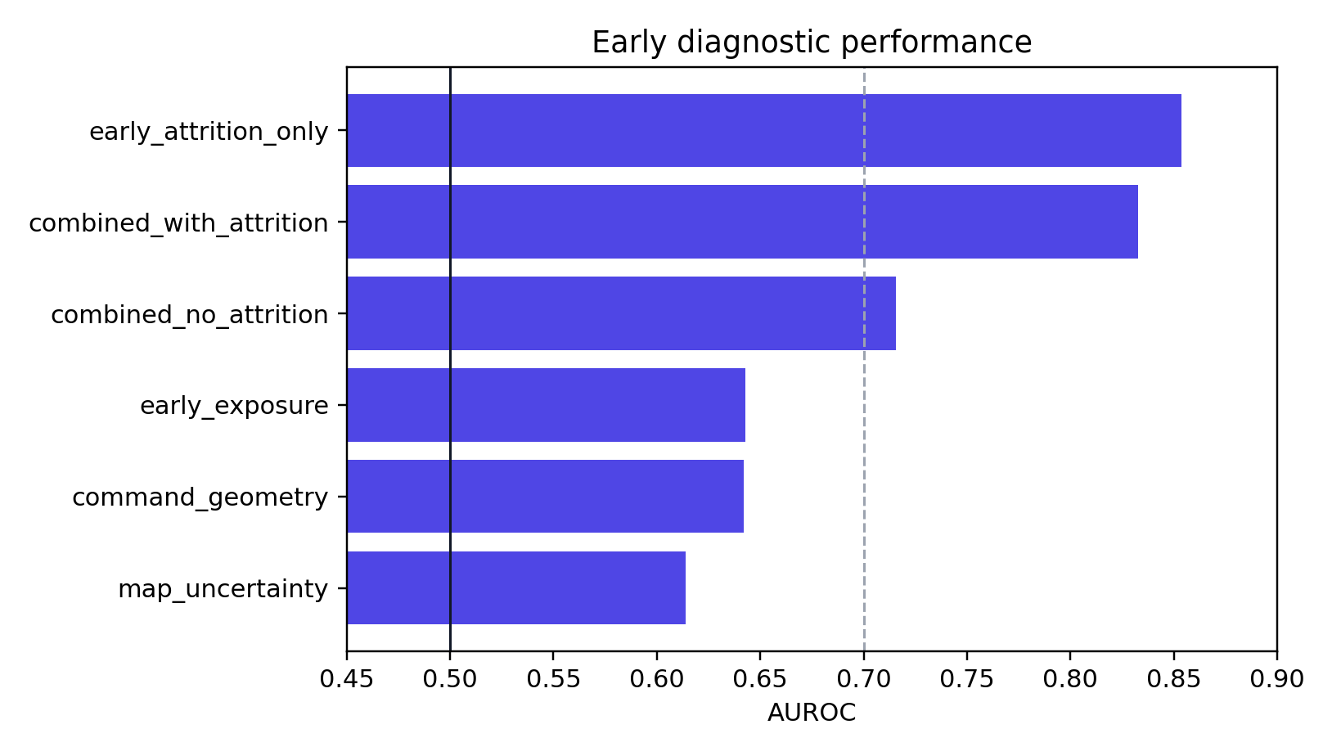
- Diagnostic AUROC values. Combined early signals are more informative than command geometry alone, so diagnostics are treated as auxiliary evidence.
DISCUSSION
The results support a conservative design principle. Increasing relay capacity improves map freshness, but the embodied cost of relay-rich allocation can reduce safe delivery. In other words, communication improvement is not equivalent to mission-safety improvement.
The Webots validation is important because it moves the result beyond one custom simulator. The same relay-rich harm appears when robots are controlled through wheel-speed commands in a physics simulator. This does not prove hardware transfer, but it reduces the risk that the result is solely an artifact of the continuous simulator.
The command-layer results should be read differently. The continuous simulator shows command-layer benefits, and Webots shows some degraded-regime support, but grid-world transfer fails. This pattern is more useful than a single positive claim: it shows that command aggregation requires risk-aware design and environment-sensitive validation.
For designers of heterogeneous multi-robot teams, the practical implication is to treat relay count as a constrained design variable. A relay-rich team may look attractive if evaluation focuses only on delay or map freshness. It may look worse when safe delivery, attrition, and physical exposure are included.
The most important practical implication is measurement choice. If evaluation stops at latency, relay-rich allocation appears successful. If evaluation includes safe delivery, attrition, degraded outcome, and exposure, the same allocation can become undesirable. Multi-robot communication design should therefore be evaluated with task-safety endpoints rather than with network freshness alone.
The second implication concerns command interfaces. A global command vector can help when it summarizes useful shared information and does not fight local hazard geometry. It can hurt when it encourages locally unsafe movement or when the environment representation changes. Command aggregation should therefore be treated as a conditional supervisory input, not as a replacement for validated local autonomy.
THREATS TO VALIDITY AND LIMITATIONS
This paper is simulation-based. Although Webots adds physics and differential-drive actuation, the results are not hardware trials. The paper therefore avoids claims about field deployment outcomes.
The command layer is synthetic. It models delayed, noisy, quantized aggregate commands, but it does not represent measured human behavior. A future human-subject or operator-log study would be required to claim human behavioral validity.
The simulators share a common conceptual hazard-task structure. The grid-world and Webots layers reduce single-simulator dependence, but additional benchmarks and planner comparisons would strengthen generality.
The relay model abstracts communication into effective delay and packet-loss changes. This is appropriate for trade-off characterization but not a substitute for a full network simulation or hardware communication experiment.
The Webots panel has a modest run count relative to the continuous simulator. It is used to test whether the direction of the relay trade-off survives physics, not to estimate deployment-level reliability. The strongest Webots evidence is under severe stress; degraded-regime Webots effects should be interpreted with wider uncertainty.
The matched-composition diagnostic reduces, but does not eliminate, team-composition concerns. Relay count, role mix, robot dynamics, and communication assumptions are coupled in realistic multi-robot design. The paper therefore frames the result as an allocation trade-off rather than as a universal monotonic law about relay robots.
REPRODUCIBILITY
The public reproducibility package includes simulation code, Webots world files, controller scripts, configuration files, CSV outputs, and plotting scripts. The Webots validation used Webots R2025a with the world file swarm_validation.wbt and 12 local SwarmBot differential-drive robots.
All reported contrasts are computed from saved CSV outputs using bootstrap confidence intervals. The analysis files produce the tables, figures, and claim-level readouts used in this manuscript.
The repository is organized so that readers can verify the numerical claims without rerunning the most expensive simulations. The checker validates file presence, row counts, saved contrast values, raw mean reconstructions for grid-world and Webots contrasts, and diagnostic AUROC values. Full reruns remain possible from the included scripts but are not required for claim-level reproduction.
TABLE IX
Public reproducibility package contents.
Component | Contents | Purpose
src/ | Continuous and grid-world simulation scripts | Rerun core experiments and regenerate analysis outputs
webots_validation/ | World, PROTO, controller, and batch runner files | Rerun the Webots validation panel
data/ | Saved seed-level CSV files and contrast tables | Verify all numerical claims without rerunning long simulations
figures/ | Core manuscript figures | Inspect the main command, relay, and diagnostic results
scripts/ | Claim-level reproducibility checker | Recompute row counts, contrasts, and diagnostic values
reports/ | Validation summary | Document evidence layers and claim boundaries

The checker is intentionally stricter than a file-presence test. It verifies required files, row counts, key contrast values, raw mean reconstructions for grid-world and Webots contrasts, and diagnostic AUROC values. The pre-release gate for the public package required three independent checker runs above a 0.95 reproducibility threshold.
The manuscript file itself is not required for reproducing the numerical results. Therefore, the public repository package separates reproducibility artifacts from the formatted submission document. This separation reduces repository size and prevents editorial manuscript metadata from being confused with executable research artifacts.
CONCLUSION
This paper evaluated command-layer intervention and relay allocation in heterogeneous multi-robot teams under delayed hazard information. The data do not support an unconditional claim that command aggregation improves safety across environments. They do support a stronger and more defensible claim: relay-rich over-allocation can reduce information delay while worsening safe delivery and attrition.
Across continuous simulation, relay-count sweeps, grid-world transfer, and Webots physics validation, the strongest replicated effect is the latency-safety trade-off. Command-layer aggregation remains useful but environment dependent. Future work should test the same design principle on hardware, with recognized multi-robot benchmarks, and with real operator command data.
ACKNOWLEDGMENT
The author thanks Friedrich-Alexander-Universität Erlangen-Nürnberg for institutional support.
FUNDING
This research received no specific grant funding from any funding agency in the public, commercial, or not-for-profit sectors.
USE OF GENERATIVE AI
Generative AI tools were used for language refinement, editorial drafting, and code organization. They were not used to generate data, select models, derive results, or make scientific claims. The author reviewed and remains responsible for all manuscript content, code, analyses, and interpretations.
REFERENCES
- B. P. Gerkey and M. J. Mataric, "A formal analysis and taxonomy of task allocation in multi-robot systems," Int. J. Robot. Res., vol. 23, no. 9, pp. 939-954, Sep. 2004, doi: 10.1177/0278364904045564.
- M. Brambilla, E. Ferrante, M. Birattari, and M. Dorigo, "Swarm robotics: A review from the swarm engineering perspective," Swarm Intell., vol. 7, no. 1, pp. 1-41, 2013, doi: 10.1007/s11721-012-0075-2.
- L. E. Parker, D. Rus, and G. S. Sukhatme, "Multiple mobile robot systems," in Springer Handbook of Robotics, B. Siciliano and O. Khatib, Eds. Berlin, Germany: Springer, 2008, pp. 921-941.
- R. Vaughan, "Massively multi-robot simulation in stage," Swarm Intell., vol. 2, no. 2-4, pp. 189-208, 2008, doi: 10.1007/s11721-008-0014-4.
- R. Olfati-Saber, J. A. Fax, and R. M. Murray, "Consensus and cooperation in networked multi-agent systems," Proc. IEEE, vol. 95, no. 1, pp. 215-233, Jan. 2007, doi: 10.1109/JPROC.2006.887293.
- J. P. Hespanha, P. Naghshtabrizi, and Y. Xu, "A survey of recent results in networked control systems," Proc. IEEE, vol. 95, no. 1, pp. 138-162, Jan. 2007, doi: 10.1109/JPROC.2006.887288.
- M. A. Goodrich, B. S. Pendleton, P. Sujit, and J. Pinto, "Human-swarm interaction: A survey," IEEE Trans. Human-Mach. Syst., vol. 43, no. 3, pp. 289-302, May 2013.
- A. Kolling, P. Walker, N. Chakraborty, K. Sycara, and M. Lewis, "Human interaction with robot swarms: A survey," IEEE Trans. Human-Mach. Syst., vol. 46, no. 1, pp. 9-26, Feb. 2016, doi: 10.1109/THMS.2015.2480801.
- S. Thrun, W. Burgard, and D. Fox, Probabilistic Robotics. Cambridge, MA, USA: MIT Press, 2005.
- O. Khatib, "Real-time obstacle avoidance for manipulators and mobile robots," Int. J. Robot. Res., vol. 5, no. 1, pp. 90-98, 1986, doi: 10.1177/027836498600500106.
- B. Yamauchi, "A frontier-based approach for autonomous exploration," in Proc. IEEE Int. Symp. Comput. Intell. Robot. Autom., Monterey, CA, USA, 1997, pp. 146-151, doi: 10.1109/CIRA.1997.613851.
- J. van den Berg, S. J. Guy, M. Lin, and D. Manocha, "Reciprocal n-body collision avoidance," in Robotics Research, vol. 70. Berlin, Germany: Springer, 2011, pp. 3-19, doi: 10.1007/978-3-642-19457-3_1.
- N. Koenig and A. Howard, "Design and use paradigms for Gazebo, an open-source multi-robot simulator," in Proc. IEEE/RSJ Int. Conf. Intell. Robots Syst., Sendai, Japan, 2004, pp. 2149-2154, doi: 10.1109/IROS.2004.1389727.
- O. Michel, "Webots: Professional mobile robot simulation," Int. J. Adv. Robot. Syst., vol. 1, no. 1, pp. 39-42, 2004, doi: 10.5772/5618.
- M. Quigley et al., "ROS: An open-source robot operating system," in Proc. ICRA Workshop Open Source Software, Kobe, Japan, 2009.
- M. Dorigo, M. Birattari, and M. Brambilla, "Swarm robotics," Scholarpedia, vol. 9, no. 1, Art. no. 1463, 2014, doi: 10.4249/scholarpedia.1463.
- A. Howard, M. J. Mataric, and G. S. Sukhatme, "Mobile sensor network deployment using potential fields: A distributed, scalable solution to the area coverage problem," in Distributed Autonomous Robotic Systems 5. Tokyo, Japan: Springer, 2002, pp. 299-308, doi: 10.1007/978-4-431-65941-9_30.
- Cyberbotics Ltd., Webots R2025a. Lausanne, Switzerland: Cyberbotics Ltd., 2025. [Online]. Available: https://cyberbotics.com

It is recommended that footnotes be avoided (except for the unnumbered footnote with the receipt date on the first page). Instead, try to integrate the footnote information into the text.

