Manuscript prepared for journal submission, July 2026.
Digital Object Identifier: IEEE-assigned DOI pending acceptance.
A Reproducible Utility Framework for Agent-Count Stopping in Bounded Collective Systems
BongKeun Song
Friedrich-Alexander-Universität Erlangen-Nürnberg (FAU), Erlangen, Germany
Corresponding author: BongKeun Song (e-mail: bongkeun.song@fau.de).
This work was conducted as a secondary analysis of public datasets and previously published or extracted benchmark results. No new human-subject experiment was conducted.
ABSTRACT Collective systems often improve as additional agents, annotators, or robots are added, but bounded performance creates a practical stopping problem: the statistically best attainable performance may occur later than the cost-aware operating point. This article presents a reproducible utility framework for agent-count stopping in bounded collective systems. The framework defines N* as the agent count that maximizes normalized performance net of deployment cost, separates retrograde systems with a peak reference N_peak from monotone-saturating systems with an operational saturation reference N_95, and reports budget sensitivity explicitly. The final raw-bootstrap closure uses CIFAR-10H as a controlled gold-accuracy validation domain and ChaosNLI as a semantic reference-distribution recovery domain; both yielded identifiable N_95 references (22 and 27, respectively). Snapshot Serengeti is retained as supporting citizen-science evidence. Bingöl/USL is included as an analytical retrograde benchmark, Snow et al. as a marginal-gain to utility-stopping bridge, and Nitti et al. as boundary/admissibility stress-test evidence. The results support a conservative engineering interpretation: the framework estimates budget-aware operating regions and sensitivity to reference and budget choices, not a universal stopping constant.
INDEX TERMS collective intelligence, crowdsourcing, swarm robotics, utility optimization, optimal stopping, budget sensitivity, uncertainty quantification, reproducibility.

INTRODUCTION
Collective systems are frequently scaled by adding more agents, annotators, robots, or independent judgments. In many settings, the statistical performance curve continues to improve with N, but the practical operating decision is not whether improvement is still measurable. The decision is whether the next unit of collective input is worth its deployment or annotation cost.
This paper treats that decision as an agent-count stopping problem. Given a performance curve C(N), we define a cost-aware operating point N* by maximizing normalized performance net of a budget-normalized cost. The purpose is not to claim a universal stopping constant. The purpose is to make the stopping implication of bounded performance curves explicit, reproducible, and auditable.
A reviewer can reasonably argue that positive cost induces early stopping under concavity. The contribution here is therefore not the existence of early stopping in the abstract, but the reproducible estimation of where the operating point lies, how it changes with the performance-cost weight λ, and how it depends on reference definitions and deployment budgets.
A key feature of the framework is that it does not treat all systems as sharing one N*/N_peak ratio. Retrograde systems, such as Universal Scalability Law (USL) curves with coherence overhead, have an identifiable N_peak. Monotone-saturating systems, such as crowd-annotation and distribution-recovery data, require an operational saturation reference such as N_95. This separation prevents a false equivalence between performance decline and performance saturation.
The empirical and analytical evidence is organized in tiers. CIFAR-10H and ChaosNLI provide the final raw hierarchical-bootstrap primary closure. Snapshot Serengeti provides supporting citizen-science evidence. Bingöl/USL is retained as an analytical retrograde benchmark, Snow et al. as a bridge between marginal-gain and utility stopping, and Nitti et al. as boundary evidence. This structure preserves the breadth of the original framework while avoiding the overclaim that every component has the same reproducibility status.
RELATED WORK
A. BOUNDED SCALABILITY AND COLLECTIVE PERFORMANCE
Bounded scalability appears in collective intelligence, robot swarms, crowdsourced annotation, citizen science, distributed sensing, and parallel systems [1], [2]. Classical aggregation results motivate the use of multiple independent judgments, but deployed systems face correlated errors, redundancy, finite task difficulty, communication overhead, and physical interference.
In robotic and computational systems, the Universal Scalability Law provides a compact description of linear, saturating, and retrograde scalability [2], [3]. In the retrograde case, performance improves initially, reaches a peak, and then declines when additional agents impose coordination or interference costs. This makes N_peak a meaningful reference for stopping.
B. HUMAN JUDGMENT AND DISTRIBUTION RECOVERY
Human-annotation datasets increasingly show that disagreement is not merely noise. CIFAR-10H provides distributions of human labels over CIFAR-10 test images and supports both gold-accuracy and distribution-sensitive analyses [4]. ChaosNLI provides many human labels per natural-language inference example and is more naturally analyzed as reference-distribution recovery than as single-label accuracy [5].
Citizen-science data add a different source of evidence. Snapshot Serengeti supplies volunteer classifications and an expert-gold subset from a deployed ecological classification platform [6]. Because the expert-gold subset and species-set transformation introduce task-specific constraints, it is used as supporting evidence rather than as a co-primary validation domain.
C. OPTIMAL STOPPING AND BUDGET-AWARE DESIGN
Optimal stopping and budget allocation literatures formalize when additional sampling or resource allocation is no longer justified [7], [8], [9]. Many empirical collective-system studies report performance curves, but do not convert them into explicit operating-point decisions with uncertainty and budget sensitivity. The present work bridges this gap for bounded collective systems.
UTILITY FRAMEWORK
A. PERFORMANCE REFERENCES
Let C(N) denote the expected performance obtained using N agents, annotators, or judgments. For retrograde systems, the relevant reference is the peak N_peak. For monotone-saturating systems, the central reference is N_95, the smallest N at which fitted performance reaches 95% of the fitted asymptotic reference. N_90 and N_99 are retained only as sensitivity references.
The reference is selected by regime: N_ref = N_peak for retrograde systems, and N_ref = N_95 for monotone-saturating systems.
B. NORMALIZED UTILITY
The cost-aware operating point is defined by a normalized utility function:
U(N) = λ C̃(N) − (1 − λ) N / N_budget. (1)
N* = arg max_N U(N). (2)
Here C̃(N) is a normalized performance curve, λ in [0,1] weights performance relative to cost, and N_budget is an explicit deployment or annotation budget. The output is therefore budget-aware by construction; it should not be interpreted as a budget-invariant universal optimum.
C. EVIDENCE TIERS
See Table I.
DATA AND ANALYSIS PIPELINE
A. PRIMARY RAW-BOOTSTRAP CLOSURE
The primary final raw-bootstrap closure is limited to CIFAR-10H gold accuracy and ChaosNLI reference-distribution recovery [4], [5]. Snapshot Serengeti was processed through the same fitted-saturation machinery as supporting field evidence, but it is not treated as a co-primary validation domain [6]. Bootstrap uncertainty follows standard resampling practice [10], [11]. Fitted families included Michaelis, logarithmic saturation, and inverse-square-root forms; nonlinear fits and AIC-based comparisons were used as model-selection diagnostics [12], [13]. N_95 is defined here as a paper-specific operational saturation reference; N_90 and N_99 are retained as sensitivity references.
CIFAR-10H is evaluated in gold-accuracy mode as a primary final raw-bootstrap validation domain. ChaosNLI is evaluated only in reference-distribution recovery mode as the second primary final raw-bootstrap validation domain, using a distance-based C(N) rather than a gold-accuracy interpretation. Snapshot Serengeti is evaluated in gold-accuracy mode as supporting field evidence only, because its expert-gold subset and species-set transformation impose task-specific constraints.
B. ANALYTICAL AND CONTEXTUAL COMPONENTS
The final raw-bootstrap closure was restricted to the augmented datasets with standardized bootstrap products. Bingöl/USL, Snow, and Nitti are therefore not promoted to primary final raw-bootstrap validation. They are retained in explicitly lower-tier roles: Bingöl/USL as an analytical retrograde benchmark reconstructed from published parameters [14], Snow as an epsilon-stopping to utility-stopping bridge [15], and Nitti et al. as a boundary/admissibility stress test based on supplementary benchmark data [16].
See Table I.
RESULTS
A. PRIMARY DATASETS HAD IDENTIFIABLE N_95 REFERENCES
The final raw-bootstrap closure identified central N_95 references for the two primary datasets. CIFAR-10H gold accuracy reached N_95=22 with a degenerate bootstrap interval [22,22], reflecting a highly stable controlled visual-judgment curve. ChaosNLI reference-distribution recovery reached N_95=27 with interval [26,31], reflecting a broader semantic-disagreement domain. Snapshot Serengeti reached N_95=30 [29,31] and is retained as supporting citizen-science evidence.
See Fig. 1.
B. UTILITY OPTIMA WERE COHERENT BUT BUDGET-AWARE
For the two primary datasets, N*(λ) increased monotonically under observed-maximum budgets. Central λ values supported stopping before N_95. However, high performance weighting exposed budget sensitivity in CIFAR-10H: at λ=0.90, observed and fixed-cap budgets did not preserve early stopping before N_95, whereas the N_95-relative budget did. This is why the manuscript is framed as an engineering framework rather than a science-first universal-law paper.
See Fig. 2.
See Fig. 3.
See Table III.
C. BINGÖL/USL RECOVERS THE RETROGRADE BRANCH
The Bingöl/USL outputs provide the retrograde component of the framework [14]. The USL conditions have identifiable analytical N_peak values ranging from about 13.00 to 28.72, and the utility-optimal N* occurs before N_peak for all reported λ values. This supports the N*/N_peak branch of the framework. Because these outputs were reconstructed from published parameters rather than included in the final raw-bootstrap closure, they are presented as an analytical benchmark rather than as co-primary empirical evidence.
See Fig. 4.
See Table IV.
D. SNOW BRIDGES MARGINAL-GAIN AND UTILITY STOPPING
The Snow analysis is retained as a bridge, not as a primary validation domain [15]. Digitized Snow task curves produced valid epsilon-stopping to utility-stopping correspondences across the analyzed tasks, with λ-equivalent values approximately in the 0.81-0.94 range. Some tasks require extrapolated ceilings and should therefore not carry the primary claim. The appropriate use is to show that an existing marginal-gain stopping criterion can be expressed within the utility framework.
See Table V.
E. NITTI ACTS AS BOUNDARY AND ADMISSIBILITY EVIDENCE
The Nitti supplementary-benchmark reanalysis is informative because it does not uniformly validate the framework [16]. Across 63 algorithm-function sheets, 32 passed the inverse-square-root R2>0.70 screen, 48 had valid epsilon-utility bridges, and 27 passed the conservative boundary checklist. Utility-optimal early stopping occurred in 63/63, 63/63, 63/63, and 61/63 sheets for λ values 0.3, 0.5, 0.7, and 0.9, respectively. This pattern is useful as boundary evidence: it shows that early stopping can be frequent even when curve admissibility and monotonicity are not universally satisfied.
See Table VI.
F. ROBUSTNESS ANALYSES SUPPORT A BOUNDED-FAMILY INTERPRETATION
The utility-family robustness file shows that Bingöl early stopping is preserved across linear, quadratic, logarithmic-utility, and exponential-cost utility families [14]. For curve-family sensitivity, InvSqrt, logarithmic, and Michaelis families passed all five Bingöl USL conditions, whereas the exponential family passed zero of five. This supports a bounded-family interpretation while warning against unqualified extrapolating models [12], [13].
DISCUSSION
A. INTERPRETATION AS A BUDGET-AWARE DECISION FRAMEWORK
The strongest contribution is an engineering and statistical decision framework, not a budget-invariant scientific law. The framework is valuable because it reports when conclusions are stable and when budget definitions change the decision. This framing supports a reproducible decision-support interpretation rather than an overgeneralized universal-law interpretation.
B. WHAT THE RESULT SUPPORTS
The evidence supports a reproducible framework for identifying cost-aware operating regions in bounded collective systems. It also supports the distinction between N*/N_peak in retrograde systems and N*/N_95 in monotone-saturating systems. Bingöl/USL restores the original retrograde branch as analytical benchmark evidence. Separately, CIFAR-10H and ChaosNLI provide the raw-bootstrap primary closure for monotone-saturating judgment systems.
C. WHAT THE RESULT DOES NOT SUPPORT
The results do not support a universal stopping constant, a single N*/N_peak ratio across all domains, or a claim that more agents are always counterproductive. Snapshot should not be promoted above supporting evidence, Snow should not be treated as primary validation, and Nitti should not be converted from boundary evidence into a positive-validation dataset.
D. PRACTICAL IMPLICATIONS
The method can be used to estimate and audit operating regions for annotation pipelines, citizen-science workflows, swarm allocation benchmarks, and other bounded collective systems. A practitioner specifies a performance reference, a budget definition, and a performance-cost weight λ; the framework returns N*(λ), reference ratios, and sensitivity flags.
E. RELATION TO CROWDSOURCING BUDGET AND LABEL-AGGREGATION LITERATURE
The framework is complementary to repeated-label acquisition, label aggregation, and budget-optimal crowdsourcing. Prior work has shown that additional noisy labels can improve data quality under some cost regimes [17], that latent-truth and annotator-reliability models estimate error rates or labeler expertise when true labels are uncertain [18]-[21], and that task allocation can be optimized under target reliability budgets [22]. In contrast, the present framework starts from an observed or fitted collective performance curve and asks for the explicit cost-aware operating region N*(λ), with sensitivity to N_budget and N_ref.
F. LIMITATIONS
The first limitation is that the primary raw-bootstrap closure is strongest for monotone-saturating judgment systems. The second limitation is budget sensitivity at high λ. The third limitation is that N_99 is usually extrapolated and should remain sensitivity-only. The fourth limitation is that the analytical and boundary components are not equal in evidence tier to the final raw-bootstrap primary datasets.
CONCLUSION
This article presents a reproducible utility framework for agent-count stopping in bounded collective systems. The framework estimates N* from normalized performance-cost utility, separates retrograde N_peak references from monotone-saturating N_95 references, and reports budget sensitivity explicitly. CIFAR-10H and ChaosNLI provide the primary raw-bootstrap closure, Snapshot Serengeti provides supporting citizen-science evidence, Bingöl/USL restores the analytical retrograde benchmark, Snow links marginal-gain stopping to utility stopping, and Nitti stress-tests boundary and admissibility conditions. The correct interpretation is deliberately conservative: the framework identifies budget-aware operating regions, not a universal stopping constant.
DATA AND CODE AVAILABILITY
All data analyzed in this article are secondary public datasets, published or digitized benchmark curves, or derived processed files. The reproducibility package accompanying this submission contains the processed item-level inputs for the two primary raw-bootstrap domains, curve-bootstrap files, final saturation summaries, utility summaries, model-comparison tables, budget-sensitivity tables, legacy benchmark inputs, analysis scripts, and the reproducibility report. The original public sources are cited in the reference list, and no new restricted human-subject, animal, or biological data were generated for this study.
ETHICS STATEMENT
No new human-subject, animal, or biological experiment was conducted. Publicly available datasets and published benchmark summaries were analyzed. Dataset-specific ethical and consent conditions remain those of the original sources.
CONFLICTS OF INTEREST
The author declares no competing interests.
AUTHOR CONTRIBUTIONS
BongKeun Song conceived the study, designed the utility framework, performed the analyses, and wrote the manuscript.
ACKNOWLEDGMENT
The author thanks Friedrich-Alexander-Universität Erlangen-Nürnberg for institutional support. OpenAI Codex was used for editorial and reproducibility-audit assistance in revising manuscript text, checking references, and organizing release materials; the author reviewed and approved all manuscript content, analyses, and claims [23].

TABLES AND FIGURES
TABLE I. Evidence-tier hierarchy used for the submission framing.
Tier | Component | Manuscript role
Primary closure | CIFAR-10H; ChaosNLI | Primary final raw-bootstrap validation only
Supporting | Snapshot Serengeti | Supporting field evidence only; not co-primary
Analytical benchmark | Bingöl/USL | Analytical retrograde N*/N_peak benchmark only
Bridge | Snow et al. | Bridge from epsilon-stopping to utility-stopping only
Boundary | Nitti et al. | Boundary/admissibility stress test only
TABLE II. Final fitted saturation references for the two primary domains and the supporting Snapshot field-evidence curve.
Dataset | Mode | Role | Fit | N_90 | N_95 [CI] | N_99
CIFAR-10H | gold accuracy | primary final raw-bootstrap validation | michaelis | 11 | 22 [22, 22] | extrapolated
ChaosNLI | reference distribution | primary saturating validation | michaelis | 14 | 27 [26, 31] | extrapolated
Snapshot Serengeti | gold accuracy | supporting citizen science evidence | michaelis | 15 | 30 [29, 31] | extrapolated
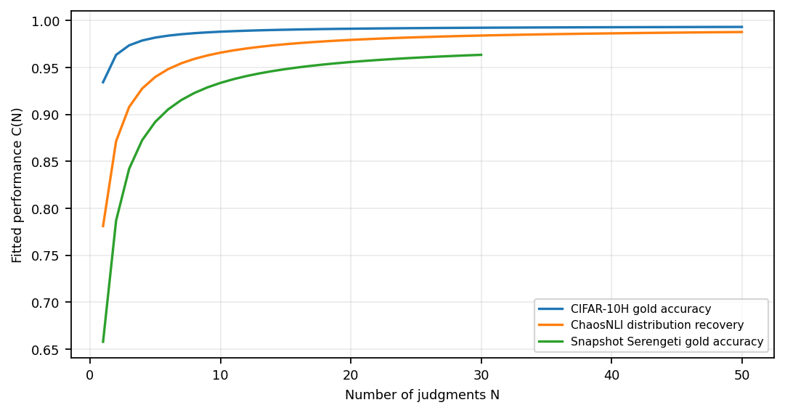
- Fitted saturation curves for CIFAR-10H and ChaosNLI as the two primary final raw-bootstrap validation domains, with Snapshot Serengeti shown as supporting field evidence only.
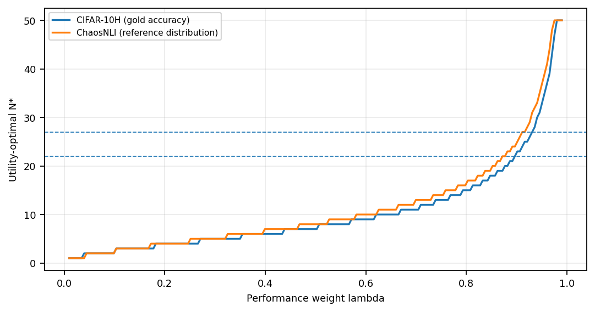
- Utility-optimal N* as a function of λ under observed-maximum budgets for the two primary validation datasets. Horizontal reference levels correspond to N_95.
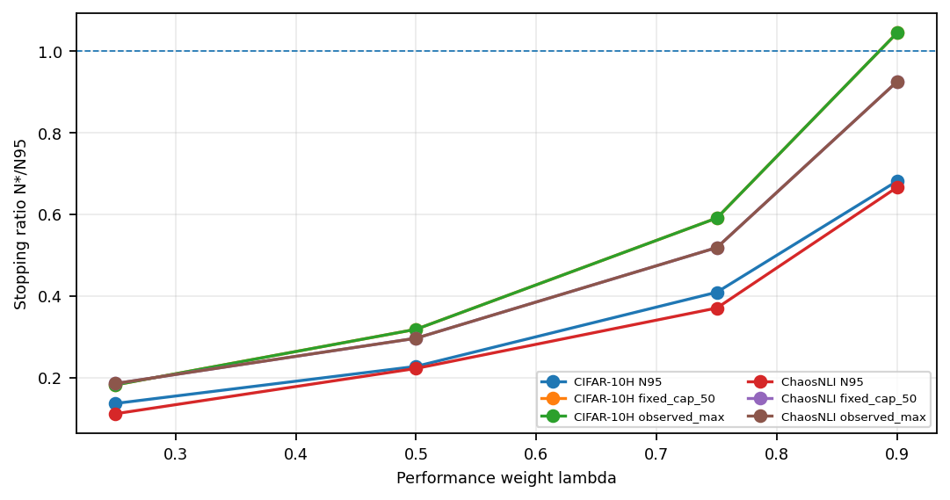
- Budget sensitivity of N*/N_95. Values below one indicate early stopping before N_95. The high-λ CIFAR-10H case is intentionally reported rather than suppressed.
TABLE III. Budget sensitivity of utility optima. Entries are N* with N*/N_95 in parentheses.
Dataset | Mode | λ | Observed max | N_95 budget | Fixed cap 50
CIFAR-10H | gold accuracy | 0.25 | 4 (0.18) | 3 (0.14) | 4 (0.18)
CIFAR-10H | gold accuracy | 0.50 | 7 (0.32) | 5 (0.23) | 7 (0.32)
CIFAR-10H | gold accuracy | 0.75 | 13 (0.59) | 9 (0.41) | 13 (0.59)
CIFAR-10H | gold accuracy | 0.90 | 23 (1.05) | 15 (0.68) | 23 (1.05)
ChaosNLI | reference distribution | 0.25 | 5 (0.19) | 3 (0.11) | 5 (0.19)
ChaosNLI | reference distribution | 0.50 | 8 (0.30) | 6 (0.22) | 8 (0.30)
ChaosNLI | reference distribution | 0.75 | 14 (0.52) | 10 (0.37) | 14 (0.52)
ChaosNLI | reference distribution | 0.90 | 25 (0.93) | 18 (0.67) | 25 (0.93)
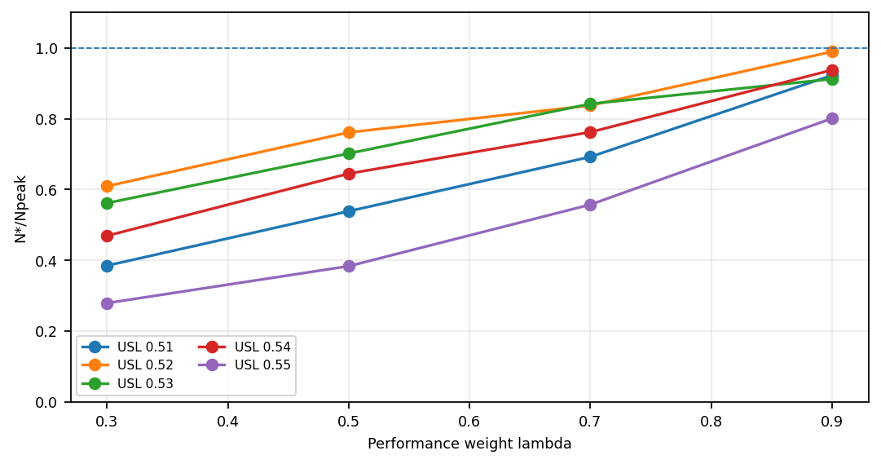
- Bingöl/USL analytical retrograde benchmark. Across reported USL conditions, N*/N_peak remains below one over the evaluated λ values.
TABLE IV. Bingöl/USL analytical retrograde benchmark. Entries are N* with N*/N_peak in parentheses.
USL condition | N_peak | λ=.3 | λ=.5 | λ=.7 | λ=.9
0.51 | 13.00 | 5 (0.38) | 7 (0.54) | 9 (0.69) | 12 (0.92)
0.52 | 13.14 | 8 (0.61) | 10 (0.76) | 11 (0.84) | 13 (0.99)
0.53 | 14.25 | 8 (0.56) | 10 (0.70) | 12 (0.84) | 13 (0.91)
0.54 | 17.06 | 8 (0.47) | 11 (0.64) | 13 (0.76) | 16 (0.94)
0.55 | 28.72 | 8 (0.28) | 11 (0.38) | 16 (0.56) | 23 (0.80)
TABLE V. Snow bridge analysis from digitized task curves. The table is contextual bridge evidence, not primary validation.
Task | Ceiling flag | N_eps obs. | N_eps ext. | λ equiv. | Verdict
Word Similarity | extrapolated | 7 | 11 | 0.831 | valid
RTE | extrapolated | 10 | 14 | 0.830 | valid
Temp Ordering | extrapolated | 10 | 17 | 0.808 | valid
WSD | bounded/marginal | 4 | 3 | 0.944 | valid
Affect avg | bounded/marginal | 10 | 17 | 0.863 | valid
TABLE VI. Nitti boundary summary. These results define admissibility limits rather than primary validation.
Diagnostic | Result
Sheets analyzed | 63
Inverse-sqrt R2>0.70 | 32/63
Valid epsilon-utility bridge | 48/63
Boundary checklist pass | 27/63
Early stop at λ=.9 | 61/63

REFERENCES
[1] M. de Condorcet, Essai sur l'application de l'analyse a la probabilite des decisions rendues a la pluralite des voix. Paris, France: Imprimerie Royale, 1785.
[2] H. Hamann and A. Reina, "Scalability in computing and robotics," IEEE Trans. Comput., vol. 71, no. 6, pp. 1453-1465, Jun. 2022, doi: 10.1109/TC.2021.3089044.
[3] N. J. Gunther, "A simple capacity model of massively parallel transaction systems," in Proc. CMG Conf., 1993, pp. 1035-1044.
[4] J. C. Peterson, R. M. Battleday, T. L. Griffiths, and O. Russakovsky, "Human uncertainty makes classification more robust," in Proc. IEEE/CVF Int. Conf. Comput. Vis. (ICCV), 2019, pp. 9617-9626.
[5] Y. Nie, X. Zhou, and M. Bansal, "What can we learn from collective human opinions on natural language inference data?" in Proc. Conf. Empirical Methods Natural Language Processing (EMNLP), 2020, pp. 9131-9143, doi: 10.18653/v1/2020.emnlp-main.734.
[6] A. Swanson et al., "Snapshot Serengeti, high-frequency annotated camera trap images of 40 mammalian species in an African savanna," Sci. Data, vol. 2, Art. no. 150026, 2015, doi: 10.1038/sdata.2015.26.
[7] T. S. Ferguson, Optimal Stopping and Applications. Los Angeles, CA, USA: UCLA, 2006.
[8] Y. Bachrach and J. S. Rosenschein, "Distributed multiagent resource allocation in diminishing marginal return domains," in Proc. 7th Int. Conf. Autonomous Agents and Multiagent Systems (AAMAS), 2008, pp. 1103-1110.
[9] T. Soma, N. Kakimura, K. Inaba, and K. Kawarabayashi, "Optimal budget allocation: Theoretical guarantee and efficient algorithm," in Proc. 31st Int. Conf. Machine Learning (ICML), PMLR, vol. 32, 2014, pp. 351-359.
[10] B. Efron and R. J. Tibshirani, An Introduction to the Bootstrap. New York, NY, USA: Chapman & Hall, 1993.
[11] A. C. Davison and D. V. Hinkley, Bootstrap Methods and Their Application. Cambridge, U.K.: Cambridge Univ. Press, 1997, doi: 10.1017/CBO9780511802843.
[12] H. Akaike, "A new look at the statistical model identification," IEEE Trans. Autom. Control, vol. AC-19, no. 6, pp. 716-723, Dec. 1974, doi: 10.1109/TAC.1974.1100705.
[13] D. M. Bates and D. G. Watts, Nonlinear Regression Analysis and Its Applications. New York, NY, USA: Wiley, 1988.
[14] S. A. Bingöl, T. Töpfer, S. Kosub, H. Hamann, and A. Reina, "Optimal scalability-aware allocation of swarm robots: From linear to retrograde performance via marginal gains," arXiv:2512.23431, 2025.
[15] R. Snow, B. O'Connor, D. Jurafsky, and A. Y. Ng, "Cheap and fast-but is it good? Evaluating non-expert annotations for natural language tasks," in Proc. Conf. Empirical Methods Natural Language Processing (EMNLP), 2008, pp. 254-263.
[16] A. Nitti, M. D. de Tullio, I. Federico, and G. Carbone, "A collective intelligence model for swarm robotics applications," Nat. Commun., vol. 16, Art. no. 6572, 2025, doi: 10.1038/s41467-025-61985-7.
[17] V. S. Sheng, F. Provost, and P. G. Ipeirotis, "Get another label? Improving data quality and data mining using multiple, noisy labelers," in Proc. 14th ACM SIGKDD Int. Conf. Knowl. Discovery Data Mining (KDD), 2008, pp. 614-622, doi: 10.1145/1401890.1401965.
[18] A. P. Dawid and A. M. Skene, "Maximum likelihood estimation of observer error-rates using the EM algorithm," J. Roy. Stat. Soc. Ser. C (Appl. Stat.), vol. 28, no. 1, pp. 20-28, 1979, doi: 10.2307/2346806.
[19] J. Whitehill, T.-F. Wu, J. Bergsma, J. R. Movellan, and P. L. Ruvolo, "Whose vote should count more: Optimal integration of labels from labelers of unknown expertise," in Adv. Neural Inf. Process. Syst., vol. 22, 2009, pp. 2035-2043.
[20] P. Welinder, S. Branson, S. Belongie, and P. Perona, "The multidimensional wisdom of crowds," in Adv. Neural Inf. Process. Syst., vol. 23, 2010, pp. 2424-2432.
[21] V. C. Raykar et al., "Learning from crowds," J. Mach. Learn. Res., vol. 11, no. 43, pp. 1297-1322, 2010.
[22] D. R. Karger, S. Oh, and D. Shah, "Budget-optimal task allocation for reliable crowdsourcing systems," Oper. Res., vol. 62, no. 1, pp. 1-24, 2014, doi: 10.1287/opre.2013.1235.
[23] OpenAI, "Introducing Codex," May 16, 2025. [Online]. Available: https://openai.com/index/introducing-codex/
BIOGRAPHY
BongKeun Song received the M.S. degree in microbial and biochemical engineering and is currently a doctoral researcher affiliated with Friedrich-Alexander-Universität Erlangen-Nürnberg. His research interests include collective systems, human-in-the-loop control, simulation-based evaluation, and reproducible decision frameworks.

It is recommended that footnotes be avoided (except for the unnumbered footnote with the receipt date on the first page). Instead, try to integrate the footnote information into the text.

