Supplementary Information S4. Supplementary Tables and Figures
This file contains the supplementary tables and figures referenced in the main text. Table and figure numbering follows first mention in the main text.
Supplementary Table S1. System-class assumptions
ID | Assumption
S1 | planar discrete-time tracking state with first-order smoothing memory
S2 | finite directional quantizer on the aggregate command channel
S3 | delayed look-ahead target defined on a reference path
S4 | local projection coordinates available only on smooth single-branch path intervals
S5 | non-smooth path changes, projection ambiguity, and quantizer crossings treated as mode/event structure
S6 | public aggregate heading available as an auditable collective-direction variable
Supplementary Table S2. Audit-protocol conditions
ID | Protocol condition
P1 | event channels for quantizer switching and path-mode changes are explicitly logged or reproducibly reconstructed
P2 | intervention policy and implementation are fixed during audit
P3 | no threshold tuning, controller refit, or model refit is performed in the audit stage
P4 | stream-separated common-random-number convention is used for the final structural audit
P5 | uncertainty for event-cost associations is clustered by base condition
Supplementary Table S3. Smooth-theorem implementation scope
Trajectory regime | Projection model | Theorem relationship | Manuscript treatment
circle | continuous smooth path | direct smooth-chart scope away from numerical degeneracy | main local lemma applies under tube assumptions
square segment interior | straight segment, K=0 | direct local straight-chart scope away from true corners | true corners charged separately
zigzag segment interior | straight segment, K=0 | direct local straight-chart scope away from vertices and endpoint wrap | endpoint wrap excluded from theorem
sampled lemniscate | nearest among 800 sampled path points | discrete projection implementation outside direct C2 theorem scope without interpolation/discretization remainder | lemniscate replay relief is an audit proxy; branch and sampling discontinuities are obstructions
Supplementary Table S4. Formal-claim scope summary
Item | Status | Main-text role
Smooth local normal drift | Proved under assumptions | Main positive lemma
Strict same-side local relief | Proved under assumptions | Main positive local proposition
Quantizer frequency-burden geometry | Structural remark | General systems warning
Square true-corner charge | Conditional geometric charge with arclength-window correction | Non-smooth partial component
Zigzag interior memory | Conditional local accounting | Partial result
Zigzag endpoint wrap | Obstruction only | Scope boundary
Lemniscate branch ambiguity | Obstruction only | Scope boundary
Finite-horizon global benefit expression | Closure target schema only | Open master-inequality target
Supplementary Table S5. Pairwise q contrasts
Metric | Contrast | Mean | 95% CI low | 95% CI high
mean vote-jump chord2 per vote opportunity | q4_minus_q8 | -0.019782 | -0.104528 | 0.067016
mean vote-jump chord2 per vote opportunity | q8_minus_q16 | 0.239790 | 0.150200 | 0.328106
mean vote-jump chord2 per vote opportunity | q4_minus_q16 | 0.220008 | 0.136213 | 0.310490
aggregate jump chord2 | q4_minus_q8 | -0.376146 | -0.518396 | -0.239405
aggregate jump chord2 | q8_minus_q16 | 0.449022 | 0.338951 | 0.565471
aggregate jump chord2 | q4_minus_q16 | 0.072876 | -0.034596 | 0.187033
path/vote co-occurrence | q4_minus_q8 | -0.013438 | -0.027656 | 0.001875
path/vote co-occurrence | q8_minus_q16 | 0.013281 | -0.000158 | 0.026486
path/vote co-occurrence | q4_minus_q16 | -0.000156 | -0.014063 | 0.015547
positive intervention error-squared increment | q4_minus_q8 | 0.199923 | 0.158428 | 0.240543
positive intervention error-squared increment | q8_minus_q16 | 0.052101 | 0.033046 | 0.072338
positive intervention error-squared increment | q4_minus_q16 | 0.252024 | 0.204328 | 0.299219
mean counterfactual event cost | q4_minus_q8 | -0.002747 | -0.012279 | 0.005658
mean counterfactual event cost | q8_minus_q16 | -0.002376 | -0.008986 | 0.004146
mean counterfactual event cost | q4_minus_q16 | -0.005123 | -0.013255 | 0.002317
mean positive-part counterfactual cost | q4_minus_q8 | 0.223549 | 0.170728 | 0.273471
mean positive-part counterfactual cost | q8_minus_q16 | 0.092685 | 0.054599 | 0.127317
mean positive-part counterfactual cost | q4_minus_q16 | 0.316234 | 0.256488 | 0.372893
Supplementary Table S6. Linear q-coarseness model, base-condition clustered
Term | Estimate | 95% CI low | 95% CI high | Excludes zero
q coarseness | 1.789337 | 1.020660 | 2.582424 | yes
vote event | 0.002244 | -0.202844 | 0.202911 | no
path event | 0.142235 | -0.351617 | 0.657303 | no
q x vote | -4.336568 | -5.492429 | -3.263838 | yes
q x path | 0.962349 | -0.691075 | 2.733094 | no
vote x path | -0.443359 | -0.813922 | -0.089269 | yes
Supplementary Table S7. Categorical q sensitivity, q4 reference
Term | Estimate | 95% CI low | 95% CI high | Excludes zero
q8 main | -0.195697 | -0.314585 | -0.069048 | yes
q16 main | -0.374058 | -0.560244 | -0.199693 | yes
q8 x vote | 0.637621 | 0.460248 | 0.831936 | yes
q16 x vote | 0.844274 | 0.622648 | 1.077204 | yes
q8 x path | -0.321846 | -0.570069 | -0.087848 | yes
q16 x path | -0.142409 | -0.476031 | 0.158096 | no
vote x path | -0.420342 | -0.767045 | -0.097278 | yes
Supplementary Table S8. System parameters
Quantity | Value or definition | Role
N_AGENTS | 50 | Number of voting agents
DT | 1/60 | Simulation step
DUR / final audit FRAMES | 65.0 s in original engine; 1800 frames in final structural audit | Run length convention
WIN / VOTE_INT | 0.3 s / 18 frames | Vote update period
MSPD | 5.0 | Target speed in smoothing update
SMOOTH alpha | 0.2 | First-order velocity smoothing
LOOK | 2.0 arclength units | Delayed look-ahead distance
COHERENCE | 1.0 | All minority-policy votes committed to anti-aggregate direction
baseline quantizer | q = 8 | Original fixed implementation
structural quantizers | q = 4, 8, 16 | Mechanism discrimination only; fixed settings
original-grid trajectories | circle, square, zigzag, lemniscate | Path set used in the original 96-cell grid (Table 1)
original-grid minority fractions | tr = 0.20, 0.30, 0.40 | Design axis for the original 96-cell grid only
original-grid delays | d = 0, 8, 18, 26, 34, 44, 56, 68 frames | Design axis for the original 96-cell grid only
original-grid replicates | MC = 50 | Repeated random schedules per original-grid cell
original-grid total cells | 4 x 3 x 8 = 96 | 4 trajectories x 3 minority fractions x 8 delays
Supplementary Table S9. Agent composition
minority fraction | active honest | sluggish honest | other honest | minority | total
0.25 | 28 | 8 | 2 | 12 | 50
0.35 | 24 | 7 | 1 | 18 | 50
Supplementary Table S10. Vote-generation rules
Agent class | Vote rule
active honest | intended angle + U[-3 deg, 3 deg]
sluggish honest | previous intended angle + wrapped intended-angle difference x (1 - U[0.2, 0.5])
other honest | intended angle + U[-30 deg, 30 deg]
honest-counterfactual minority | intended angle + U[-3 deg, 3 deg] from a separate minority stream in the final audit
intervention minority | nearest quantized bin opposite the delayed public-consensus direction
Supplementary Table S11. Path definitions
Path | Definition used by implementation
circle | radius 10; projection by radial closest point; at(s) = 10[cos(s/10), sin(s/10)]
square | vertices (10,0),(10,10),(-10,10),(-10,-10),(10,-10),(10,0); true corners s=10,30,50,70; seam at s=0 and s=80 excluded
zigzag | open projection polyline through (0,0),(5,5),(10,0),...,(50,0); at(s) uses modulo arclength
lemniscate | 800-point Bernoulli-type sampled path: x=7 cos(t)/(1+sin^2 t), y=7 sin(t)cos(t)/(1+sin^2 t); closest point by nearest sample, discrete nearest-sample projection
Supplementary Table S12. Event definitions
Event | Detector
square true-corner event | closest arclength within r_arc = 0.5 of s = 10, 30, 50, or 70
zigzag path event | closest arclength within r = 0.5 of an interior zigzag vertex
zigzag endpoint wrap | delayed_arclength >= path_circumference - LOOK
lemniscate branch event | d2 - d1 <= 0.75, arc separation >= 5.0, and tangent disagreement >= 0.25
vote event | any per-agent vote-bin switch or aggregate quantization-cell switch since previous vote
vote/path coincidence | vote event and path event in the same vote window
Supplementary Table S13. Quantization and aggregation conventions
Operation | Definition
vote quantization | nearest representative among q equally spaced unit directions
vote-bin tie rule | first minimum returned by argmin
aggregate command | mean of voted direction representatives
zero aggregate norm | reuse previous command direction as fallback
aggregate cell | floor((heading + pi/q)/(2pi/q)) mod q
Supplementary Table S14. Final structural-audit design
Component | Values | Purpose
trajectories | circle, square, zigzag, lemniscate | Smooth, corner, endpoint-wrap, and branch regimes
minority fractions | 0.25, 0.35 | Two fixed shares for final audit
delays | 12, 34 frames | Two fixed delay levels for final audit
replicates | MC = 8 | Repeated random schedules per base condition
quantizer directions | 4, 8, 16 | Resolution discrimination
base conditions | 4 trajectories x 2 fractions x 2 delays x 8 reps = 128 | Shared-noise cluster unit
mode simulations | intervention and honest counterfactual at each q | 384 paired condition rows; 768 simulations
event rows | 38,400 intervention vote-event rows | Vote/path event analysis
Supplementary Table S15. Dataset lineage and analysis roles
Dataset | Purpose | Fitted? | Held out? | Used for final inference? | Role
Original 96-cell grid | Initial benefit/harm map and reduced-order model fitting | yes, for descriptive reduced-order models | no | no final inference; motivates obstruction analysis | exploratory/development
Heldout3 96-cell grid | Frozen low-dimensional closure stress test | no refit | held out from the frozen correction | no final structural inference; used to falsify compact closure | frozen diagnostic
Proof-oriented replay logs | Audit theorem terms such as local relief, tail bridge, and switch bounds | no | diagnostic replay source | proof-observability audit only | audit
Final structural audit | q/vote/path event-cost analysis with stream-separated common random numbers | no controller/model tuning | separate fixed audit grid | primary event-association inference | base-condition clustered
Supplementary Table S16. Proof-oriented audit and provenance
Audit item | Replay status | Use | Boundary
strict local smooth relief | observed and summed in replay audit | lower-bound local theorem component | overlapping horizons and replay states preclude use as a global relief constant
local tail bridge | locally instantiable in replay audit | projection-tube diagnostic | global use requires consistent interval accounting
switch-frame jump quantities | observable with universal and aggregate variants | scale and observability check | observed counts are audit quantities only
fixed-cell divergence | open | needed for master inequality | open term
stochastic coupling | open | needed for expectation-level theorem | open term
neutral strictness margin and gamma lower bound | open | needed for strict finite-horizon closure | open term
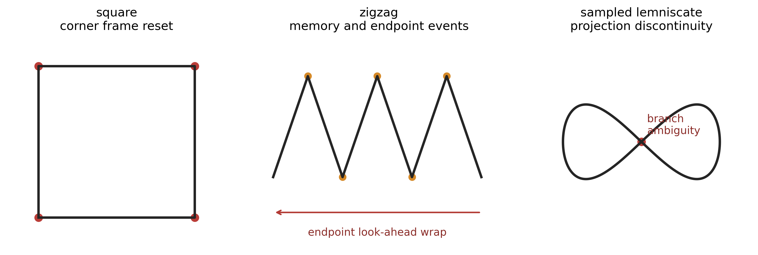
Supplementary Fig. S1. Non-smooth regimes are separated rather than forced into the smooth theorem: square true-corner reset, zigzag interior memory plus endpoint wrap, and lemniscate branch-ambiguity obstruction.
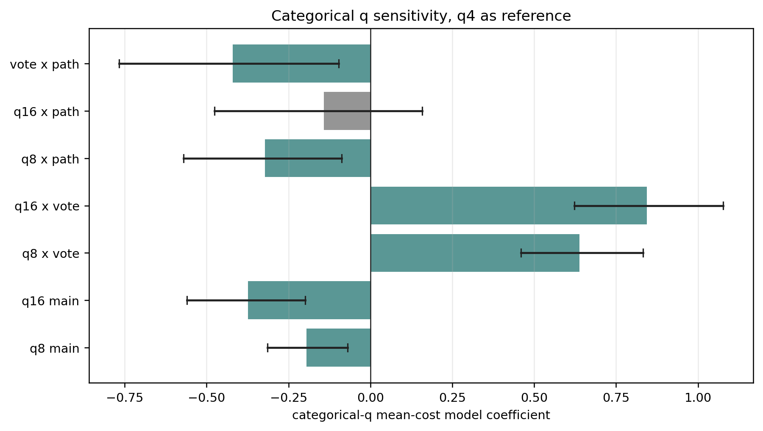
Supplementary Fig. S2. Categorical q sensitivity for the mean counterfactual event-cost outcome. The sensitivity analysis is used to prevent overinterpretation of a single linear q-coarseness coefficient.
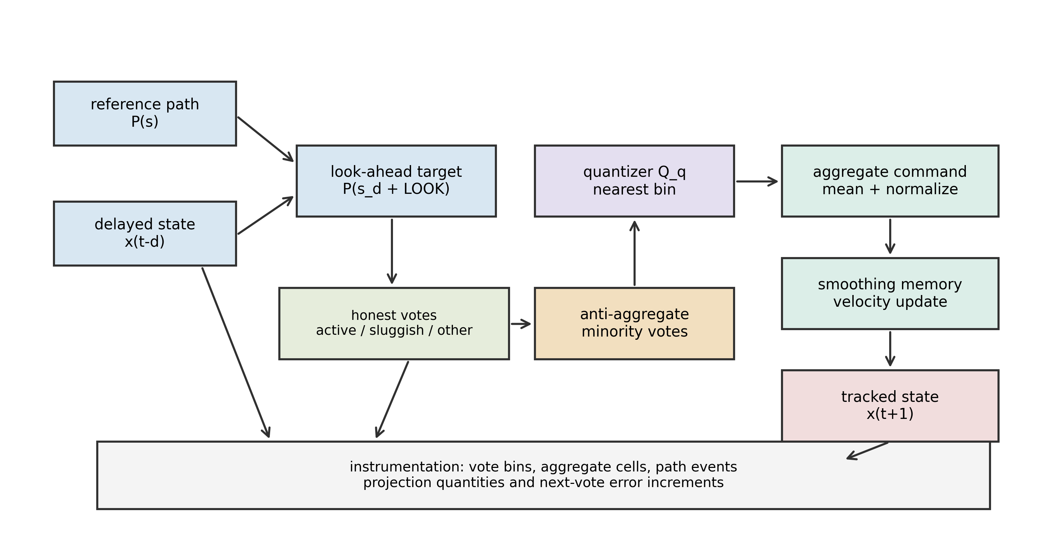
Supplementary Fig. S3. Fixed simulation and instrumentation flow. The figure shows the quantities specified in Tables 1-7 and the data flow used in the structural audit.

