Baseline-Free Real-Time Detection of Coordinated Manipulation in Crowd-Sourced Continuous Control
BongKeun Song
Department of Chemical and Bioengineering (CBI), Friedrich-Alexander-Universität Erlangen-Nürnberg (FAU), 91054 Erlangen, Germany
Corresponding author: BongKeun Song (e-mail: bongkeun.song@fau.de)
ABSTRACT Crowd-sourced continuous control (CSCC) systems aggregate many concurrent directional votes into a single real-time control signal, enabling collective steering in applications such as live-streaming interaction and participatory control. These systems are vulnerable to coordinated manipulation: an influx of adversarial participants can degrade or hijack the aggregated signal. Detecting this in real time is hard because the normal operating point is unknown and varies across sessions, trajectories, crowd sizes, and moments, and because identity-level or content-level moderation may be unavailable at the timescale of a control tick. We propose a baseline-free detector that monitors the consensus strength gamma - the magnitude of the mean vote vector - and flags manipulation onset using an exponentially weighted moving-average (EWMA) baseline estimate combined with cumulative-sum (CUSUM) change detection and a suspicion-triggered freeze that limits corruption of the baseline during a suspected attack. Across simulated CSCC scenarios the detector achieves a true positive rate (TPR) of 0.98 at a false positive rate (FPR) of 0.03, whereas a fixed-threshold baseline has no usable operating point (best case 0.47 TPR at 0.63 FPR). Detection remains near-perfect at adversarial fractions of 15% and above across N = {50, 120, 200}, while the 10% regime exposes an empirical low-fraction detectability floor in the tested grid. The detector also handles step, ramp, burst, weak-burst, and periodic attack schedules. All results are simulation-based; no human-subject validation is performed.
INDEX TERMS Adversarial robustness, anomaly detection, change detection, consensus, crowd-sourced systems, cumulative sum, real-time systems.

I. Introduction
Systems that let many people jointly control a single entity in real time are increasingly common, from live-streaming audiences steering a game character to participatory platforms that aggregate continuous preference signals [1], [2], [3], [4]. We refer to this class as crowd-sourced continuous control (CSCC): at each step, N participants cast directional votes that are aggregated by vector synthesis into one continuous command. Prior CSCC work has studied how response speed and aggregation choices affect tracking performance [5]. The present paper does not depend on that result as a premise; it uses the same class of vector-voting control channels as the setting for an online manipulation-detection problem.
A defining vulnerability of CSCC is that the control channel is open to whoever participates. A coordinated group of adversaries can inject votes that distort the aggregate. This concern parallels the classical Byzantine generals problem [6], in which a system must behave correctly despite a subset of components acting arbitrarily or maliciously. Unlike content-level abuse, manipulation in CSCC operates at the level of the aggregated control signal and may be invisible to conventional content moderation.
Detecting such manipulation in real time faces a central obstacle: the normal level of consensus among honest participants is not known a priori. It depends on task difficulty, trajectory, crowd size, and the moment within a session. A detector requiring a pre-specified normal baseline is therefore impractical. We address this with a baseline-free approach that learns the normal operating point online and detects deviations as they emerge.
A second obstacle is observability. Many plausible defenses rely on account histories, identity continuity, content semantics, or retrospective interaction graphs. In a control channel, however, the system may need to react before those signals are available, and the aggregate command itself may be the only reliable quantity exposed to the defender. This makes the detection problem stricter than ordinary abuse moderation: the detector must operate online, at the voting-tick timescale, and from a low-dimensional aggregate signal rather than from rich user-level metadata.
Our contributions are threefold. First, we identify the consensus strength gamma as a directly observable statistic whose sustained collapse can signal manipulation onset, and propose a detector combining an EWMA baseline, CUSUM accumulation, and a suspicion-triggered freeze that keeps the baseline anchored to the pre-attack operating point during suspicious periods. Second, we evaluate the detector against a fixed-threshold baseline across four trajectory geometries, three crowd sizes, four adversarial fractions, multiple time-varying schedules, and attack-composition variants. Third, we characterize the practical evasion regime observed in simulation: detection is reliable for sufficiently coherent or sufficiently large attacks, but low-fraction dispersed attacks around 10% approach a statistical floor where manipulation-induced consensus loss becomes comparable to ordinary fluctuation. The contribution is therefore an engineering characterization of an aggregate-signal detector, not a human-participant validation study.
The remainder of this article is organized as follows. Section II reviews related work on robust aggregation, coordinated-behavior detection, and sequential change detection. Section III describes the consensus-strength observable, the baseline-free detector, and the experimental protocol. Section IV reports the results, including robustness, time-varying schedules, attack composition, an ablation, threshold sensitivity, and a representative detector trace. Section V discusses implications, operating choices, the boundary between detection and mitigation, and limitations, and Section VI concludes.
II. Related Work
A. Robust Aggregation and Byzantine Fault Tolerance
Preserving the integrity of an aggregate when some inputs are adversarial is a long-standing problem. The Byzantine generals formulation [6] established that a system can tolerate a bounded fraction of arbitrarily-behaving components, and this idea underlies modern robust aggregation in distributed learning. Krum selects the gradient closest to its nearest neighbors to exclude outliers [7], while coordinate-wise median and trimmed-mean estimators attain order-optimal robustness to a fixed fraction of corrupted updates [8]. These approaches share two assumptions that do not hold in our setting: a known or bounded adversarial fraction, and access to per-contributor state that can be compared against a model of expected behavior. They also act by filtering individual contributions rather than by detecting, in time, that the aggregate as a whole has been compromised. Our detector makes neither assumption: it monitors only the scalar consensus magnitude and targets the onset of manipulation.
B. Detection of Coordinated Behavior
On social platforms, the detection of automated and coordinated accounts is a mature area. Cresci surveys a decade of social-bot detection and documents a shift away from classifying individual accounts toward identifying coordinated behavior at the group level [9]. This literature generally operates on accounts, content, and interaction graphs accumulated over hours or days, and is therefore retrospective relative to the time scale of a control channel. The broader wisdom-of-crowds tradition shows that aggregated judgments can be remarkably accurate [10], [11], but also that social influence and correlated inputs can erode that accuracy [12], [13] — the same vulnerability that a coordinated push exploits in continuous control. Our work differs in operating online, on the instantaneous consensus signal, where a decision must be reached within a handful of ticks rather than after the fact.
C. Sequential Change Detection
Detecting a shift in a monitored statistic as quickly as possible is the subject of sequential change-point analysis. The cumulative-sum (CUSUM) procedure [14] accumulates evidence of a change and signals when the accumulation crosses a threshold, and the exponentially weighted moving-average (EWMA) control chart [15] tracks a slowly varying baseline; the run-length properties of both are understood through the first-passage theory of sequential tests [16]. Our detector combines these classical tools with a domain-specific addition — a suspicion-triggered freeze of the baseline — so that the quantity being monitored continues to estimate the honest operating point even while an attack is in progress. To our knowledge this combination has not previously been applied to consensus-strength monitoring in crowd-sourced control.
These three literatures motivate but do not directly solve the CSCC problem. Robust aggregation aims to compute a better aggregate despite corrupted inputs, coordinated-behavior detection usually relies on user-level histories or network structure, and classical sequential tests assume that an appropriate monitored statistic and baseline model are already defined. The missing piece is an online detector for the integrity of the aggregate control stream itself, using only information that is naturally produced by vector voting and making a decision within a few voting ticks. This is the gap addressed by the present work.
III. Methods
A. System and Threat Model
We model a crowd-sourced continuous control (CSCC) channel in which N participants each cast, at every voting tick, a vote in one of eight compass directions. The system aggregates these votes by vector synthesis: it sums the unit vectors of the cast votes and uses the direction of the resultant as the control command. Honest participants vote toward the direction that advances the shared task, perturbed by independent angular noise that reflects differing reaction times and judgments. The aggregate of many noisy-but-aligned honest votes therefore has a large resultant magnitude.
The adversary controls a fraction p of the participants and coordinates their votes to disrupt the aggregate. We make conservative assumptions in the adversary's favor: the adversary may join at any time, may choose how its votes are distributed across directions (from fully concentrated on one disruptive heading to fully dispersed), and may vary its intensity over time (an abrupt onset, a gradual ramp, an intermittent burst, or a periodic pattern). We do not assume the adversary is rate-limited or identifiable by account-level features; the only signal available to the defender is the aggregate vote stream itself. The adversary's goal is to degrade or capture the control command while remaining undetected for as long as possible. The defender's goal is to detect the onset of coordinated manipulation as early as possible, with few false alarms, and without any pre-specified notion of what the normal operating point should be, because that operating point varies with the task, trajectory, crowd size, and moment.
This model abstracts away the content of individual votes and the identities of participants, and reduces the defender's view to a single time series: the consensus strength of the aggregate at each tick. The remainder of this section defines that quantity and the detector built on it.
The nominal, non-attack condition is not assumed to be perfectly clean. In the simulation engine, a small background adversarial/noisy component of 5% is retained even before programmed attack onset and in non-attack traces. The detector therefore is not being compared against an unrealistically noise-free baseline; it must distinguish a coordinated increase in disruptive participation from the ordinary disagreement already present in the control stream.
B. Consensus Strength
At each voting tick, every participant casts a vote in one of eight directions. The cast unit vectors are averaged; the consensus strength gamma is the Euclidean norm of this mean vote vector. When honest participants agree on a direction, the unit vectors reinforce and gamma approaches one. When adversarial votes are injected in conflicting directions, the vectors partially cancel and gamma drops. Thus gamma is a continuous, bounded indicator of how unified the crowd is at each moment, and a sustained drop signals possible manipulation.
gamma(t) = || (1/N) Σ vᵢ(t) ||, 0 ≤ gamma ≤ 1 (1)
where vᵢ(t) is the unit vote vector of participant i at tick t; gamma ranges from zero (maximal disagreement) to one (perfect agreement).
Two properties make gamma a suitable observable for manipulation detection. First, it is the very quantity the aggregation rule already computes, so monitoring it adds no new sensing and is causally tied to the control command: a drop in gamma is, by construction, a degradation of the command the crowd produces. Second, it is invariant to the absolute heading and to the crowd size in expectation — it measures the degree of agreement rather than its direction or the number of voters — so a single detector applies across trajectories and crowd sizes without recalibration. Alternative observables such as the per-direction vote histogram or the command's angular velocity are either higher-dimensional, requiring a model of the expected distribution, or confounded by legitimate sharp maneuvers; the scalar consensus magnitude isolates the agreement signal that coordinated manipulation necessarily disturbs.
This normalization is important for transfer across crowd sizes. A raw vote-count imbalance would naturally grow with N and would require retuning as the audience changes. By contrast, gamma is the length of a mean vector. Increasing the number of voters reduces sampling fluctuation, but the expected level of agreement under a fixed adversarial fraction is governed mainly by the directional mixture of votes. This is why the same detector threshold can be tested across N without introducing a separate crowd-size calibration step.
C. Baseline-Free Adaptive Detector
The detector maintains an EWMA baseline estimate of the mean and variance of gamma, in the spirit of the exponentially weighted moving-average control chart [15], and accumulates standardized downward deviations in a cumulative-sum (CUSUM) statistic [14], raising an alarm when it exceeds a threshold h. The run-length behavior of such sequential tests is governed by first-passage theory [16]. Crucially, the EWMA baseline is updated only while the system is not under suspicion (CUSUM below half the threshold); once suspicion rises, the baseline freezes, so an ongoing attack cannot pull the estimated normal toward the manipulated state. This freeze allows a baseline-free estimator to remain valid during an attack. Algorithm 1 summarizes the procedure.
The freeze rule is deliberately conservative. When the CUSUM statistic remains below h/2, the stream is treated as non-suspicious and the baseline adapts to slow legitimate variation in the task. When S reaches h/2, the baseline stops adapting, but no alarm is raised until S crosses h. This creates a buffer zone: the detector can accumulate evidence of a sustained drop without allowing the same drop to redefine normal behavior. The mechanism is especially relevant for gradual ramps, where an unfrozen EWMA can otherwise follow the attack downward and reduce sensitivity.
Algorithm 1 Baseline-Free Adaptive Detector
Input: gamma stream γ[t], warmup W, decay λ, slack δ, threshold h
Output: alarm tick, or none
μ ← mean(γ[0:W]); v ← max(var(γ[0:W]), ε)
S ← 0
for t = W, W+1, … do
dev ← (μ − γ[t]) / (√v + ε)
S ← max(0, S + dev − δ)
if S > h then return t // alarm
if S < h/2 then // not suspicious: adapt
μ ← (1−λ)μ + λ·γ[t]
v ← (1−λ)v + λ·(γ[t]−μ)²
// else: freeze baseline (do not update μ, v)
return none

D. Fixed-Threshold Baseline
As a comparison, we implement a fixed-threshold detector that raises an alarm whenever the standardized drop of gamma below a sliding-window mean exceeds a constant z-score k. The sliding window is 10 voting ticks, and k is swept over the range used to draw the operating curve. This represents the natural local-statistics baseline: it does not learn a protected pre-attack operating point and has no freeze mechanism. It is therefore expected either to overreact to ordinary gamma fluctuation or to miss sustained manipulation after the local window adapts.
E. Experimental Setup
All experiments use a simulated CSCC environment in which a crowd steers an agent along a target trajectory for 3900 simulation frames. Votes are cast every 18 frames in one of eight compass directions and are aggregated by vector synthesis. Honest participants vote toward a delayed look-ahead direction on the target trajectory with heterogeneous behavior: most non-adversarial voters are accurate with small angular noise, a smaller group lags behind the changing target direction, and the remaining group contributes broader angular noise. The agent follows the aggregate direction with velocity smoothing. This setup makes gamma fluctuate even without an attack, which is necessary for testing whether the detector can separate manipulation from ordinary task-induced variation.
Table I summarizes the simulation and detector parameters. The detector parameters (EWMA decay, CUSUM slack, and warmup window) were held fixed across experiments. The adaptive threshold h and the fixed z-score k were swept only when tracing operating-point curves; the main reported adaptive operating point uses h = 14 unless otherwise noted. All detections are reported in voting ticks rather than frames, because the detector receives one gamma observation per vote.
TABLE I. Simulation and Detector Parameters.
Parameter | Symbol | Value
Agent speed | v | 5.0 m/s
Velocity smoothing | — | 0.20
Perception delay | — | 26 frames
Vote interval | — | 18 frames
Look-ahead | — | 2.0 m
Vote directions | — | 8
EWMA decay | λ | 0.15
CUSUM slack | δ | 0.5
Warmup window | W | 15 ticks

F. Evaluation Protocol and Reproducibility
The core ROC experiment is evaluated at 20% adversarial participation and N = 120. Robustness is evaluated on the discrete grid p in {10%, 15%, 20%, 30%} and N in {50, 120, 200}; values between these grid points are not inferred. For each condition, each repetition constructs 25 traces per trajectory across four trajectories (circle, square, lemniscate, and zigzag), producing 100 attack traces and 100 non-attack traces per repetition. The programmed attack onset is sampled uniformly between 30% and 70% of the session length and then snapped to the nearest voting tick, so the detector is evaluated after an initial non-attack period but before end-of-session truncation effects dominate.
All operating points are averaged over five independent pool repetitions with different random seed offsets. Attack and non-attack pools are regenerated for each repetition; the non-attack pool uses the same nominal background disagreement but no programmed attack onset. TPR is the fraction of attack traces for which an alarm occurs at or after the programmed attack onset. FPR is the fraction of non-attack traces that raise an alarm. Latency is the number of voting ticks between attack onset and alarm; within each repetition the median latency over detected attack traces is used, and the reported latency is the mean of those median values across repetitions. This scoring choice prevents a small number of very late detections from dominating the latency summary.
The time-varying schedule experiment uses the same trajectory pool and adaptive threshold h = 14. The step schedule jumps from the 5% background level to 30%; the ramp schedule increases gradually from 5% to 25%; the burst schedule applies a 30% attack for 10 voting ticks; the weak-burst schedule applies a 20% attack for 10 voting ticks; and the periodic schedule alternates between the 5% background level and a 25% attack state with random phase. These schedules test whether the freeze mechanism remains useful when manipulation is not a single permanent step change. Fully detector-aware adaptive adversaries, human learning, fatigue, imitation, and social coordination between honest participants are outside the scope of the present simulation and are treated as limitations rather than hidden assumptions.
For reproducibility, the result archive stores the aggregated JSON files used for the ROC, robustness, schedule, ablation, attack-composition, and signal-measurement analyses, together with the analysis scripts used to generate the reported result data. The manuscript reports rounded values, while the archive retains full-precision means and standard deviations. Runs that do not raise an alarm have undefined latency and are excluded from latency means; in standards-compliant JSON exports these undefined values are represented as null rather than as nonstandard NaN values.
G. Attack-Composition and Signal Diagnostics
In addition to the main robustness grid, the attack-composition analysis varies how adversarial votes are distributed. The coherence parameter c controls the fraction of adversarial votes assigned to a structured direction rather than random directions, with c in {0.0, 0.2, 0.4, 0.6, 0.8, 1.0}. The tested composition modes include target-opposite voting, bandwagon voting on a persistent arbitrary heading, scatter voting over a small set of headings, and mixed variants. This analysis is used to identify whether poor detectability at low adversarial fractions is caused by the fraction alone or by the combination of fraction and directional coherence.
The archive also includes signal-level diagnostic summaries that estimate the pre-attack gamma baseline, baseline fluctuation, effective transition fluctuation, and post-onset gamma drop for each composition condition. These diagnostics are not treated as separate hypothesis tests in the main paper; they provide a consistency check that the detector fails primarily when the attack-induced gamma drop is small relative to ordinary variation. This is why the main text describes the 10-15% region as an empirical low-fraction detectability regime rather than as a formally estimated universal threshold.
IV. Results
A. Adaptive Versus Fixed Threshold
Figure 1 shows the detection ROC at a representative condition (20% adversarial fraction, N = 120). The fixed-threshold detector has no usable operating point: lowering k floods the system with false alarms (FPR approaching 1.0), while raising k suppresses detection, with a best case of only 0.47 TPR at 0.63 FPR. The adaptive detector reaches 0.98 TPR at 0.03 FPR (h = 14), and at h = 20 attains 0.98 TPR at 0.00 FPR with increased latency. The curve therefore separates two design choices: h = 14 is the fast low-FPR operating point, whereas h = 20 is the conservative zero-FPR operating point for this representative condition. A fixed local baseline is insufficient because it either responds to normal fluctuations too often or adapts to the manipulated state too quickly.
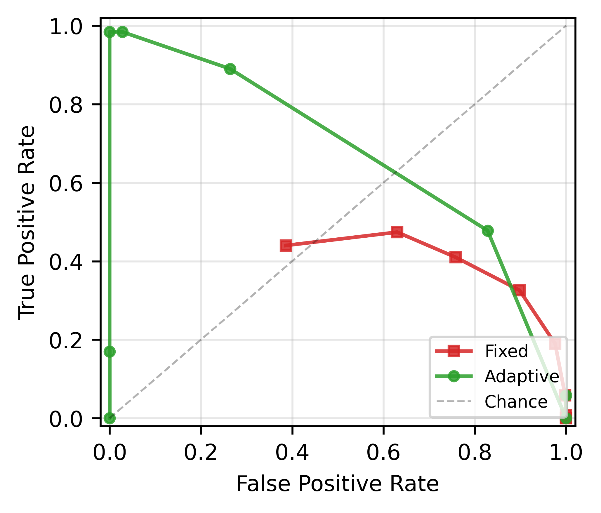
FIGURE 1. Detection ROC: adaptive (EWMA+CUSUM+freeze) versus fixed-threshold detector (20% attack, N = 120). The adaptive detector reaches the top-left corner; the fixed detector has no usable operating point.
B. Robustness Across Attack Intensity and Crowd Size
Table II and Figure 2 report the adaptive detector across adversarial fractions p in {10%, 15%, 20%, 30%} and crowd sizes N in {50, 120, 200}. For fractions of 15% and above, detection is near-perfect (TPR 0.98-1.00) with low false positives, and latency shortens as the attack strengthens (about one tick at 30%, six to seven ticks at 15%). Performance is largely independent of crowd size over this tested grid. When the adversarial fraction falls to 10%, the detector degrades gracefully (TPR 0.41-0.58, latency 16-18 ticks), reflecting the difficulty of distinguishing weak manipulation from normal fluctuation.
Three patterns in these numbers follow from the mechanism. The shortening latency with stronger attacks is expected from CUSUM: a larger adversarial fraction drives a larger per-tick deviation of gamma, so the accumulator crosses the threshold in fewer ticks. The weak dependence on N arises because gamma is a normalized mean - its honest value and its drop under a fixed adversarial fraction are, to first order, set by the fraction and directional composition rather than by the absolute count. The degradation around the ten-percent condition is the practical detectability floor in this experiment: when the manipulation-induced drop in gamma becomes comparable to honest tick-to-tick fluctuation, no threshold can separate the two without incurring false alarms, and the standard deviation of TPR widens accordingly (for example 0.08 at the ten-percent, N = 120 point).
TABLE II. Adaptive Detector Robustness (h = 14, Mean Over 5 Reps).
Attack | N | TPR | FPR | Latency
30% | 50–200 | 0.98–1.00 | 0.01–0.06 | ~1
20% | 50–200 | 0.98–1.00 | 0.01–0.06 | 2–3
15% | 50–200 | 0.98–0.99 | 0.01–0.06 | 6–7
10% | 50–200 | 0.41–0.58 | 0.01–0.06 | 16–18

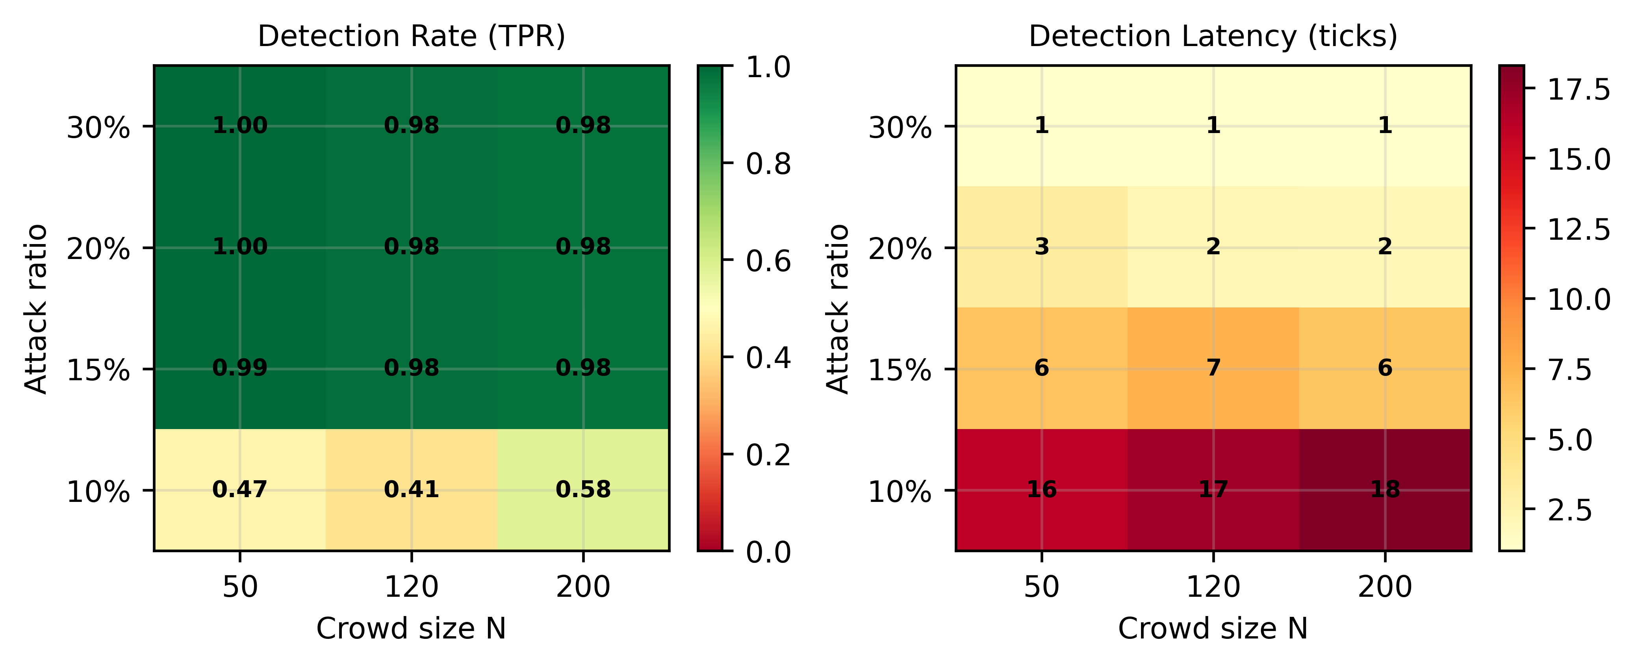
FIGURE 2. Detection rate (TPR) and latency across attack ratio and crowd size (adaptive, h = 14).
C. Time-Varying Attack Schedules
Real adversaries need not attack at a constant rate. Figure 3 and Table III evaluate five schedules: an abrupt step, a gradual ramp, a short burst, a weaker burst, and a periodic on/off pattern. The detector handles all five, with detection rates of 0.92-1.00. The ramp case, where a slowly rising fraction could in principle fool an adaptive baseline, is detected at 1.00, supporting the role of the suspicion-freeze in limiting baseline drift during gradual manipulation. Burst and weak-burst attacks show that the detector can react to finite-duration manipulation rather than only to permanent changes. The periodic schedule is the most challenging because the attack repeatedly disappears before returning, but it is still detected at 0.92.
TABLE III. Detection Across Time-Varying Attack Schedules (h = 14).
Schedule | TPR | Latency
Step | 0.98 | 2.0
Ramp | 1.00 | 9.2
Burst | 1.00 | 1.0
Burst-weak | 0.93 | 2.6
Periodic | 0.92 | 2.7

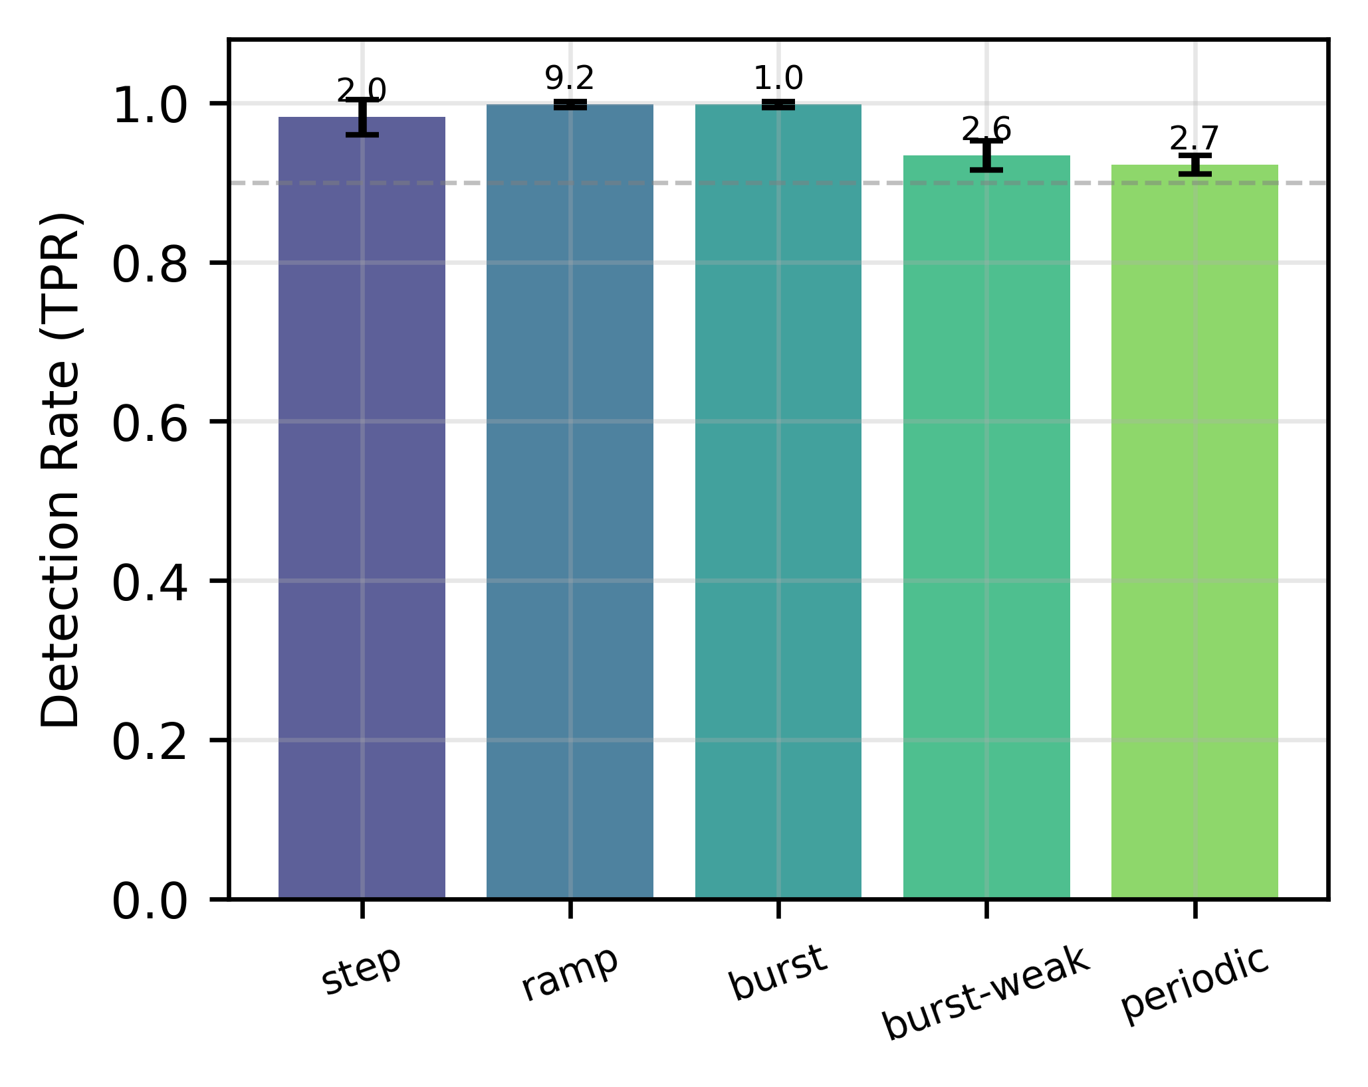
FIGURE 3. Detection across time-varying attack schedules (step, ramp, burst, burst-weak, periodic; adaptive, h = 14).
D. Effect of Attack Composition
We also varied how adversaries vote, from dispersed directions to coherent disruptive headings. The composition grid separates the adversarial fraction p from directional coherence c, so that a ten-percent attack can be tested either as diffuse random disagreement or as a coordinated push against the honest direction. Detection rate depends on this composition in the low-fraction regime. At a ten-percent adversarial fraction, fully dispersed attacks are detected least reliably, whereas target-opposite concentrated attacks are detected almost always; broader concentrated or mixed compositions can still vary because their effect depends on whether adversarial votes consistently cancel the honest direction or merely add diffuse noise. At fifteen percent and above, all tested compositions become substantially easier to detect. Thus the practical evasion strategy is not simply "be concentrated" or "be dispersed," but to keep both the fraction and the induced gamma drop small. We report this dependence as an empirical observation; a formal first-principles account of the concentration-fraction relationship is beyond the scope of the present empirical detector evaluation.
E. Ablation: Contribution of Each Component
To assess what each component contributes, we compare four variants on the same scenarios: a fixed threshold, EWMA only (no CUSUM), EWMA + CUSUM without the freeze, and the full detector (EWMA + CUSUM + freeze). Because these variants use different score scales and operating ranges, each is evaluated at a stable representative operating point from its sweep rather than forcing the same numeric threshold on all methods. Table IV reports TPR/FPR using compact labels: CUSUM denotes EWMA + CUSUM without the freeze, and Full denotes the proposed EWMA + CUSUM + freeze detector. The fixed and EWMA-only variants are unusable (FPR 0.39-0.49); adding CUSUM accumulation is what makes detection possible, jumping to 0.99-1.00 on step and fast-ramp attacks. On these abrupt attacks the freeze adds little, because CUSUM raises the alarm before a non-frozen baseline can adapt to the attack. Its value appears under slow attacks: on a gradual ramp that rises over roughly eighty ticks, the non-frozen baseline partially adapts to the creeping manipulation and misses more of it (TPR 0.85, FPR 0.09), whereas the freeze keeps the baseline valid and recovers both detection and false-positive rate (TPR 0.96, FPR 0.03). The freeze is therefore a safety mechanism against slow, stealthy attacks rather than a contributor on abrupt ones; CUSUM accumulation is the primary source of detection power.
TABLE IV. Ablation (TPR / FPR; 20% attack, N = 120, mean over 5 reps).
Variant | Step | Fast ramp | Slow ramp
Fixed | 0.43/0.39 | 0.07/0.39 | 0.12/0.39
EWMA | 0.59/0.49 | 0.13/0.49 | 0.20/0.49
CUSUM | 0.99/0.00 | 1.00/0.00 | 0.85/0.09
Full | 0.98/0.03 | 1.00/0.00 | 0.96/0.03

F. Threshold Sensitivity
Detection depends on the CUSUM threshold h in an interpretable way (sweep at 20% attack, N = 120). Small h is over-sensitive: at h = 7, FPR is 0.83 with TPR 0.48; at h = 10, TPR rises to 0.89 but FPR is still 0.26. The operating point sharpens around h = 14 (TPR 0.98, FPR 0.03), and h = 20 reaches TPR 0.98 at FPR 0.00 at the cost of higher latency (about eleven ticks versus two). Beyond this, large h suppresses detection (TPR 0.17 at h = 30). The detector thus has a stable operating region around h = 14-20 rather than a single fragile setting. In deployment terms, h = 14 is appropriate when fast mitigation is more valuable than eliminating every false alarm, while h = 20 is appropriate when false positives are more costly and several additional voting ticks of delay are acceptable.
G. Representative Detector Dynamics
Figure 4 illustrates the detector dynamics on a single simulated ramp attack. This single run is taken directly from the simulation engine, not synthesized for illustration, and is not used as an additional aggregate performance statistic; it is included to show how the variables in Algorithm 1 interact over time on one representative ramp attack. As the adversarial fraction rises, gamma begins to fall below the EWMA baseline. The CUSUM statistic then accumulates standardized downward deviations. Once suspicion exceeds h/2, the baseline stops adapting, so the subsequent low-gamma observations increase the evidence for an alarm rather than redefining the baseline as normal. 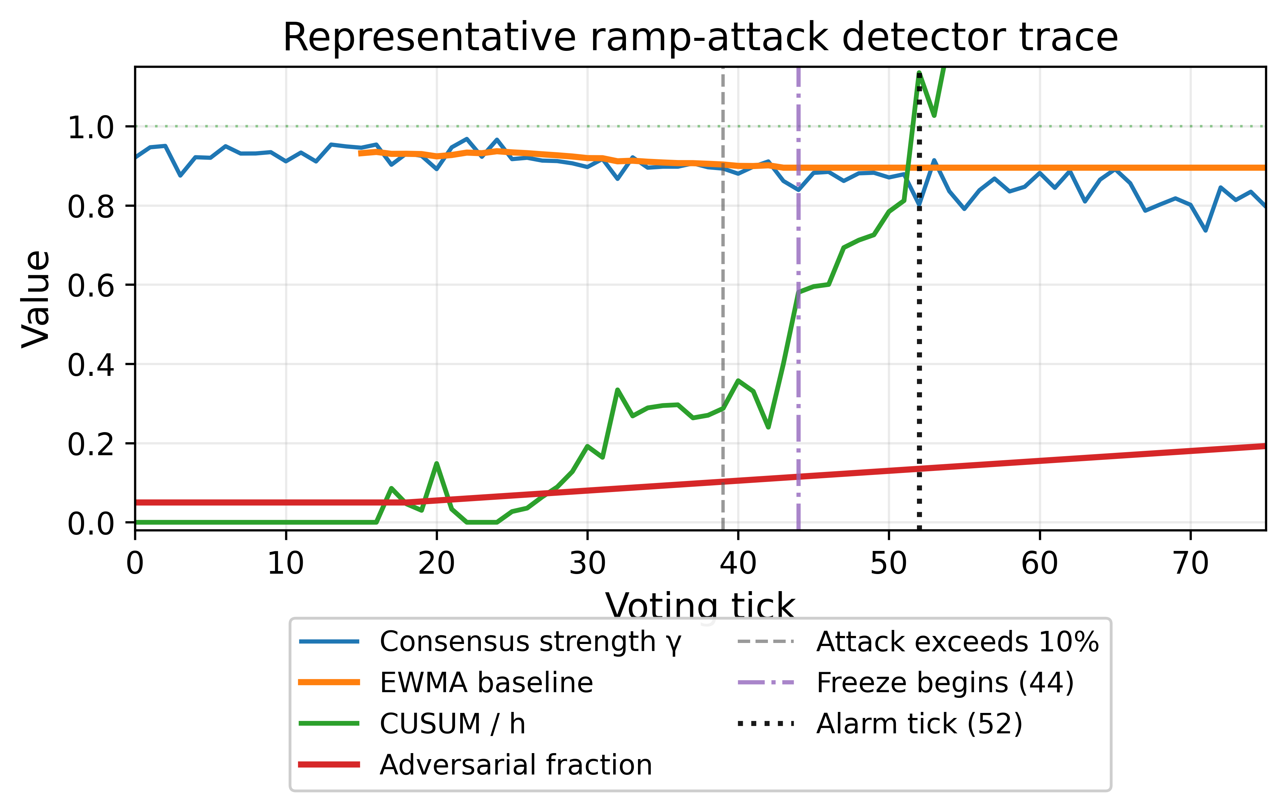
FIGURE 4. Representative simulated ramp-attack trace showing consensus strength gamma, EWMA baseline, normalized CUSUM statistic, adversarial fraction, freeze onset, and alarm tick (N = 120, h = 14). The trace is a single measured simulation run (not an aggregate statistic) and complements the schedule results in Table III; it is generated by the same simulation engine and detector used throughout, with the full time series provided in the result archive.

V. Discussion
A. Role of the Baseline Freeze
Monitoring consensus strength with a baseline-free adaptive detector identifies manipulation onset in the simulated CSCC scenarios tested here, where a fixed threshold fails outright. The core reason is that CSCC does not have a universal normal consensus level. Gamma changes with trajectory geometry, momentary curvature, crowd composition, and ordinary voting noise. A fixed detector therefore has to choose between being sensitive enough for low-consensus moments and conservative enough for high-consensus moments, which produces the poor ROC observed in Figure 1.
The freeze mechanism solves a different problem from CUSUM itself. CUSUM provides accumulation: a single noisy low-gamma tick is not enough to alarm, but repeated downward deviations build evidence. The freeze provides baseline integrity: once those deviations become suspicious, they are no longer allowed to update the EWMA estimate of normal behavior. Without this separation, a slow ramp can be absorbed into the baseline and become less visible over time. The ablation and representative trace support this division of labor: CUSUM supplies most of the power on abrupt attacks, while the freeze protects the detector against gradual, stealthy manipulation in the tested simulation setting.
B. Engineering Implications
The detector is attractive as a deployment candidate because it is inexpensive and self-configuring. It maintains only a handful of scalars per channel (an EWMA mean and variance and a single CUSUM accumulator), so its per-tick cost is negligible and it scales to many simultaneous channels. Because it is baseline-free, it requires no per-session calibration: it learns the operating point online from the first few ticks and adapts to whatever trajectory, task, or crowd size is in effect. The alarm it raises can serve as a trigger for downstream mitigation - for example throttling new participants, increasing the smoothing of the aggregate, temporarily reducing the weight of newly joined voters, or flagging the segment for human review - although the present work addresses only detection.
The results also suggest how a CSCC platform could treat alarms operationally. A fast operating point such as h = 14 can be used as an early-warning trigger that activates reversible mitigation, whereas a more conservative point such as h = 20 can be reserved for stronger interventions. Because the detector monitors the aggregate rather than individual accounts, it should not be interpreted as an attribution mechanism. It can say that the channel is behaving as if coordinated manipulation has begun; it does not identify which participants are responsible.
C. Parameter Selection and Operating Use
The threshold sweep indicates that the detector is not tuned to a single fragile number. The region around h = 14-20 produces the useful trade-off: lower values become dominated by false alarms, and much higher values delay or suppress detection. This gives the parameter a practical interpretation. Lower thresholds are appropriate for systems where a false alarm merely triggers a reversible safety mode, while higher thresholds are appropriate when an alarm carries a direct cost such as interrupting a live session or requiring moderator attention.
The low-fraction regime should be interpreted similarly. The 10% condition is not a hard universal boundary; it is the region where the gamma drop produced by dispersed manipulation becomes comparable to normal fluctuations in this simulated environment. A platform with more stable honest behavior, more frequent votes, or a more coherent attack may shift that boundary. Conversely, a noisier human population may make weak attacks harder to distinguish. The contribution of the present study is therefore an engineering characterization of the detector and its failure mode within a specified simulation grid, not a universal theorem about a fixed adversarial percentage.
D. Boundary Between Detection and Mitigation
The proposed detector is intended as an alarm layer rather than as a complete defense stack. Its output can be combined with mitigation policies, but those policies involve separate design choices: whether to slow the control command, temporarily downweight new participants, require additional confirmation, or route the episode to a human moderator. Keeping detection separate from mitigation is useful because the same detector can support different risk tolerances. A game-like live stream may prefer reversible smoothing after a low-confidence alarm, whereas a safety-critical teleoperation setting would likely require a more conservative threshold and an independent confirmation layer.
E. Limitations
Several limitations should be acknowledged. First, all evaluation is in simulation; honest and adversarial voting are modeled, and transfer to real crowds requires empirical validation with human participants. Second, the current simulations use a fixed eight-direction voting interface, a fixed voting interval, a fixed smoothing parameter, and a finite set of trajectory geometries. These choices are appropriate for isolating the detector mechanism, but they do not exhaust all possible CSCC designs. Third, human learning, fatigue, imitation, social influence among honest participants, and variable response delay are not modeled; these factors may alter the baseline stability of gamma in real deployments. Fourth, detection degrades when the adversarial fraction is small and dispersed, where weak manipulation is statistically hard to separate from normal fluctuation in the tested environment. Fifth, the detector identifies the onset of manipulation but does not attribute it to specific participants; coupling detection with mitigation or attribution is future work. Finally, fully detector-aware adaptive adversaries are not evaluated. An adversary aware of the detector might attempt to shape gamma to evade it, and the present results only cover the tested step, ramp, burst, periodic, and composition variants. CSCC also connects to classical nonlinear control [17] and to human-swarm interaction [18], [19], which suggest avenues for coupling detection with control-level mitigation.
VI. Conclusion
We presented a baseline-free, real-time detector for coordinated manipulation in crowd-sourced continuous control. By monitoring the magnitude of the aggregate vote vector and combining an EWMA baseline with CUSUM change detection and a suspicion-triggered freeze, the method detects manipulation onset without any pre-specified normal baseline. In simulation it achieves 0.98 detection at 0.03 false positives where a fixed threshold has no usable operating point, remains effective across crowd sizes and adversarial fractions of 15% and above, and handles diverse time-varying schedules. The 10% regime identifies an empirical low-fraction detectability floor for weak dispersed attacks in the tested environment. The approach is a candidate aggregate-signal defense for real-time collective control channels, pending validation with human participants and integration with mitigation mechanisms.
Data Availability
The simulation code and result data supporting the findings of this study are openly available in the LETG-d repository at https://doi.org/10.5281/zenodo.20576828, released under the CC-BY-4.0 license. The archive includes the CSCC simulation engine, analysis scripts used to generate the reported result data, and aggregated JSON result files supporting the reported tables and figures.
Funding
This research received no external funding.
Author Contributions
BongKeun Song conceived the study, designed and executed the simulation framework, performed all analyses, and wrote the manuscript.
Conflict of Interest
The author declares no conflicts of interest.
Acknowledgment
The author used a generative AI assistant to support drafting, code prototyping, and manuscript editing. All scientific content, experimental design, analysis, and conclusions were conceived, verified, and approved by the author, who takes full responsibility for the work.
References
[1] W. S. Lasecki, K. I. Murray, S. White, R. C. Miller, and J. P. Bigham, "Real-time crowd control of existing interfaces," in Proc. UIST, 2011, pp. 23–32, doi: 10.1145/2047196.2047200.
[2] J. P. Bigham, J. O. Wobbrock, and W. S. Lasecki, "Target acquisition and the crowd actor," Human Comput., vol. 2, no. 2, pp. 135–154, 2015, doi: 10.15346/hc.v2i2.2.
[3] J. Seering et al., "Audience participation games: Blurring the line between player and spectator," in Proc. ACM DIS, 2017, pp. 429–440, doi: 10.1145/3064663.3064732.
[4] A. Aleta and Y. Moreno, "The dynamics of collective social behavior in a crowd controlled game," EPJ Data Sci., vol. 8, p. 22, 2019, doi: 10.1140/epjds/s13688-019-0200-1.
[5] B. Song, "Speed over strategy: Why agent velocity dominates aggregation method in crowd-sourced continuous control," Res. Sq., preprint, 2025, doi: 10.21203/rs.3.rs-9326125/v1.
[6] L. Lamport, R. Shostak, and M. Pease, "The Byzantine generals problem," ACM Trans. Program. Lang. Syst., vol. 4, no. 3, pp. 382–401, Jul. 1982, doi: 10.1145/357172.357176.
[7] P. Blanchard, E. M. El Mhamdi, R. Guerraoui, and J. Stainer, "Machine learning with adversaries: Byzantine tolerant gradient descent," in Adv. Neural Inf. Process. Syst. (NeurIPS), vol. 30, 2017, pp. 119–129.
[8] D. Yin, Y. Chen, K. Ramchandran, and P. Bartlett, "Byzantine-robust distributed learning: Towards optimal statistical rates," in Proc. ICML, 2018, pp. 5650–5659.
[9] S. Cresci, "A decade of social bot detection," Commun. ACM, vol. 63, no. 10, pp. 72–83, Oct. 2020, doi: 10.1145/3409116.
[10] J. Surowiecki, The Wisdom of Crowds. New York, NY, USA: Anchor Books, 2005.
[11] A. Almaatouq et al., "Adaptive social networks promote the wisdom of crowds," Proc. Nat. Acad. Sci. USA, vol. 117, no. 21, pp. 11379–11386, 2020, doi: 10.1073/pnas.1917687117.
[12] T. Bose, A. Reina, and J. A. R. Marshall, "Collective decision-making," Curr. Opin. Behav. Sci., vol. 16, pp. 30–34, 2017, doi: 10.1016/j.cobeha.2017.03.004.
[13] J. Lorenz, H. Rauhut, F. Schweitzer, and D. Helbing, "How social influence can undermine the wisdom of crowd effect," Proc. Nat. Acad. Sci. USA, vol. 108, no. 22, pp. 9020–9025, 2011, doi: 10.1073/pnas.1008636108.
[14] E. S. Page, "Continuous inspection schemes," Biometrika, vol. 41, no. 1–2, pp. 100–115, Jun. 1954, doi: 10.1093/biomet/41.1-2.100.
[15] S. W. Roberts, "Control chart tests based on geometric moving averages," Technometrics, vol. 1, no. 3, pp. 239–250, Aug. 1959, doi: 10.1080/00401706.1959.10489860.
[16] D. Siegmund, Sequential Analysis: Tests and Confidence Intervals. New York, NY, USA: Springer, 1985, doi: 10.1007/978-1-4757-1862-1.
[17] H. K. Khalil, Nonlinear Systems, 3rd ed. Upper Saddle River, NJ, USA: Prentice-Hall, 2002.
[18] A. Kolling, P. Walker, N. Chakraborty, K. Sycara, and M. Lewis, "Human interaction with robot swarms: A survey," IEEE Trans. Human-Mach. Syst., vol. 46, no. 1, pp. 9–26, 2016, doi: 10.1109/THMS.2015.2480801.
[19] G. Niemeyer and J.-J. E. Slotine, "Stable adaptive teleoperation," IEEE J. Ocean. Eng., vol. 16, no. 1, pp. 152–162, 1991, doi: 10.1109/48.64895.
Biography

BONGKEUN SONG is a Ph.D. candidate in the Department of Chemical and Bioengineering (CBI) at Friedrich-Alexander-Universität Erlangen-Nürnberg (FAU), Erlangen, Germany. His research interests include crowd-sourced continuous control, real-time aggregation of human input, and the detection of coordinated manipulation in collective control systems.

