Baseline-Free Real-Time Detection of Coordinated Manipulation in Crowd-Sourced Continuous Control
BongKeun Song
Department of Chemical and Biological Engineering, FAU Erlangen-Nürnberg

Abstract
Crowd-sourced continuous control (CSCC) systems aggregate many concurrent user inputs into a single real-time control signal, enabling collective steering of an agent in applications such as live-streaming interaction, online collective decision-making, and participatory control. Such systems are vulnerable to coordinated manipulation: an influx of adversarial participants (trolls or bots) can degrade or hijack the aggregated signal. Detecting this manipulation in real time is challenging because the normal operating point of the system is not known in advance and varies across sessions, trajectories, and moments. We propose a baseline-free detector that monitors the consensus strength gamma(t)—the magnitude of the mean vote vector—and flags manipulation onset using an exponentially weighted baseline estimate combined with cumulative-sum change detection and a suspicion-triggered freeze that prevents an ongoing attack from corrupting the baseline. Across simulated CSCC scenarios, the proposed adaptive detector achieves a true positive rate of 0.98 at a false positive rate of 0.03, whereas a fixed-threshold baseline has no usable operating point (best case 0.47 TPR at 0.63 FPR). The detector remains effective across crowd sizes (N=50–200) and a range of attack intensities, degrading gracefully only when the adversarial fraction falls to 10%, and detects step, ramp, burst, and periodic attack schedules. All results are obtained in simulation; no human-subject validation is performed.

1. Introduction
Systems that let many people jointly control a single entity in real time have become increasingly common, from live-streaming audiences collectively steering a game character to online platforms that aggregate continuous preference signals. We refer to this class as crowd-sourced continuous control (CSCC): at each time step, N participants cast directional votes that are aggregated—typically by vector synthesis—into one continuous control command.
A defining vulnerability of CSCC is that the control channel is open to whoever participates. A coordinated group of adversarial participants—trolls acting in concert, or automated bots—can inject votes that distort the aggregate. Unlike content-level abuse, this manipulation operates at the level of the aggregated control signal itself, and may be invisible to conventional content moderation.
Detecting such manipulation in real time faces a central obstacle: the normal level of consensus among honest participants is not known a priori. It depends on the task difficulty, the trajectory being followed, the crowd size, and the moment within a session. A detector that requires a pre-specified normal baseline is therefore impractical. We address this with a baseline-free approach that learns the normal operating point online and detects deviations as they emerge.
Our contribution is threefold. First, we identify the consensus strength gamma(t)—the magnitude of the mean unit vote vector—as an observable signal whose collapse indicates manipulation onset. Second, we propose a detection method combining an exponentially weighted moving-average (EWMA) baseline, cumulative-sum (CUSUM) accumulation, and a suspicion-triggered freeze that prevents the baseline from adapting to an ongoing attack. Third, we evaluate the method against a fixed-threshold baseline across attack intensities, crowd sizes, and time-varying attack schedules, characterizing both its operating envelope and its limitations.

2. Related Work
Robustness of aggregation to adversarial inputs has been studied extensively in distributed systems (Byzantine fault tolerance) and in multi-robot or swarm coordination, where anomaly detection typically identifies misbehaving agents relative to a model of expected behavior. These approaches generally assume either a known fault model or a learned profile of normal operation. Our setting differs in three respects: the domain is human crowd-control rather than autonomous agents; the monitored signal is the magnitude of a continuous vector aggregate rather than per-agent state; and the method requires no pre-specified or pre-trained baseline. Change-point detection methods such as CUSUM and EWMA control charts are classical tools in statistical process monitoring; we adapt them with a suspicion-freeze mechanism specific to the manipulation-detection setting, where the quantity being monitored must continue to estimate the honest baseline even as an attack unfolds.

3. Method

3.1 Consensus strength
At each voting tick, every participant casts a vote in one of eight directions. Let the unit vectors of the cast votes be summed and averaged; the consensus strength gamma is the Euclidean norm of this mean vector. When honest participants agree on a direction, the unit vectors reinforce and gamma approaches 1. When adversarial votes are injected in conflicting directions, the vectors partially cancel and gamma drops. Thus gamma(t) is a continuous, bounded indicator of how unified the crowd is at each moment, and a sustained drop signals possible manipulation.

3.2 Baseline-free adaptive detector
The detector maintains an EWMA estimate of the honest baseline mean and variance of gamma. At each tick it computes a standardized deviation (how far gamma has dropped below the current baseline in standard-deviation units) and accumulates positive deviations in a CUSUM statistic with a small slack term that ignores negligible drops. An alarm is raised when the CUSUM statistic exceeds a threshold h. Crucially, the EWMA baseline is updated only while the system is not under suspicion (CUSUM below half the threshold); once suspicion rises, the baseline freezes, so an ongoing attack cannot pull the estimated normal toward the manipulated state. This freeze is the key element that lets a baseline-free estimator remain valid during an attack.
We compare against a fixed-threshold detector that raises an alarm whenever the standardized drop of gamma below a sliding-window mean exceeds a constant z-score k. This represents the natural non-adaptive approach.

4. Experimental Setup
All experiments use a simulated CSCC environment in which a crowd steers an agent along a target trajectory. Honest participants vote toward the trajectory's look-ahead direction with angular noise; adversarial participants vote to disrupt consensus. We evaluate on four trajectories (circle, square, lemniscate, zigzag) spanning a range of geometric difficulty. For each condition we build pools of attack traces (with manipulation onset at a random time) and clean traces (no attack), and report the true positive rate (TPR), false positive rate (FPR), and detection latency in voting ticks. Each operating point is averaged over five independent pool repetitions; we report mean and standard deviation. The adaptive threshold h and the fixed z-score k are each swept to trace full operating-point curves. All results are simulation-only; no human-subject study is conducted, and transfer to real crowds requires future empirical validation.

5. Results

5.1 Adaptive vs. fixed threshold
Figure 1 shows the detection ROC at a representative condition (20% adversarial fraction, N=120). The fixed-threshold detector has no usable operating point: lowering k floods the system with false alarms (FPR approaching 1.0), while raising k suppresses detection, with a best case of only 0.47 TPR at 0.63 FPR. The adaptive detector, by contrast, reaches 0.98 TPR at 0.03 FPR (h=14), and at h=20 attains 0.98 TPR at 0.00 FPR with increased latency. This demonstrates that a simple fixed baseline is insufficient and that the adaptive freeze mechanism is necessary.
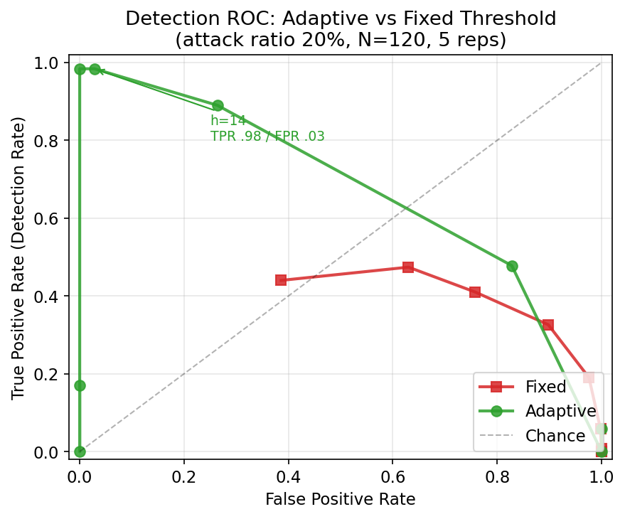
Figure 1. Detection ROC: adaptive (green) vs. fixed (red) threshold at 20% attack, N=120. The adaptive detector reaches the top-left corner; the fixed detector cannot.

5.2 Robustness across attack intensity and crowd size
Table 1 and Figure 2 report the adaptive detector (h=14) across adversarial fractions of 10–30% and crowd sizes of 50–200. For attack fractions of 15% and above, detection is near-perfect (TPR 0.98–1.00) with low false positives, and latency shortens as the attack strengthens (about 1 tick at 30%, 6–7 ticks at 15%). Performance is largely independent of crowd size. When the adversarial fraction falls to 10%, the detector degrades gracefully (TPR 0.41–0.58, latency 16–18 ticks), reflecting the intrinsic difficulty of distinguishing weak manipulation from normal fluctuation.
Attack | N | TPR | FPR | Latency
30% | 50–200 | 0.98–1.00 | 0.01–0.06 | ~1 tick
20% | 50–200 | 0.98–1.00 | 0.01–0.06 | 2–3 ticks
15% | 50–200 | 0.98–0.99 | 0.01–0.06 | 6–7 ticks
10% | 50–200 | 0.41–0.58 | 0.01–0.06 | 16–18 ticks
Table 1. Adaptive detector robustness (h=14, mean over 5 reps).
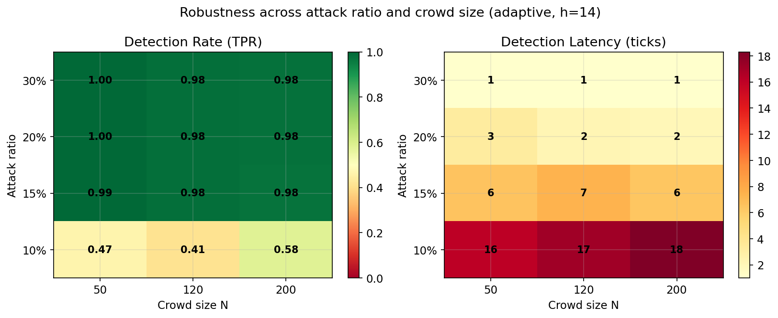
Figure 2. Detection rate (left) and latency (right) across attack ratio and crowd size. Detection is strong at >=15% attack and degrades gracefully at 10%.

5.3 Time-varying attack schedules
Real adversaries need not attack at a constant rate. Figure 3 evaluates five attack schedules: an abrupt step, a gradual ramp, a short burst, a weaker burst, and a periodic on/off pattern. The adaptive detector handles all five, with detection rates of 0.92–1.00. The ramp case—where a slowly rising adversarial fraction could in principle fool an adaptive baseline—is detected at 1.00, confirming that the suspicion-freeze prevents the baseline from drifting into the attack. The periodic schedule, the most challenging because the detector repeatedly re-adapts during clean intervals, is still detected at 0.92.
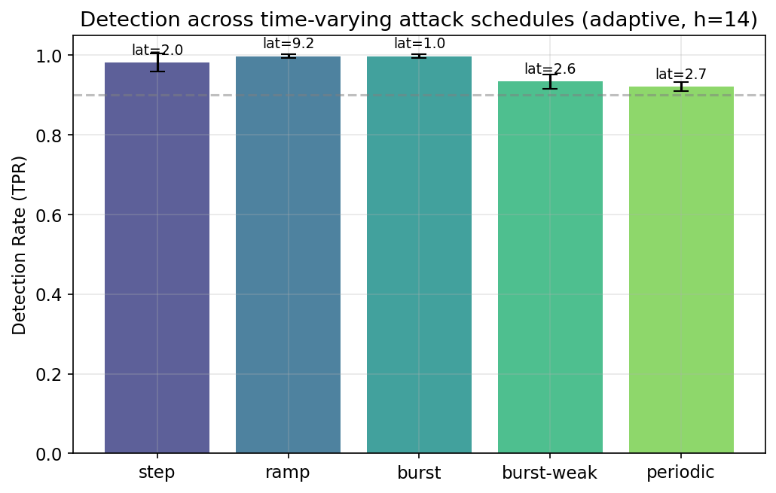
Figure 3. Detection across time-varying attack schedules (h=14). All five are detected above 0.92; latency annotated above each bar.

5.4 Operating-point trade-off
The threshold h exposes a tunable trade-off between detection latency and false positives (Figure 4). A lower h (e.g., 14) yields fast detection (about 2 ticks) at a small false-positive cost (0.03), while a higher h (e.g., 20) eliminates false positives entirely at the cost of slower detection (about 11 ticks). Operators can select h according to whether rapid response or zero false alarms is more important for their application.
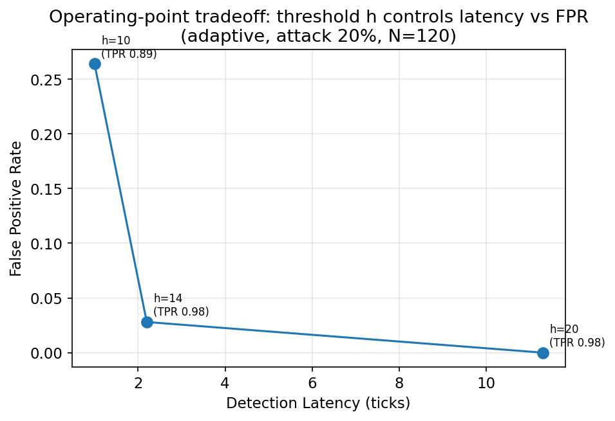
Figure 4. Threshold h trades detection latency against false positive rate (adaptive, 20% attack, N=120).

6. Discussion and Limitations
The results show that monitoring consensus strength with a baseline-free adaptive detector reliably identifies manipulation onset in simulated CSCC, across a wide operating envelope, where a fixed threshold fails outright. The method is simple, interpretable, and imposes negligible computational cost, making it suitable for real-time deployment.
Several limitations bound these claims. First, all evaluation is in simulation; honest and adversarial voting are modeled, and transfer to real human crowds requires empirical validation. Second, detection degrades when the adversarial fraction is small (10%), where weak manipulation is statistically hard to separate from normal fluctuation; applications requiring sensitivity to such subtle attacks would need additional signals. Third, the detector identifies the onset of manipulation but does not attribute it to specific participants; coupling detection with mitigation or attribution is left to future work. Finally, an adversary aware of the detector might attempt to shape gamma to evade it; analyzing such adaptive adversaries is an important direction.

7. Conclusion
We presented a baseline-free, real-time detector for coordinated manipulation in crowd-sourced continuous control. By monitoring the magnitude of the aggregate vote vector and combining an EWMA baseline with CUSUM change detection and a suspicion-triggered freeze, the method detects manipulation onset without any pre-specified normal baseline. In simulation it achieves 0.98 detection at 0.03 false positives where a fixed threshold has no usable operating point, remains effective across crowd sizes and attack intensities down to 15%, and handles diverse time-varying attack schedules. The approach offers a practical first line of defense for the integrity of real-time collective control channels, pending validation with human participants.

