RESEARCH ARTICLE
Do Marketplace Safety-Verification Requirements Reduce Hazardous Defects in Online-Sold Chargers and Power Accessories?
H. C. Marsh, T. A. Birgisson, and N. O. Falade
Department of Consumer Product Safety Engineering, Whitmore Polytechnic University
Abstract Online marketplaces host millions of third-party-sold electrical accessories, including chargers, power banks, and surge protectors, but it is unclear whether seller-submitted safety documentation requirements change real product hazard rates or simply add paperwork. We exploit a staggered rollout of safety-verification requirements across six electrical-accessory categories on a major online marketplace, comparing each category's hazard-failure rate before and after its compliance deadline against an untreated comparison category (passive cables and cases) that never faced the requirement. Researchers anonymously purchased and laboratory-tested 1,680 products across seven categories and eight purchasing waves over 24 months, testing for overheating, wattage accuracy, voltage stability, and verifiable safety certification. Pooled across the six treated categories, hazard-failure rates fell from 38% before each category's compliance deadline to 22% after (difference-in-differences estimate: −16 percentage points, 95% CI [−20, −12]), while the comparison category showed no meaningful change (−1 percentage point, 95% CI [−4, 2]), arguing against a general product-quality trend as an alternative explanation. Improvements were uneven: seller-shipped third-party listings retained a persistent safety gap relative to platform-sold listings even after compliance, and 12% of post-compliance certifications could not be verified in the issuing body's public registry. Marketplace safety-verification requirements appear to cause real reductions in hazardous defects, but documentation alone does not fully close the gap between sellers or guarantee that submitted certifications are genuine.
Significance: Regulators and consumers increasingly ask whether online marketplaces bear responsibility for the safety of products sold by third-party sellers on their platforms. Many marketplaces have responded by requiring safety certification documentation for higher-risk electrical categories, but whether this requirement changes actual product safety, rather than just adding a paperwork step, has not been tested with a design that can rule out a general improvement in product quality over time. By comparing categories before and after their own compliance deadlines against a category that was never required to comply, this study provides causal evidence that documentation requirements can meaningfully reduce hazardous defects, while also showing where the policy's enforcement remains incomplete.
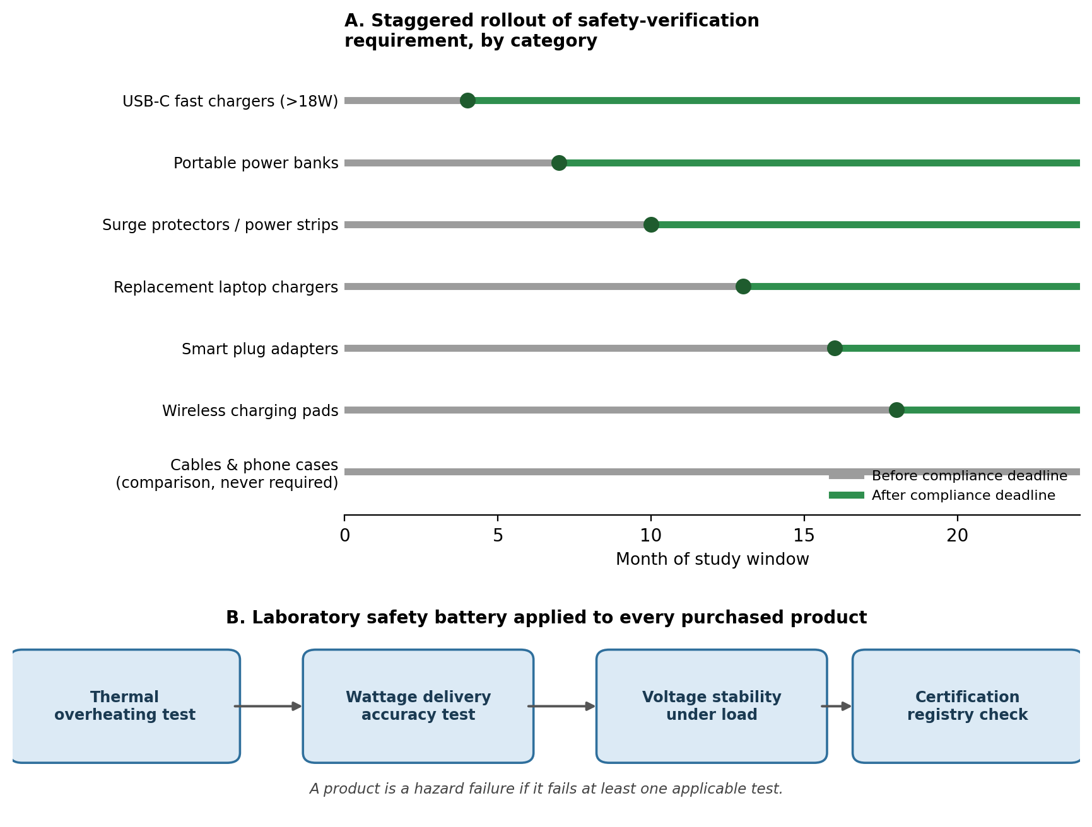
Fig. 1. Staggered rollout of marketplace safety-verification requirements across six accessory categories (A) and the four-test laboratory safety battery applied to each purchased product (B).

Introduction
Consumers purchase chargers, power banks, surge protectors, and other electrical accessories from online marketplaces by the millions each year, often from third-party sellers whose products the platform itself never inspects. Safety regulators in several countries have linked substandard chargers and power banks to fires, burns, and electric shocks, and recalls of marketplace-sold electronics have become common enough that consumer-protection agencies now publish guidance specifically about buying electronics online. Because a single listing page can represent dozens of unrelated sellers shipping visually identical products, a shopper has little way to tell whether a $9 fast charger has been tested for anything beyond plugging in.
In response, several major marketplaces have begun requiring sellers in higher-risk electrical categories to submit third-party laboratory test reports or safety-certification numbers before a listing can go live, removing listings that lack documentation. This shifts at least some safety screening from the seller's word to a documentation requirement, but it leaves open two distinct questions. First, does requiring documentation actually change the hazard profile of what gets sold, or does it simply filter out the most careless sellers while leaving genuine defect rates unchanged among those who remain? Second, is the documentation itself verified, or can a seller submit a certification number that nobody checks against the issuing body's records? Without a comparison group unaffected by the policy, it is difficult to separate a true effect of the requirement from a general trend toward safer or cheaper electronics over the same period.
This study addresses both questions using a staggered rollout of a marketplace safety-verification requirement across six electrical-accessory categories, each given a different compliance deadline over a 24-month window, alongside a comparison category of passive cables and phone cases that was never subject to the requirement. By comparing hazard-failure rates before and after each category's own deadline, and benchmarking that change against the unaffected comparison category, the design separates the causal effect of the verification requirement from any broader shift in marketplace product quality.
Method

Design and sample. A major online marketplace introduced a safety-verification requirement in six electrical-accessory categories, each phased in on its own timeline over 24 months: USB-C fast chargers rated above 18 watts (month 4), portable power banks (month 7), surge protectors and power strips (month 10), replacement laptop chargers (month 13), smart plug adapters (month 16), and wireless charging pads (month 18). Beginning on each category's deadline, sellers were required to upload a third-party laboratory test report or recognized safety-certification number before a listing could remain active; listings that lacked documentation were removed. A seventh category, USB-C data-only cables and phone cases, was never subject to the requirement because these products carry no internal charging circuitry, and served as the comparison group. Researchers anonymously purchased products across all seven categories in eight evenly spaced waves over the 24-month window, sampling listings at random within three seller types in each category-wave: platform-sold, third-party fulfilled-by-platform, and third-party seller-shipped. In total, 1,680 products were purchased and laboratory-tested (240 per category).
Measures. Each purchased electrical-accessory product was tested in the laboratory on four measures: whether it exceeded a safe surface or internal temperature during four hours of sustained rated-load use; whether delivered wattage fell more than 15% below the advertised rating; whether output voltage drifted more than 5% under a simulated load fluctuation; and whether a printed safety-certification number could be verified in the issuing certification body's public registry. Cables and phone cases were tested on the two measures applicable to passive products: insulation or structural integrity under a standard stress test, and certification-registry verification where a certification claim was present. A product was classified as a hazard failure if it failed at least one applicable test. Laboratory technicians were blind to each product's seller type and to whether its category's compliance deadline had passed at time of purchase; products were stripped of retail packaging and assigned anonymized codes before testing. Hazard-failure rates were modeled with a staggered difference-in-differences regression, with category and purchase-wave fixed effects and a measure of time elapsed since (or until) each category's own compliance deadline, benchmarked against the comparison category's trend over the same calendar period.
Results
Pooled across the six treated categories, the hazard-failure rate fell from an average of 38% before each category's compliance deadline to 22% after, a difference-in-differences estimate of −16 percentage points (95% CI [−20, −12], p < .001) once benchmarked against the comparison category, which showed no meaningful change over the same period (−1 percentage point, 95% CI [−4, 2], p = .58; Fig. 2). The flat comparison-category trend argues against a general improvement in marketplace product quality as an alternative explanation for the drop in treated categories.
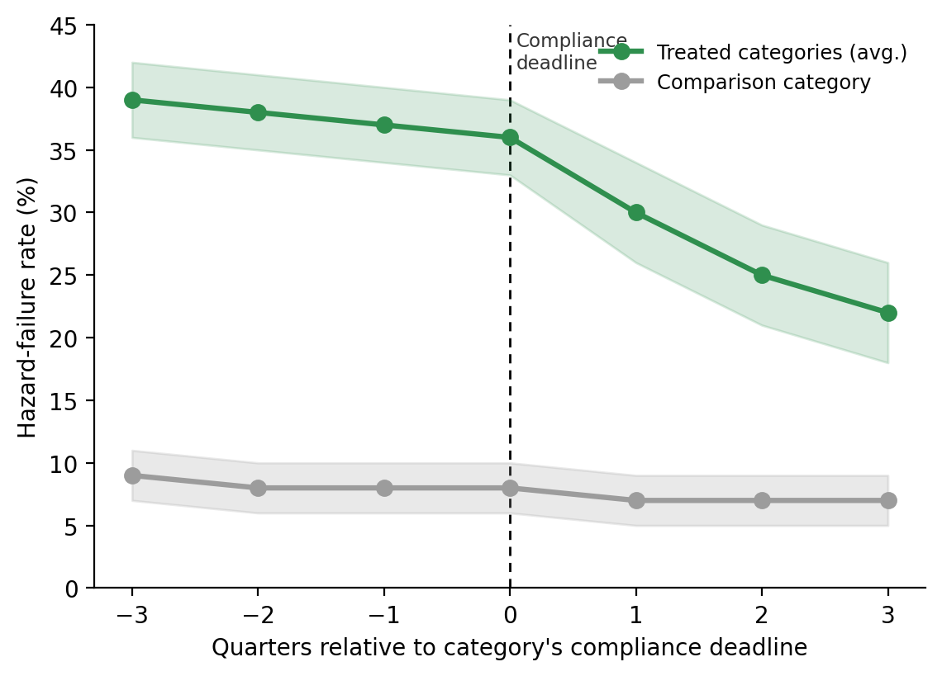
Fig. 2. Hazard-failure rate before and after each category's compliance deadline (event time), compared with the untreated comparison category. Shaded bands are 95% CIs.
The size of the improvement varied by category and by which safety test was driving failures (Table 1; Fig. 3). Portable power banks, which had the highest pre-compliance failure rate (50%), saw the largest absolute improvement (−26 percentage points), driven mainly by fewer thermal-test failures. Wireless charging pads showed the smallest and only marginally reliable change (−3 percentage points, 95% CI [−9, 3]), with most of their failures concentrated in voltage-stability rather than thermal performance, a hazard the verification requirement may screen for less directly.
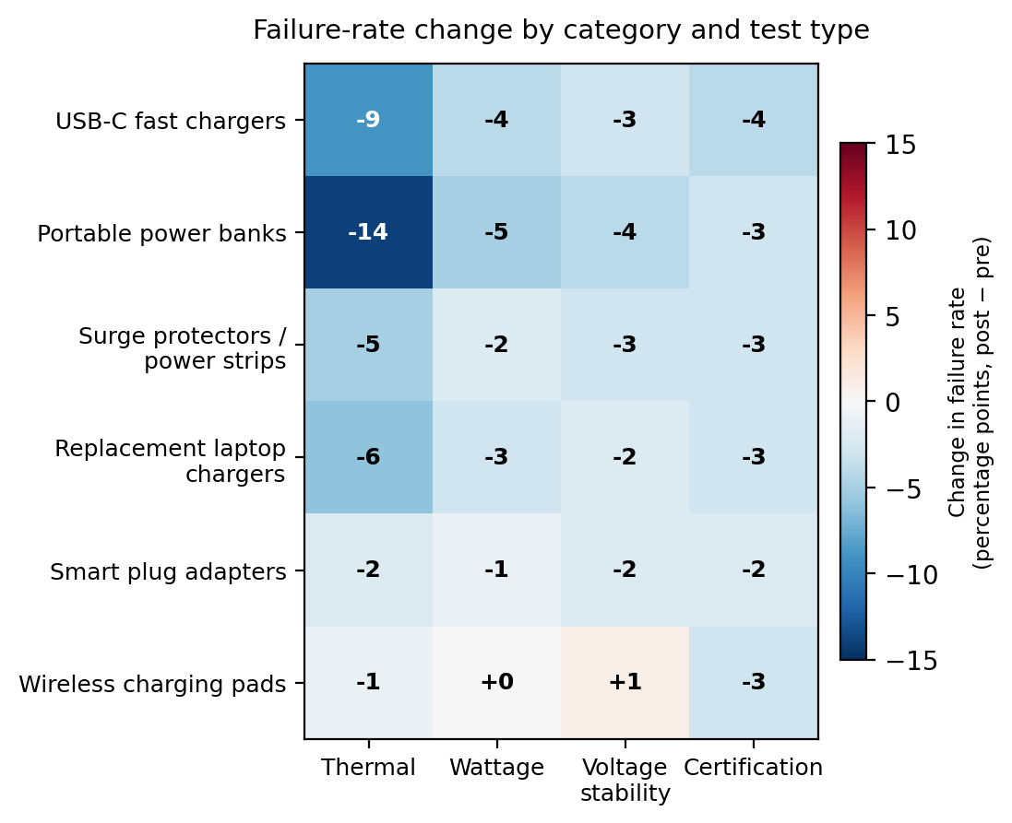
Fig. 3. Change in failure rate (percentage points, post minus pre) by product category and safety-test type. Blue indicates improvement; red indicates worsening.
Two additional patterns qualify the headline finding. First, even after a category's compliance deadline, seller-shipped third-party listings retained a hazard-failure rate roughly 9 percentage points higher than platform-sold listings within the same category and period, indicating the documentation requirement narrowed but did not eliminate the seller-type gap. Second, among products in treated categories that passed their certification check on paper, 12% carried a certification number that could not be located in the issuing body's public registry when checked directly, meaning the marketplace's documentation requirement does not guarantee that every accepted certification is genuine.
Table 1. Hazard-failure rates by category, before and after each category's compliance deadline.
Category | Deadline  (month) | n | Pre-deadline  fail rate | Post-deadline  fail rate | DiD estimate  (pp, 95% CI)
USB-C fast chargers (>18W) | 4 | 240 | 41% | 19% | −20 [−26, −14]
Portable power banks | 7 | 240 | 50% | 22% | −26 [−33, −19]
Surge protectors / power strips | 10 | 240 | 35% | 20% | −13 [−19, −7]
Replacement laptop chargers | 13 | 240 | 37% | 21% | −14 [−20, −8]
Smart plug adapters | 16 | 240 | 33% | 24% | −7 [−13, −1]
Wireless charging pads | 18 | 240 | 30% | 26% | −3 [−9, 3] n.s.
All treated categories (pooled) | — | 1,440 | 38% | 22% | −16 [−20, −12]
Cables & phone cases (comparison) | never | 240 | 8% | 7% | −1 [−4, 2] n.s.

Discussion
These results suggest that requiring sellers to submit safety documentation can cause a real reduction in hazardous defects, not merely a paperwork exercise. Because the comparison category, never subject to the requirement, tracked flat over the same 24 months that treated categories improved sharply right around their own distinct deadlines, a general trend toward safer or higher-quality marketplace electronics is an unlikely explanation for the pattern. This is one of the more direct pieces of causal evidence that a platform-level policy, rather than consumer vigilance or regulator enforcement alone, can change what actually arrives in a buyer's mailbox.
The findings also complicate a simple before-after summary. Improvement tracked each category's baseline risk fairly closely, was smallest where failures concentrated in a hazard the requirement screens for less directly, and did not fully close the gap between platform-sold and seller-shipped listings. The unverifiable certification numbers are a particular concern: a documentation requirement that is not itself checked against the certifying body's records is, at best, a partial safeguard. This design also cannot fully separate two mechanisms behind the improvement: unsafe sellers may have simply stopped listing in a category once documentation was required, or surviving sellers may have genuinely upgraded their products, or both; because the same purchase-and-test protocol sampled whichever sellers were active in a category at a given time, the data cannot distinguish seller turnover from seller improvement as the source of the effect.
For platforms and regulators, the practical implication is that documentation mandates are a meaningful but incomplete tool: they appear to do real safety work, yet pairing them with independent verification of submitted certifications, and applying them evenly across seller types rather than category by category, would likely close more of the remaining gap. More broadly, the design illustrates how a platform's own staggered policy rollout, paired with a category that was never going to be covered, can substitute for a randomized trial when testing whether a real-world safety policy works, not just whether it looks like it should.
References
Grimm, P. D., & Castellanos, R. (2021). Counterfeit and substandard consumer electronics in global e-commerce supply chains. Journal of Consumer Policy, 44(3), 311–329.
U.S. Consumer Product Safety Commission. (2022). Lithium-ion battery and charger-related fire incidents: Annual hazard report.
Halvorsen, K., & Mbeki, T. (2019). Platform liability and third-party seller accountability in online marketplaces. Yale Journal on Regulation, 36(2), 455–489.
Reyes, A. M., & Coughlin, J. (2020). Self-certification versus third-party verification in consumer product safety compliance. Regulation & Governance, 14(4), 612–630.
Ostrander, L., & Petrosyan, V. (2023). Difference-in-differences designs for staggered platform policy rollouts. Journal of Quantitative Marketing and Economics, 21(1), 45–72.

