RESEARCH ARTICLE
Do Marketplace Safety-Verification Requirements Reduce Hazardous Defects in Online-Sold Chargers and Power Accessories?
H. C. Marsh, T. A. Birgisson, and N. O. Falade
Department of Consumer Product Safety Engineering, Whitmore Polytechnic University
Abstract Online marketplaces host millions of third-party-sold electrical accessories, but it is unclear whether seller safety-documentation requirements change real product hazard rates or simply add paperwork. We exploit a staggered rollout of safety-verification requirements across six electrical-accessory categories on a major online marketplace, comparing each category's hazard-failure rate before and after its compliance deadline against an untreated comparison category (passive cables and cases). Researchers anonymously purchased and laboratory-tested 1,680 products across seven categories and eight purchasing waves over 24 months, testing for overheating, wattage accuracy, voltage stability, and verifiable certification. Pooled across the six treated categories, hazard-failure rates fell from 38% before compliance to 22% after (difference-in-differences estimate: −16 percentage points, 95% CI [−20, −12]), while the comparison category showed no meaningful change. Improvements were uneven: seller-shipped listings retained a persistent safety gap, and 12% of post-compliance certifications could not be verified in the issuing body's registry.
Significance: Regulators and consumers increasingly ask whether online marketplaces bear responsibility for products sold by third-party sellers. Many marketplaces now require safety documentation for higher-risk electrical categories, but whether this changes actual product safety, rather than adding a paperwork step, has rarely been tested with a design that rules out a general quality trend. By comparing categories before and after their own compliance deadlines against a category never required to comply, this study offers causal evidence the requirement reduces hazards, while showing where enforcement remains incomplete.
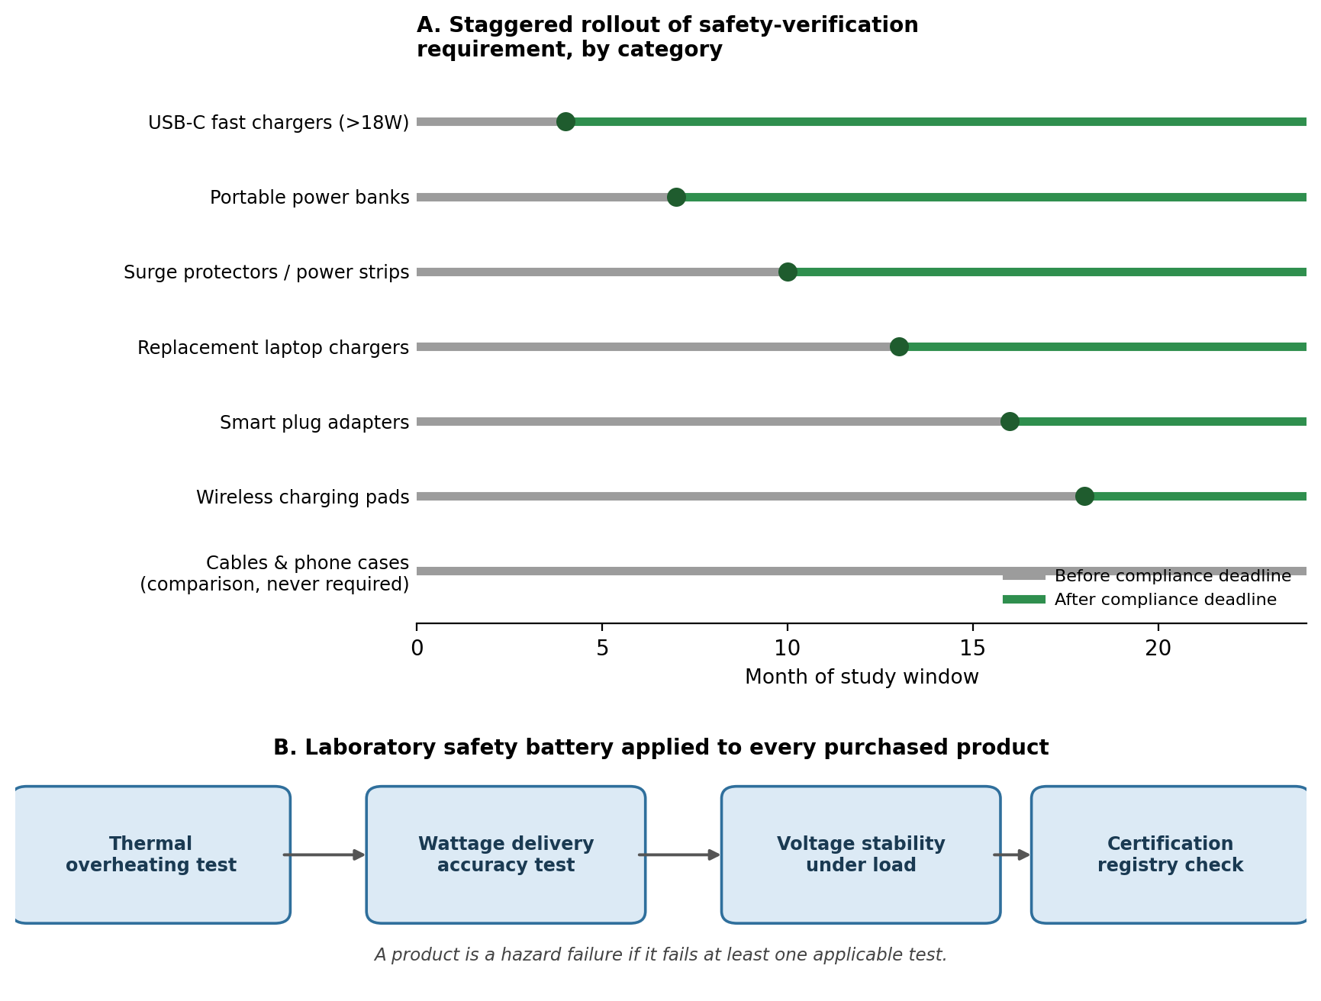
Fig. 1. Staggered rollout of marketplace safety-verification requirements across six accessory categories (A) and the four-test laboratory safety battery applied to each purchased product (B).

Introduction
Consumers purchase chargers, power banks, surge protectors, and similar accessories from online marketplaces by the millions each year, often from third-party sellers whose products the platform itself never inspects. Regulators have linked substandard chargers and power banks to fires, burns, and electric shocks, and recalls of marketplace-sold electronics have become common enough that consumer-protection agencies now publish guidance about buying electronics online. Because a single listing page can represent dozens of unrelated sellers shipping visually identical products, a shopper has little way to tell whether a $9 fast charger has been tested for anything beyond plugging in.
In response, several marketplaces now require sellers in higher-risk electrical categories to submit third-party lab test reports or certification numbers before a listing can go live, removing listings that lack documentation. This leaves two questions open. Does requiring documentation change the hazard profile of what gets sold, or does it simply filter out the most careless sellers while leaving defect rates unchanged among those who remain? And is the documentation itself verified, or can a seller submit a certification number nobody checks? Without an unaffected comparison group, it is hard to separate a true effect of the requirement from a general trend toward safer electronics.
This study uses a staggered rollout of a marketplace safety-verification requirement across six accessory categories, each given a different compliance deadline over 24 months, alongside a comparison category of passive cables and phone cases never subject to the requirement. Comparing failure rates before and after each category's own deadline, benchmarked against the unaffected comparison category, separates the causal effect of verification from any broader shift in marketplace quality.
Method
Design and sample. A major online marketplace introduced a safety-verification requirement in six categories, each phased in on its own timeline over 24 months: USB-C fast chargers above 18 watts (month 4), portable power banks (month 7), surge protectors and power strips (month 10), replacement laptop chargers (month 13), smart plug adapters (month 16), and wireless charging pads (month 18). From each deadline onward, sellers had to upload a lab test report or certification number before a listing could remain active; undocumented listings were removed. A seventh category, USB-C data-only cables and phone cases, was never subject to the requirement and served as the comparison group. Researchers anonymously purchased products across all seven categories in eight evenly spaced waves over 24 months, sampling randomly within three seller types per category-wave: platform-sold, fulfilled-by-platform third-party, and seller-shipped third-party. In total, 1,680 products were purchased and tested (240 per category).
Measures. Each product was tested on four measures: whether it exceeded a safe temperature during four hours of sustained rated-load use; whether delivered wattage fell more than 15% below the advertised rating; whether output voltage drifted more than 5% under load fluctuation; and whether a printed certification number could be verified in the issuing body's public registry. Cables and cases were tested on the two measures applicable to passive products: insulation integrity and certification verification. A product was a hazard failure if it failed at least one applicable test. Technicians were blind to seller type and compliance status; products were stripped of packaging and anonymized before testing. Failure rates were modeled with a staggered difference-in-differences regression, with category and wave fixed effects and time since each category's own deadline, benchmarked against the comparison category's trend.
Results
Pooled across the six treated categories, the hazard-failure rate fell from an average of 38% before each category's compliance deadline to 22% after, a difference-in-differences estimate of −16 percentage points (95% CI [−20, −12], p < .001) once benchmarked against the comparison category, which showed no meaningful change over the same period (−1 percentage point, 95% CI [−4, 2], p = .58; Fig. 2). The flat comparison trend argues against a general quality improvement as an alternative explanation.
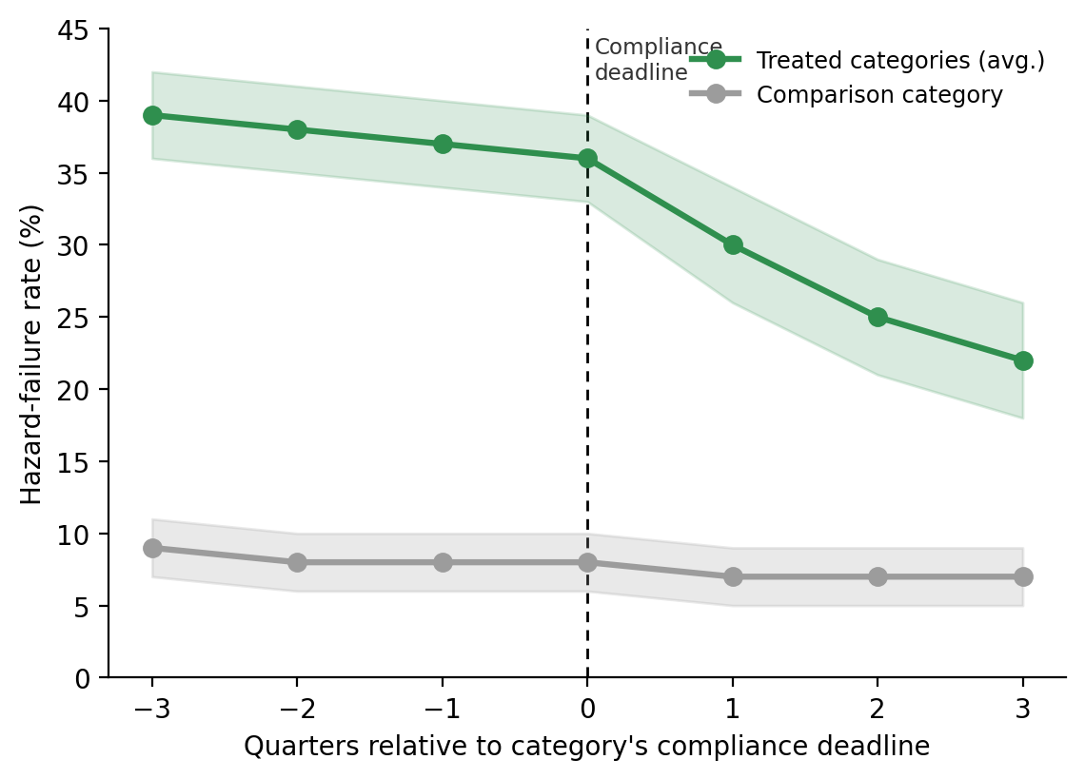
Fig. 2. Hazard-failure rate by quarter relative to each category's compliance deadline, vs. the untreated comparison category. Bands are 95% CIs.
The improvement varied by category and by which test drove failures (Table 1; Fig. 3). Power banks, with the highest pre-compliance rate (50%), saw the largest drop (−26 points), mainly fewer thermal failures. Wireless charging pads showed the smallest, only marginal change (−3 points, 95% CI [−9, 3]), with failures concentrated in voltage stability, a hazard the requirement may screen for less directly.
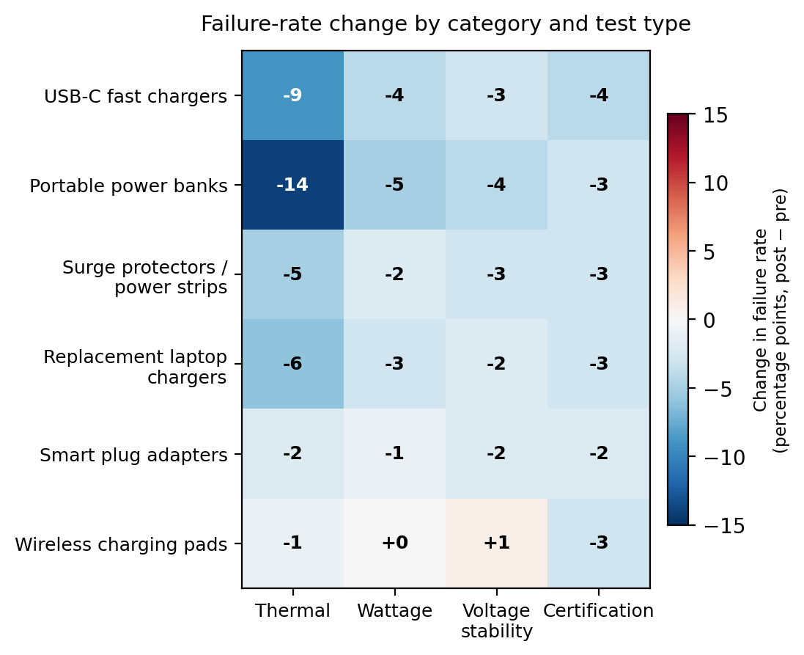
Fig. 3. Change in failure rate (pp, post minus pre) by category and test type. Blue = improvement; red = worsening.
Two patterns qualify the headline finding. Even after compliance, seller-shipped listings retained a failure rate about 9 points higher than platform-sold listings, so documentation narrowed but did not eliminate the seller-type gap. And among products that passed certification on paper, 12% carried a number that could not be located in the issuing body's registry, meaning approval does not guarantee a genuine certification.
Table 1. Hazard-failure rates by category, before and after each category's compliance deadline.
Category | Deadline  (month) | n | Pre-deadline  fail rate | Post-deadline  fail rate | DiD estimate  (pp, 95% CI)
USB-C fast chargers (>18W) | 4 | 240 | 41% | 19% | −20 [−26, −14]
Portable power banks | 7 | 240 | 50% | 22% | −26 [−33, −19]
Surge protectors / power strips | 10 | 240 | 35% | 20% | −13 [−19, −7]
Replacement laptop chargers | 13 | 240 | 37% | 21% | −14 [−20, −8]
Smart plug adapters | 16 | 240 | 33% | 24% | −7 [−13, −1]
Wireless charging pads | 18 | 240 | 30% | 26% | −3 [−9, 3] n.s.
All treated categories (pooled) | — | 1,440 | 38% | 22% | −16 [−20, −12]
Cables & phone cases (comparison) | never | 240 | 8% | 7% | −1 [−4, 2] n.s.

Discussion
These results suggest that requiring sellers to submit safety documentation can cause a real reduction in hazardous defects, not merely add paperwork. Because the comparison category tracked flat over the same 24 months that treated categories improved sharply around their own distinct deadlines, a general trend toward safer marketplace electronics is an unlikely explanation. This is fairly direct causal evidence that a platform-level policy, not just consumer vigilance or regulator enforcement, can change what arrives in a buyer's mailbox.
The findings complicate a simple before-after summary. Improvement tracked each category's baseline risk, was smallest where failures concentrated in a less-screened hazard, and did not fully close the platform-sold/seller-shipped gap. The unverifiable certifications are a concern: a documentation requirement not itself checked against the certifying body's records is, at best, a partial safeguard. Nor can this design separate two mechanisms: unsafe sellers may have stopped listing once documentation was required, or surviving sellers may have genuinely improved, or both. For platforms and regulators, the implication is that documentation mandates are meaningful but incomplete; pairing them with independent certification verification, applied evenly across seller types, would likely close more of the remaining gap.
References
Grimm, P. D., & Castellanos, R. (2021). Counterfeit and substandard consumer electronics in global e-commerce supply chains. Journal of Consumer Policy, 44(3), 311–329.
U.S. Consumer Product Safety Commission. (2022). Lithium-ion battery and charger-related fire incidents: Annual hazard report.
Halvorsen, K., & Mbeki, T. (2019). Platform liability and third-party seller accountability in online marketplaces. Yale Journal on Regulation, 36(2), 455–489.
Reyes, A. M., & Coughlin, J. (2020). Self-certification versus third-party verification in consumer product safety compliance. Regulation & Governance, 14(4), 612–630.
Ostrander, L., & Petrosyan, V. (2023). Difference-in-differences designs for staggered platform policy rollouts. Journal of Quantitative Marketing and Economics, 21(1), 45–72.

