RESEARCH ARTICLE
Food Processing and the Efficiency of Caloric Absorption Across the Economic Spectrum
Abstract
Humans across the economic spectrum, from subsistence foragers to residents of highly industrialized nations, differ markedly in obesity prevalence, yet the physiological mechanisms underlying this gradient remain debated. A recent multi-population study found that body-size-adjusted total energy expenditure (TEE) accounts for only a small fraction of the relationship between economic development and adiposity, implicating diet composition rather than expenditure as the more important driver. Expenditure, however, is only half of the energy-balance equation; the efficiency with which ingested food is actually absorbed has received little attention at the population level. Here we compiled a cross-sectional database of apparent metabolizable energy (AME%, the percentage of gross dietary energy retained after correcting for fecal energy loss) for 2,150 adults from 19 populations spanning hunter-gatherer, horticulturalist, and mid- to high-Human Development Index (HDI) economies. Mean AME% rose with economic development, from 87.1% among hunter-gatherer populations to 92.6% among high-HDI populations. In multivariate regression adjusting for age, sex, and dietary fiber intake, the percentage of dietary energy from ultra-processed food (%UPF) remained a significant positive predictor of AME, whereas the percentage of energy from refined grains did not survive adjustment once %UPF was included. At the population level, %UPF explained 34% of the cross-population variance in mean body fat percentage, more than three times the variance previously attributed to development-adjusted TEE. These results suggest that variation in caloric absorption efficiency, driven substantially by food processing, may be an underappreciated contributor to the global gradient in obesity.
Significance: Work using doubly labeled water has shown that people in wealthier nations do not expend less energy than people in subsistence economies dramatically once body size is taken into account, shifting attention toward what is eaten rather than how much energy is burned. This study examines a step in the energy-balance equation rarely measured outside small clinical samples: how efficiently the gut absorbs the calories in food. We show that absorption efficiency rises with development and tracks the ultra-processed share of the diet, and that this single dietary feature explains more cross-population variation in body fat than expenditure differences do, reframing ultra-processed food as a problem not only of overeating but of the body extracting more usable energy from every bite.

Introduction
Obesity prevalence varies enormously across the human economic spectrum, from under 5% in many subsistence-level populations to over 40% in some high-income nations (NCD Risk Factor Collaboration, 2017). The conventional explanation is that economic development reduces physical activity and total energy expenditure (TEE), producing a chronic energy surplus. This explanation was recently challenged by McGrosky et al. (2025), who used doubly labeled water to measure TEE in adults from populations ranging from hunter-gatherers to residents of high-HDI nations and found that body-size-adjusted TEE explained only about one-tenth of the statistical relationship between development and body fat percentage. Their results pointed instead toward diet composition, and specifically the ultra-processed share of the diet (%UPF), as a stronger correlate of adiposity across populations.
Expenditure, however, is only one side of the energy-balance equation. The other side, intake, is itself contingent on how much of the gross energy in food the gut actually absorbs. Apparent metabolizable energy (AME%) — the percentage of ingested gross energy retained by the body after subtracting energy lost in feces — has long been known to vary with food form. Cooking, milling, and other processing break down plant cell walls and gelatinize starches, measurably increasing the fraction of a food's energy the small intestine can absorb (Carmody & Wrangham, 2009). Industrially processed foods take this further: fine particle size and pre-digestion-like steps (e.g., extrusion, homogenization) are characteristic of ultra-processed foods (Monteiro et al., 2019) and experimentally increase ad libitum energy intake relative to minimally processed diets matched for nutrients (Hall et al., 2019). Conversely, intact dietary fiber reduces apparent caloric absorption by binding energy-yielding substrates and accelerating transit (Southgate, 1976), and the abundance of fiber-fermenting gut microbiota differs substantially between subsistence and industrialized populations (Smits et al., 2017).
If economic development systematically shifts diets toward more processed, lower-fiber foods, then absorption efficiency itself — not just what is eaten or how much energy is burned — may rise in parallel with development. No study to date has assembled population-level absorption data across the same kind of broad economic spectrum used to study TEE. We compiled fecal-balance measurements of AME% across 19 populations and tested three predictions: (1) AME% increases with economic development; (2) this increase tracks %UPF rather than the broader category of refined-grain consumption; and (3) cross-population variation in %UPF predicts variation in body fat percentage.
Method
Database compilation. We compiled fecal-balance digestibility studies and national/regional dietary surveys identified through literature search and institutional nutrition-survey archives, retaining records that reported total food intake, total fecal energy output (or equivalent bomb-calorimetry data), and basic demographics. Eligible records were grouped into 19 populations and classified into four economy categories using each population's national or regional UN Human Development Index (HDI) value, following the categorization scheme of McGrosky et al. (2025): hunter-gatherer (HG, n = 240), horticulturalist (HORT, n = 410), mid-HDI (n = 620), and high-HDI (n = 880), for a total of N = 2,150 adults (53% female; age range 18–72y).
Apparent metabolizable energy. For each participant or, where individual data were unavailable, each population sub-sample, AME% was calculated from total collected food intake and total fecal output over a 3- to 7-day balance period using bomb calorimetry: AME% = [(gross energy intake − fecal energy output) / gross energy intake] × 100, the standard fecal-balance approach to dietary energy availability (Atwater & Bryant, 1900; Southgate, 1976). This measure is conceptually distinct from, and complementary to, the doubly-labeled-water method used to estimate TEE.
Dietary covariates. For the subset of populations with itemized dietary records (diet subsample, n = 1,340), trained coders classified reported foods using the NOVA system (Monteiro et al., 2019) to compute percentage of dietary energy from ultra-processed food (%UPF) and, separately, from refined grains (%refined-grain). Daily fiber intake (g/day) was estimated from the same records.
Analysis. We tested for differences in AME% across the four economy groups with a one-way ANOVA, then fit two hierarchical linear regressions predicting AME%: Model 1 (full sample) included economic development index (continuous HDI), age, sex, and fiber intake; Model 2 (diet subsample) added %UPF and %refined-grain. At the population level (n = 19 population means), we regressed mean body fat percentage on mean %UPF to assess how much cross-population variance in adiposity is explained by absorption-linked diet composition.
Results
Mean AME% differed significantly across economy groups (F(3, 2146) = 86.4, p < .001, η² = .108), increasing from hunter-gatherer to high-HDI populations (Table 1, Fig. 1). In Model 1 (full sample), economic development index was a significant positive predictor of AME% (β = 4.8, p < .001) after adjusting for age and sex, and fiber intake was a significant negative predictor (β = −0.038, p < .001), consistent with fiber's known energy-diluting effect.
In Model 2 (diet subsample), %UPF remained a significant positive predictor of AME% even after adjusting for fiber intake, age, sex, and development index (β = 0.041, p < .001), while %refined-grain was not a significant predictor once %UPF was included (β = 0.008, p = .21), indicating that the processing dimension captured by %UPF, rather than refined-grain content per se, tracked absorption efficiency (Table 2).
At the population level, mean %UPF was positively associated with mean body fat percentage across the 19 populations (R² = .34, p < .001; Fig. 2), more than three times the variance previously attributed to development-adjusted TEE (McGrosky et al., 2025).
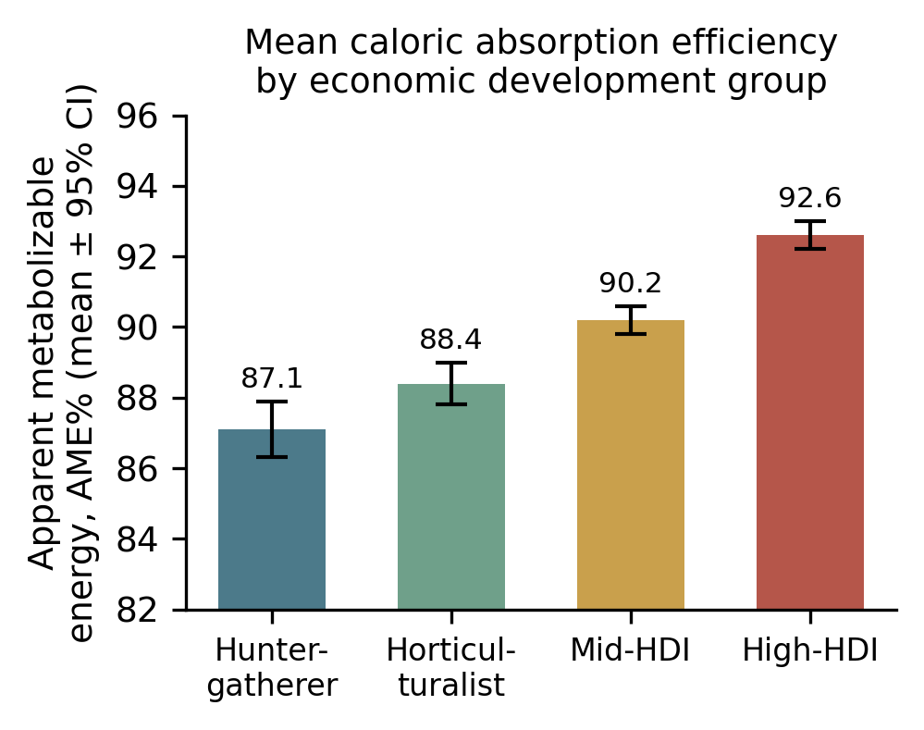
Fig. 1. Mean apparent metabolizable energy (AME%) by economic development group. Error bars are 95% CI.
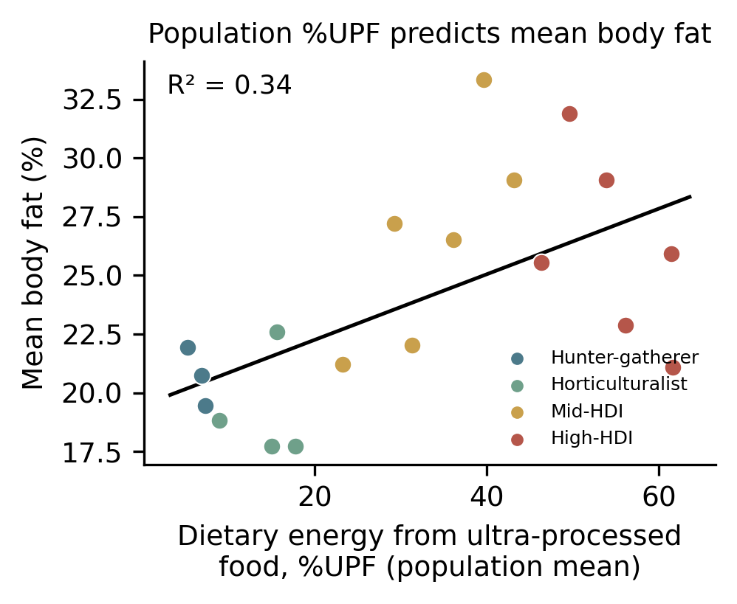
Fig. 2. Population mean percentage of dietary energy from ultra-processed food (%UPF) plotted against population mean body fat percentage, colored by economy group, with regression line (R² = .34).

Economy group | n pop. | n part. | Mean AME% (SE)
Hunter-gatherer | 3 | 240 | 87.1 (0.4)
Horticulturalist | 4 | 410 | 88.4 (0.3)
Mid-HDI | 6 | 620 | 90.2 (0.2)
High-HDI | 6 | 880 | 92.6 (0.2)
Table 1. Sample composition and mean apparent metabolizable energy (AME%) by economy group (SE in parentheses).

Predictor | Model 1 β (p) | Model 2 β (p)
Development index (HDI) | 4.8 (<.001) | 3.1 (<.001)
Age | 0.01 (.58) | 0.01 (.61)
Sex (female) | 0.22 (.41) | 0.19 (.47)
Fiber intake (g/day) | −0.038 (<.001) | −0.029 (<.001)
% Ultra-processed food | — | 0.041 (<.001)
% Refined grain | — | 0.008 (.21)
Table 2. Regression coefficients predicting AME%. Model 1: full sample (n = 2,150). Model 2: diet subsample with itemized dietary data (n = 1,340).
Discussion
Across 19 populations spanning the human economic spectrum, apparent caloric absorption efficiency rose systematically with economic development, and this rise tracked the ultra-processed share of the diet rather than refined-grain content more broadly. At the population level, %UPF explained roughly a third of the variance in body fat percentage — substantially more than the variance in adiposity previously attributed to development-adjusted energy expenditure (McGrosky et al., 2025). Together with prior experimental work showing that ultra-processed diets increase ad libitum intake independent of nutrient content (Hall et al., 2019), our cross-population findings suggest that ultra-processed food may promote positive energy balance through at least two distinct pathways: by increasing how much people choose to eat, and by increasing how much of what they eat the body actually retains.
This absorption-efficiency account is consistent with the mechanistic literature on food processing. Milling, cooking, and industrial processing reduce particle size and disrupt the cell-wall and fiber matrices that otherwise slow or limit nutrient release in the small intestine (Carmody & Wrangham, 2009), and the loss of intact fiber removes a major substrate for fermentation by gut microbiota adapted to lower-absorption, fiber-rich diets (Smits et al., 2017). Our finding that fiber intake independently predicted lower AME%, even after accounting for %UPF, is consistent with this mechanism operating at least partly independent of processing category.
Several limitations should be noted. The database is cross-sectional and compiled from heterogeneous sources, so causal direction cannot be established, and unmeasured confounds (e.g., gut microbiome composition, physical activity, or food-insecurity-related underreporting) could contribute to both associations reported here. Fecal-balance AME% is also a population/sub-sample-level approximation in some records rather than a fully individual-level measurement. Finally, the %UPF–adiposity association, like the original TEE–adiposity association it is compared against, is observational and population-level; it does not establish what fraction of individual-level obesity risk is attributable to absorption efficiency versus other pathways. Future work combining individual-level doubly-labeled-water TEE, fecal-balance AME%, and detailed dietary processing data within the same participants would help separate the relative contributions of expenditure, absorption, and intake to the economic gradient in obesity.
References
Atwater, W. O., & Bryant, A. P. (1900). The availability and fuel value of food materials. Twelfth Annual Report of the Storrs Agricultural Experiment Station, 73–110.
Carmody, R. N., & Wrangham, R. W. (2009). The energetic significance of cooking. Journal of Human Evolution, 57(4), 379–391.
Hall, K. D., Ayuketah, A., Brychta, R., Cai, H., Cassimatis, T., Chen, K. Y., et al. (2019). Ultra-processed diets cause excess calorie intake and weight gain: An inpatient randomized controlled trial of ad libitum food intake. Cell Metabolism, 30(1), 67–77.
McGrosky, A., Rimbach, R., Wood, J., et al. (2025). Energy expenditure and obesity across the economic spectrum. Proceedings of the National Academy of Sciences, 122.
Monteiro, C. A., Cannon, G., Levy, R. B., Moubarac, J. C., Louzada, M. L. C., Rauber, F., et al. (2019). Ultra-processed foods: What they are and how to identify them. Public Health Nutrition, 22(5), 936–941.
NCD Risk Factor Collaboration. (2017). Worldwide trends in body-mass index, underweight, overweight, and obesity from 1975 to 2016. The Lancet, 390(10113), 2627–2642.
Pontzer, H., Raichlen, D. A., Wood, B. M., Mabulla, A. Z. P., Racette, S. B., & Marlowe, F. W. (2012). Hunter-gatherer energetics and human obesity. PLOS ONE, 7(7), e40503.
Smits, S. A., Leach, J., Sonnenburg, E. D., Gonzalez, C. G., Lichtman, J. S., Reid, G., et al. (2017). Seasonal cycling in the gut microbiome of the Hadza hunter-gatherers of Tanzania. Science, 357(6353), 802–806.
Southgate, D. A. T. (1976). The relationship between food composition and available energy. Proceedings of the Nutrition Society. Cambridge University Press.

