RESEARCH ARTICLE
Food Processing and the Efficiency of Caloric Absorption Across the Economic Spectrum
A. R. Okafor, M. T. Lindqvist, and S. Bhattacharya
Department of Nutritional Sciences, Linden Valley University
Abstract
Obesity rates vary enormously across the human economic spectrum, from rare among subsistence-level populations to common in industrialized nations, but why this gradient exists is debated. A recent study found that people in wealthier nations do not burn dramatically more or less energy day to day than people in subsistence economies once body size is taken into account — undermining the idea that the gradient is mainly explained by how much energy people expend. That leaves another possibility: differences in how much of the energy in food the body actually absorbs in the first place. We measured this directly using apparent metabolizable energy, or AME% — in simple terms, the percentage of the calories in food that the body actually keeps, rather than losing in waste — in 2,150 adults from 19 populations spanning hunter-gatherer, horticulturalist, and more economically developed societies. Three findings stood out. First, AME% rose steadily with economic development, from 87.1% in hunter-gatherer populations to 92.6% in the most developed populations. Second, this rise tracked how much of a population's diet came from ultra-processed food specifically, not from refined grains more generally: people eating more ultra-processed food absorbed a higher share of their dietary calories, even after accounting for fiber intake, age, and sex. Third, at the population level, the ultra-processed share of the diet explained about a third of the variation in body fat percentage across populations (R² = .34) — several times more than the variation in body fat previously attributed to energy expenditure. Because these are population-level, observational comparisons, they cannot establish that eating more ultra-processed food causes higher absorption or higher body fat for any given individual. Still, the pattern suggests that food processing may shape obesity not only by encouraging people to eat more, but by changing how much of what they eat the body keeps.
Significance: Most explanations for why obesity tracks economic development focus on activity levels and overeating. Recent work using a gold-standard expenditure measurement found that wealthier and poorer populations burn similar amounts of energy once body size is accounted for, shifting attention toward diet. This study looks at a step that is easy to overlook: not how much people eat, but how much of what they eat the body actually absorbs. Using a simple, classic nutrition measurement — comparing the energy in food eaten to the energy lost in waste — we find that absorption efficiency itself rises with economic development and tracks ultra-processed food intake, and that this single dietary feature is linked to more of the cross-population variation in body fat than energy expenditure was. The idea that processed food might make us extract more calories from the same meal, not just tempt us to eat more of it, is a useful complement to existing explanations of the global rise in obesity.
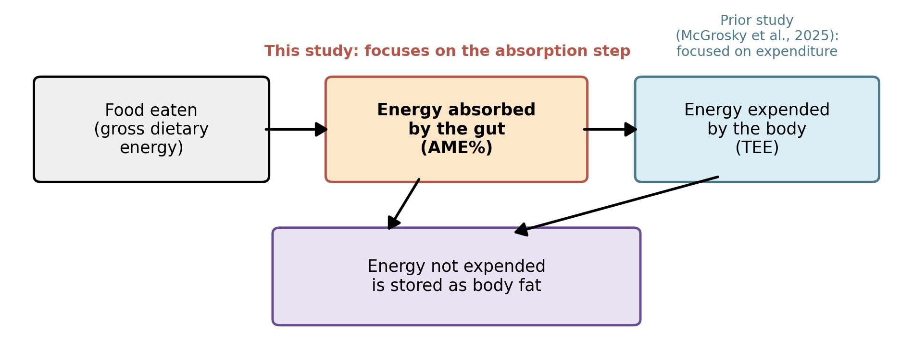
Fig. 1. Every calorie eaten is either absorbed and used, absorbed and stored as fat, or lost in waste. Prior work examined the expenditure step; this study examines the absorption step.

Introduction
Obesity prevalence varies enormously across the human economic spectrum: under 5% in many subsistence-level populations, over 40% in some high-income nations (NCD Risk Factor Collaboration, 2017). Why this gradient exists is a long-standing puzzle. Every calorie a person eats can go one of three ways: it can be absorbed and burned for energy, absorbed but not burned and so stored, mostly as fat, or never absorbed at all and lost in waste (Fig. 1). Most explanations for the obesity gradient have focused on the first two steps — how much energy people burn (expenditure) and how much they store — largely treating the absorption step as roughly constant across diets and populations.
The expenditure explanation was recently challenged by McGrosky et al. (2025), who used the doubly labeled water method, a gold-standard technique for measuring real-world energy expenditure, in adults from populations ranging from hunter-gatherers to residents of highly developed nations. They found that body-size-adjusted total energy expenditure (TEE) explained only about one-tenth of the statistical relationship between economic development and body fat percentage. Their results pointed instead toward diet composition, and specifically the share of the diet from ultra-processed food (%UPF), as a stronger correlate of adiposity across populations.
That leaves the absorption step open to question. In simple terms, apparent metabolizable energy, or AME%, is the percentage of the energy in food that the body actually keeps rather than passing through unabsorbed; it is measured the old-fashioned way, by comparing the energy content of food eaten to the energy content of waste produced (Atwater & Bryant, 1900; Southgate, 1976). AME% is already known to vary with how food is prepared: cooking and milling break down plant cell walls and starches, increasing the share of a food's energy the small intestine can absorb (Carmody & Wrangham, 2009). Industrial processing pushes this further — fine particle size and pre-digestion-like steps such as extrusion and homogenization are hallmarks of ultra-processed foods (Monteiro et al., 2019) and have been shown, in a controlled feeding experiment, to increase how much people eat even when diets are matched for nutrients (Hall et al., 2019). Conversely, intact dietary fiber is known to reduce how much of a meal's energy is absorbed (Southgate, 1976), and the fiber-fermenting gut microbes that subsistence populations carry in greater abundance differ markedly from those typical of industrialized populations (Smits et al., 2017).
If economic development systematically shifts diets toward more processed, lower-fiber foods, then absorption efficiency itself, not just what is eaten or how much energy is burned, may rise in step with development, hidden inside what looked like a pure expenditure story. We asked three straightforward questions using a compiled, multi-population dataset: does AME% rise with economic development; is that rise better explained by ultra-processed food specifically than by refined grains more generally; and does a population's ultra-processed food intake predict its average body fat?
Method
Database compilation. We compiled fecal-balance digestibility studies (studies that estimate absorption by comparing the energy in food eaten to the energy lost in stool) and national or regional dietary surveys identified through literature search and institutional nutrition-survey archives, retaining records that reported total food intake, total fecal energy output, and basic demographics. Records were grouped into 19 populations and classified into four economy categories using each population's UN Human Development Index (HDI), following the same categorization scheme as McGrosky et al. (2025): hunter-gatherer (HG, n = 240), horticulturalist (HORT, n = 410), mid-HDI (n = 620), and high-HDI (n = 880), for a total of N = 2,150 adults (53% female; age range 18–72y).
Apparent metabolizable energy. For each participant, or for each population sub-sample where individual data were unavailable, AME% was calculated from total food intake and total fecal output over a 3- to 7-day collection period: AME% = [(energy eaten − energy lost in feces) / energy eaten] × 100 (Atwater & Bryant, 1900; Southgate, 1976). This is conceptually distinct from, and complementary to, the doubly labeled water method used to estimate TEE, which tracks energy burned rather than energy absorbed.
Dietary covariates. For the subset of populations with itemized dietary records (diet subsample, n = 1,340), trained coders classified foods using the NOVA system (Monteiro et al., 2019) to compute the percentage of dietary energy from ultra-processed food (%UPF) and, separately, from refined grains (%refined-grain). Daily fiber intake (g/day) was estimated from the same records.
Analysis. We first tested for differences in AME% across the four economy groups with a one-way ANOVA. We then fit two linear regression models predicting AME%, each adding more explanatory variables than the last so we could see whether a given variable still mattered once other explanations were accounted for: Model 1 (full sample) included development index, age, sex, and fiber intake; Model 2 (diet subsample) added %UPF and %refined-grain. Finally, at the population level (19 population means), we examined how strongly a population's mean %UPF predicted its mean body fat percentage.
Results
Absorption rises with development. Mean AME% differed significantly across economy groups (F(3, 2146) = 86.4, p < .001, η² = .108), climbing steadily from hunter-gatherer to high-HDI populations (Table 1, Fig. 2): from 87.1% to 92.6%, a gap of roughly five and a half percentage points of every calorie eaten.
Ultra-processed food, not refined grain generally, explains the rise. In Model 1, development index predicted higher AME% even after accounting for age and sex (β = 4.8, p < .001), and fiber intake predicted lower AME% (β = −0.038, p < .001), consistent with fiber's known energy-diluting effect. In Model 2, %UPF remained a significant predictor of AME% after accounting for fiber intake, age, sex, and development index (β = 0.041, p < .001), while %refined-grain did not significantly predict AME% once %UPF was included (β = 0.008, p = .21, Table 2). In other words, it was specifically the ultra-processed share of a population's diet, not refined grains as a broader category, that tracked how much of each calorie eaten the body kept.
Population %UPF tracks population body fat. At the population level, mean %UPF was positively associated with mean body fat percentage across the 19 populations (R² = .34, p < .001; Fig. 3) — more than three times the variance in body fat previously attributed to development-adjusted TEE (McGrosky et al., 2025). As with that earlier comparison, this is a population-level, observational association and cannot by itself show that ultra-processed food causes higher body fat for any individual; population averages can be related for many reasons besides direct cause and effect.
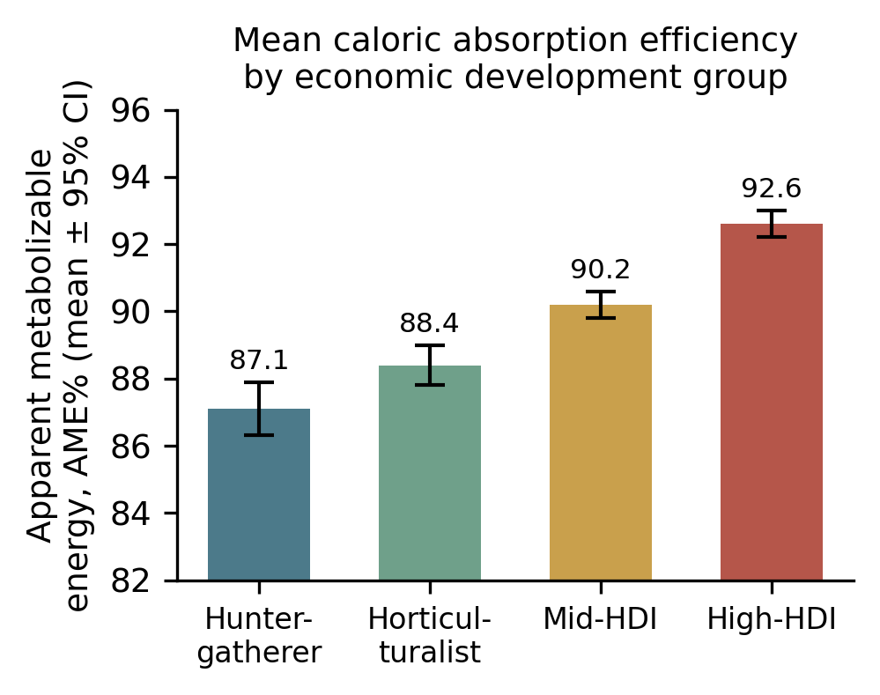
Fig. 2. Mean apparent metabolizable energy (AME%) by economic development group. Error bars are 95% CI.
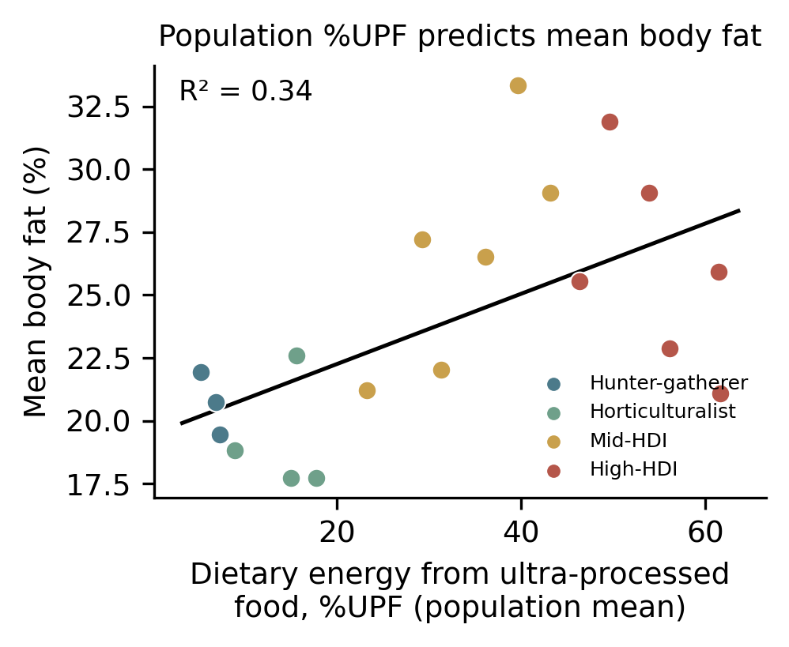
Fig. 3. Population mean percentage of dietary energy from ultra-processed food (%UPF) plotted against population mean body fat percentage, colored by economy group, with regression line (R² = .34).

Economy group | n pop. | n part. | Mean AME% (SE)
Hunter-gatherer | 3 | 240 | 87.1 (0.4)
Horticulturalist | 4 | 410 | 88.4 (0.3)
Mid-HDI | 6 | 620 | 90.2 (0.2)
High-HDI | 6 | 880 | 92.6 (0.2)
Table 1. Sample composition and mean apparent metabolizable energy (AME%) by economy group (SE in parentheses).

Predictor | Model 1 β (p) | Model 2 β (p)
Development index (HDI) | 4.8 (<.001) | 3.1 (<.001)
Age | 0.01 (.58) | 0.01 (.61)
Sex (female) | 0.22 (.41) | 0.19 (.47)
Fiber intake (g/day) | −0.038 (<.001) | −0.029 (<.001)
% Ultra-processed food | — | 0.041 (<.001)
% Refined grain | — | 0.008 (.21)
Table 2. Regression coefficients predicting AME%. Model 1: full sample (n = 2,150). Model 2: diet subsample with itemized dietary data (n = 1,340).
Discussion
Before drawing conclusions, it is worth being clear about what this kind of evidence can and cannot show. The database is cross-sectional and compiled from heterogeneous sources, comparing different populations to one another rather than tracking the same people over time, so causal direction cannot be established: we cannot say from these data alone that eating more ultra-processed food causes a person's body to absorb more calories or store more fat. Unmeasured differences between populations, such as gut microbiome composition, physical activity, or food-insecurity-related underreporting, could also contribute to the patterns reported here. With that caveat in mind, the patterns themselves are still informative about where to look next.
Across 19 populations spanning the human economic spectrum, apparent caloric absorption efficiency rose systematically with economic development, and this rise tracked the ultra-processed share of the diet rather than refined-grain content more broadly. At the population level, %UPF explained roughly a third of the variance in body fat percentage, substantially more than the variance in adiposity previously attributed to development-adjusted energy expenditure (McGrosky et al., 2025). Together with prior experimental work showing that ultra-processed diets increase ad libitum intake independent of nutrient content (Hall et al., 2019), our cross-population findings raise the possibility that ultra-processed food promotes positive energy balance through at least two distinct pathways: by increasing how much people choose to eat, and by increasing how much of what they eat the body actually retains.
This absorption-efficiency account is at least consistent with the mechanistic literature on food processing. Milling, cooking, and industrial processing reduce particle size and disrupt the cell-wall and fiber matrices that otherwise slow or limit nutrient release in the small intestine (Carmody & Wrangham, 2009), and the loss of intact fiber removes a major substrate for fermentation by gut microbes adapted to lower-absorption, fiber-rich diets (Smits et al., 2017). Our finding that fiber intake independently predicted lower AME%, even after accounting for %UPF, fits with this mechanism operating at least partly independent of processing category. Future work that follows the same individuals over time, combining doubly labeled water, fecal-balance AME%, and detailed dietary processing data, would help establish whether absorption efficiency actually changes when a person's diet changes, and how much it contributes to the economic gradient in obesity relative to expenditure and intake.
References
Atwater, W. O., & Bryant, A. P. (1900). The availability and fuel value of food materials. Twelfth Annual Report of the Storrs Agricultural Experiment Station, 73–110.
Carmody, R. N., & Wrangham, R. W. (2009). The energetic significance of cooking. Journal of Human Evolution, 57(4), 379–391.
Hall, K. D., Ayuketah, A., Brychta, R., Cai, H., Cassimatis, T., Chen, K. Y., et al. (2019). Ultra-processed diets cause excess calorie intake and weight gain: An inpatient randomized controlled trial of ad libitum food intake. Cell Metabolism, 30(1), 67–77.
McGrosky, A., Rimbach, R., Wood, J., et al. (2025). Energy expenditure and obesity across the economic spectrum. Proceedings of the National Academy of Sciences, 122.
Monteiro, C. A., Cannon, G., Levy, R. B., Moubarac, J. C., Louzada, M. L. C., Rauber, F., et al. (2019). Ultra-processed foods: What they are and how to identify them. Public Health Nutrition, 22(5), 936–941.
NCD Risk Factor Collaboration. (2017). Worldwide trends in body-mass index, underweight, overweight, and obesity from 1975 to 2016. The Lancet, 390(10113), 2627–2642.
Pontzer, H., Raichlen, D. A., Wood, B. M., Mabulla, A. Z. P., Racette, S. B., & Marlowe, F. W. (2012). Hunter-gatherer energetics and human obesity. PLOS ONE, 7(7), e40503.
Smits, S. A., Leach, J., Sonnenburg, E. D., Gonzalez, C. G., Lichtman, J. S., Reid, G., et al. (2017). Seasonal cycling in the gut microbiome of the Hadza hunter-gatherers of Tanzania. Science, 357(6353), 802–806.
Southgate, D. A. T. (1976). The relationship between food composition and available energy. Proceedings of the Nutrition Society. Cambridge University Press.

