RESEARCH ARTICLE
Food Processing and the Efficiency of Caloric Absorption Across the Economic Spectrum
Abstract
Obesity prevalence rises sharply with economic development, but why is debated. A recent study found that energy expenditure differs little between wealthier and subsistence populations once body size is accounted for, pointing attention toward diet. We measured a different piece of the puzzle directly: apparent metabolizable energy, or AME% — in simple terms, the percentage of a food's calories the body actually keeps rather than losing in waste. Across 2,150 adults from 19 populations spanning hunter-gatherer to high-HDI societies, AME% rose steadily with development, from 87.1% to 92.6%. This rise tracked ultra-processed food intake (%UPF) specifically, not refined grains, even after adjusting for fiber, age, and sex. At the population level, %UPF explained about a third of cross-population variation in body fat (R² = .34) — several times more than expenditure did in prior work. Because these are population-level, observational comparisons, they cannot establish that ultra-processed food causes higher absorption or body fat in any individual. Still, food processing may shape obesity not only through overeating, but through how much of what we eat the body keeps.
Significance: Most explanations for why obesity tracks development focus on activity and overeating. This study examines a step that is easy to overlook: not how much people eat, but how much of it the body absorbs. Using a classic nutrition measurement — comparing energy eaten to energy lost in waste — we find that absorption efficiency itself rises with development and tracks ultra-processed food intake, and that this single dietary feature relates to more cross-population variation in body fat than expenditure differences do.
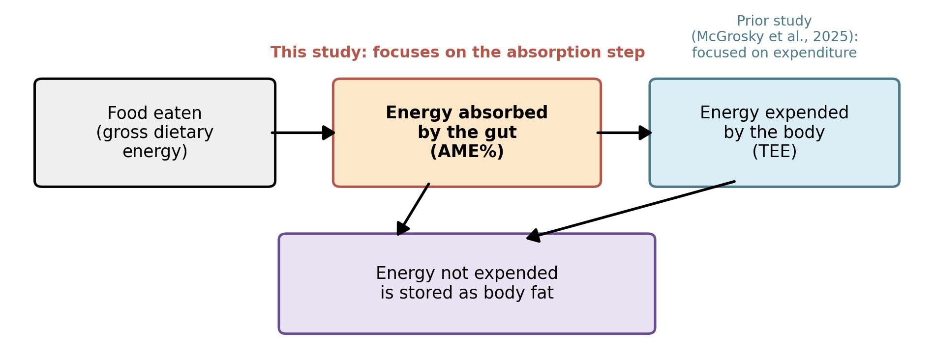
Fig. 1. Every calorie eaten is absorbed and used, absorbed and stored as fat, or lost in waste. Prior work examined expenditure; this study examines absorption.
Quick glossary
AME% | How much of a food's energy the body actually keeps, rather than losing in waste.
%UPF | Share of the diet from ultra-processed food.
TEE | Total energy expenditure — energy burned, measured in prior work (McGrosky et al., 2025).
HDI | Human Development Index — a standard measure of a population's economic development.
These four terms recur throughout the paper; this box is meant as a running reference.

Introduction
Obesity prevalence ranges from under 5% in many subsistence-level populations to over 40% in some high-income nations (NCD Risk Factor Collaboration, 2017). Every calorie eaten is either absorbed and burned, absorbed and stored as fat, or lost in waste (Fig. 1). Most explanations for this gradient focus on the first two steps, expenditure and storage, treating absorption as roughly constant.
McGrosky et al. (2025) challenged the expenditure explanation, using the doubly labeled water method to measure energy expenditure in populations from hunter-gatherers to residents of high-HDI nations. Body-size-adjusted total energy expenditure (TEE) explained only about a tenth of the relationship between development and body fat. Diet composition, especially the ultra-processed share of the diet (%UPF), correlated more strongly with adiposity.
That leaves absorption open to question. In simple terms, apparent metabolizable energy (AME%) is the share of a food's energy the body actually keeps rather than passing through unabsorbed, measured by comparing energy eaten to energy in waste (Atwater & Bryant, 1900; Southgate, 1976). Cooking and milling break down cell walls and starches, increasing how much energy the gut absorbs (Carmody & Wrangham, 2009); industrial processing pushes this further and has been shown to increase intake even in nutrient-matched diets (Hall et al., 2019). Intact fiber, conversely, reduces absorption (Southgate, 1976), and gut microbiota differ between subsistence and industrialized populations in ways that may matter here (Smits et al., 2017). If development shifts diets toward more processed, lower-fiber foods, absorption efficiency itself may rise in step. We asked:
- Does AME% rise with development?
- Is the rise better explained by %UPF than by refined grains?
- Does a population's %UPF predict its body fat?
Method
Database and AME%. We compiled fecal-balance digestibility studies (which estimate absorption by comparing energy eaten to energy lost in stool) and dietary surveys, retaining records with food intake, fecal output, and demographics. Records spanned 19 populations grouped into four economy categories by national Human Development Index (HDI), following McGrosky et al. (2025): hunter-gatherer (HG, n = 240), horticulturalist (HORT, n = 410), mid-HDI (n = 620), and high-HDI (n = 880); total N = 2,150 (53% female, ages 18–72). AME% was calculated for each participant or sub-sample from a 3- to 7-day collection period: AME% = [(energy eaten − energy lost in feces) / energy eaten] × 100 (Atwater & Bryant, 1900). This differs from, and complements, doubly labeled water, which tracks energy burned rather than absorbed.
Covariates and analysis. For the subset with itemized dietary records (n = 1,340), foods were classified using the NOVA system (Monteiro et al., 2019) to compute %UPF and %refined-grain; fiber intake (g/day) was estimated from the same records. We tested AME% differences across economy groups with a one-way ANOVA, then fit two regressions predicting AME%: Model 1 (full sample) included development index, age, sex, and fiber; Model 2 (diet subsample) added %UPF and %refined-grain. At the population level (19 means), we regressed mean body fat on mean %UPF.
Results
Absorption rises with development. Mean AME% differed significantly across economy groups (F(3, 2146) = 86.4, p < .001, η² = .108), climbing from 87.1% to 92.6% — about five and a half points of every calorie eaten (Table 1, Fig. 2).
Ultra-processed food, not refined grain, explains the rise. In Model 1, development index predicted higher AME% (β = 4.8, p < .001) and fiber predicted lower AME% (β = −0.038, p < .001). In Model 2, %UPF remained a significant predictor after adjustment (β = 0.041, p < .001), while %refined-grain did not (β = 0.008, p = .21, Table 2) — it was specifically the ultra-processed share of the diet that tracked absorption.
Population %UPF tracks population body fat. Mean %UPF predicted mean body fat across the 19 populations (R² = .34, p < .001; Fig. 3) — more than three times the variance previously attributed to TEE (McGrosky et al., 2025). This is a population-level, observational association: it compares averages across 19 populations, not individuals within them, so it cannot show that ultra-processed food causes higher body fat for any one person. A population could show this pattern even if, within each population, the people who eat the most ultra-processed food are not the ones with the most body fat.
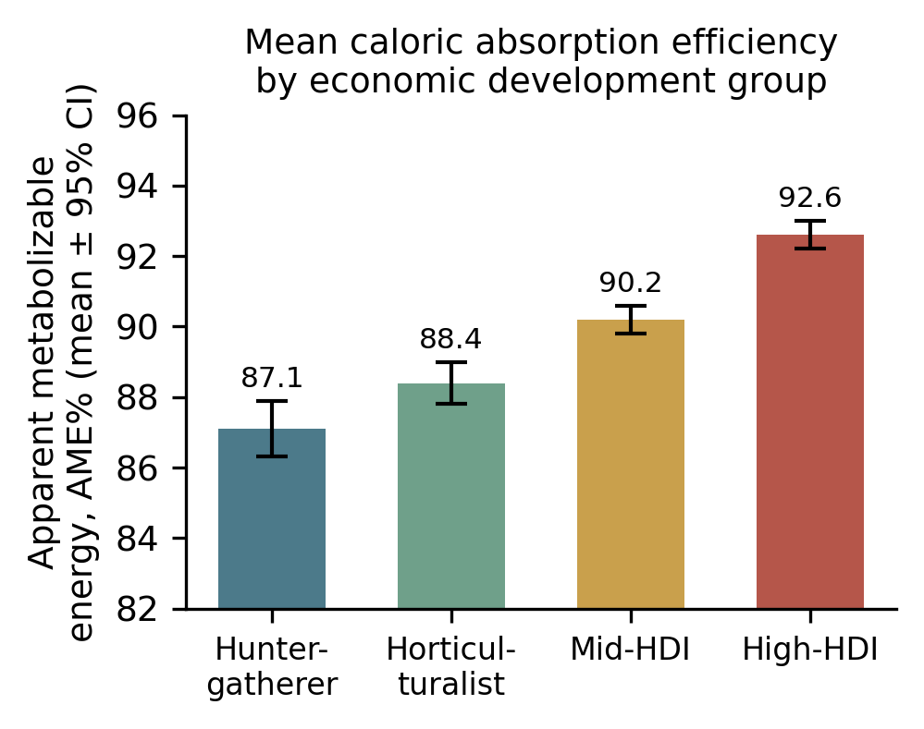
Fig. 2. Mean apparent metabolizable energy (AME%) by economic development group. Error bars are 95% CI.
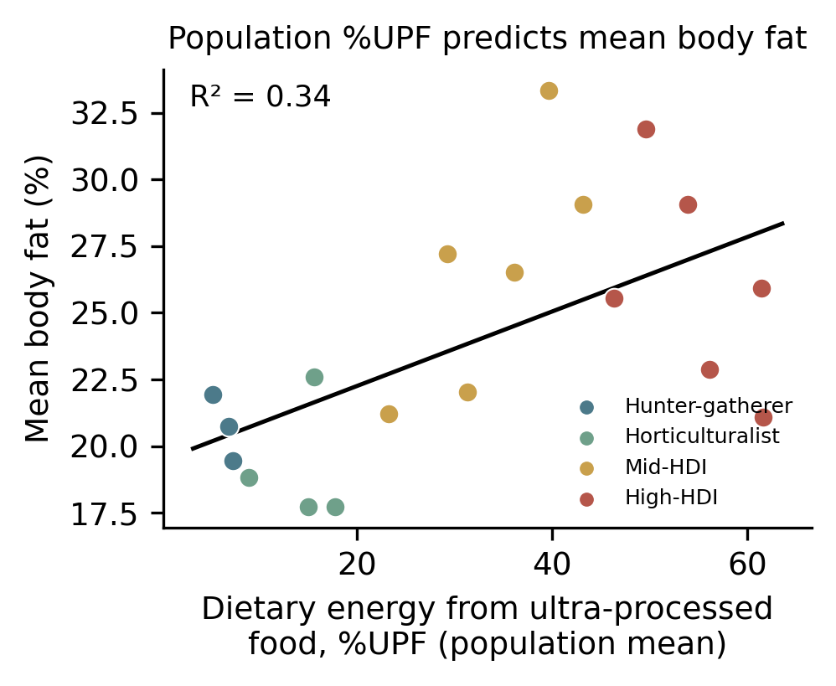
Fig. 3. Population mean %UPF plotted against population mean body fat percentage, colored by economy group, with regression line (R² = .34).

Economy group | n pop. | n part. | Mean AME% (SE)
Hunter-gatherer | 3 | 240 | 87.1 (0.4)
Horticulturalist | 4 | 410 | 88.4 (0.3)
Mid-HDI | 6 | 620 | 90.2 (0.2)
High-HDI | 6 | 880 | 92.6 (0.2)
Table 1. Sample composition and mean apparent metabolizable energy (AME%) by economy group (SE in parentheses).

Predictor | Model 1 β (p) | Model 2 β (p)
Development index (HDI) | 4.8 (<.001) | 3.1 (<.001)
Age | 0.01 (.58) | 0.01 (.61)
Sex (female) | 0.22 (.41) | 0.19 (.47)
Fiber intake (g/day) | −0.038 (<.001) | −0.029 (<.001)
% Ultra-processed food | — | 0.041 (<.001)
% Refined grain | — | 0.008 (.21)
Table 2. Regression coefficients predicting AME%. Model 1: full sample (n = 2,150). Model 2: diet subsample with itemized dietary data (n = 1,340).
Discussion
These data are cross-sectional and compiled from heterogeneous sources, comparing populations to one another rather than tracking individuals over time, so causal direction cannot be established: we cannot say that eating more ultra-processed food causes a person's body to absorb more calories or store more fat. This population-versus-individual distinction matters in practice: a pattern that holds across 19 populations does not tell us what would happen if one particular person changed their own diet, because other differences between those populations (not ultra-processed food itself) could be driving part of the pattern. Unmeasured differences between populations, such as gut microbiome composition, activity, or food-insecurity-related underreporting, could also contribute. With that caveat, the patterns are still informative: absorption efficiency rose with development and tracked %UPF rather than refined-grain content, and %UPF explained roughly a third of population variance in body fat, more than the variance previously attributed to expenditure (McGrosky et al., 2025). Combined with experimental evidence that ultra-processed diets increase intake even when nutrient-matched (Hall et al., 2019), this raises the possibility that ultra-processed food promotes positive energy balance through two pathways: more eating, and more retention of what is eaten.
This fits the mechanistic literature on food processing: milling, cooking, and industrial processing disrupt the cell-wall and fiber matrices that otherwise limit nutrient release in the small intestine (Carmody & Wrangham, 2009), and loss of intact fiber removes a substrate for gut microbes adapted to fiber-rich diets (Smits et al., 2017). That fiber intake independently predicted lower AME%, even after accounting for %UPF, fits this mechanism. Future longitudinal work combining doubly labeled water, fecal-balance AME%, and dietary processing data within the same individuals would help separate the relative contributions of expenditure, absorption, and intake to the economic gradient in obesity.
References
Atwater, W. O., & Bryant, A. P. (1900). The availability and fuel value of food materials. Twelfth Annual Report of the Storrs Agricultural Experiment Station, 73–110.
Carmody, R. N., & Wrangham, R. W. (2009). The energetic significance of cooking. Journal of Human Evolution, 57(4), 379–391.
Hall, K. D., Ayuketah, A., Brychta, R., Cai, H., Cassimatis, T., Chen, K. Y., et al. (2019). Ultra-processed diets cause excess calorie intake and weight gain: An inpatient randomized controlled trial of ad libitum food intake. Cell Metabolism, 30(1), 67–77.
McGrosky, A., Rimbach, R., Wood, J., et al. (2025). Energy expenditure and obesity across the economic spectrum. Proceedings of the National Academy of Sciences, 122.
Monteiro, C. A., Cannon, G., Levy, R. B., Moubarac, J. C., Louzada, M. L. C., Rauber, F., et al. (2019). Ultra-processed foods: What they are and how to identify them. Public Health Nutrition, 22(5), 936–941.
NCD Risk Factor Collaboration. (2017). Worldwide trends in body-mass index, underweight, overweight, and obesity from 1975 to 2016. The Lancet, 390(10113), 2627–2642.
Pontzer, H., Raichlen, D. A., Wood, B. M., Mabulla, A. Z. P., Racette, S. B., & Marlowe, F. W. (2012). Hunter-gatherer energetics and human obesity. PLOS ONE, 7(7), e40503.
Smits, S. A., Leach, J., Sonnenburg, E. D., Gonzalez, C. G., Lichtman, J. S., Reid, G., et al. (2017). Seasonal cycling in the gut microbiome of the Hadza hunter-gatherers of Tanzania. Science, 357(6353), 802–806.
Southgate, D. A. T. (1976). The relationship between food composition and available energy. Proceedings of the Nutrition Society. Cambridge University Press.

