RESEARCH ARTICLE
Do Protected Intersection Redesigns Reduce Near-Misses for Pedestrians, Cyclists, and Drivers?
M. A. Bellweather, T. O. Quintana, and J. R. Solberg
Department of Civil and Urban Engineering, Castlebridge Institute of Technology
Abstract
Cities increasingly redesign intersections with curb extensions, protected bike corners, and pedestrian refuge islands, but it is often unclear which road users actually benefit. We used a staggered, citywide rollout of these redesigns as a natural experiment to test whether they reduced near-misses, and whether the reduction differed for pedestrians, cyclists, and drivers. A mid-sized city converted 64 intersections to a protected design across four phases over two years; we compared near-miss rates, vehicle turning speed, and vehicle-to-cyclist/pedestrian passing distance before and after redesign to the same measures at 64 matched intersections still awaiting later phases, using video-coded conflicts and a difference-in-differences analysis. Near-misses fell substantially more at redesigned intersections than at comparison intersections, but the size of the drop depended on which road users were involved: cyclist-vehicle near-misses fell 41%, pedestrian-vehicle near-misses fell 18%, and vehicle-vehicle near-misses, an outcome the redesign was not intended to affect, changed by only 3% and did not differ reliably from zero. Vehicle turning speed dropped sharply at redesigned intersections but barely changed at comparison intersections, consistent with slower, tighter turns as the mechanism behind fewer conflicts. Because intersections were not randomly assigned to redesign order, this cannot rule out every alternative explanation as confidently as a randomized trial, but the unaffected negative-control outcome makes a coincidental citywide trend a less likely account. The findings suggest these redesigns help most road users, but unevenly — a pattern relevant to how cities decide where to build them next.
Significance: Cities spend substantial public funds on intersection redesigns intended to improve safety, but evidence on who actually benefits has rarely separated pedestrians, cyclists, and drivers using the same method at the same intersections. By using a staggered rollout as a natural experiment with a built-in negative control, this study offers more credible causal evidence than a simple before-after comparison, directly relevant to how transportation departments prioritize where to redesign next.
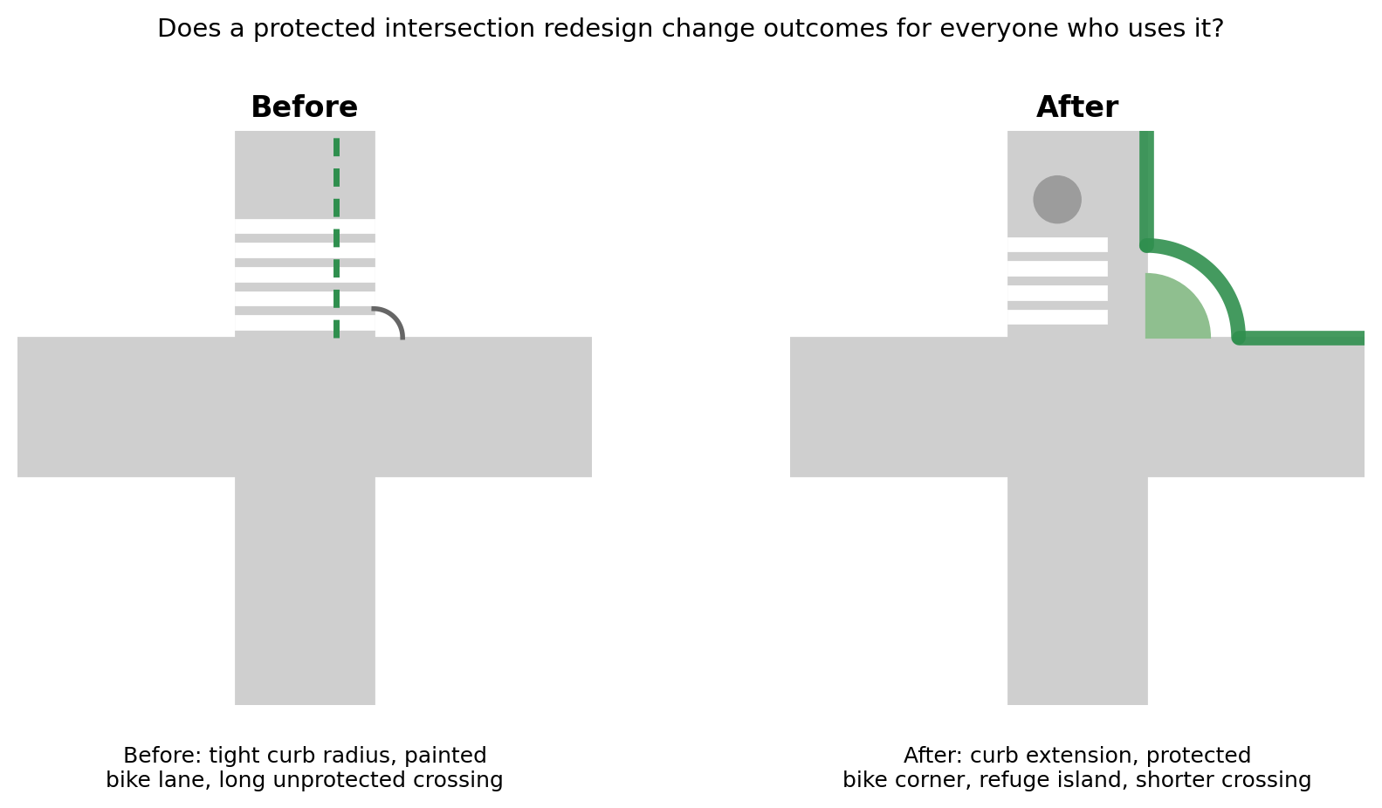
Fig. 1. A protected intersection redesign changes the geometry for every road user who passes through, not just cyclists.

Introduction
Most adults cross a street, drive through an intersection, or ride a bike near one almost every day, and intersections are where a large share of traffic injuries occur, because they are the points where people moving in different directions and at different speeds must cross paths (Marshall & Garrick, 2011). Traditional intersection design favors smooth, fast vehicle movement: wide turn lanes and large curb radii let cars take corners quickly, but the same geometry lengthens the distance pedestrians must cross and gives cyclists no separation from turning traffic. Newer protected intersection designs reverse this trade-off: curb extensions narrow the road and force tighter, slower turns, protected bike corners route cyclists around the outside of a turn rather than through it, and pedestrian refuge islands shorten how long a person is exposed to traffic (Monsere et al., 2014). If slower turning speeds and shorter crossings are what actually reduce conflict, these changes should reduce near-misses for the road users they are designed to protect — but it is less clear whether they benefit pedestrians, cyclists, and drivers equally, or mostly just one group.
Existing evidence on protected bike infrastructure has mostly measured outcomes for cyclists alone. Teschke et al. (2012) found that cycling routes with physical separation from traffic carried substantially lower injury risk than routes without it, and Monsere et al. (2014) found fewer conflicts at protected intersections than at conventional ones. But intersection redesigns change the geometry for everyone passing through, not just cyclists, and few studies have measured pedestrian and driver-related outcomes at the same intersections using the same method, which makes it hard to know whether these redesigns mostly help cyclists, help everyone, or shift risk somewhere else.
This study asks a more even-handed version of the question: when a city redesigns an intersection, does conflict risk fall for pedestrians and drivers as well as for cyclists, by how much, and is the reduction explained by the same mechanism — slower, more visible turning movements — for everyone? We used a citywide rollout of protected intersection redesigns, phased in over two years, as a natural experiment, comparing near-miss rates, turning speed, and passing distance before and after redesign at treated intersections relative to matched intersections still awaiting their turn.
Method
Design and sample. A mid-sized city (population approximately 310,000) redesigned 64 signalized intersections in four roughly six-month phases over two years, adding curb extensions, protected bike corners, and pedestrian refuge islands to each. Each redesigned intersection was matched to a comparison intersection not yet redesigned, selected for similar baseline traffic volume, number of approach lanes, posted speed limit, and signal control, using city department of transportation records. For each of the 128 intersections, we obtained two weeks of traffic camera footage from immediately before its matched pair's redesign and two weeks of footage from three months after, with comparison intersections sampled over the same calendar windows.
Measures. Trained coders, blind to which intersections were redesigned, reviewed footage using a structured conflict-coding protocol adapted from the Swedish Traffic Conflict Technique (Hyden, 1987), logging any encounter in which a road user braked sharply, swerved, or stopped suddenly to avoid another. Each conflict was classified by the road users involved — pedestrian-vehicle, cyclist-vehicle, or vehicle-vehicle — and expressed as a rate per 1,000 crossing or turning events. For a random subsample of conflicts, coders also recorded the turning vehicle's speed and its closest passing distance to the other road user. Vehicle-vehicle conflicts, which the redesign was not intended to affect, served as a negative control: a true effect of the redesign should not change this rate, while a change driven by an unrelated citywide trend likely would. Near-miss rates were modeled with a difference-in-differences regression comparing the before-to-after change at redesigned intersections to the same-period change at comparison intersections, with intersection and time-period fixed effects.
Results
Near-misses fell substantially more at redesigned intersections than at matched comparison intersections. Averaged across all road-user pairs, the redesign was associated with a 27% larger drop in near-misses than the change observed at comparison intersections over the same period (p < .001), consistent with the redesign itself, rather than a general citywide trend, driving the reduction.
The size of the effect depended heavily on which road users were involved (Fig. 2). Cyclist-vehicle near-misses fell 41% relative to comparison intersections, and pedestrian-vehicle near-misses fell 18% — both reliably different from zero (p < .001 and p = .004). Vehicle-vehicle near-misses, the outcome the redesign was not intended to affect, changed by only 3%, indistinguishable from zero (p = .61). Because the redesign moved the outcome it targeted while leaving the negative-control outcome essentially flat, a coincidental citywide trend is a less likely explanation for the pattern.
The mechanism for this reduction was visible in vehicle behavior at the intersection itself. Mean turning speed dropped from 22.1 to 15.8 mph at redesigned intersections but barely changed at comparison intersections (21.4 to 20.6 mph; Fig. 3), and the closest passing distance between turning vehicles and pedestrians or cyclists increased by an average of 1.4 feet at redesigned intersections versus 0.2 feet at comparison intersections (p < .001; Table 1). Slower, wider-berth turns line up with fewer near-misses for the road users a turning vehicle is most likely to encounter.
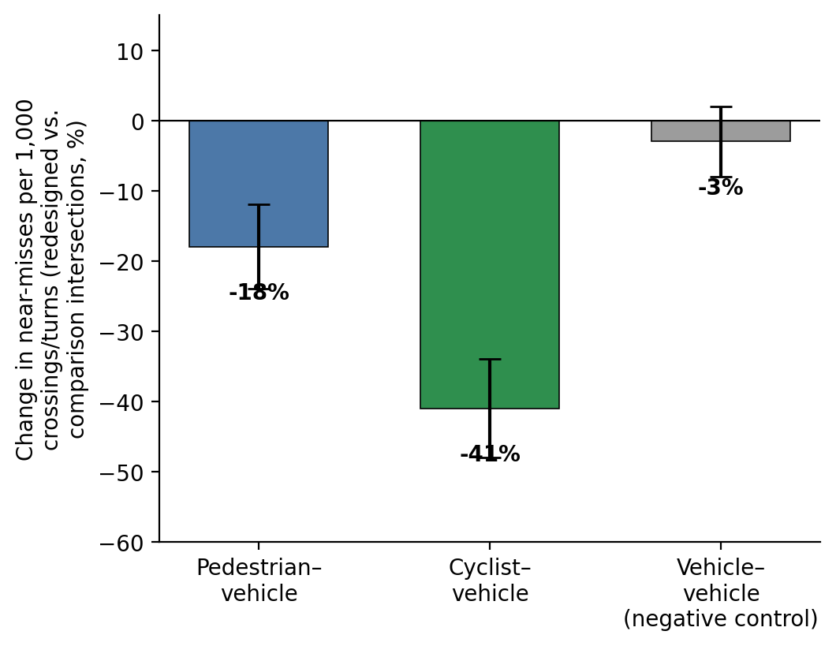
Fig. 2. Change in near-misses by road-user group, redesigned vs. comparison intersections. Error bars are 95% CI.
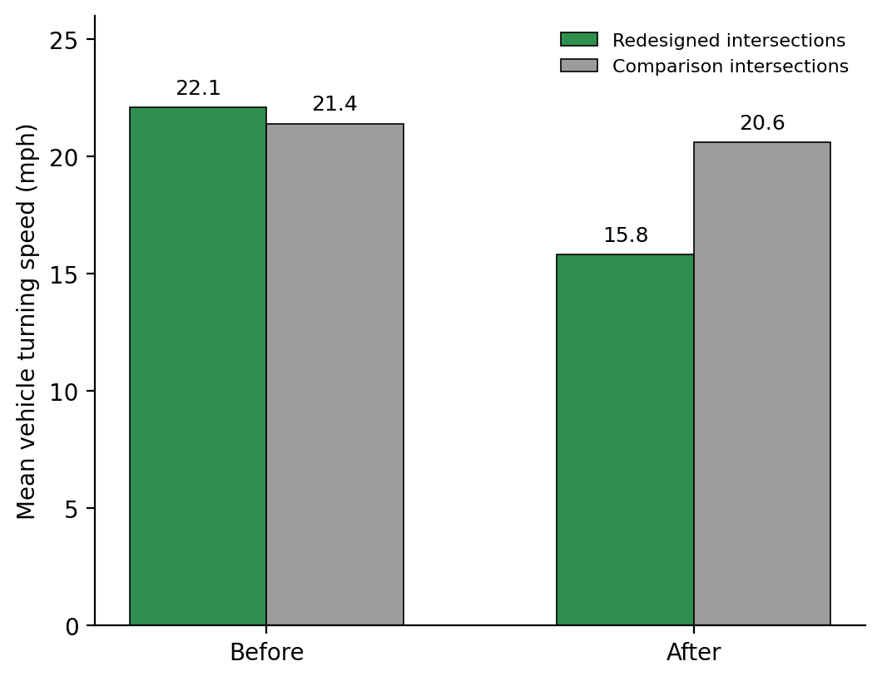
Fig. 3. Mean vehicle turning speed before and after, by intersection type.

Measure | Comparison | Redesigned
Pedestrian-vehicle near-misses (% change) | +1% | -17%
Cyclist-vehicle near-misses (% change) | +2% | -39%
Vehicle-vehicle near-misses (% change, negative control) | -1% | -4%
Vehicle turning speed (mph, before to after) | 21.4 to 20.6 | 22.1 to 15.8
Passing distance (change, feet) | +0.2 | +1.4
Table 1. Change in outcomes from before to after redesign at redesigned intersections versus matched comparison intersections over the same period.
Discussion
This was a quasi-experimental field study, not a randomized trial, so it cannot rule out every alternative explanation as confidently as a true experiment could. But the staggered rollout helps: because intersections were redesigned in phases for reasons related to construction scheduling and funding rather than to how dangerous they already were, the comparison intersections awaiting later phases are a reasonable stand-in for what would have happened at the redesigned intersections without the change. The negative-control result strengthens this further — if some unrelated citywide trend, such as less traffic or different weather during the after period, were driving the findings, vehicle-vehicle near-misses should have moved too, and they did not.
Some limitations remain. Video-coded conflicts are a proxy for actual injuries, not injuries themselves, and a near-miss that looks similar on camera may carry different real risk depending on speed and impact angle, which we addressed only partly by also measuring speed and passing distance directly. The two-week observation windows, while substantial, cannot capture rare events like actual crashes, which occur far less often than near-misses and would require many more years of data to study directly. And although intersections were matched on traffic volume, lane count, and speed limit, they were not randomly assigned to redesign order, so some unmeasured difference between intersections selected for earlier versus later phases could still contribute to the pattern, even with the negative control in place.
Most people do not think of themselves as belonging to a road-user category, but everyone who has crossed a street, ridden a bike, or driven through an intersection has experienced the kind of moment this study measures: a car turning a little too fast, a crossing that takes a little too long, a near-miss that resolves into nothing more than a held breath. The findings suggest protected intersection redesigns make these moments measurably less frequent, but not equally so for everyone who passes through — cyclists appear to benefit the most, pedestrians a more modest amount, and drivers' encounters with each other barely at all. For cities deciding where to spend a limited redesign budget, that unevenness is itself a useful finding: it suggests these redesigns are doing what they were built to do, for the road users they were built to protect, rather than producing a general, evenly distributed safety improvement.
References
Hyden, C. (1987). The development of a method for traffic safety evaluation: The Swedish Traffic Conflicts Technique. Bulletin 70, Lund Institute of Technology, Department of Traffic Planning and Engineering.
Marshall, W. E., & Garrick, N. W. (2011). Does street network design affect traffic safety? Accident Analysis & Prevention, 43(3), 769-781.
Monsere, C., McNeil, N., Dill, J., et al. (2014). Lessons from the green lanes: Evaluating protected bike lanes in the U.S. Portland, OR: National Institute for Transportation and Communities.
Reynolds, C. C. O., Harris, M. A., Teschke, K., Cripton, P. A., & Winters, M. (2009). The impact of transportation infrastructure on bicycling injuries and crashes: A review of the literature. Environmental Health, 8, 47.
Teschke, K., Harris, M. A., Reynolds, C. C. O., Winters, M., Babul, S., Chipman, M., et al. (2012). Route infrastructure and the risk of injuries to bicyclists: A case-crossover study. American Journal of Public Health, 102(12), 2336-2343.

