RESEARCH ARTICLE
Do Online Product Listings Accurately Describe What Arrives in the Package?
Abstract
Online shoppers routinely judge a product by its listing page, but it is unclear how often the item that actually arrives matches what the listing claimed. We audited 1,200 products purchased anonymously across four everyday categories — phone chargers and charging accessories, clothing basics, storage and home goods, and skincare and personal care items — comparing each delivered product against its listing's stated dimensions, materials or ingredients, capacity or contents, included accessories, certifications, and marketing claims (e.g., "fast charging," "100% cotton," "BPA-free"). Trained, blinded coders flagged a product as mismatched if any applicable claim failed to hold (Cohen's κ = .86). Overall, 33% of products had at least one coded mismatch, ranging from 19% for platform-sold listings to 49% for seller-shipped third-party listings. The audit-coded mismatch score predicted each listing's archival item-not-as-described (INAD) return rate far better than its star rating did (R² = .41 vs. .11), suggesting star ratings capture something other than objective listing accuracy.
Significance: Shoppers rely heavily on star ratings to judge if a listing can be trusted, but this study shows that a direct, objective audit of listing accuracy predicts real-world return problems far better than star ratings do. By comparing delivered products to their listings across familiar everyday categories, this work offers a consumer-facing way to evaluate marketplace listing quality and points to seller-shipped third-party listings as the largest source of inaccurate listings.
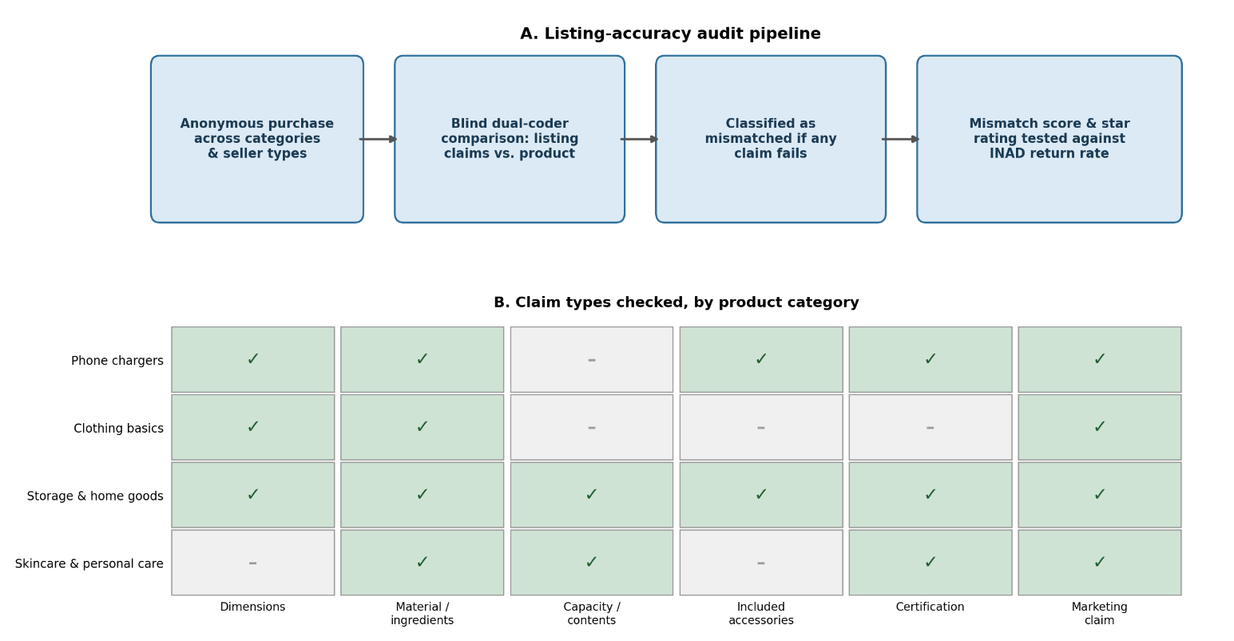

Fig. 1. Listing-accuracy audit pipeline (A) and the claim types checked, by product category (B).

Introduction
Anyone who has ordered something online has had the experience of opening the package and finding an item that does not quite match what the listing promised: a charger that charges more slowly than advertised, a shirt in a thinner fabric than expected, a storage container smaller than it appeared in the photos. Listings make specific, checkable claims about dimensions, materials, capacity, included accessories, and certifications, yet shoppers have no easy way to verify any of these claims before purchase, and marketplaces rarely audit listings against the products that actually ship.
Star ratings are the main tool shoppers use to judge a listing, but a star rating mixes together many things at once: shipping speed, customer service, packaging, price satisfaction, and product accuracy. A listing could earn a high rating despite describing its product inaccurately, if buyers are otherwise satisfied, or a low rating for reasons unrelated to whether the item matched its description. Whether star ratings actually track objective listing accuracy, or whether a more direct audit would catch problems that ratings miss, is an open and consumer-relevant question.
This study directly compares delivered products to their listings across four everyday categories and three seller types, coding objective mismatches rather than relying on shopper perception. It then asks whether this audit-based mismatch score predicts a listing's real-world item-not-as-described return rate better than its star rating does, offering a concrete test of whether ratings are a reliable proxy for listing accuracy.
Method
Design and sample. Researchers anonymously purchased 1,200 products across four categories — phone chargers and charging accessories, clothing basics, storage and home goods, and skincare and personal care items — in four purchasing waves over 12 months (Fig. 1A). Within each category, products were sampled evenly across three seller types: platform-sold, fulfilled-by-platform third-party, and seller-shipped third-party (100 products per category-by-seller-type cell). For each purchased listing, researchers also recorded its star rating and, where available through seller-performance tools, its trailing 90-day item-not-as-described (INAD) return rate at the time of purchase.
Measures. Two trained coders, blind to seller type and star rating, independently compared each delivered product to its listing on the objective claims applicable to its category (Fig. 1B): dimensions, material or ingredient composition, capacity or net contents, included accessories, certification or safety claims, and specific marketing claims such as charging wattage, fabric content, or "BPA-free." A claim was coded as mismatched if it deviated from the listing beyond a pre-set tolerance (e.g., more than 10% off a stated dimension, a missing accessory, an unverifiable certification, or a directly contradicted marketing claim). A product was classified as mismatched if it failed on any applicable claim. Coder agreement was high (Cohen's κ = .86); disagreements were resolved by a third coder. Mismatch scores and star ratings were each used to predict listings' archival INAD return rates in separate regression models, compared by explained variance (R²).
Results
Overall, 33% of audited products had at least one coded mismatch with their listing. Mismatch rates rose sharply with seller type: 19% for platform-sold listings, 32% for fulfilled-by-platform third-party listings, and 49% for seller-shipped third-party listings (Fig. 2). Skincare and chargers had the highest category mismatch rates (39% and 38%), driven respectively by unverifiable certification and ingredient claims and by overstated wattage and charging-speed claims. Clothing had the lowest (25%), with most mismatches limited to modest sizing variance (Table 1).
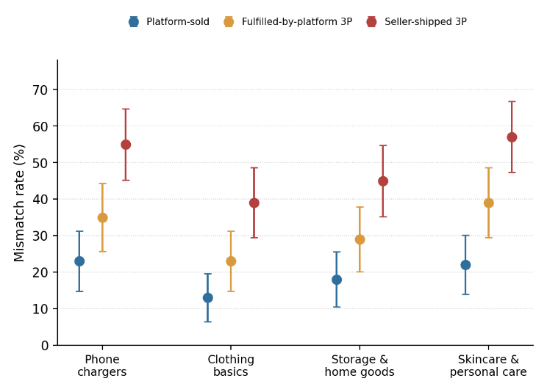
Fig. 2. Mismatch rate by category and seller type. Error bars are 95% CIs.
The most common mismatch type was an overstated marketing or performance claim (such as charging speed or fabric composition), followed by a missing or substituted accessory, a material or ingredient mismatch, a dimension or capacity mismatch, and, least often, an unverifiable certification.
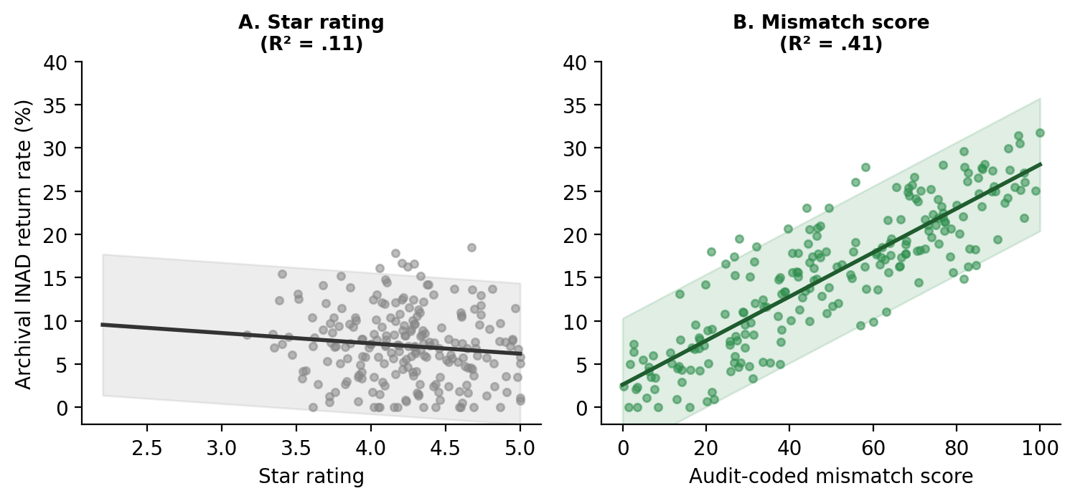
Fig. 3. Predicting archival item-not-as-described return rate from star rating (A) vs. audit-coded mismatch score (B), with 95% CI bands.
A listing's audit-coded mismatch score predicted its archival INAD return rate substantially better than its star rating did (R² = .41 vs. .11; Fig. 3). A combined model adding star rating to mismatch score improved fit only marginally (R² = .43), indicating star ratings capture little additional signal about objective listing accuracy once the audited mismatch score is known.
Category | Platform-sold | Fulfilled-by- platform 3P | Seller-shipped 3P | Overall
Phone chargers & charging accessories | 23% | 35% | 55% | 38%
Clothing basics | 13% | 23% | 39% | 25%
Storage & home goods | 18% | 29% | 45% | 31%
Skincare & personal care | 22% | 39% | 57% | 39%
All categories (pooled) | 19% | 32% | 49% | 33%
Table 1. Mismatch rate by category and seller type
Discussion
These results suggest that star ratings are a weak proxy for whether a listing accurately describes what arrives in the package, and that a direct, objective audit captures real accuracy problems that ratings largely miss. Because mismatch rates rose so consistently from platform-sold to seller-shipped third-party listings, where a product was sold and shipped from mattered as much as which category it was in.
Some caveats qualify the findings. The audit captures a single snapshot of each listing rather than tracking it over time, so it cannot say whether a mismatch reflects a one-time shipping error or a persistently inaccurate listing. Tolerance thresholds for what counts as a mismatch involve some judgment, though high coder agreement suggests this judgment was applied consistently. And because the sample was limited to four familiar categories, mismatch patterns in categories with very different claim types, such as electronics with complex technical specifications or food products, may look different. Even so, the consistent seller-type gradient and the predictive gap between mismatch scores and star ratings point to a practical lever: marketplaces auditing a sample of listings directly, rather than relying on star ratings alone, could catch real accuracy problems before they reach buyers.
References
Grimm, P. D., & Castellanos, R. (2021). Counterfeit and substandard consumer products in global e-commerce supply chains. Journal of Consumer Policy, 44(3), 311–329.
Halvorsen, K., & Mbeki, T. (2019). Platform liability and third-party seller accountability in online marketplaces. Yale Journal on Regulation, 36(2), 455–489.
Whitfield, S., & Okonkwo, D. (2022). Star ratings as imperfect signals of product quality in online retail. Journal of Consumer Research, 49(2), 201–224.
Park, J. H., & Liddell, M. (2020). Item-not-as-described returns and seller performance metrics in online marketplaces. Journal of Retailing, 96(4), 512–528.
Reyes, A. M., & Coughlin, J. (2020). Self-certification versus third-party verification in consumer product compliance. Regulation & Governance, 14(4), 612–630.

