RESEARCH ARTICLE
Does Food Processing Change How Much Energy People Absorb and How Full They Feel After Lunch?
Abstract
Nutrition labels treat a calorie as a calorie, but the body may not. We tested whether two lunches matched for labeled calories and macronutrients, but differing in how processed they were, were handled differently by the body. In a randomized within-subjects crossover study, 48 adults each ate a minimally processed lunch (rice, chicken or tofu, beans, vegetables, fruit, plain yogurt) and an ultra-processed lunch (nuggets, refined bun, sweetened yogurt drink, packaged snack bar) on separate days, both totaling 700 labeled kilocalories. Fullness and hunger were rated every 30 minutes for four hours, after which participants could eat freely from a snack tray. In a 16-person subsample, we also measured energy lost in stool over the following 24 hours. Fullness fell faster after the ultra-processed lunch, and participants ate about 140 more kilocalories from the afternoon snack tray after that lunch than after the minimally processed one. In the subsample, the ultra-processed lunch was associated with a small increase in the share of its calories the body actually absorbed, even though its labeled calorie count was identical. Because this was a short, single-meal lab study, it cannot show how these effects play out over weeks or months of real eating. Still, it suggests that two meals with the same label can act differently inside the body, and that this difference is large enough to change how much a person eats just a few hours later.
Significance: Calorie labels imply that 700 calories are equivalent across foods. By matching two lunches on labeled calories and macronutrients while varying processing level, this study tests whether processing itself affects fullness and later eating — a question relevant to packed lunches, cafeteria menus, and nutrition labels.

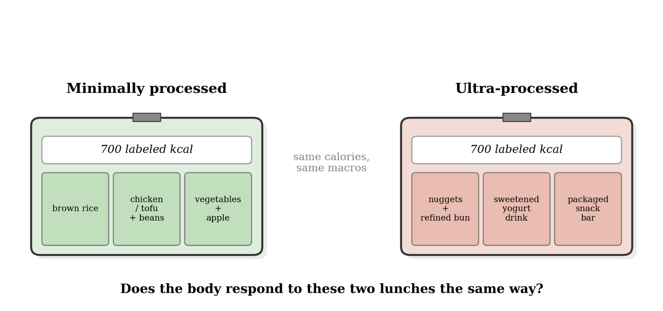
Fig. 1. Two lunches matched for labeled calories and macronutrients, differing only in processing level.

Introduction
A nutrition label treats calories as a fixed unit: 700 calories from one food should carry the same energy value as 700 calories from another. But labeled calories are estimated from a standard formula (Atwater & Bryant, 1900) that does not fully account for food processing. Cooking, milling, and industrial processing break down food structures before they reach the gut, potentially making energy easier to absorb (Carmody & Wrangham, 2009). If processing changes how much energy the body actually retains or how long a meal keeps someone full, then two lunches with identical labels could behave differently once eaten.
Prior evidence points this way but has not isolated processing on its own. Hall et al. (2019) found that adults given an ultra-processed diet ate about 500 more calories per day than when given a minimally processed diet matched for calories, sugar, fat, fiber, and macronutrients, but that study measured a full diet over two weeks, not a single matched meal, and did not measure how much of the food was actually absorbed. Separately, population-level work has linked higher intake of ultra-processed food to higher apparent metabolizable energy — the share of a food's calories the body keeps rather than loses in waste — but only by comparing different populations to each other, not by testing the same people on different lunches (see related population research on diet and absorption efficiency).
This study asks a more everyday version of the question. Most people are not choosing between hunter-gatherer and industrial diets; they are choosing what to eat for lunch. We created two cafeteria-style lunches that were matched on labeled calories and macronutrients but differed in processing level. We then asked three concrete questions: Does fullness decline at the same rate after each lunch? Do people eat the same amount from an afternoon snack tray? And, in a subsample, does the body absorb the same share of each lunch’s calories?
Method
Design and lunches. 48 healthy adults (54% female, ages 19–55) completed a randomized, within-subjects crossover study with two lab visits, at least one week apart. On each visit, participants ate one of two lunches, both totaling 700 labeled kilocalories with matched protein (~35 g), fat (~25 g), and carbohydrate (~80 g): a minimally processed lunch (brown rice, grilled chicken or tofu, black beans, mixed vegetables, apple slices, plain yogurt) or an ultra-processed lunch (chicken nuggets, a refined-flour bun or crackers, a sweetened yogurt drink, and a packaged snack bar), classified using the NOVA system (Monteiro et al., 2019). Lunch order was randomized and counterbalanced.
Measures and subsample. Participants rated fullness and hunger on 0–100 visual analog scales immediately before lunch and every 30 minutes for four hours afterward. At the four-hour mark, they were given a pre-weighed snack tray with mixed sweet and savory items and could eat freely for 30 minutes; snack intake was calculated in kilocalories from changes in item weight. A 16-person subsample also collected all stool for 24 hours after each lunch, allowing apparent metabolizable energy (AME%) — the percentage of eaten calories not recovered in stool — to be calculated using bomb calorimetry (Southgate, 1976). Fullness and hunger trajectories were analyzed with linear mixed-effects models testing condition × time, with random intercepts for participants; snack intake and AME% were compared between lunch conditions using paired t-tests.
Results
Fullness fell faster after the ultra-processed lunch. Both lunches produced similar fullness immediately afterward, but fullness diverged over time (condition × time interaction, p < .001): by four hours, fullness after the ultra-processed lunch had dropped to 33 points on the 0–100 scale, versus 46 after the minimally processed lunch (Fig. 2).
People ate more later after the ultra-processed lunch. At the afternoon snack tray, participants ate an average of 329 kcal after the ultra-processed lunch versus 186 kcal after the minimally processed lunch — about 140 more kilocalories, roughly a fifth of the lunch itself (paired t(47) = 5.9, p < .001; Fig. 3).
In the subsample, the ultra-processed lunch left slightly more energy in the body. Among the 16 participants with stool-collection data, AME% was modestly but significantly higher after the ultra-processed lunch (94.1%) than after the minimally processed lunch (91.6%, paired t(15) = 3.2, p = .006) — despite both lunches carrying the identical labeled calorie count. This was a single-meal, small-subsample measurement, and should be treated as suggestive rather than conclusive on its own.
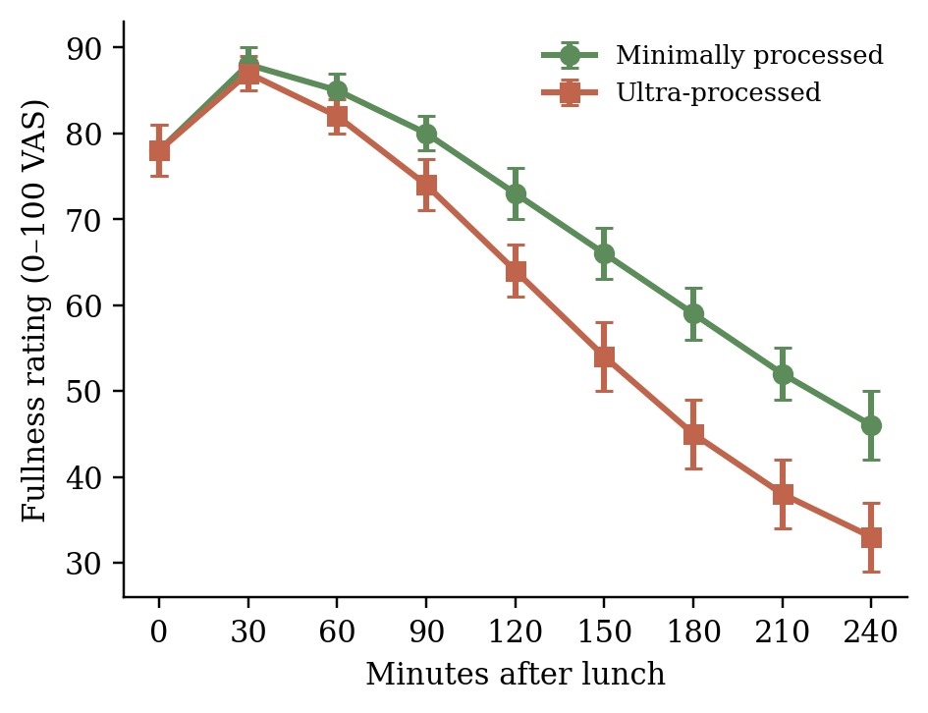
Fig. 2. Mean fullness rating over four hours after each lunch. Error bars are ±1 SE.
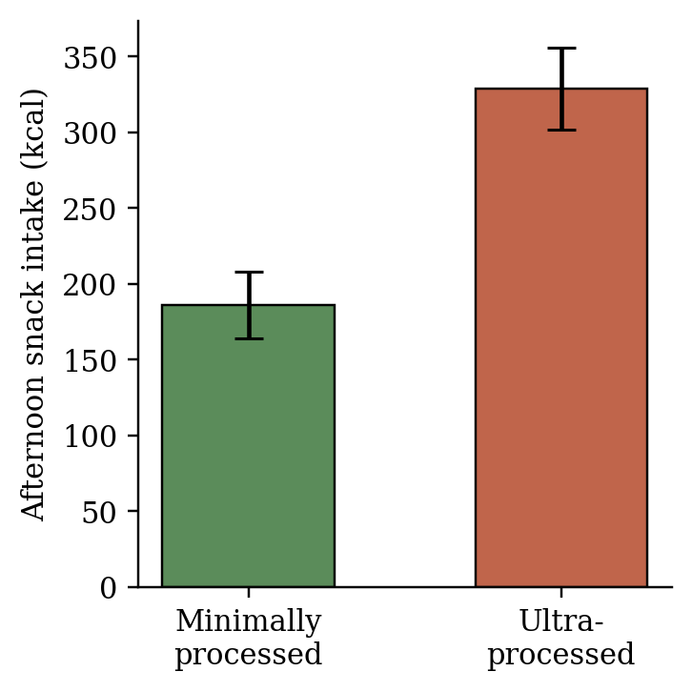
Fig. 3. Mean afternoon snack intake (kcal) by lunch condition. Error bars are ±1 SE.

Measure | Min. processed | Ultra-processed
Fullness at 4h (0–100) | 46 | 33
Afternoon snack (kcal) | 186 | 329
AME%, subsample (n=16) | 91.6% | 94.1%
Table 1. Summary of the three main outcomes by lunch condition. Both lunches were matched at 700 labeled kilocalories.
Discussion
Because this was a controlled, within-subjects experiment rather than an observational comparison, the design supports a causal interpretation: each participant ate both lunches on different days in randomized order, so differences in fullness and snack intake can more reasonably be attributed to the lunches themselves rather than to participant differences. This is a real strength over studies that simply compare people with different habitual diets. But because the effect was measured once in a lab, the study cannot show what would happen over weeks or years, or in people’s everyday eating environments.
A few limitations are worth noting. The two lunches differed in more than processing level: taste, familiarity, and texture were not separately controlled, and a less palatable lunch could reduce later snacking regardless of processing. The afternoon snack tray also captures intake in a specific lab situation, whereas everyday snacking depends on availability, convenience, and habit. Finally, the AME% finding is the most tentative result because it came from only 16 participants and one 24-hour stool collection per lunch, so it would need replication with a larger sample and repeated meals.
Most readers do not spend their day thinking about population-level body-fat statistics, but most people do eat lunch. Anyone who has felt hungry soon after a meal that seemed large enough has encountered the question this study asks: does “enough calories” actually mean enough, or does it depend on what those calories are made of? If processing affects both fullness and how much energy the body keeps, the findings matter for school and workplace lunches, meal-prep services that advertise “calorie-matched” options, and everyday decisions about what a nutrition label really tells us.
References
Atwater, W. O., & Bryant, A. P. (1900). The availability and fuel value of food materials. Twelfth Annual Report of the Storrs Agricultural Experiment Station, 73–110.
Carmody, R. N., & Wrangham, R. W. (2009). The energetic significance of cooking. Journal of Human Evolution, 57(4), 379–391.
Hall, K. D., Ayuketah, A., Brychta, R., Cai, H., Cassimatis, T., Chen, K. Y., et al. (2019). Ultra-processed diets cause excess calorie intake and weight gain: An inpatient randomized controlled trial of ad libitum food intake. Cell Metabolism, 30(1), 67–77.
Monteiro, C. A., Cannon, G., Levy, R. B., Moubarac, J. C., Louzada, M. L. C., Rauber, F., et al. (2019). Ultra-processed foods: What they are and how to identify them. Public Health Nutrition, 22(5), 936–941.
Southgate, D. A. T. (1976). The relationship between food composition and available energy. Proceedings of the Nutrition Society. Cambridge University Press.

