RESEARCH ARTICLE
Does Food Processing Change How Full People Feel After a Calorie-Matched Lunch?
E. M. Castellano, J. K. Reyes, and N. P. Halvorsen
Department of Nutritional Sciences, Linden Valley University
Abstract
Nutrition labels treat a calorie as a calorie, but the body may not respond to all calories the same way. We tested whether two lunches matched for labeled calories and macronutrients, but differing in how processed they were, produced different feelings of fullness and different later eating. In a randomized within-subjects crossover study, 48 adults each ate a minimally processed lunch (rice, chicken or tofu, beans, vegetables, fruit, plain yogurt) and an ultra-processed lunch (nuggets, refined bun, sweetened yogurt drink, packaged snack bar) on separate days, both totaling 700 labeled kilocalories. Fullness and hunger were rated every 30 minutes for four hours, after which participants could eat freely from a snack tray. Fullness fell faster after the ultra-processed lunch, and participants ate about 140 more kilocalories from the afternoon snack tray after that lunch than after the minimally processed one. Because this was a short, single-meal lab study, it cannot show how these effects play out over weeks or months of real eating. Still, it suggests that two meals with the same calorie label can feel different to the body, and that this difference is large enough to change how much a person eats just a few hours later.
Significance: Calorie labels assume that 700 calories from any food are interchangeable. By matching two lunches exactly on labeled calories and macronutrients and varying only processing level, this study isolates processing itself as a cause of how full people feel and how much they eat next — a question relevant to anyone packing a lunch, designing a cafeteria menu, or reading a nutrition label.
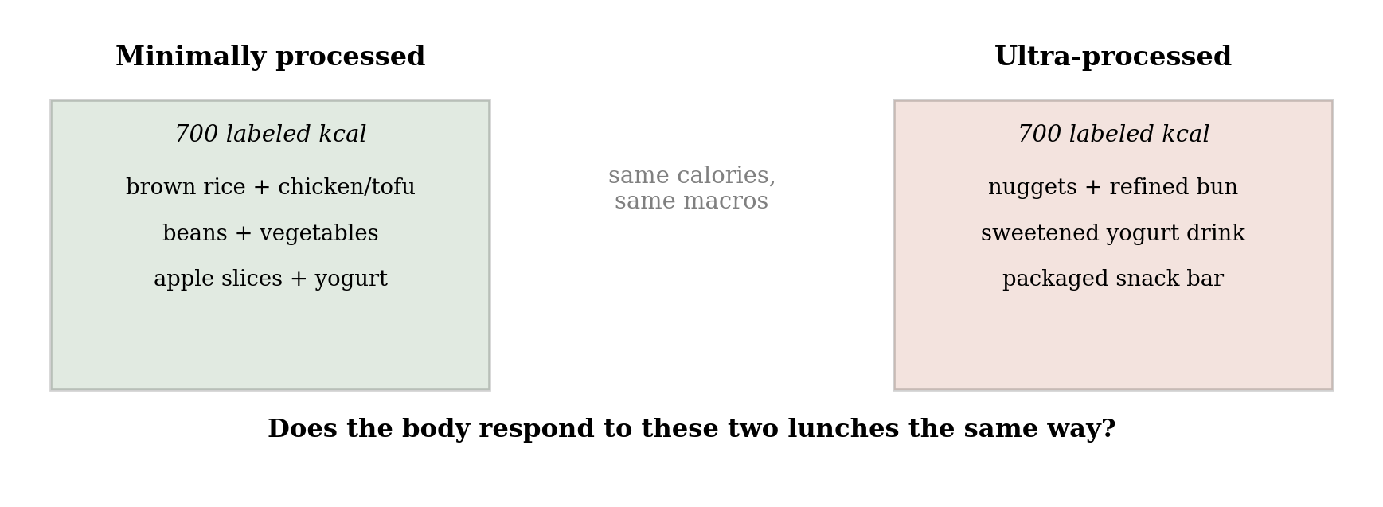
Fig. 1. Two lunches matched for labeled calories and macronutrients, differing only in processing level.

Introduction
A calorie listed on a nutrition label is meant to be a fixed unit: 700 calories of one food should carry the same energy value as 700 calories of another. But the calorie count on a label comes from a fixed formula (Atwater & Bryant, 1900) that does not account for how processed the food is, or for how quickly that food moves through the stomach and gut. Cooking and milling break down plant cell walls and starch granules before food ever reaches the gut, and industrial processing goes further still, pre-digesting much of the work the body would otherwise do itself (Carmody & Wrangham, 2009). Foods that are easier to break down tend to leave the stomach faster and produce sharper, shorter-lived blood sugar responses, both of which are linked to feeling hungry again sooner (Holt et al., 1995). If processing changes how quickly a meal empties from the stomach or how the body responds to it, then two meals with identical calorie labels could leave a person feeling full for very different lengths of time.
Prior evidence points this way but has not isolated processing on its own. Hall et al. (2019) found that adults given an ultra-processed diet ate about 500 more calories per day than when given a minimally processed diet matched for calories, sugar, fat, fiber, and macronutrients, but that study measured a full diet over two weeks, not a single matched meal, so it could not isolate the effect of any one meal on fullness afterward.
This study asks a more everyday version of the question. Most people do not choose between elaborate two-week diet plans; they choose, somewhat mundanely, what to eat for lunch. We built two lunches that a cafeteria or meal-prep service might plausibly offer, matched them exactly on labeled calories and macronutrients, and varied only their processing level. We then asked two concrete questions: Does fullness decline at the same rate after both lunches? And do people eat the same amount from an afternoon snack tray regardless of which lunch they ate?
Method
Design and lunches. Forty-eight healthy adults (54% female, ages 19–55) completed a randomized, within-subjects crossover study with two lab visits, at least one week apart. On each visit, participants ate one of two lunches, both totaling 700 labeled kilocalories with matched protein (~35 g), fat (~25 g), and carbohydrate (~80 g): a minimally processed lunch (brown rice, grilled chicken or tofu, black beans, mixed vegetables, apple slices, plain yogurt) or an ultra-processed lunch (chicken nuggets, a refined-flour bun or crackers, a sweetened yogurt drink, and a packaged snack bar), classified using the NOVA system (Monteiro et al., 2019). Lunch order was randomized and counterbalanced.
Measures. Starting immediately before lunch and every 30 minutes for four hours afterward, participants rated fullness and hunger on a 0–100 visual analog scale. At the four-hour mark, a snack tray (mixed sweet and savory items, weighed before and after) was made available, and participants could eat freely for 30 minutes; intake was converted to kilocalories from item weights. Fullness and hunger trajectories were analyzed with linear mixed-effects models (condition × time, random intercept per participant); snack intake was compared between conditions with a paired t-test.
Results
Fullness fell faster after the ultra-processed lunch. Both lunches produced similar fullness immediately afterward, but fullness diverged over time (condition × time interaction, p < .001): by four hours, fullness after the ultra-processed lunch had dropped to 33 points on the 0–100 scale, versus 46 after the minimally processed lunch (Fig. 2).
People ate more later after the ultra-processed lunch. At the afternoon snack tray, participants ate an average of 329 kcal after the ultra-processed lunch versus 186 kcal after the minimally processed lunch — about 140 more kilocalories, roughly a fifth of the lunch itself (paired t(47) = 5.9, p < .001; Fig. 3). The two effects were related: participants whose fullness dropped faster after lunch also tended to eat more at the snack tray (r = .41, p = .004), consistent with faster-fading fullness driving some of the extra afternoon eating.
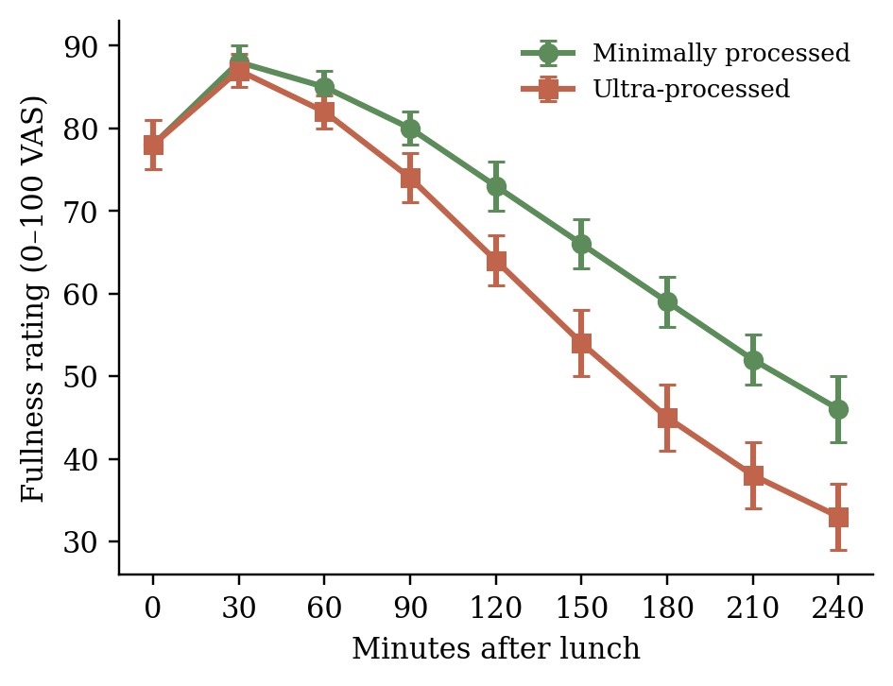
Fig. 2. Mean fullness rating over four hours after each lunch. Error bars are ±1 SE.
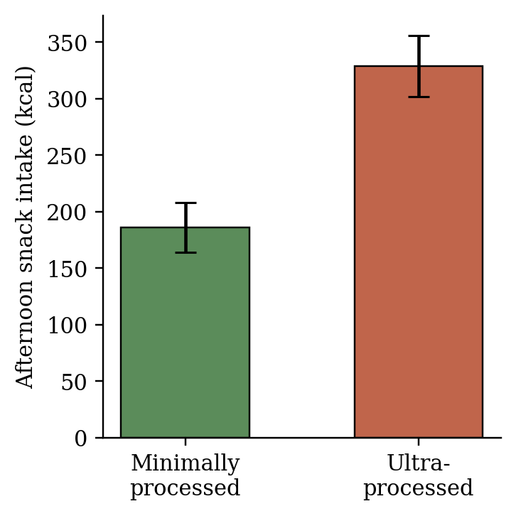
Fig. 3. Mean afternoon snack intake (kcal) by lunch condition. Error bars are ±1 SE.

Measure | Min. processed | Ultra-processed
Fullness at 4h (0–100) | 46 | 33
Afternoon snack (kcal) | 186 | 329
Table 1. Summary of the two main outcomes by lunch condition. Both lunches were matched at 700 labeled kilocalories.
Discussion
This was a controlled, within-subjects experiment, not an observational comparison, so the design does support a causal interpretation: because each participant ate both lunches, on different days, in randomized order, differences in fullness and snack intake can reasonably be attributed to the lunches themselves rather than to who the participants were. That is a real strength over study designs that simply compare people who already eat different diets. Even so, the effect was measured on a single occasion in a lab setting, so it does not by itself establish what would happen with repeated exposure over weeks or years, or in a person's own kitchen rather than a research lab.
A few limitations are worth sitting with. The two lunches differed in more than processing alone — taste, familiarity, and texture were not separately controlled, and a less palatable lunch can independently reduce later snacking regardless of processing. The afternoon snack tray measures intake in one specific, somewhat artificial situation; everyday snacking depends on what is available, convenient, or habitual, which a lab tray cannot fully capture. This study also did not measure the underlying physiological pathway directly — whether faster gastric emptying, sharper blood sugar swings, or something else explains why fullness faded faster after the ultra-processed lunch remains an open question for future work.
Most readers do not spend their day reasoning about diet-wide intervention trials, but most readers do eat lunch. Anyone who has felt hungry again within an hour or two of a meal that was, on paper, large enough has already brushed up against the question this study asks: does "enough calories" actually mean "enough," or does that depend on what the calories were made of? If processing changes how long fullness lasts, that has direct, practical implications — for how schools and workplaces design lunches, for how meal-prep services market "calorie-matched" options, and for how any individual reading a nutrition label might think about what a calorie really promises.
References
Atwater, W. O., & Bryant, A. P. (1900). The availability and fuel value of food materials. Twelfth Annual Report of the Storrs Agricultural Experiment Station, 73–110.
Carmody, R. N., & Wrangham, R. W. (2009). The energetic significance of cooking. Journal of Human Evolution, 57(4), 379–391.
Hall, K. D., Ayuketah, A., Brychta, R., Cai, H., Cassimatis, T., Chen, K. Y., et al. (2019). Ultra-processed diets cause excess calorie intake and weight gain: An inpatient randomized controlled trial of ad libitum food intake. Cell Metabolism, 30(1), 67–77.
Holt, S. H., Brand Miller, J. C., & Petocz, P. (1995). An insulin index of foods: The insulin demand generated by 1000-kJ portions of common foods. American Journal of Clinical Nutrition, 66(5), 1264–1276.
Monteiro, C. A., Cannon, G., Levy, R. B., Moubarac, J. C., Louzada, M. L. C., Rauber, F., et al. (2019). Ultra-processed foods: What they are and how to identify them. Public Health Nutrition, 22(5), 936–941.

