RESEARCH ARTICLE
Do Marketplace Safety-Verification Requirements Reduce Hazardous and Substandard Products Sold Online?
H. C. Marsh, T. A. Birgisson, and N. O. Falade
Department of Consumer Product Safety Engineering, Whitmore Polytechnic University
Abstract Online marketplaces host third-party sellers across nearly every consumer product category, but it is unclear whether requiring sellers to submit safety or quality documentation changes what actually arrives in a buyer's package or simply adds paperwork. We exploit a staggered rollout of a safety-and-quality verification requirement across six unrelated product categories on a major online marketplace — electrical chargers and power banks, children's toys, cookware and food-contact items, cosmetics and skincare, dietary supplements, and children's sleepwear — comparing each category's failure rate before and after its own compliance deadline against an untreated comparison category (decorative home and novelty items) that never faced the requirement. Researchers anonymously purchased and tested 1,680 products across seven categories and eight waves over 24 months, applying each category's relevant hazard test plus a shared certification-registry check. Pooled across the six treated categories, failure rates fell from 36% before compliance to 24% after (difference-in-differences estimate: −12 percentage points, 95% CI [−16, −8]), while the comparison category showed no meaningful change. Improvements were uneven across category and test type, seller-shipped listings retained a persistent gap, and 13% of post-compliance certifications could not be verified in the issuing body's registry.
Significance: Online marketplaces increasingly require third-party sellers to submit safety or quality documentation, not just for electronics but for toys, cosmetics, supplements, and other consumer goods, yet it is unclear whether this changes what is actually sold or merely adds a paperwork step. Using a staggered rollout across six unrelated product categories and an untreated comparison category, this study offers causal evidence that verification requirements can meaningfully reduce hazardous and substandard products across very different kinds of goods, while showing where enforcement remains uneven.
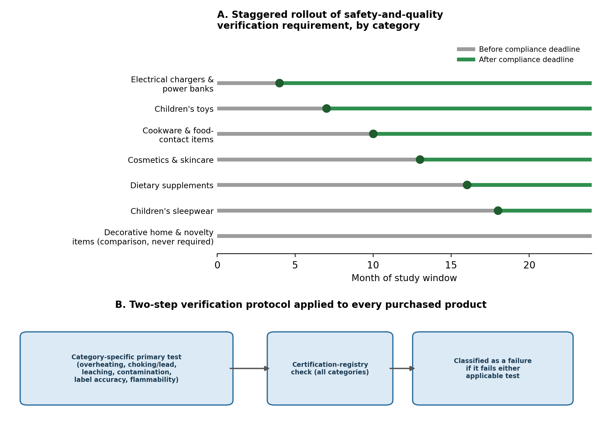
Fig. 1. Staggered rollout of marketplace safety-and-quality verification requirements across six unrelated product categories (A) and the two-step verification protocol applied to every purchased product (B).

Introduction
Consumers buy toys, cookware, cosmetics, supplements, chargers, and clothing from online marketplaces by the millions each year, often from third-party sellers whose products the platform itself never inspects. Safety and quality concerns differ sharply by category — a charger can overheat, a toy can pose a choking or lead-exposure hazard, cookware can leach heavy metals, a supplement can contain far less of its labeled ingredient than advertised — but in every case a shopper has little way to tell from a listing page whether a product has actually been tested against any relevant standard, particularly as counterfeit and substandard goods have grown harder to detect at a glance (Berman, 2008).
In response, several marketplaces have begun requiring sellers across higher-risk categories to submit third-party test reports or certification numbers before a listing can go live, removing listings that lack documentation — a shift accelerated by court rulings holding marketplaces strictly liable for third-party sellers' defective products (Bolger v. Amazon.com, 2020) and echoing a certification model already mandatory for children's products under U.S. law (Consumer Product Safety Improvement Act, 2008). This leaves two questions open across very different products. Does requiring documentation change the hazard or quality profile of what gets sold, or does it merely filter out the most careless sellers while defect rates stay unchanged among those who remain? And is the documentation itself verified, or can a seller submit a certification number nobody checks? Without an untouched comparison category, it is hard to separate a true effect of the requirement from a general trend toward higher-quality marketplace goods.
This study uses a staggered rollout of a marketplace safety-and-quality verification requirement across six unrelated product categories, each given a different compliance deadline over 24 months, alongside a comparison category of decorative home and novelty items never subject to the requirement. Comparing failure rates before and after each category's own deadline, benchmarked against the unaffected comparison category, separates the causal effect of verification from any broader shift in marketplace quality, regardless of product type.
Method
Design and sample. A major online marketplace introduced a safety-and-quality verification requirement in six categories, each phased in on its own timeline over 24 months: electrical chargers and power banks (month 4), children's toys (month 7), cookware and food-contact items (month 10), cosmetics and skincare (month 13), dietary supplements (month 16), and children's sleepwear (month 18; Fig. 1A). From each deadline onward, sellers had to upload a relevant lab test report or certification number before a listing could remain active; undocumented listings were removed. A seventh category, decorative home and novelty items, was never subject to the requirement because no specific safety standard applies to it, and served as the comparison group. Researchers anonymously purchased products across all seven categories in eight evenly spaced waves over 24 months, sampling randomly within three seller types per category-wave: platform-sold, fulfilled-by-platform third-party, and seller-shipped third-party. In total, 1,680 products were purchased and tested (240 per category).
Measures. Each product went through the same two-step verification protocol (Fig. 1B): a category-specific primary test for the hazard most relevant to it, followed by a certification-registry check applied across categories. Primary tests were overheating and wattage accuracy for chargers and power banks; choking-hazard dimensions and lead content for toys; heavy-metal leaching under heat for cookware; microbial contamination and banned ingredients for cosmetics; active-ingredient content relative to the label for supplements; and flammability under a standard flame test for sleepwear. Comparison-category items were checked only for basic structural integrity, since no specific standard applies. Every product with a printed certification claim was also checked against the issuing body's public registry. A product was a failure if it failed its category's primary test or carried an unverifiable certification. Technicians were blind to seller type and compliance status; products were stripped of packaging and anonymized before testing. Failure rates were modeled with a staggered difference-in-differences regression, with category and wave fixed effects and time since each category's own deadline, benchmarked against the comparison category's trend, following staggered-adoption DiD estimators designed to avoid two-way-fixed-effects bias (Callaway & Sant'Anna, 2021; Goodman-Bacon, 2021).
Results
Pooled across the six treated categories, the failure rate fell from an average of 36% before each category's compliance deadline to 24% after, a difference-in-differences estimate of −12 percentage points (95% CI [−16, −8], p < .001) once benchmarked against the comparison category, which showed no meaningful change over the same period (−1 percentage point, 95% CI [−4, 2], p = .59; Fig. 2). The flat comparison trend argues against a general marketplace-wide quality improvement as an alternative explanation.
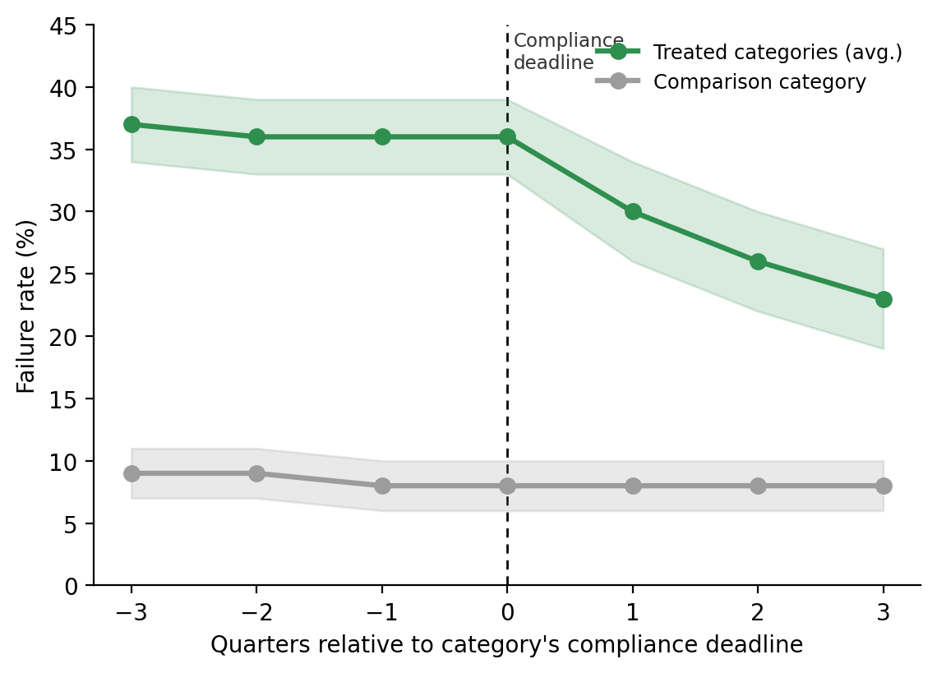
Fig. 2. Failure rate by quarter relative to each category's compliance deadline, vs. the untreated comparison category. Bands are 95% CIs.
The improvement varied widely by category and by which test drove failures (Table 1; Fig. 3). Electrical chargers and power banks, with the highest pre-compliance rate (43%), saw the largest drop (−20 points), driven by fewer overheating failures. Children's sleepwear showed the smallest, only marginal change (−3 points, 95% CI [−9, 3]), with most failures concentrated in the flammability test rather than the certification check, a hazard the paperwork requirement may screen for less directly.
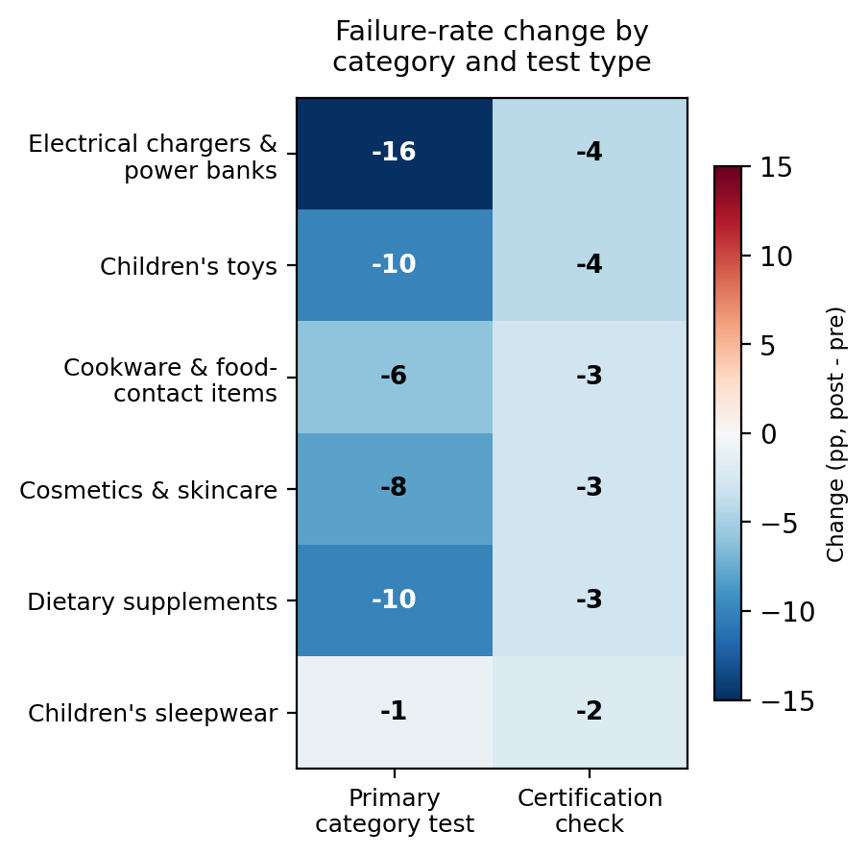
Fig. 3. Change in failure rate (pp, post minus pre) by category and test type. Darker blue = larger improvement.
Two patterns qualify the headline finding. Even after compliance, seller-shipped listings retained a failure rate about 8 points higher than platform-sold listings across categories, so documentation narrowed but did not eliminate the seller-type gap. And among products that passed certification on paper, 13% carried a claim that could not be located in the issuing body's registry, meaning approval does not guarantee a genuine certification, regardless of product type.
Table 1. Failure rates by category, before and after each category's compliance deadline.
Category | Deadline  (month) | n | Pre-deadline  fail rate | Post-deadline  fail rate | DiD estimate  (pp, 95% CI)
Electrical chargers & power banks | 4 | 240 | 43% | 23% | −20 [−26, −14]
Children's toys | 7 | 240 | 39% | 25% | −14 [−20, −8]
Cookware & food-contact items | 10 | 240 | 31% | 22% | −9 [−15, −3]
Cosmetics & skincare | 13 | 240 | 34% | 23% | −11 [−17, −5]
Dietary supplements | 16 | 240 | 40% | 27% | −13 [−19, −7]
Children's sleepwear | 18 | 240 | 27% | 24% | −3 [−9, 3] n.s.
All treated categories (pooled) | — | 1,440 | 36% | 24% | −12 [−16, −8]
Decorative home & novelty items (comparison) | never | 240 | 9% | 8% | −1 [−4, 2] n.s.

Discussion
These results suggest that requiring sellers to submit safety or quality documentation can cause a real reduction in hazardous and substandard products, not merely add paperwork, and that this holds across very different kinds of goods rather than being specific to electronics. Because the comparison category tracked flat over the same 24 months that six unrelated treated categories each improved sharply around their own distinct deadlines, a general trend toward higher-quality marketplace goods is an unlikely explanation. This is fairly direct causal evidence that a platform-level policy, not just consumer vigilance or regulator enforcement, can change what arrives in a buyer's package, whatever that package contains.
The findings complicate a simple before-after summary. Improvement tracked each category's baseline risk, was smallest where failures concentrated in a hazard the requirement screens for less directly, such as sleepwear flammability, and did not fully close the platform-sold/seller-shipped gap. The unverifiable certifications are a concern across every category, not just electronics: a documentation requirement not itself checked against the certifying body's records is, at best, a partial safeguard, consistent with accounts of certification serving an informational role only when shoppers can trust it has been verified (Guan, Jiang, & Wang, 2025). Nor can this design separate two mechanisms: unsafe sellers may have stopped listing once documentation was required, or surviving sellers may have genuinely upgraded their products, or both. For platforms and regulators, the implication is that verification mandates are meaningful but incomplete across product types; pairing them with independent certification verification, applied evenly across seller types and categories, would likely close more of the remaining gap.
References
Berman, B. (2008). Strategies to detect and reduce counterfeiting activity. Business Horizons, 51(3), 191–199.
Bolger v. Amazon.com, LLC, 53 Cal. App. 5th 431 (2020).
Callaway, B., & Sant'Anna, P. H. C. (2021). Difference-in-differences with multiple time periods. Journal of Econometrics, 225(2), 200–230.
Goodman-Bacon, A. (2021). Difference-in-differences with variation in treatment timing. Journal of Econometrics, 225(2), 254–277.
Guan, X., Jiang, Y., & Wang, Y. (2025). Platform certification and seller disclosure in online selling. Manufacturing & Service Operations Management, 28(2), 381–399.
U.S. Consumer Product Safety Improvement Act of 2008, Pub. L. No. 110-314, 122 Stat. 3016.

