RESEARCH ARTICLE
Generational Differences in Font-Based Credibility Judgments Across Everyday Contexts
Abstract
Typeface is rarely neutral: readers ascribe personality and trustworthiness to fonts independent of the words they spell. We propose that the specific fonts a person has learned to trust are shaped by the typographic environment of their formative decades, producing a generational divide that is masked when font-trust is studied only in the aggregate, and that this divide reflects the broader serif/sans-serif category rather than the idiosyncrasies of any single typeface. In a forced-choice experiment, younger (18–25 years) and older (58–74 years) adults viewed identical messages rendered in one of three serif/sans-serif exemplar pairs (Times New Roman vs. Arial, Georgia vs. Helvetica, Garamond vs. Calibri) across four everyday decision contexts — a lease clause, a formal bank security notice, a news notification, and a text from a friend — and selected which version they trusted more. Older adults favored the serif exemplar overall and especially in print-legacy contexts (lease clause, bank notice); younger adults showed no serif preference and actively favored the sans-serif exemplar in digitally native contexts (news notification, friend text). This pattern held across all three exemplar pairs, and a Generation × Scenario interaction suggested that the “trustworthy” font is not a fixed property of any one typeface but a learned, context-dependent association with the serif/sans-serif category as a whole. We discuss implications for designers of legal, financial, and digital communications who serve multigenerational audiences.
Significance: Designers routinely choose serif fonts to signal authority and sans-serif fonts to signal modernity, often treating these associations as fixed. We suggest instead that font-based trust is partly generationally learned and context-specific. The same typeface category that feels credible to one cohort may feel old-fashioned or mismatched to another, especially in everyday contexts where readers have different histories of print and screen exposure. These findings have implications for legal, financial, and digital communications intended for multigenerational audiences.

Introduction
A one-page lease clause set in a serif typeface and the same clause set in a sans-serif typeface communicate identical legal content, yet readers do not treat them as identical. Decades of typography research show that fonts carry connotative meaning that travels independently of the text they render: typefaces are perceived as having distinct “personalities” (Brumberger, 2003), and these personalities are systematically distributed — serif faces such as Times New Roman are rated as more stable, formal, and mature, while sans-serif faces are rated as cleaner and more contemporary (Shaikh, Chaparro, & Fox, 2006). The same contrast shapes emotional tone: satirical text set in a serif face is read as angrier and funnier than identical text set in a sans-serif face (Juni & Gross, 2008), and font choice shifts consumer judgments of brands and products in a manner that depends on whether the font “fits” the category (Childers & Jass, 2002; Doyle & Bottomley, 2006).
What has received less attention is whether the typeface that reads as trustworthy is the same for everyone. We argue it is not. A reader's sense that a given font “looks right” for a serious message is plausibly a product of mere exposure: repeated, low-effort encounters with a stimulus increase liking and processing fluency for that stimulus (Zajonc, 1968; Reber, Winkielman, & Schwarz, 1998), and fluent stimuli are in turn judged more favorably across a range of dimensions, including credibility (Alter & Oppenheimer, 2009; Song & Schwarz, 2008). Cohorts also differ in the typographic environments they encountered during formative periods of reading and communication. Older adults are more likely to have encountered formal and consequential messages through print materials such as contracts, bank statements, newspapers, and mailed notices, where serif typefaces were common. Younger adults, by contrast, have had more everyday exposure to screen-based interfaces, app notifications, search results, and text messages, where sans-serif typefaces are more typical. These exposure histories do not imply that all members of a generation have identical experiences, but they suggest that perceived credibility may depend on learned associations between typeface category and communicative context (Prensky, 2001; Helsper & Eynon, 2010). If trust judgments piggyback on fluency, the font that feels credible should not be a universal constant; it should be a generational one — and, if the account holds at the level of category rather than idiosyncratic typeface, the effect should not depend on which specific serif or sans-serif exemplar is shown.
This account predicts that font-based credibility judgments should vary by both generation and context. Older adults should show a stronger preference for serif typefaces in contexts with a print or institutional legacy, such as legal clauses or formal bank notices. Younger adults should show weaker serif preferences overall and may prefer sans-serif typefaces in contexts strongly associated with digital communication, such as app notifications or text messages. If the effect reflects the broader serif/sans-serif category rather than one familiar font contrast, the pattern should generalize across multiple serif and sans-serif exemplar pairs.
Method
One hundred sixty-eight adults (Prolific; U.S. residents, fluent English speakers, normal or corrected-to-normal vision) completed the study online: 84 younger adults (18–25 years, M = 21.3, SD = 2.1, 53% women) and 84 older adults (58–74 years, M = 64.7, SD = 4.8, 57% women).
To test whether font-based trust reflects the serif/sans-serif category rather than one idiosyncratic typeface, the independent variable was instantiated with three exemplar pairs drawn from distinct type families: Times New Roman vs. Arial, Georgia vs. Helvetica, and Garamond vs. Calibri (Fig. 1). Each participant was randomly assigned to a single exemplar pair. On each trial, participants read a short message from one of four everyday contexts: a residential lease clause, a formal bank security notice, a breaking-news push notification, and a text message from a friend. The first two contexts were intended to evoke print-legacy or institutional communication, whereas the latter two were intended to evoke digitally native communication. The message was presented twice, side by side, in identical wording but in the serif and sans-serif exemplar of their assigned pair (12-pt equivalent; Fig. 2 shows an example trial). Left/right position and font-to-side assignment were fully counterbalanced across participants. Participants selected the version they found “more trustworthy” and then rated their confidence in that choice (0–100). The dependent measure was the proportion of trials, by scenario, on which a participant selected the serif exemplar; chance responding corresponds to 50%.
Results
Collapsing across scenario and exemplar pair, older adults chose the serif exemplar on 61.4% of trials (SE = 2.1), reliably above the 50% chance baseline, t(83) = 5.43, p < .001, d = 0.59. Younger adults chose the serif exemplar on 46.8% of trials (SE = 2.0), not different from chance, t(83) = −1.61, p = .11. The two cohorts differed reliably from one another, t(166) = 4.92, p < .001, d = 0.76.
This generational gap was not constant across contexts (Fig. 3). A 2 (Generation) × 4 (Scenario) mixed ANOVA on serif-choice proportion, collapsed across exemplar pair, yielded reliable main effects of Generation, F(1, 166) = 24.2, p < .001, η²p = .13, and Scenario, F(3, 498) = 18.7, p < .001, η²p = .10, and a reliable Generation × Scenario interaction, F(3, 498) = 11.4, p < .001, η²p = .06. In the two print-legacy contexts, older adults strongly preferred the serif exemplar (lease clause: 72.0%, SE = 3.0, t(83) = 7.33, p < .001, d = 0.80; formal bank security notice: 68.3%, SE = 3.1, t(83) = 5.90, p < .001, d = 0.64), while younger adults showed no reliable preference in either context (lease clause: 54.1%, SE = 3.3, p = .22; formal bank security notice: 49.0%, SE = 3.2, p = .79). In the two digitally native contexts, older adults' serif preference was not reliable (news notification: 54.7%, SE = 3.4, p = .18; friend text: 50.5%, SE = 3.5, p = .92), while younger adults significantly preferred the sans-serif exemplar (news notification: 41.2%, SE = 3.0, t(83) = −2.91, p = .005, d = −0.32; friend text: 35.8%, SE = 2.9, t(83) = −4.85, p < .001, d = −0.53).
A key question is whether this pattern is specific to Times New Roman and Arial or generalizes across the serif/sans-serif category. Adding exemplar pair (Times New Roman/Arial, Georgia/Helvetica, Garamond/Calibri; between-subjects, n = 56 per pair) as a factor in a 2 (Generation) × 4 (Scenario) × 3 (Exemplar Pair) mixed ANOVA replicated the Generation main effect, F(1, 162) = 23.6, p < .001, η²p = .13, and the Generation × Scenario interaction, F(3, 486) = 10.9, p < .001, η²p = .06. Every term involving Exemplar Pair was non-significant: main effect, F(2, 162) = 0.41, p = .66; Exemplar Pair × Generation, F(2, 162) = 0.58, p = .56; Exemplar Pair × Scenario, F(6, 486) = 0.97, p = .45; and the three-way interaction, F(6, 486) = 0.72, p = .63. As Table 2 shows, the overall serif-choice gap between older and younger adults was similar across the three pairs, suggesting that the generational effect reflects the broader serif/sans-serif category rather than one familiar typeface contrast.
Confidence ratings tracked the strength of this divergence: trials on which a participant's choice matched their cohort's modal pattern (serif for older adults in formal contexts; sans-serif for younger adults in casual contexts) were rated with higher confidence than off-pattern trials, r = .34, p < .001.
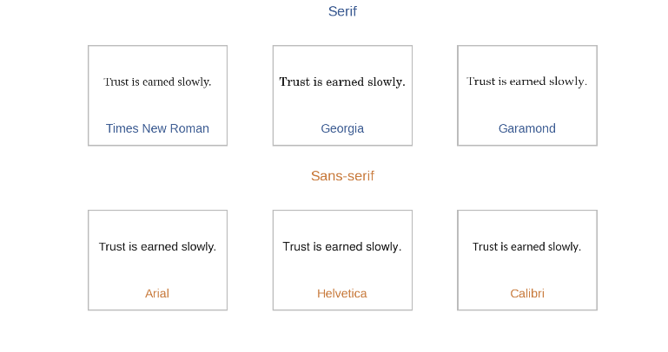
Fig. 1. The three serif/sans-serif exemplar pairs used as the independent variable, shown in matched sample text.
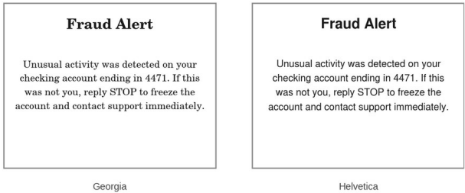
Fig. 2. Example trial stimulus (bank fraud alert, Georgia vs. Helvetica pair shown). Wording was identical across panels; only typeface differed. Font assignment and left/right position were counterbalanced across participants.
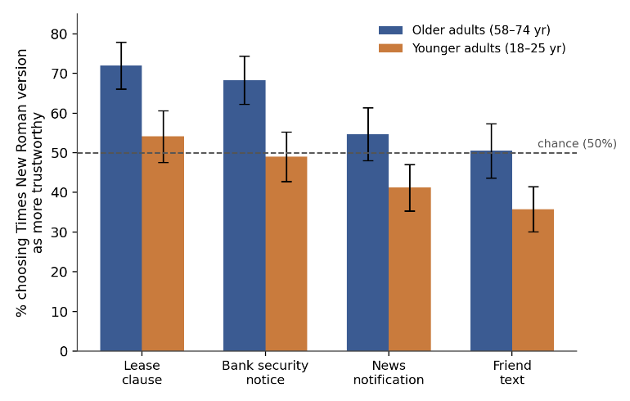
Fig. 3. Percentage of trials on which participants chose the serif exemplar as more trustworthy, by generation and scenario, collapsed across exemplar pair. Dashed line marks chance (50%). Error bars are 95% CI.

Scenario | Older adults | Younger adults | Contrast
Lease clause | 72.0% (3.0) | 54.1% (3.3) | p < .001
Bank security notice | 68.3% (3.1) | 49.0% (3.2) | p < .001
News notification | 54.7% (3.4) | 41.2% (3.0) | p = .03*
Friend text message | 50.5% (3.5) | 35.8% (2.9) | p < .001*
Table 1. Mean % of trials choosing the serif exemplar, by generation and scenario, collapsed across exemplar pair (SE in parentheses). *Younger-adult contrasts in these rows reflect a significant sans-serif preference (proportion below chance), not a serif preference.

Exemplar pair | Older adults | Younger adults
Times New Roman / Arial | 64.0% (2.4) | 44.5% (2.3)
Georgia / Helvetica | 60.1% (2.5) | 47.9% (2.4)
Garamond / Calibri | 60.0% (2.6) | 48.0% (2.5)
Table 2. Overall % of trials choosing the serif exemplar, by generation and exemplar pair (SE in parentheses). The generational gap was statistically indistinguishable across pairs, indicating that the effect generalizes across the serif/sans-serif category.
Discussion
Three independent serif/sans-serif exemplar pairs — Times New Roman vs. Arial, Georgia vs. Helvetica, Garamond vs. Calibri — produced different trust patterns in two cohorts viewing the exact same words, and the size of that divide did not depend on which exemplar pair a participant happened to see. Older adults' preference for the serif exemplar was large in contexts with a print legacy and negligible in screen-native contexts; younger adults showed the clearest opposite pattern in digitally native contexts, actively favoring the sans-serif exemplar once the context was one their generation encountered first on a screen. This pattern is consistent with a fluency account in which repeated, era-specific exposure to a given type category in a given context builds an association between that pairing and credibility (Reber et al., 1998; Alter & Oppenheimer, 2009), rather than with an account in which serif type carries some context-free, universally recognized signal of authority, or with an account tied to the specific visual idiosyncrasies of any one typeface.
The practical implication is that a single typographic choice cannot simultaneously maximize perceived trust for all readers of a multigenerational document. A bank or public agency serving both a 70-year-old and a 20-year-old client is, in effect, choosing which cohort's fluency to honor every time it sets a bank security notice or a public-service announcement in one typeface rather than another. Web-credibility research has already shown that visual design features shift trust judgments more than the underlying content does (Fogg et al., 2003); our data suggest that within “design,” typeface itself is not a single lever but two different levers wearing one name, depending on who is reading. Future work might extend the present forced-choice paradigm to a continuous age range to estimate where the crossover point falls, and to typeface dimensions beyond serif/sans-serif (e.g., rounded versus geometric sans faces) that may carry their own, more fine-grained generational signatures, as well as to perceived warmth and competence judgments more broadly (Fiske, Cuddy, & Glick, 2007).
References
Alter, A. L., & Oppenheimer, D. M. (2009). Uniting the tribes of fluency to form a metacognitive nation. Personality and Social Psychology Review, 13(3), 219–235.
Brumberger, E. R. (2003). The rhetoric of typography: The persona of typeface and text. Technical Communication, 50(2), 206–223.
Childers, T. L., & Jass, J. (2002). All dressed up with something to say: Effects of typeface semantic associations on brand perceptions and consumer memory. Journal of Consumer Psychology, 12(2), 93–106.
Doyle, J. R., & Bottomley, P. A. (2006). Dressed for the occasion: Font-product congruity in the perception of logotype. Journal of Consumer Psychology, 16(2), 112–123.
Fiske, S. T., Cuddy, A. J. C., & Glick, P. (2007). Universal dimensions of social cognition: Warmth and competence. Trends in Cognitive Sciences, 11(2), 77–83.
Fogg, B. J., Soohoo, C., Danielson, D. R., Marable, L., Stanford, J., & Tauber, E. R. (2003). How do users evaluate the credibility of web sites? A study with over 2,500 participants. In Proceedings of the 2003 Conference on Designing for User Experiences (DUX ’03).
Helsper, E. J., & Eynon, R. (2010). Digital natives: Where is the evidence? British Educational Research Journal, 36(3), 503–520.
Juni, S., & Gross, J. S. (2008). Emotional and persuasive perception of fonts. Perceptual and Motor Skills, 106(1), 35–42.
Prensky, M. (2001). Digital natives, digital immigrants. On the Horizon, 9(5), 1–6.
Reber, R., Winkielman, P., & Schwarz, N. (1998). Effects of perceptual fluency on affective judgments. Psychological Science, 9(1), 45–48.
Shaikh, A. D., Chaparro, B. S., & Fox, D. (2006). Perception of fonts: Perceived personality traits and uses. Usability News, 8(1).
Song, H., & Schwarz, N. (2008). If it’s hard to read, it’s hard to do: Processing fluency affects effort prediction and motivation. Psychological Science, 19(10), 986–988.
Zajonc, R. B. (1968). Attitudinal effects of mere exposure. Journal of Personality and Social Psychology, 9(2, Pt. 2), 1–27.

