RESEARCH ARTICLE
Does Food Processing Change Blood Sugar and Insulin Responses to a Calorie-Matched Lunch?
Abstract
Nutrition labels treat a calorie as a calorie, but the body may not respond to all calories the same way. We tested whether two lunches matched for labeled calories and macronutrients, but differing in processing level, produced different metabolic and later-eating responses. In a randomized within-subjects crossover study, 48 adults wore continuous glucose monitors and ate two 700-kcal lunches on separate days: a minimally processed lunch (rice, chicken or tofu, beans, vegetables, fruit, plain yogurt) and an ultra-processed lunch (nuggets, refined bun, sweetened yogurt drink, packaged snack bar). Blood draws before lunch and 60 minutes afterward measured insulin and triglycerides, and participants later had free access to a snack tray. The ultra-processed lunch produced a sharper glucose spike, a larger insulin rise, and a later dip below pre-lunch glucose levels, while the minimally processed lunch produced a flatter, more sustained glucose curve. Participants also ate about 140 more kilocalories from the snack tray after the ultra-processed lunch, and larger glucose drops predicted greater snack intake. Because this was a short, single-meal lab study, it cannot show how these patterns unfold over weeks or months. Still, it suggests that two meals with the same calorie label can produce different metabolic responses, which may shape how much people eat a few hours later.
Significance: Calorie labels assume that 700 calories from any food are metabolically interchangeable. By matching two lunches on labeled calories and macronutrients while varying processing level, this study tests whether processing is associated with differences in blood sugar, insulin response, and later eating — a question relevant to anyone packing a lunch, designing a cafeteria menu, or managing their own blood sugar.
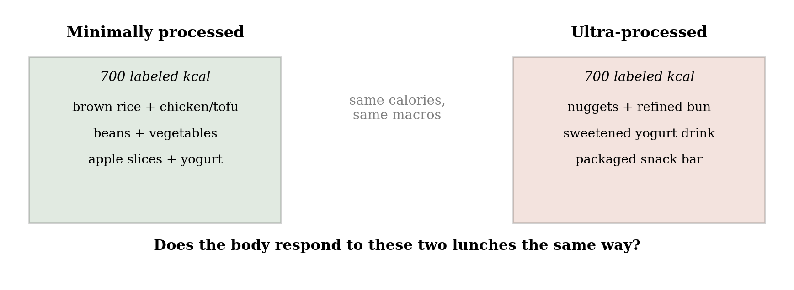
Fig. 1. Two lunches matched for labeled calories and macronutrients, differing only in processing level.

Introduction
A calorie listed on a nutrition label is meant to be a fixed unit: 700 calories of one food should carry the same energy value as 700 calories of another. But the calorie count on a label comes from a fixed formula (Atwater & Bryant, 1900) that does not account for how processed the food is, or for how quickly that food moves through the stomach and gut. Cooking and milling break down plant cell walls and starch granules before food ever reaches the gut, and industrial processing goes further still, pre-digesting much of the work the body would otherwise do itself (Carmody & Wrangham, 2009). Foods that are easier to break down tend to leave the stomach faster, producing a sharper rise in blood sugar and a larger insulin response; that sharp rise is often followed by a steeper drop, sometimes below the level a person started at, which is linked to feeling hungry again sooner (Holt et al., 1995; Ludwig, 2002). If processing changes how quickly a meal raises and then lowers blood sugar, two meals with identical calorie labels could leave the body in very different states a few hours later.
Prior evidence points this way but has not isolated processing on its own. Hall et al. (2019) found that adults given an ultra-processed diet ate about 500 more calories per day than when given a minimally processed diet matched for calories, sugar, fat, fiber, and macronutrients, but that study measured a full diet over two weeks, not a single matched meal, so it could not isolate the effect of any one meal on fullness afterward.
This study asks a more everyday version of the question. Most people are not choosing between elaborate diet plans; they are choosing what to eat for lunch. We created two plausible cafeteria or meal-prep lunches, matched them on labeled calories and macronutrients, and varied only processing level. We then asked whether the two lunches produced the same blood-sugar response and whether people ate the same amount from an afternoon snack tray afterward.
Method
Design and lunches. Forty-eight healthy adults (54% female, ages 19–55) completed a randomized within-subjects crossover study with two lab visits at least one week apart. At each visit, participants ate one of two 700-kcal lunches matched for protein (~35 g), fat (~25 g), and carbohydrate (~80 g). The minimally processed lunch included brown rice, grilled chicken or tofu, black beans, mixed vegetables, apple slices, and plain yogurt. The ultra-processed lunch included chicken nuggets, a refined-flour bun or crackers, a sweetened yogurt drink, and a packaged snack bar. Lunches were classified using the NOVA system, and order was randomized and counterbalanced.
Measures. Participants wore a continuous glucose monitor (CGM), a small sensor patch on the back of the upper arm, from the morning of each visit, recording interstitial glucose every 15 minutes throughout the four-hour observation window. A venous blood sample was drawn once immediately before lunch (fasting baseline) and once 60 minutes after lunch, when insulin and triglyceride responses to a meal typically peak, and assayed for insulin and triglycerides; this kept blood draws to two per visit rather than a repeated-sampling protocol. At the four-hour mark, a snack tray (mixed sweet and savory items, weighed before and after) was made available, and participants could eat freely for 30 minutes; intake was converted to kilocalories from item weights. Glucose curves were summarized as peak value and minutes spent below fasting baseline; insulin, triglycerides, and snack intake were compared between conditions with paired t-tests, and snack intake was correlated with each person's lowest post-lunch glucose value.
Results
Blood sugar rose and fell more sharply after the ultra-processed lunch. Glucose increased at a similar rate for both lunches during the first 30 minutes, but the ultra-processed lunch then produced a higher peak (142 vs. 116 mg/dL) and a later dip below pre-lunch baseline. Over the next two hours, glucose spent 38 minutes below baseline after the ultra-processed lunch, compared with 6 minutes after the minimally processed lunch (p < .001; Fig. 2).
Insulin rose more after the ultra-processed lunch. At the 60-minute draw, insulin was higher after the ultra-processed lunch (52 µIU/mL) than after the minimally processed lunch (31 µIU/mL, paired t(47) = 6.1, p < .001); triglycerides were also modestly higher (118 vs. 104 mg/dL, paired t(47) = 2.4, p = .02), though this rests on a single post-meal timepoint and should be read as a smaller, more tentative finding than the glucose and insulin results (Table 1).
People ate more later after the ultra-processed lunch, in proportion to how far their blood sugar had dropped. At the afternoon snack tray, participants ate an average of 329 kcal after the ultra-processed lunch versus 186 kcal after the minimally processed lunch — about 140 more kilocalories, roughly a fifth of the lunch itself (paired t(47) = 5.9, p < .001; Fig. 3). The two effects were related: participants whose glucose fell further below baseline also tended to eat more at the snack tray (r = .44, p = .002), consistent with the glucose dip itself contributing to the drive to eat again.
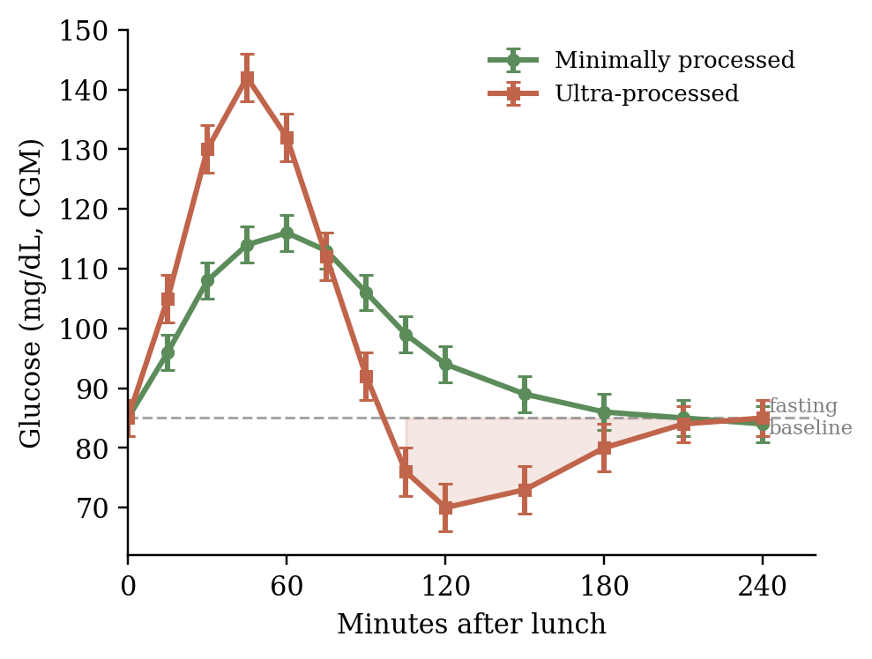
Fig. 2. Mean CGM-measured glucose over four hours after each lunch, relative to fasting baseline (dashed line). Shaded region shows time spent below baseline after the ultra-processed lunch. Error bars are ±1 SE.
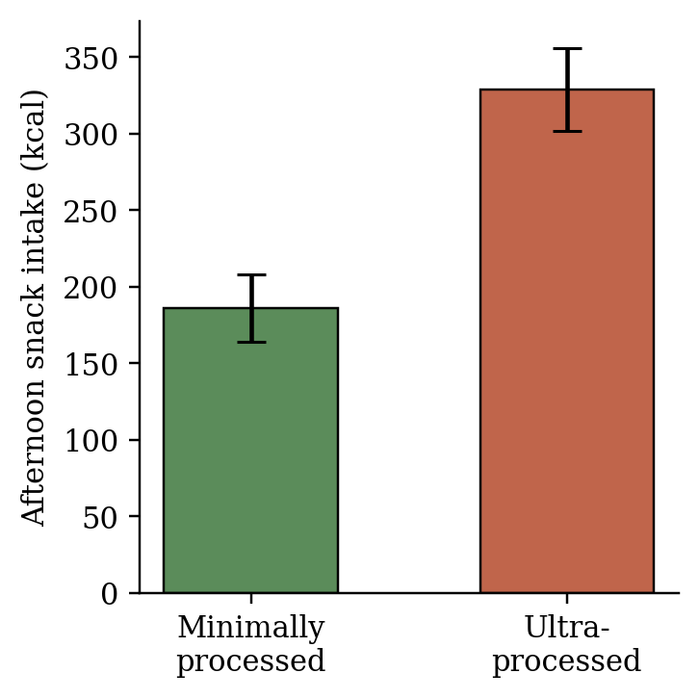
Fig. 3. Mean afternoon snack intake (kcal) by lunch condition. Error bars are ±1 SE.

Measure | Min. processed | Ultra-processed
Glucose peak (mg/dL) | 116 | 142
Time below baseline (min) | 6 | 38
Insulin at 60 min (µIU/mL) | 31 | 52
Triglycerides at 60 min (mg/dL) | 104 | 118
Afternoon snack (kcal) | 186 | 329
Table 1. Summary of the main outcomes by lunch condition. Both lunches were matched at 700 labeled kilocalories.
Discussion
Because this was a controlled within-subjects experiment rather than an observational comparison, the design supports a causal interpretation: each participant ate both lunches on different days in randomized order, so differences in blood sugar, insulin, and snack intake can more reasonably be attributed to the lunches themselves rather than to participant differences. This is a real strength over studies that simply compare people who already eat different diets. However, the effects were measured after a single lab-based meal, so the study cannot show what would happen after repeated exposure over weeks or years, or in people’s everyday eating environments.
Several limitations are worth noting. The two lunches differed in more than processing level: taste, familiarity, and texture were not separately controlled, and a less palatable lunch could reduce later snacking independent of processing. The afternoon snack tray also captures intake in a specific lab situation, whereas real-world snacking depends on availability, convenience, and habit. The CGM data should be interpreted with some caution because CGMs measure glucose in interstitial fluid rather than directly in blood, creating a short lag and some noise. Finally, because insulin and triglycerides were measured at only one post-meal timepoint, those results reflect a single snapshot rather than a full response curve and should be treated as more tentative than the glucose finding.
Most readers do not spend their day reasoning about diet-wide intervention trials, but most readers do eat lunch. Anyone who has felt a slump, or felt hungry again, an hour or two after a meal that was, on paper, large enough has already brushed up against the question this study asks: does "enough calories" actually mean "enough," or does that depend on what the calories were made of? If processing changes how the body's blood sugar rises and falls after a meal, that has direct, practical implications — for how schools and workplaces design lunches, for how meal-prep services market "calorie-matched" options, and for how any individual reading a nutrition label might think about what a calorie really promises.
References
Atwater, W. O., & Bryant, A. P. (1900). The availability and fuel value of food materials. Twelfth Annual Report of the Storrs Agricultural Experiment Station, 73–110.
Carmody, R. N., & Wrangham, R. W. (2009). The energetic significance of cooking. Journal of Human Evolution, 57(4), 379–391.
Hall, K. D., Ayuketah, A., Brychta, R., Cai, H., Cassimatis, T., Chen, K. Y., Chung, S. T., Costa, E., Courville, A., Darcey, V., Fletcher, L. A., Forde, C. G., Gharib, A. M., Guo, J., Howard, R., Joseph, P. V., McGehee, S., Ouwerkerk, R., Raisinger, K., ... Zhou, M. (2019). Ultra-processed diets cause excess calorie intake and weight gain: An inpatient randomized controlled trial of ad libitum food intake. Cell Metabolism, 30(1), 67–77.e3. https://doi.org/10.1016/j.cmet.2019.05.008
Holt, S. H., Brand Miller, J. C., & Petocz, P. (1995). An insulin index of foods: The insulin demand generated by 1000-kJ portions of common foods. American Journal of Clinical Nutrition, 66(5), 1264–1276.
Ludwig, D. S. (2002). The glycemic index: Physiological mechanisms relating to obesity, diabetes, and cardiovascular disease. JAMA, 287(18), 2414–2423.
Monteiro, C. A., Cannon, G., Levy, R. B., Moubarac, J.-C., Louzada, M. L. C., Rauber, F., Khandpur, N., Cediel, G., Neri, D., Martinez-Steele, E., Baraldi, L. G., & Jaime, P. C. (2019). Ultra-processed foods: What they are and how to identify them. Public Health Nutrition, 22(5), 936–941. https://doi.org/10.1017/S1368980018003762

