

***Bahir Dar Institute of Technology***

***Faculty of Computing***

***Department of Information Technology***

*Object oriented indivdual assignment*

*Name Bete Goshme*

*Id 1201157*

*Submitted to Biniam*

*Submission date*

**Assignment 1 and Assignment 2 are attached**

**1.regular expression**

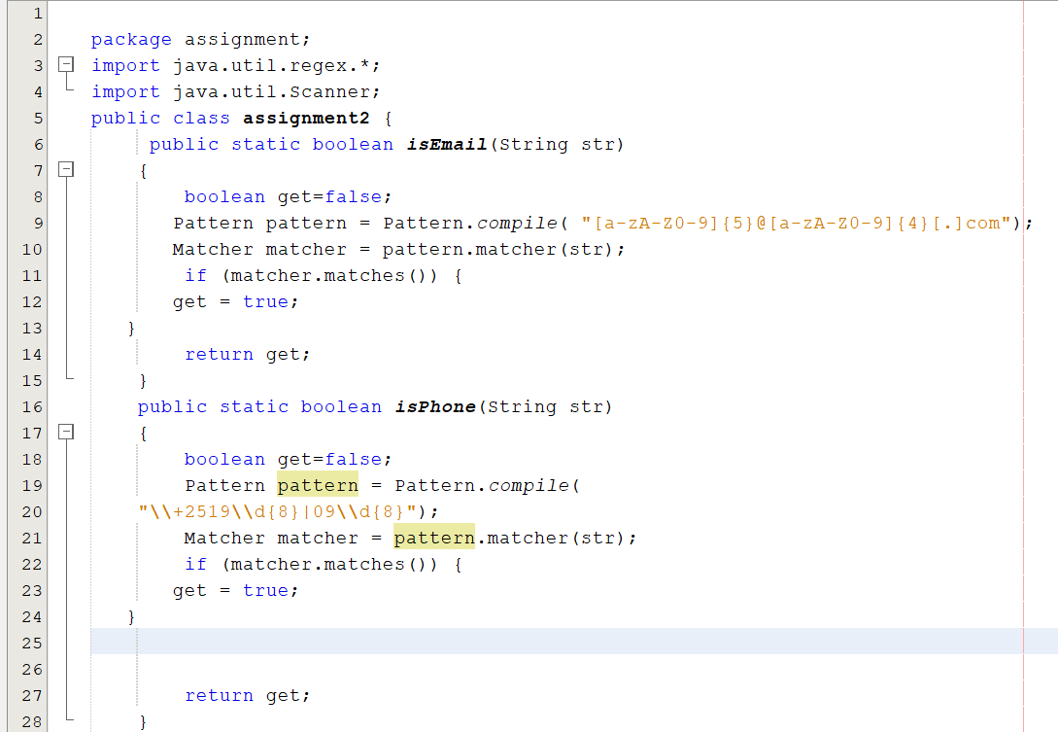

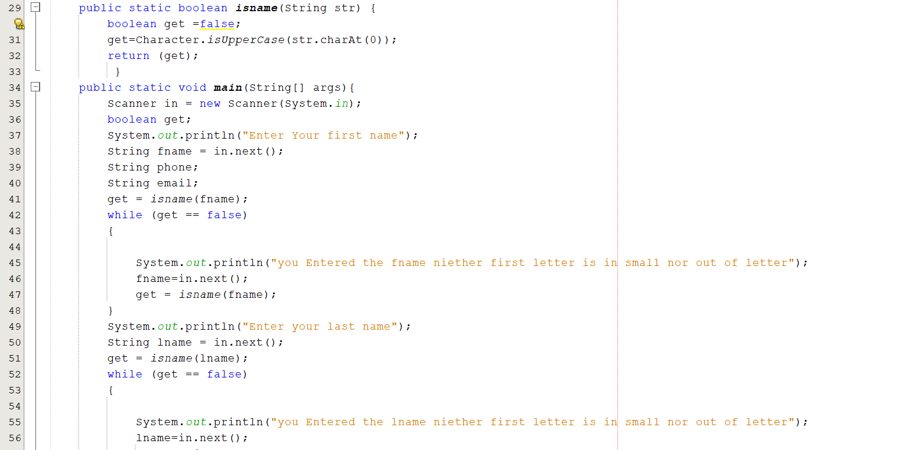

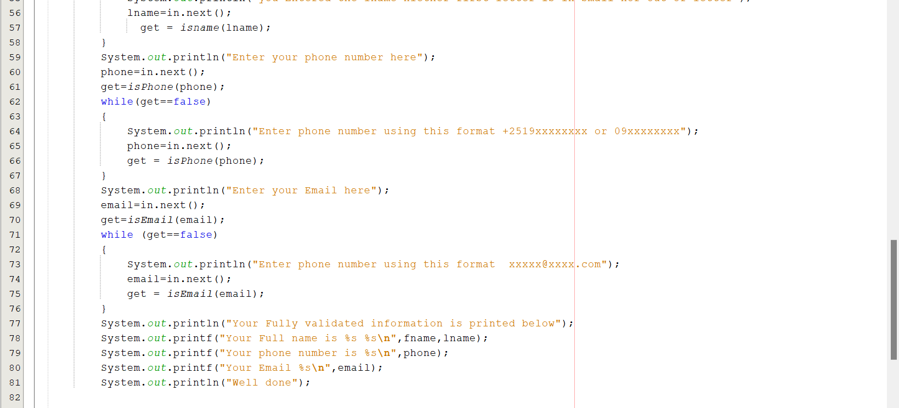

**output**

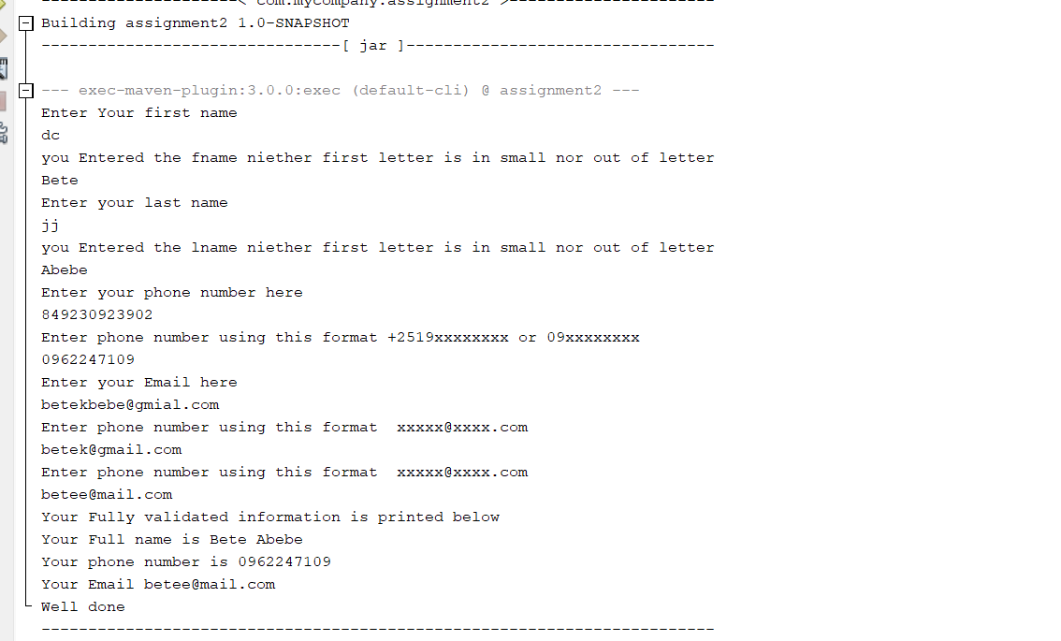

**2**

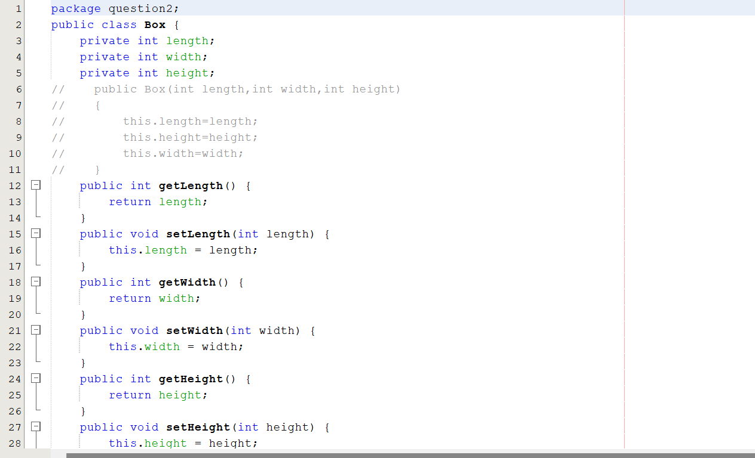

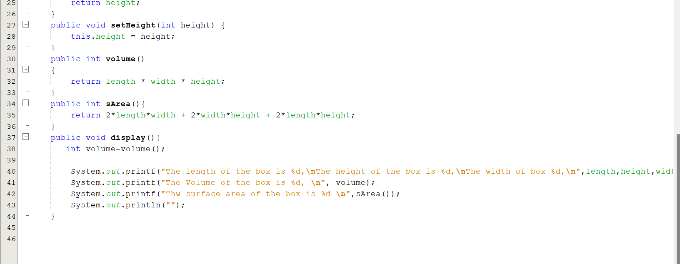

**Output**

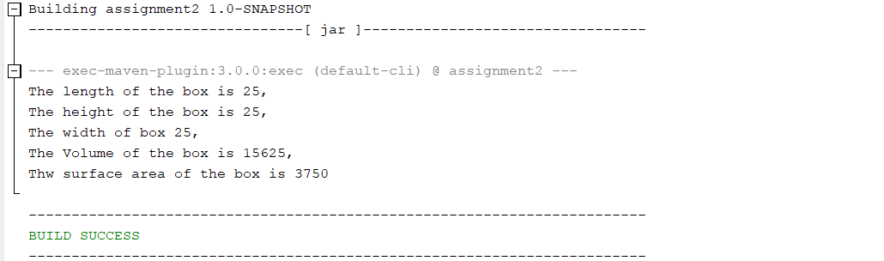

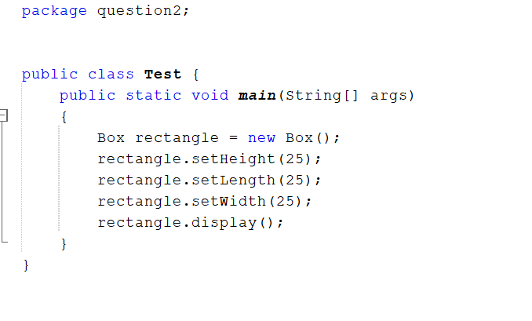

**3.**

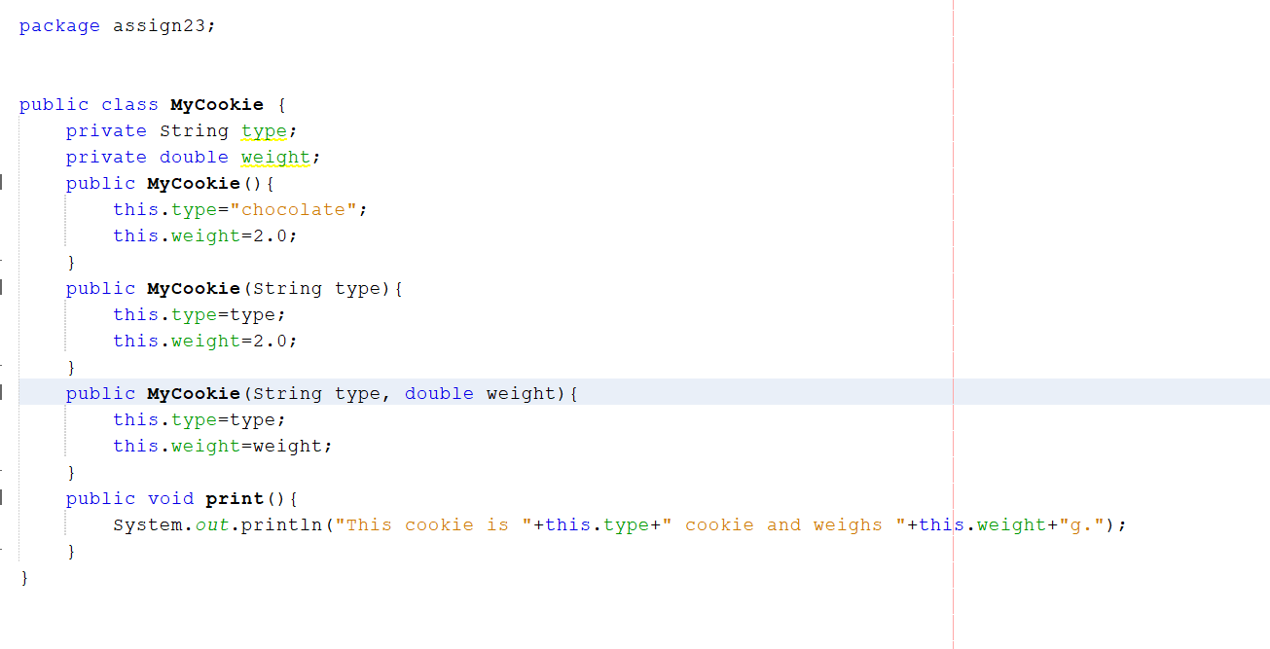

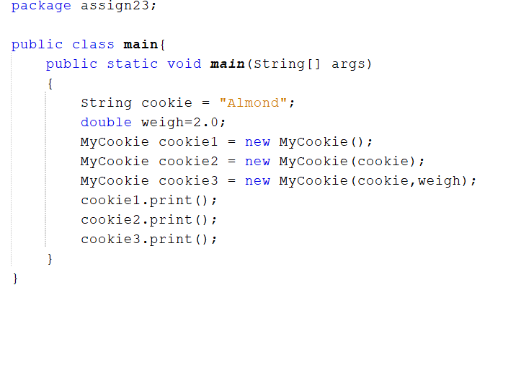

**Output**

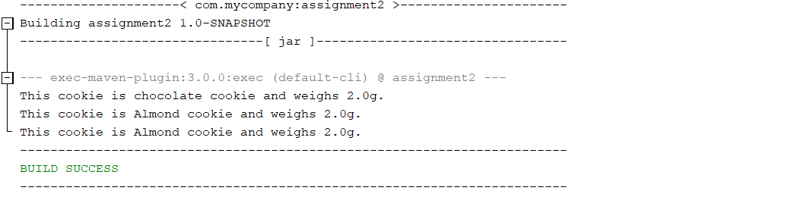

**Assignment 3**

**Electronic class**

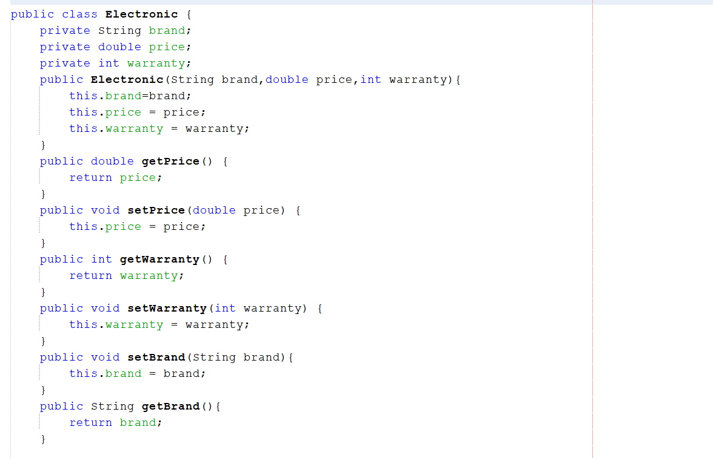

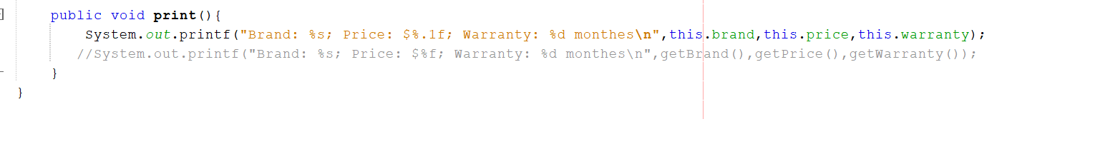

**Computer class**

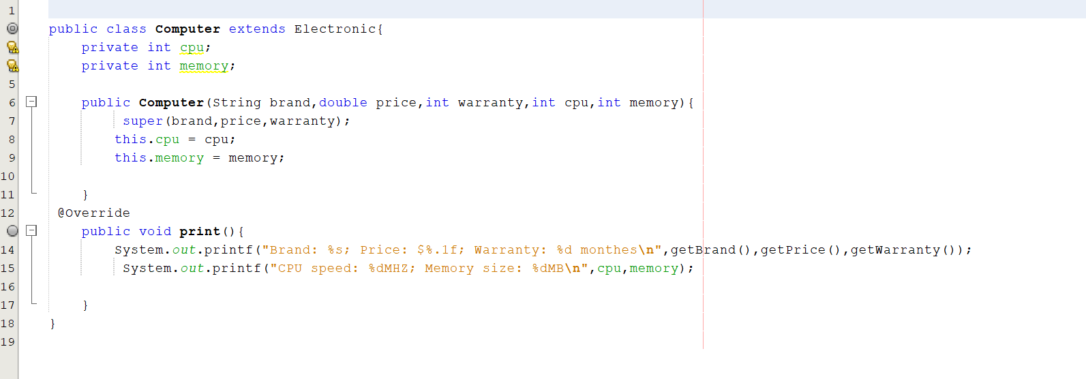

**Cellphone class**

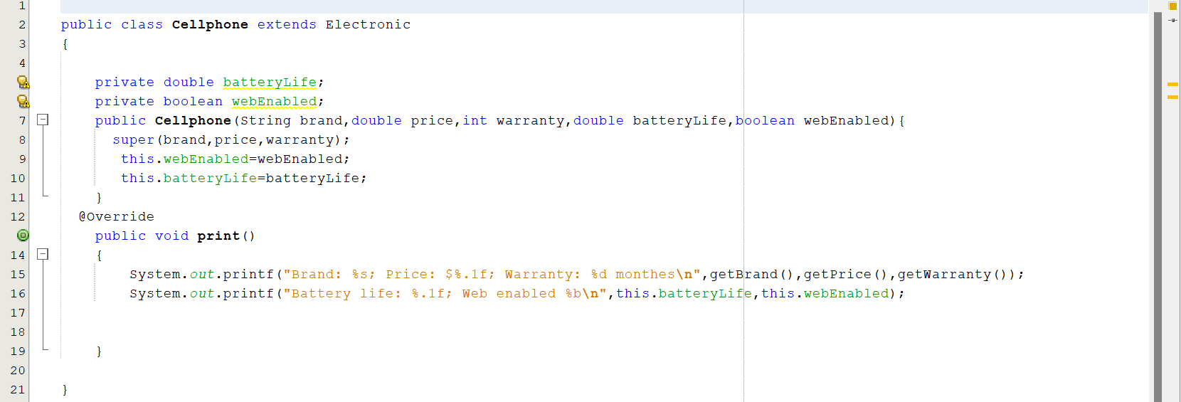

**Laptop class**

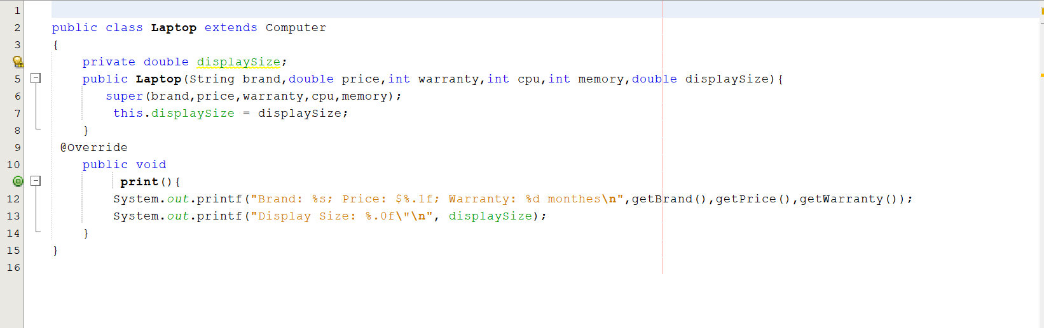

**Electronic main class**

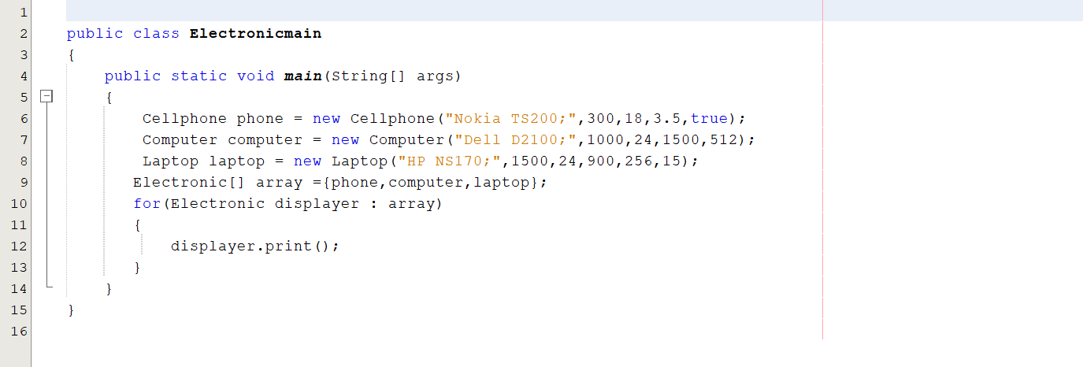

**Out put**

