
SCHOOL OF COMPUTING
Department of Artificial Intelligence and Machine Learning

LIBRARY MANAGEMENT SYSTEM
A Cornerstone Project Report
BATCH NUMBER : 5
Submitted in partial fulfillment of the requirements for the award of the degree of
BACHELOR OF TECHNOLOGY
in
ARTIFICIAL INTELLIGENCE AND MACHINE LEARNING
Submitted by
B. Divya Sai Sri - AIML | (25B11AI113)
G. Nandini - AIML | (26B61AI362)
G. Prakash Kumar - AIML | (25B11AI309)
- Manoj Kumar - AIML | (25B11AI748)

Under the guidance of
Dr. P. Kishorekumar, PhD.
Associate Professor, Department of AIML
ADITYA UNIVERSITY, SURAMPALEM
Academic Year: 2026 - 2027

SCHOOL OF COMPUTING
Department of Artificial Intelligence and Machine Learning
CERTIFICATE
This is to certify that the Cornerstone project work entitled “ LIBRARY MANAGEMENT SYSTEM” is submitted by

B. Divya Sai Sri - AIML | (25B11AI113)
G. Nandini - AIML | (26B61AI362)
G. Prakash Kumar - AIML | (25B11AI309)
- Manoj Kumar - AIML | (25B11AI748)

In partial fulfillment of the requirements for the award of the B.Tech. degree in Artificial Intelligence and Machine Learning for the academic year 2026-2027.

Project Guide  Dr. P. Kishorekumar, PhD.  Associate Professor, Department of AIML | Head of the Department:  Dr. Kovvuri N Bhargavi  Associate Professor & HOD

DECLARATION
We hereby declare that the Cornerstone project entitled "LIBRARY MANAGEMENT SYSTEM" is original and is submitted to ADITYA UNIVERSITY, Surampalem, in partial fulfillment of the requirements for the award of the B.Tech. Degree in Artificial Intelligence and Machine Learning. We further declare that this project work has not been submitted, either in full or in part, for the award of any degree in this or any other institution. We also confirm that this work complies with the Institutional Academic Integrity and AI Usage Policy.
Place: Surampalem
Date:
By

B. Divya Sai Sri - AIML | (25B11AI113)
G. Nandini - AIML | (26B61AI362)
G. Prakash Kumar - AIML | (25B11AI309)
- Manoj Kumar - AIML | (25B11AI748)

ACKNOWLEDGEMENT
It is with immense pleasure that we express our sincere gratitude to our Cornerstone Project Guide, Dr. P. Kishorekumar, PhD. Associate Professor, Department of AIML, who has guided us throughout the project. His valuable support, encouragement, and guidance have greatly contributed to the successful completion of this work.
We would like to thank our Deputy Heads of the Department, Dr. B. Manikyala Rao, Associate Professor, Dr. R. Suneetha, Assistant Professor and Dr. D. Veeraswamy, Assistant Professor for their support and valuable suggestions.
Our deepest thanks to our Head of the Department Dr. K. Naga Bhargavi, Associate Professor & HOD, for her inspiration and for providing all the necessary facilities and resources required for this project.
We also extend our sincere thanks to Dr. M.V. Rajesh, Associate Dean, School of Computing for their encouragement and support during the course of our project.
We would like to express our sincere gratitude to Dr. G. Suresh, Registrar, Dr. A. Ramesh, Pro Vice-Chancellor (Engineering & Sciences), Dr. S. Rama Sree, Pro Vice-Chancellor (Academics), Dr. M.B. Srinivas, Vice-Chancellor, Dr. M. Sreenivasa Reddy, Deputy Pro Chancellor and Management, Aditya University for providing excellent infrastructure and state-of-the-art laboratories.
Finally, we would like to thank the faculty members, lab technicians, non-teaching staff, and our friends who have directly or indirectly supported us in completing this Cornerstone project successfully.
By

B. Divya Sai Sri - AIML | (25B11AI113)
G. Nandini - AIML | (26B61AI362)
G. Prakash Kumar - AIML | (25B11AI309)
- Manoj Kumar - AIML | (25B11AI748)

TABLE OF CONTENTS

1. Project Cover Page i
2. Certificate ii
3. Declaration iii
4. Acknowledgement iv
5. Abstract 2
6. List of Figures / List of Tables / Acronyms 3
7. Introduction 4
8. System Analysis 6
9. Database Design 7
10. ER Diagram 8
11. Relational Schema 10
12. Table Design 11
13. Normalization 14
14. SQL Implementation 15
15. SQL Queries & Screenshots 23
16. Conclusion & Future Enhancements 32
17. References 33

ABSTRACT

The Library Management System is a relational database application designed to manage major library activities in a structured and efficient manner. The system stores and manages information related to books, authors, members, categories, book issues, returns, and fines. It reduces manual record keeping and supports adding, updating, deleting, and retrieving library records.
The database uses primary keys and foreign keys to establish relationships between tables and maintain referential integrity. SQL operations support data insertion, modification, deletion, retrieval, joins, aggregate analysis, CRUD operations, and views. The database design is normalized up to Third Normal Form (3NF), helping reduce redundancy and maintain consistency.
The project provides a strong database foundation for managing book availability, member borrowing, returns, and fine information and can be extended with additional library service.

LIST OF FIGURES

Figure 1. ER Diagram of the Library Management System

LIST OF TABLES

Table 1. Major Database Entities
Table 2. Entity Relationships and Cardinality
Table 3. Relational Schema Summary
Table 4. Book Table Structure
Table 5. Author Table Structure
Table 6. Member Table Structure
Table 7. Category Table Structure
Table 8. Issue Table Structure
Table 9. Return Table Structure
Table 10. Fine Table Structure
Table 11. Keys and Constraints Summary

ACRONYMS

- DBMS – Database Management System
- ER – Entity Relationship
- SQL – Structured Query Language
- DDL – Data Definition Language
- DML – Data Manipulation Language
- DQL – Data Query Language
- DCL – Data Control Language
- TCL – Transaction Control Language
- PK – Primary Key
- FK – Foreign Key
- 1NF – First Normal Form
- 2NF – Second Normal Form
- 3NF – Third Normal Form

1 INTRODUCTION

1.1 Brief Information about the Project
The Library Management System manages and organizes major library activities through a centralized relational database. It maintains details of books, members, authors, categories, issues, returns, and fines. The system is designed to reduce manual record keeping and make library operations efficient, accurate, organized, and easy to manage.

1.2 Motivation and Contribution
- Reduce manual and paper-based record maintenance.
- Minimize data duplication and errors.
- Track book availability and borrowing information.
- Maintain issue, due-date, return, and fine records.
- Provide faster retrieval of library information using SQL.
- Demonstrate practical application of DBMS concepts.

1.3 OBJECTIVES
- Identify the major entities involved in library management.
- Identify suitable attributes for each entity.
- Establish relationships between the identified entities.
- Design an Entity–Relationship (ER) diagram.
- Convert the ER model into a relational database schema.
- Identify Primary Keys and Foreign Keys.
- Manage book, member, author, and borrowing details efficiently.
- Reduce data redundancy and maintain data consistency.
- Support SQL-based retrieval, reporting, and database operations.

1.4 Scope of the Project
The scope of the project covers database-oriented management of library resources. The system manages book details, author information, members, categories, book issues, returns, fines, and payment records. The system can be used as the database backend for a library administration application. It can also be extended in the future with features such as automated due-date alerts, member authentication, book availability tracking, fine notifications, borrowing reports, and dashboard-based analytics.

2. SYSTEM ANALYSIS

2.1 Existing System
- Manual record keeping.
- Paper-based or disconnected book records.
- Difficult tracking of available books.
- Manual issue and return records.
- Difficulty maintaining fine details.
- Data duplication and entry errors.
- Time-consuming searching and reporting.

2.2 Proposed System
The proposed system uses a centralized relational database. Library information is organized into related tables and connected using primary keys and foreign keys. SQL queries are used for data manipulation and retrieval.
Existing System | Proposed Database System
Manual record keeping | Centralized relational database
Paper-based book records | Structured BOOK table
Difficult to track availability | Availability status maintained
Manual issue/return records | ISSUE and RETURN tables
Difficult fine records | FINE table
Data duplication/errors | Keys and constraints
Time-consuming searching | SQL-based retrieval

2.3 Functional Requirements
- Add, update, delete and search book details.
- Maintain book availability status.
- Store author information and associate authors with books.
- Store member/student information.
- Maintain book categories.
- Record issue and due dates.
- Record returned books and return status.
- Store fine amount and payment status.
- Retrieve information using SELECT, JOIN, GROUP BY and other SQL queries.

2.4 Non-Functional Requirements
- Integrity: invalid references and duplicate key values should be prevented.
- Usability: information should be organized and easy to retrieve.
- Reliability: database operations should preserve consistent records.
- Performance: normal library queries should return efficiently.
- Scalability: the design can be extended with additional library features.

2.5 Requirements Specification
Category | Requirement
Hardware | Intel i3 or above; 4 GB RAM minimum; adequate storage; standard display and keyboard/mouse.
Operating System | Windows 10/11 or an equivalent supported platform.
Database | MySQL Relational Database Management System.

3. DATABASE DESIGN

3.1 Major Entities
Entity | Description
BOOK | Stores book details and availability.
AUTHOR | Stores author details.
MEMBER | Stores member/student details.
CATEGORY | Stores book category details.
ISSUE | Records books issued to members.
RETURN | Records returned books.
FINE | Stores fine amount and payment status.

3.2 ER Model
The ER model represents the major library management entities and the relationships between them. Author is related to Book, while Book is connected to Category, Issue, Return, and Fine. Members are connected to Books through the Issue entity, which records book borrowing details. Return manages returned books, while Fine stores information about overdue charges and payments.

3.3 Entity Relationships
Relationship | Cardinality | Meaning
Author → Book | 1 : M | One author can write many books.
Book → Category | M : 1 | A category can contain many books.
Member → Book / Issue | 1 : M | One member can have many issue records over time.
Book → Issue | 1 : M | A book can have many issue records over time.
Issue → Return | 1 : 1 | An issue record can have one return record.
Return → Fine | 1 : 1 | A returned book may generate one fine.

4. ER DIAGRAM
Figure 1: ER Diagram of the Library Management Analysis System (SOFTWARE BASED).
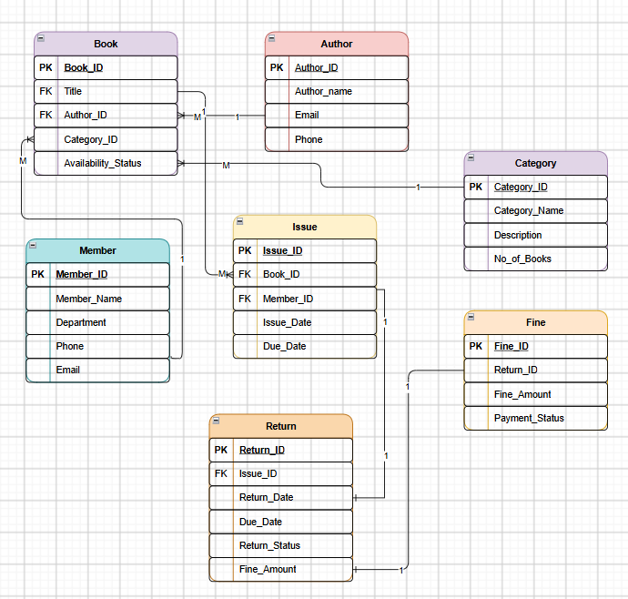

Figure 2: ER Diagram of the Library Management System (MANUAL)

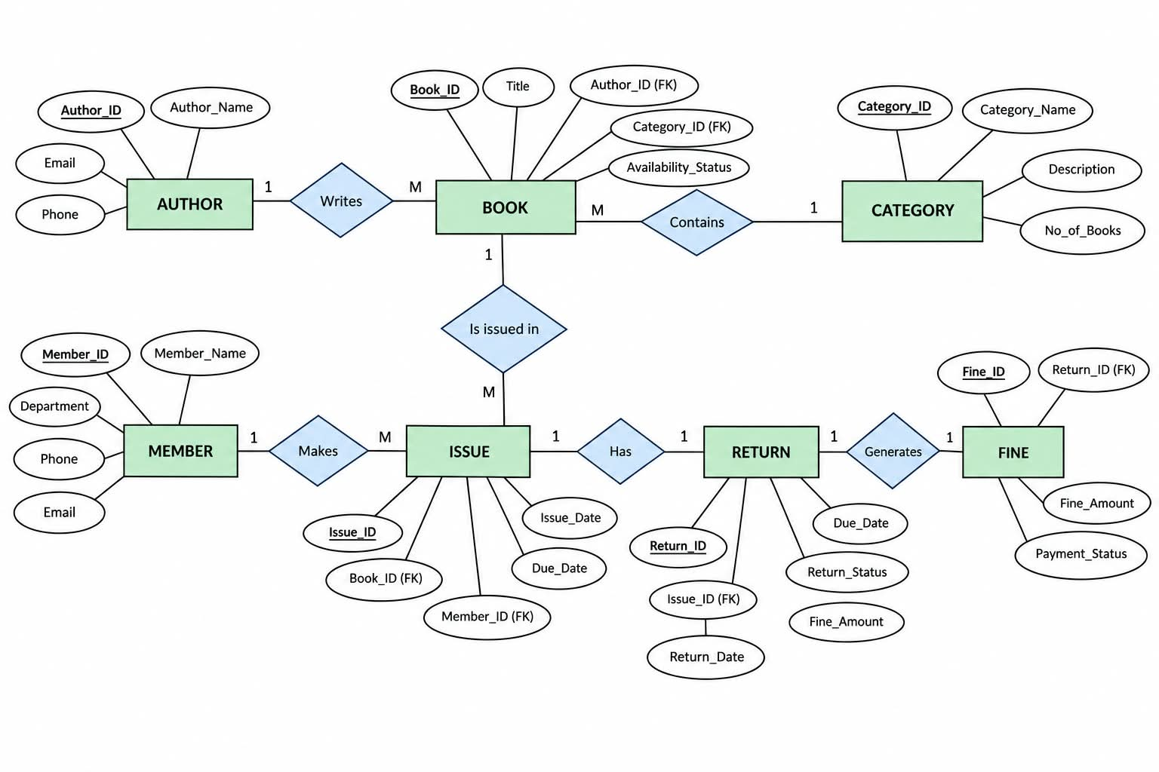

5. RELATIONAL SCHEMA

Table | Relational Schema | Keys
BOOK | BOOK(Book_ID, Title, Author_ID, Category_ID, Availability_Status) | PK: Book_ID; FK: Author_ID, Category_ID
AUTHOR | AUTHOR(Author_ID, Author_Name, Email, Phone) | PK: Author_ID
MEMBER | MEMBER(Member_ID, Member_Name, Department, Phone, Email) | PK: Member_ID
CATEGORY | CATEGORY(Category_ID, Category_Name, Description, No_of_Books) | PK: Category_ID
ISSUE | ISSUE(Issue_ID, Book_ID, Member_ID, Issue_Date, Due_Date) | PK: Issue_ID; FK: Book_ID, Member_ID
RETURN | RETURN(Return_ID, Issue_ID, Return_Date, Due_Date, Return_Status, Fine_Amount) | PK: Return_ID; FK: Issue_ID
FINE | FINE(Fine_ID, Return_ID, Fine_Amount, Payment_Status) | PK: Fine_ID; FK: Return_ID

6. TABLE DESIGN

6.1 Book Table
Attribute | Data Type | Constraint | Description
Book_ID | INT | PK | Unique identifier for each book
Title | VARCHAR(150) | NOT NULL | Title of the book
Author_ID | INT | FK | Identifies the related author
Category_ID | INT | FK | Identifies the related category
Availability_Status | VARCHAR(50) | NOT NULL | Availability status of the book

6.2 Author Table
Attribute | Data Type | Constraint | Description
Author_ID | INT | PK | Unique identifier for each author
Author_Name | VARCHAR(100) | NOT NULL | Name of the author
Email | VARCHAR(100) | UNIQUE | Author email address
Phone | VARCHAR(15) | — | Author contact number

6.3 Member Table
Attribute | Data Type | Constraint | Description
Member_ID | INT | PK | Unique identifier for each member
Member_Name | VARCHAR(100) | NOT NULL | Name of the library member
Department | VARCHAR(100) | — | Department of the member
Phone | VARCHAR(15) | — | Member contact number
Email | VARCHAR(100) | UNIQUE | Member email address

6.4 Category Table
Attribute | Data Type | Constraint | Description
Category_ID | INT | PK | Unique identifier for each category
Category_Name | VARCHAR(100) | NOT NULL | Name of the book category
Description | VARCHAR(255) | — | Description of the category
No_of_Books | INT | — | Number of books in the category

6.5 Issue Table
Attribute | Data Type | Constraint | Description
Issue_ID | INT | PK | Unique identifier for each issue
Book_ID | INT | FK | Identifies the issued book
Member_ID | INT | FK | Identifies the member who borrowed the book
Issue_Date | DATE | NOT NULL | Date when the book was issued
Due_Date | DATE | NOT NULL | Date by which the book should be returned

6.6 Return Table
Attribute | Data Type | Constraint | Description
Return_ID | INT | PK | Unique identifier for each return
Issue_ID | INT | FK | Identifies the related issue
Return_Date | DATE | NOT NULL | Date when the book was returned
Due_Date | DATE | NOT NULL | Due date of the issued book
Return_Status | VARCHAR(50) | NOT NULL | Status of the book return
Fine_Amount | DECIMAL(10,2) | — | Fine amount charged for late return

6.7 Fine Table
Attribute | Data Type | Constraint | Description
Fine_ID | INT | PK | Unique identifier for each fine
Return_ID | INT | FK | Identifies the related return
Fine_Amount | DECIMAL(10,2) | NOT NULL | Amount of fine charged
Payment_Status | VARCHAR(50) | NOT NULL | Status of fine payment

6.8 Keys and Constraints
Constraint | Applied To / Purpose
Primary Key | Book_ID, Author_ID, Member_ID, Category_ID, Issue_ID, Return_ID, Fine_ID
Foreign Key | Book.Author_ID, Book.Category_ID, Issue.Book_ID, Issue.Member_ID, Return.Issue_ID, Fine.Return_ID
NOT NULL | Required names, identifiers, dates, and status values
UNIQUE | Author.Email, Member.Email
CHECK | Valid No_of_Books, Fine_Amount and other numeric values
DEFAULT | Default availability, return, and payment status values

7. NORMALIZATION UP TO 3NF

7.1 UNF – Unnormalized Form
Library information may initially contain repeated book, author, member, issue, return, and fine details in a single record. This can create duplication and make updates difficult.

7.2 1NF – First Normal Form
- Remove repeating groups.
- Each attribute contains a single atomic value.
- Each record is uniquely identified.

7.3 2NF – Second Normal Form
- Remove partial dependencies.
- Separate book, member, author, category and issue information into different tables.
- Non-key attributes should depend on the complete key.

7.4 3NF – Third Normal Form
- Remove transitive dependencies.
- Author information is stored in AUTHOR.
- Category information is stored in CATEGORY.
- Fine information is stored in FINE.
- The final database contains seven related tables.
Final relations: BOOK, AUTHOR, MEMBER, CATEGORY, ISSUE, RETURN, FINE.
Relation | Reason for Separation
Book | Stores book-specific details such as title, author reference, category reference, and availability status in one place.
Author | Stores author-specific information such as author name, email, and phone separately instead of repeating author details for every book.
Member | Stores member-specific details such as name, department, phone, and email independently.
Category | Stores category-specific information such as category name, description, and number of books.
Issue | Stores book borrowing information, including the book, member, issue date, and due date.
Return | Stores return-related information such as issue reference, return date, due date, return status, and fine amount.
Fine | Stores fine-related information separately, including return reference, fine amount, and payment status.

8. SQL IMPLEMENTATION

8.1 DDL – Data Definition Language
DDL commands are used to create and modify the database structure. The implementation covers CREATE DATABASE, CREATE TABLE and ALTER TABLE, along with Primary Key, Foreign Key, NOT NULL, UNIQUE and CHECK constraints where appropriate.
CREATE DATABASE LibraryManagementSystem;
USE LibraryManagementSystem;

CREATE TABLE Author (
Author_ID INT PRIMARY KEY,
Author_Name VARCHAR(100) NOT NULL,
Email VARCHAR(100) UNIQUE,
Phone VARCHAR(15)
);

CREATE TABLE Category (
Category_ID INT PRIMARY KEY,
Category_Name VARCHAR(50) NOT NULL UNIQUE,
Description VARCHAR(200),
No_of_Books INT DEFAULT 0
);

CREATE TABLE Member (
Member_ID INT PRIMARY KEY,
Member_Name VARCHAR(100) NOT NULL,
Department VARCHAR(50),
Phone VARCHAR(15),
Email VARCHAR(100) UNIQUE
);

CREATE TABLE Book (
Book_ID INT PRIMARY KEY,
Title VARCHAR(150) NOT NULL,
Author_ID INT,
Category_ID INT,
Availability_Status VARCHAR(20) DEFAULT 'Available',
FOREIGN KEY (Author_ID) REFERENCES Author(Author_ID),
FOREIGN KEY (Category_ID) REFERENCES Category(Category_ID),
CHECK (Availability_Status IN ('Available', 'Issued'))
);

CREATE TABLE Issue (
Issue_ID INT PRIMARY KEY,
Book_ID INT NOT NULL,
Member_ID INT NOT NULL,
Issue_Date DATE NOT NULL,
Due_Date DATE NOT NULL,
FOREIGN KEY (Book_ID) REFERENCES Book(Book_ID),
FOREIGN KEY (Member_ID) REFERENCES Member(Member_ID),
CHECK (Due_Date >= Issue_Date)
);

CREATE TABLE `Return` (
Return_ID INT PRIMARY KEY,
Issue_ID INT NOT NULL UNIQUE,
Return_Date DATE NOT NULL,
Due_Date DATE NOT NULL,
Return_Status VARCHAR(20),
Fine_Amount DECIMAL(10,2) DEFAULT 0,
FOREIGN KEY (Issue_ID) REFERENCES Issue(Issue_ID),
CHECK (Return_Status IN ('Returned', 'Late')),
CHECK (Fine_Amount >= 0)
);

CREATE TABLE Fine (
Fine_ID INT PRIMARY KEY,
Return_ID INT NOT NULL UNIQUE,
Fine_Amount DECIMAL(10,2) NOT NULL,
Payment_Status VARCHAR(20) DEFAULT 'Pending',
FOREIGN KEY (Return_ID) REFERENCES `Return`(Return_ID),
CHECK (Fine_Amount >= 0),
CHECK (Payment_Status IN ('Paid', 'Pending'))
);

Note: RETURN is enclosed in backticks in MySQL because RETURN can conflict with SQL syntax in some contexts.

8.2 DML – Data Manipulation Language
DML commands manage records in the database. The project demonstrates INSERT, UPDATE and DELETE operations.
INSERT INTO Author VALUES
(1, 'R.K. Sharma', 'rksharma@gmail.com', '9876543210'),
(2, 'A.P. Kumar', 'apkumar@gmail.com', '9876543211'),
(3, 'Chetan Bhagat', 'chetan@gmail.com', '9876543212'),
(4, 'J.K. Rowling', 'jkrowling@gmail.com', '9876543213'),
(5, 'George Orwell', 'george@gmail.com', '9876543214');

INSERT INTO Category VALUES
(1, 'Programming', 'Computer programming books', 0),
(2, 'Mathematics', 'Mathematics and problem solving', 0),
(3, 'Science', 'Science related books', 0),
(4, 'Literature', 'Literature and novels', 0),
(5, 'Database', 'Database management books', 0);

INSERT INTO Member VALUES
(101, 'G. Nandini', 'AIML', '9000000001', 'nandini@gmail.com'),
(102, 'B. Divya Sai Sri', 'AIML', '9000000002', 'divya@gmail.com'),
(103, 'G. Prakash Kumar', 'AIML', '9000000003', 'prakash@gmail.com'),
(104, 'A. Manoj Kumar', 'AIML', '9000000004', 'manoj@gmail.com'),
(105, 'Rahul Kumar', 'CSE', '9000000005', 'rahul@gmail.com');

INSERT INTO Book VALUES
(1001, 'Database Management Systems', 1, 5, 'Available'),
(1002, 'C Programming', 2, 1, 'Issued'),
(1003, 'Engineering Mathematics', 1, 2, 'Available'),
(1004, 'Introduction to Science', 2, 3, 'Available'),
(1005, 'Harry Potter', 4, 4, 'Issued'),
(1006, '1984', 5, 4, 'Available');

INSERT INTO Issue VALUES
(501, 1002, 101, '2026-09-01', '2026-09-15'),
(502, 1005, 102, '2026-09-05', '2026-09-19'),
(503, 1003, 103, '2026-09-10', '2026-09-24');

INSERT INTO `Return` VALUES
(601, 501, '2026-09-14', '2026-09-15', 'Returned', 0),
(602, 502, '2026-09-22', '2026-09-19', 'Late', 30);

INSERT INTO Fine VALUES
(701, 602, 30, 'Pending');

8.3. DQL AND QUERY OPERATIONS
DQL uses SELECT to retrieve information from the database.
SELECT * FROM Author;
SELECT * FROM Category;
SELECT * FROM Member;
SELECT * FROM Book;
SELECT * FROM Issue;
SELECT * FROM `Return`;
SELECT * FROM Fine;

SELECT Book_ID, Title
FROM Book
WHERE Availability_Status = 'Available';

SELECT *
FROM Book
WHERE Title LIKE '%Database%';

SELECT *
FROM Book
ORDER BY Title ASC;

ALTER TABLE AND INDEX
ALTER TABLE Member
ADD Address VARCHAR(150);

ALTER TABLE Member
MODIFY Phone VARCHAR(20);

ALTER TABLE Member
RENAME COLUMN Address TO Member_Address;

DESC Book;

CREATE INDEX idx_book_title
ON Book(Title);

SQL JOINS
- Book + Author: display book names with their authors.
- Book + Category: display books along with their categories.
- Member + Issue: display members and the books they have issued.
- Issue + Return: display issue and return details.
- Return + Fine: display return details with fine information.
- Member + Book + Issue: display which member has issued which book.
SELECT
B.Book_ID,
B.Title,
A.Author_Name
FROM Book B
INNER JOIN Author A
ON B.Author_ID = A.Author_ID;

SELECT
B.Book_ID,
B.Title,
C.Category_Name
FROM Book B
INNER JOIN Category C
ON B.Category_ID = C.Category_ID;

SELECT
I.Issue_ID,
M.Member_Name,
B.Title,
I.Issue_Date,
I.Due_Date
FROM Issue I
JOIN Member M ON I.Member_ID = M.Member_ID
JOIN Book B ON I.Book_ID = B.Book_ID;

SELECT
I.Issue_ID,
M.Member_Name,
B.Title,
A.Author_Name,
I.Issue_Date,
I.Due_Date
FROM Issue I
JOIN Member M ON I.Member_ID = M.Member_ID
JOIN Book B ON I.Book_ID = B.Book_ID
JOIN Author A ON B.Author_ID = A.Author_ID;

AGGREGATE FUNCTIONS
- COUNT() – count books or members.
- SUM() – calculate total fine amount.
- AVG() – calculate average fine amount.
- MAX() – find maximum fine.
- MIN() – find minimum fine.
- GROUP BY – group books/issues by category or member.
- HAVING – filter grouped results based on a condition.
SELECT COUNT(*) AS Total_Books FROM Book;
SELECT COUNT(*) AS Total_Members FROM Member;
SELECT SUM(Fine_Amount) AS Total_Fine FROM Fine;
SELECT AVG(Fine_Amount) AS Average_Fine FROM Fine;
SELECT MAX(Fine_Amount) AS Maximum_Fine FROM Fine;
SELECT MIN(Fine_Amount) AS Minimum_Fine FROM Fine;

SELECT
C.Category_Name,
COUNT(B.Book_ID) AS Number_Of_Books
FROM Category C
LEFT JOIN Book B ON C.Category_ID = B.Category_ID
GROUP BY C.Category_ID, C.Category_Name;

SELECT
C.Category_Name,
COUNT(B.Book_ID) AS Number_Of_Books
FROM Category C
JOIN Book B ON C.Category_ID = B.Category_ID
GROUP BY C.Category_ID, C.Category_Name
HAVING COUNT(B.Book_ID) > 1;

9.1 CRUD OPERATIONS
Operation | SQL Command | Library Example
Create | INSERT | Add a new book.
Read | SELECT | Display book details.
Update | UPDATE | Change book availability.
Delete | DELETE | Remove an eligible record.
INSERT INTO Member
VALUES
(107, 'Anil Kumar', 'ECE', '9000000007', 'anil@gmail.com', 'Kakinada');

SELECT *
FROM Member
WHERE Member_ID = 107;

UPDATE Member
SET Department = 'AIML'
WHERE Member_ID = 107;

DELETE FROM Member
WHERE Member_ID = 107;

VIEWS
A View is a virtual table created using a SQL query. Views simplify frequently required queries and present related information in an organized form.

Issued Books View
CREATE VIEW Issued_Books AS
SELECT
M.Member_Name,
B.Title,
I.Issue_Date,
I.Due_Date
FROM Issue I
JOIN Member M ON I.Member_ID = M.Member_ID
JOIN Book B ON I.Book_ID = B.Book_ID;
SELECT * FROM Issued_Books;

Fine Details View
CREATE VIEW Fine_Details AS
SELECT
M.Member_Name,
B.Title,
F.Fine_Amount,
F.Payment_Status
FROM Fine F
JOIN `Return` R ON F.Return_ID = R.Return_ID
JOIN Issue I ON R.Issue_ID = I.Issue_ID
JOIN Member M ON I.Member_ID = M.Member_ID
JOIN Book B ON I.Book_ID = B.Book_ID;
SELECT * FROM Fine_Details;

Validation Examples
INSERT INTO Author
VALUES
(1, 'Test Author', 'test@gmail.com', '9999999999');
INSERT INTO Member
VALUES
(101, 'Test Member', 'CSE', '9999999999', 'testmember@gmail.com', 'Kakinada');
INSERT INTO Book
VALUES
(1010, 'Unknown Book', 999, 1, 'Available');
INSERT INTO Book
VALUES
(1011, 'Test Book', 1, 999, 'Available');

SELECT *
FROM Book
WHERE Availability_Status = 'Issued';

SELECT *
FROM Fine
WHERE Payment_Status = 'Pending';

SELECT DISTINCT
M.Member_ID,
M.Member_Name
FROM Member M
JOIN Issue I ON M.Member_ID = I.Member_ID;

SELECT
R.Return_ID,
M.Member_Name,
B.Title,
R.Return_Date,
R.Due_Date,
R.Fine_Amount
FROM `Return` R
JOIN Issue I ON R.Issue_ID = I.Issue_ID
JOIN Member M ON I.Member_ID = M.Member_ID
JOIN Book B ON I.Book_ID = B.Book_ID
WHERE R.Return_Status = 'Late';

The above statements are intended to demonstrate constraint violations. Capture the actual MySQL error messages from the implemented database and insert them as screenshots in the final report.

9 SQL OUTPUT AND SCREENSHOTS
The final documentation should contain actual screenshots from the working MySQL implementation. Replace each placeholder below with the corresponding screenshot.

1.Database creation:
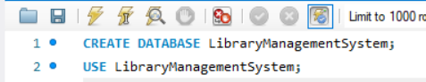

2.Author Record :

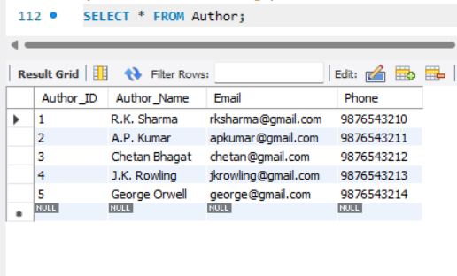

3.Categories record :

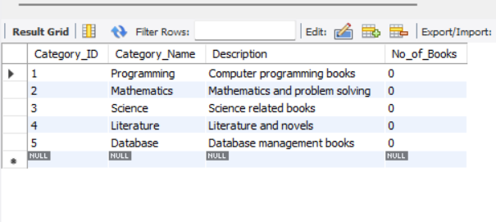

4.Member Record :

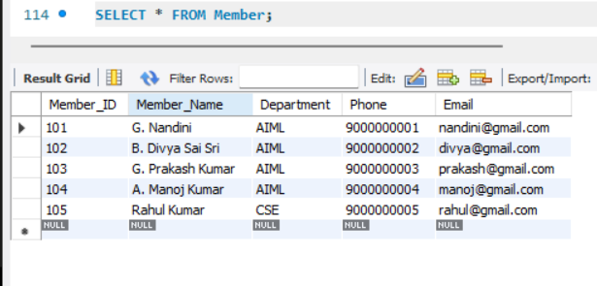

5.Book Record :

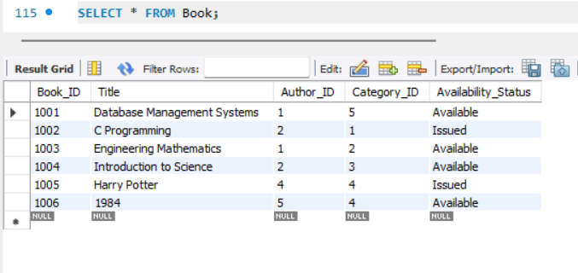

6.Issue Record :
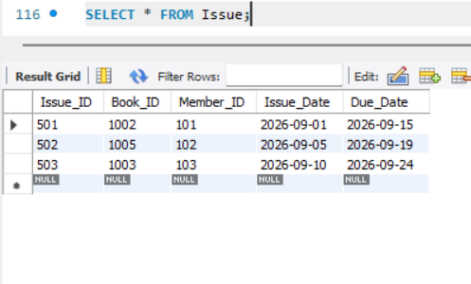

7.Return Records :

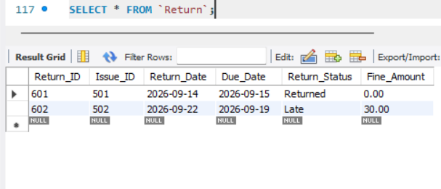

8.Fine Records :

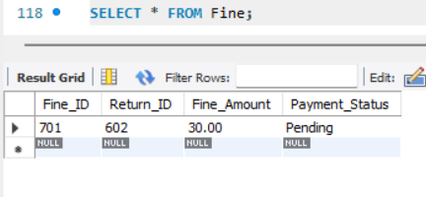

DDL Commands:
ALTER TABLE Member
ADD Address VARCHAR(150);
ALTER TABLE Member
MODIFY Phone VARCHAR(20);
ALTER TABLE Member
RENAME COLUMN Address TO Member_Address;
DESC Book;

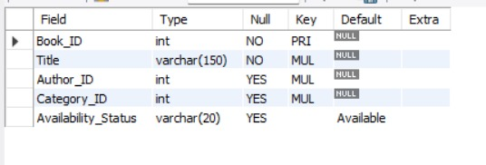

DML Commands:
INSERT:
INSERT INTO Member
VALUES
(106, 'Suresh Kumar', 'CSE', '9000000006', 'suresh@gmail.com', 'Kakinada');
UPDATE
UPDATE Book
SET Availability_Status = 'Available'
WHERE Book_ID = 1002;
DELETE
DELETE FROM Member
WHERE Member_ID = 106;

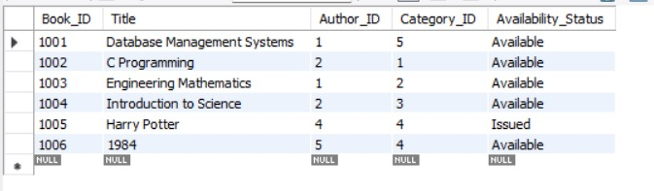

DQL Commands:

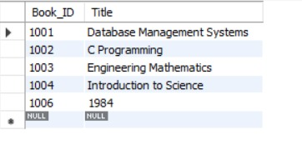

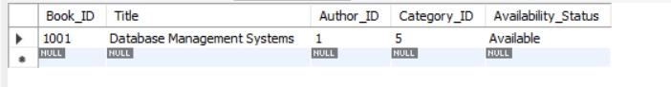

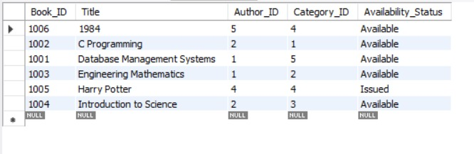

Join Query:

Inner join ( Books and author ):

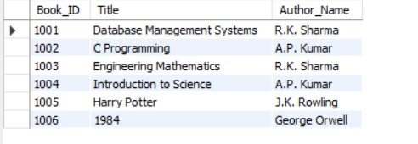

Book + Category :

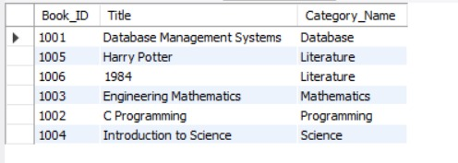

Issue + member + Record :

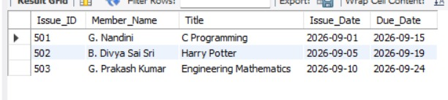

Complete issue details:

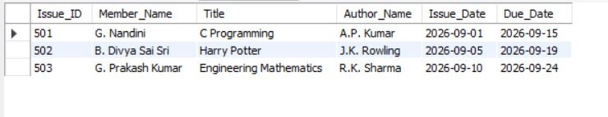

Aggregate Functions:

Count Books:
SELECT COUNT(*) AS Total_Books
FROM Book;

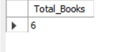

Count Members:
SELECT COUNT(*) AS Total_Members
FROM Member;
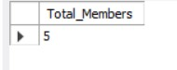
Total Fine:
SELECT SUM(Fine_Amount) AS Total_Fine
FROM Fine;
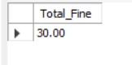
Average Fine:
SELECT AVG(Fine_Amount) AS Average_Fine
FROM Fine;
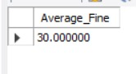
Maximum Fine:
SELECT MAX(Fine_Amount) AS Maximum_Fine
FROM Fine;
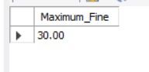
Minimum Fine:
SELECT MIN(Fine_Amount) AS Minimum_Fine
FROM Fine;
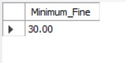

GROUP BY and HAVING:

Number of books in each category:
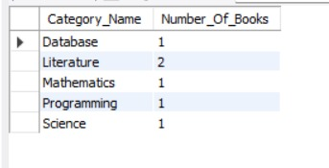
Categories having more than one book:
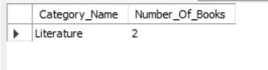

CRUD Operations:

CREATE
INSERT INTO Member
VALUES
(107, 'Anil Kumar', 'ECE', '9000000007',
'anil@gmail.com', 'Kakinada');
READ:
SELECT *
FROM Member
WHERE Member_ID = 107;
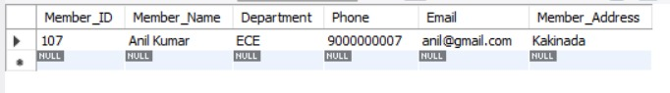
UPDATE:
UPDATE Member
SET Department = 'AIML'
WHERE Member_ID = 107;
DELETE:
DELETE FROM Member
WHERE Member_ID = 107;


Create Views:
View 1 – Issued Books
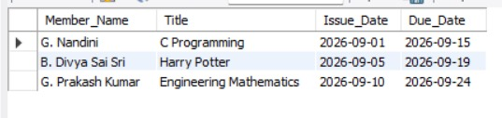
View 2 – Fine Details
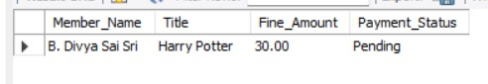

Validation / Error Screenshots:

Duplicate Primary Key:
INSERT INTO Author
VALUES
(1, 'Test Author', 'test@gmail.com', '9999999999');
Duplicate Member ID:
INSERT INTO Member
VALUES
(101, 'Test Member', 'CSE', '9999999999',
'testmember@gmail.com', 'Kakinada');
Invalid Foreign Key:
INSERT INTO Book
VALUES
(1010, 'Unknown Book', 999, 1, 'Available');
Invalid Category Foreign Key:
INSERT INTO Book
VALUES
(1011, 'Test Book', 1, 999, 'Available');

10. CONCLUSION

The Library Management System database has been designed using a relational database model. Seven related tables are used to manage books, authors, members, categories, issues, returns, and fines. Primary Keys and Foreign Keys establish relationships between the tables, while constraints support data integrity and consistency.
The project demonstrates database creation, data manipulation, data retrieval, joins, aggregate functions, CRUD operations, views, validation, and normalization up to 3NF. The implemented database provides a strong foundation for further development of the Library Management System.

FUTURE ENHANCEMENTS

- Online Book Reservation: Reserve books online.
- Barcode Scanning: Simplify book issuing and returning.
- Email Notifications: Send due-date and overdue reminders.
- Online Fine Payment: Enable digital payment of fines.
- Book Recommendations: Suggest books based on user interests.
- Mobile Application: Access library services through smartphones.
- Cloud Storage: Store and access library data securely.

REFERENCES

- Korth, H. F., Silberschatz, A., and Sudarshan, S., Database System Concepts, McGraw Hill.
- Elmasri, R. and Navathe, S. B., Fundamentals of Database Systems, Pearson.
- Connolly, T. and Begg, C., Database Systems: A Practical Approach to Design, Implementation, and Management, Pearson.
- Coronel, C. and Morris, S., Database Systems: Design, Implementation, & Management, Cengage Learning.
- MySQL 8.0 Reference Manual, Oracle Corporation, https://dev.mysql.com/doc/
- W3Schools, SQL Tutorial, https://www.w3schools.com/sql/

