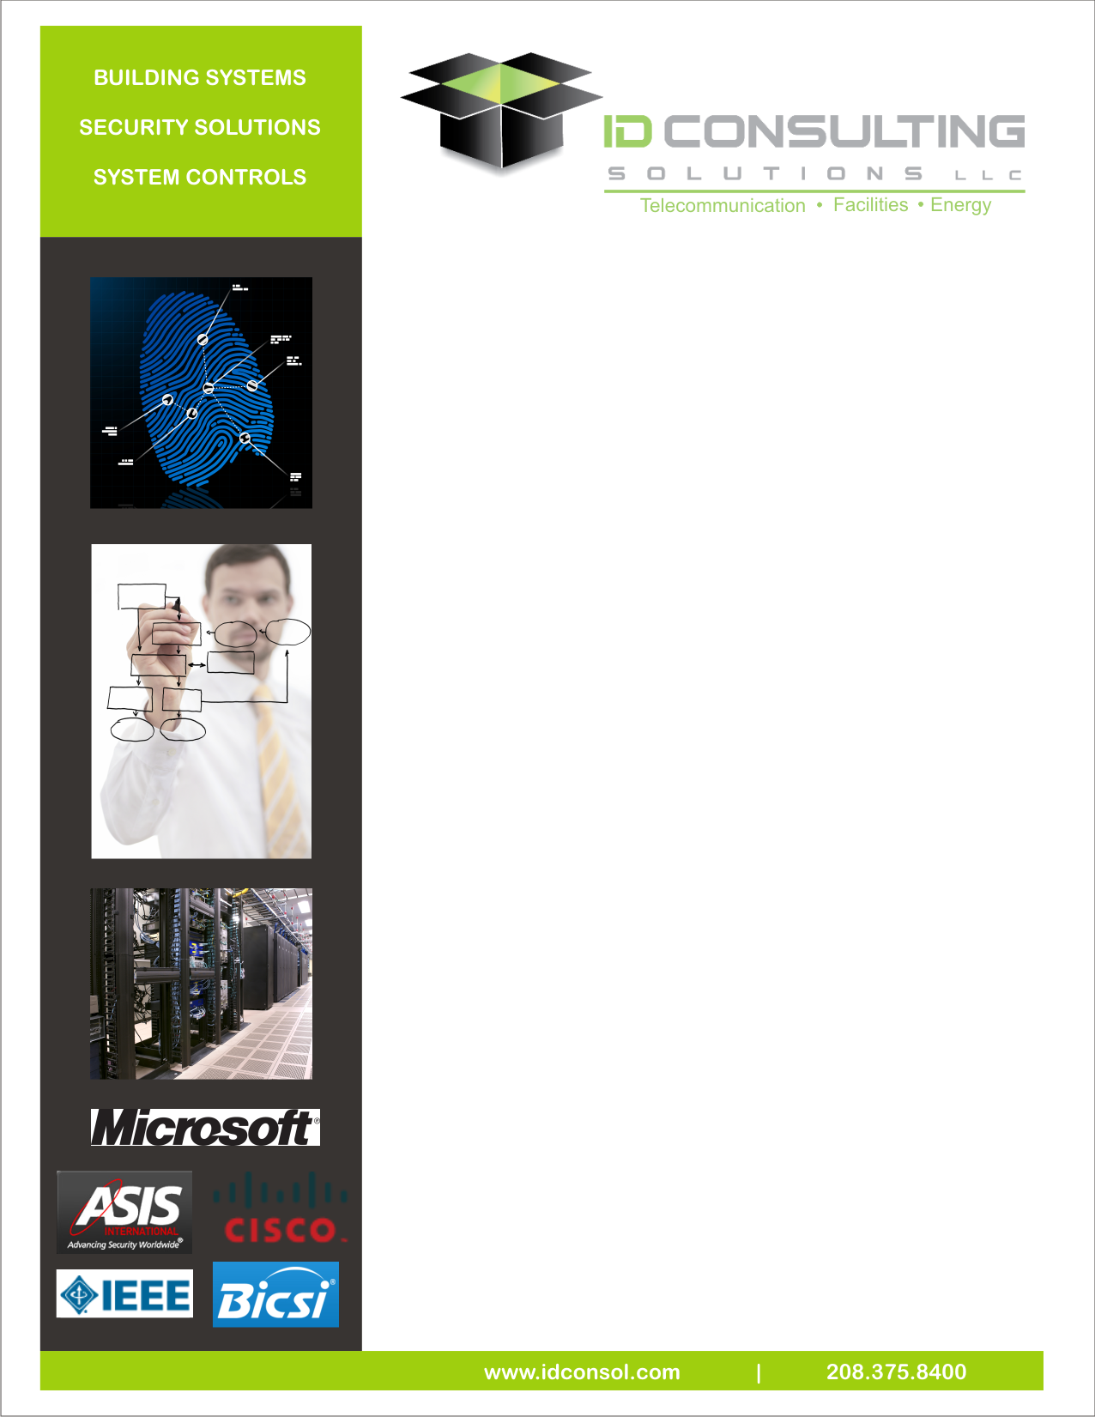

**Building Systems**

ID Consulting Solutions' facility building systems group provides full turnkey design, procurement and installation services for numerous clients. We specialize in the latest technologies and tried-and-true systems. Our team has designed and installed CCTV, access control, alarm systems, VOIP, digital video recording, video management software, fiber optic and copper networks, graphical interface, control room consoles, video analytics, software installation and implementation, and head-end electronics. Our past and present customers include airports, transportation, medical campuses, school districts, financial institutions, higher education campuses and highway districts.

**Project Engineering and Management**

Our extensive work with transportation, municipalities, utilities, and commercial clients give ID Consulting Solutions a diverse offering of services, including:

* + Project scope development
  + Conceptual system planning and design
  + Project design collaboration and secure document web review
  + Cost effective design
  + Business case analysis

**Building Systems:** Our building and facility services include:

* + IP-based CCTV and access control
  + Network system design (LAN - Fiber/Copper/Wireless)
  + Facilities and Operations Center design
  + Hardware/Electronics & Components
  + Facility design and construction
  + Cable & hardware installation
  + Equipment installation & provisioning
  + Content provider negotiation
  + Voice/Video/Data provisioning & testing
  + Hardware and software systems integration
  + Managed services (NOC Services)
  + Component product sales
  + IP CCTV and Access Control
  + Security Systems
  + On-demand/Interactive Systems
  + VOIP system integration

**Owner Benefits**

Owners can choose from a customized menu of technology options and services to meet their project needs. Some of our unique solutions include:

* + Managing high-speed Internet access
  + Managing state-of-the-art voice services, including voice-over-IP technology which allows unlimited local- and long-distance calling features
  + Providing advanced security systems with rich affordable features