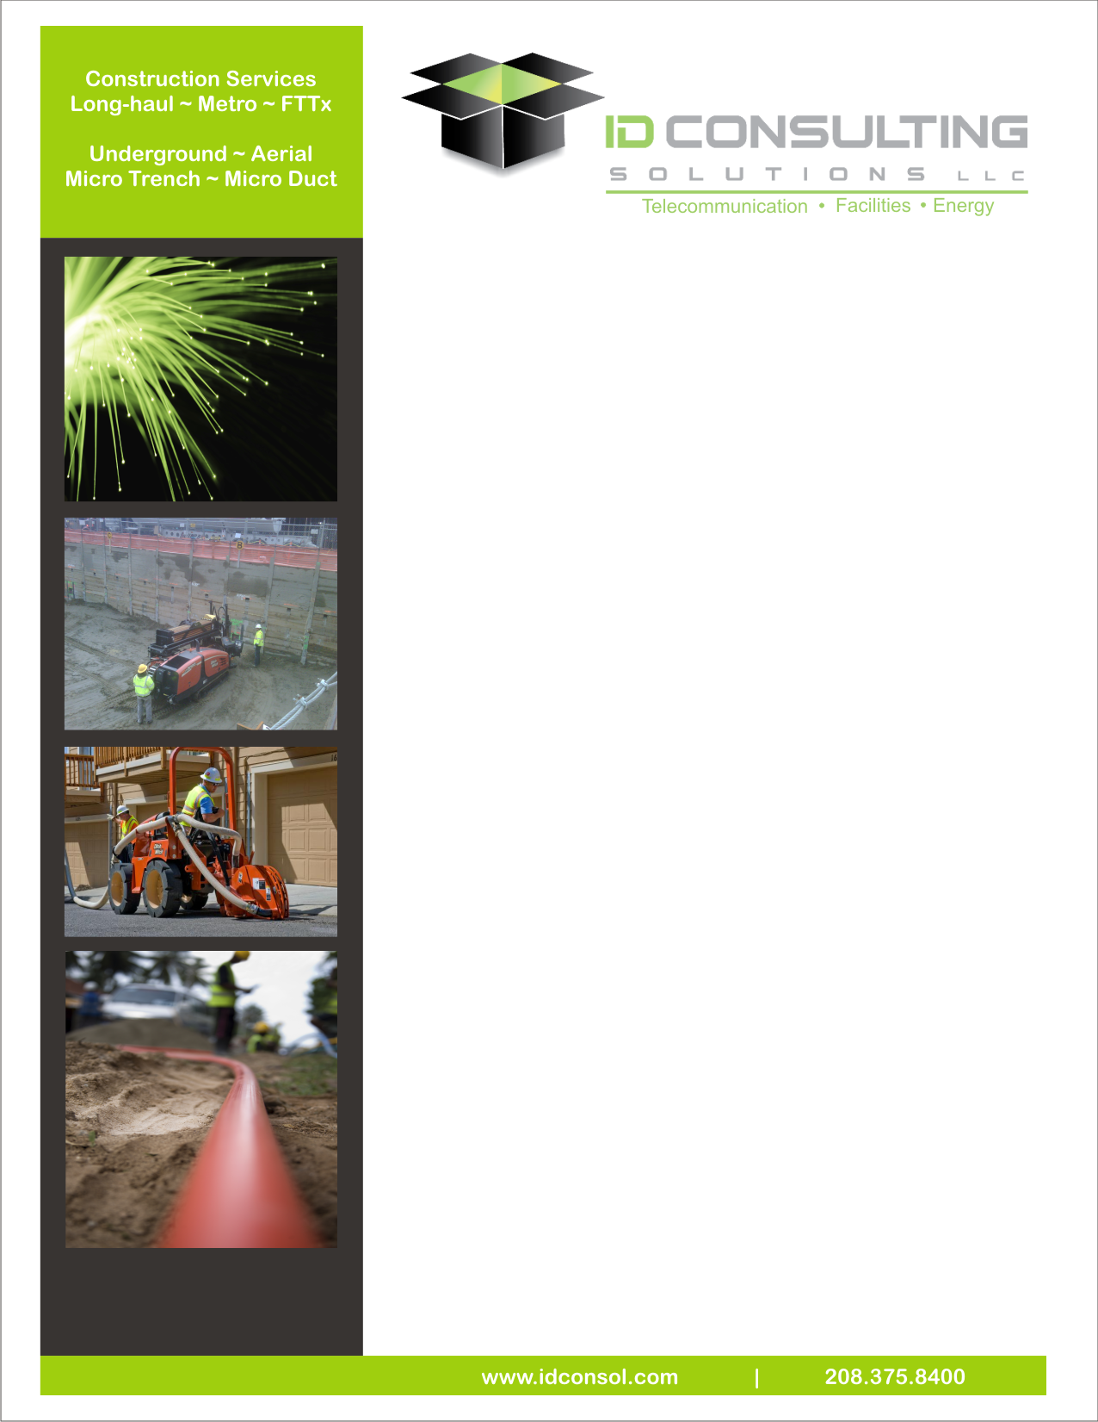

**Construction Management Services**

ID Consulting Solutions’ facilities group has extensive experience with infrastructure placement and a staff dedicated to underground/overhead fiber optic systems, wireless systems, interconnects, and hybrid cable communication systems for all aspects of rural and metro networks. Our Outside Plant team reviews the client’s goals and objectives, routing options, and permitting issues as it performs detailed route engineering. Through this process, the client can approve the options and then our team can develop construction-ready documents with sufficient detail for permitting approval and construction installation. In addition, we can provide the negotiation and acquisition of rights-of-way and private property. Our Outside Plant engineering team has expertise in:

**Construction Management Services Include:**

• Weekly meetings • Equipment & material procurement

• End-to-end construction oversight • Construction observation

• Fiber optic splicing & testing • Bid document development

•Material procurement • Contactor selections

• Procurement schedules • Budget management

• Network equipment startup • Records management

• Wireless Tower & Equipment Placement • RFP/RFQ development

• Budget monitoring • Construction Schedule

• Contractor Invoice Review • Permitting & Agency Coordination

• Weekly Progress Reports • Coordinate site safety

**Site Activities**

We provide a comprehensive approach and solution to deliver a wide range of infrastructure networks:

**Advantages:**

* Ability to mobilize quickly in market
* Ability to execute large size projects
* Competitive Pricing & Market Knowledge
* Creative approaches and solutions in middle mile applications
* Can provide budgetary pricing estimates as well as equipment and installation bids
* Ongoing support for additions, changes, and trouble shooting of existing broadband systems

We have the financial backing, best in class Insurance Coverage, best in class safety programs, and a modern fleet of vehicles and equipment to compliment our management and craft employees. Following are a few of our Support Services:

* Safety Programs – we have an in-house safety and risk management program.
* Quality Control – we monitor our QC Programs internally.
* Fleet Maintenance – Fleet maintenance and purchases are coordinated through.