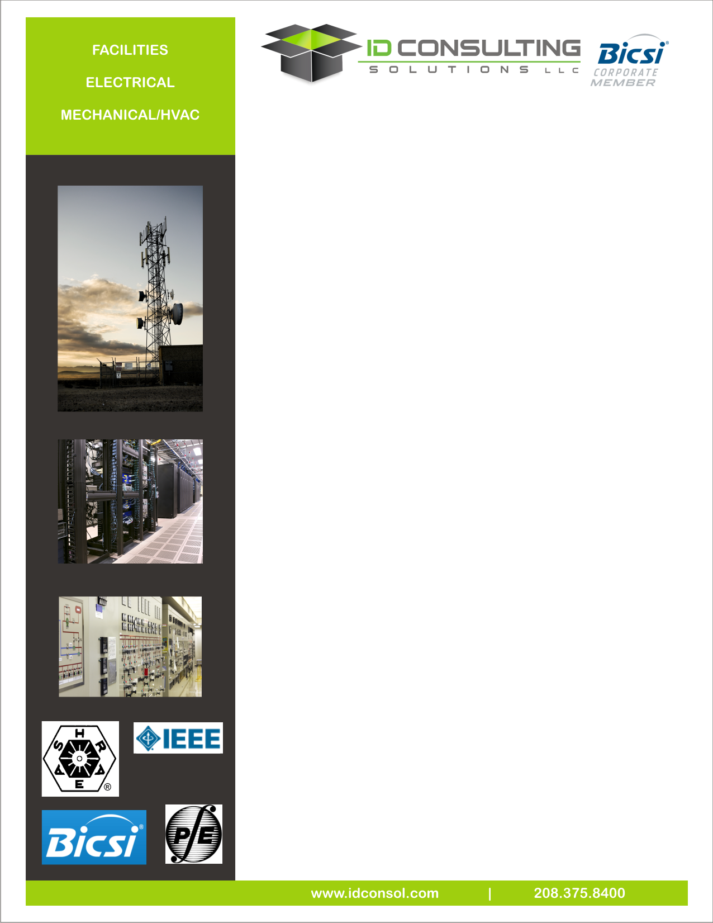

**Facilities Services**

ID Consulting Solutions’ facilities group has provided comprehensive facilities design and onsite construction management for numerous clients. In support of telecommunications networks, our team has designed point of presence centers (POPs), co-location facilities, network nodes, regeneration stations, telephone switching office relocations/upgrades, radio towers, and network building entrance links. For our clients, we are able to provide planning, engineering design, procurement and installation, and training for mechanical, electrical power and low voltage systems.

**Project Management**

Our extensive work with municipalities, utilities, commercial, and transportation clients demonstrates a broad talent for project success, including:

* Project scope development
* Multi-discipline coordination
* Cost and scope change control
* Project collaboration and secure document review
* Hazardous materials (MSDS)

**Mechanical Engineering**

Mechanical engineering is critical in the design of modern facilities. Large heat loads from technical equipment must be planned and accounted for, particularly as it relates to:

* HVAC system planning, selection and design
* Mechanical equipment specifying and procurement
* Potable water and sanitary waste design
* Building and Fire Code analysis
* Fire suppression system layout and design
* Specialized exhaust and filtration

**Electrical Engineering**

Electrical engineering will plan and provide reliable power and grounding systems for your network electronics:

* Electrical systems planning, selection and design
* Ground systems calculation and design
* Power distribution systems – 480 volt through 38kV
* Material procurement
* Construction management with full EPC delivery
* Construction budget estimates & scheduling
* Construction permitting and bid analysis
* Hazardous materials (MSDS)
* Energy codes
* Medical gas system design
* Power system over current device coordination studies
* DC power and uninterrupted power systems