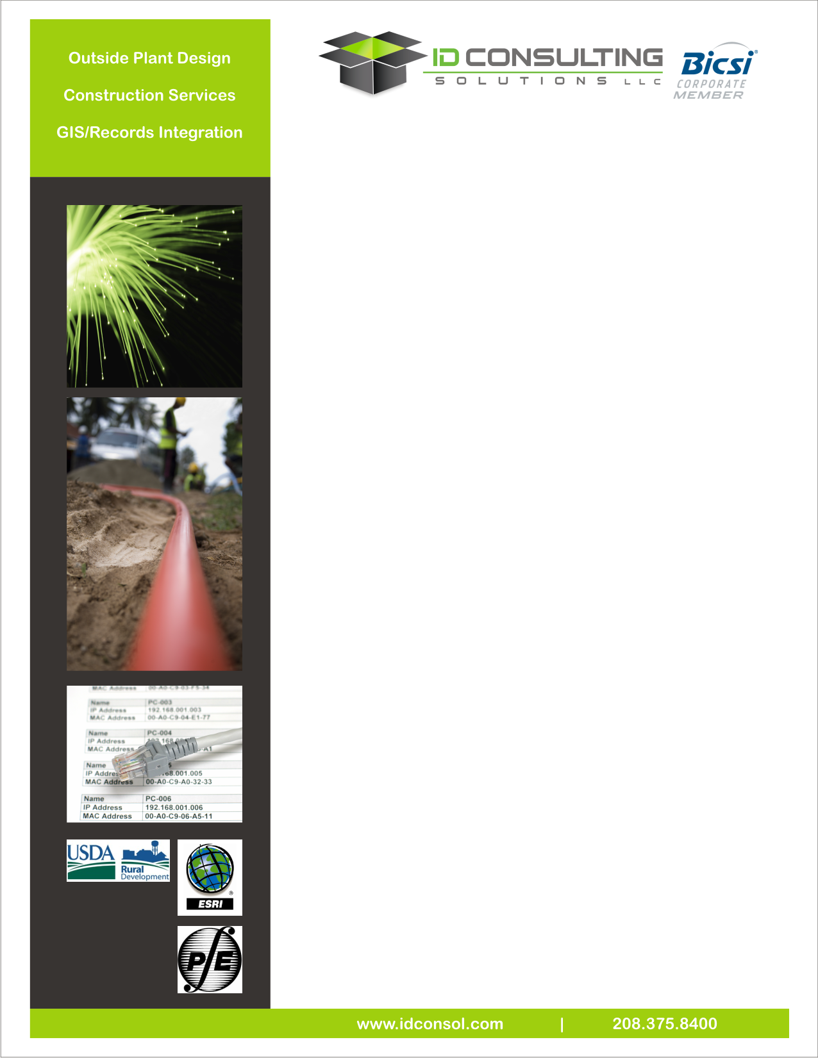

* **FTTx : Business, Home**
* **Long Haul Networks**
* **LAN Extensions**
* **Metro Fiber**
* **Private Network : Hospitals, Cities, Schools**

**Outside Plant**

ID Consulting Solutions’ facilities group has extensive experience with infrastructure placement and a staff dedicated to underground/overhead fiber optic systems, wireless systems, interconnects, and hybrid cable communication systems for all aspects of rural and metro networks. Our Outside Plant team reviews the client’s goals and objectives, routing options, and permitting issues as it performs detailed route engineering. Through this process, the client can approve the options and then our team can develop construction-ready documents with sufficient detail for permitting approval and construction installation. In addition, we can provide the negotiation and acquisition of rights-of-way and private property. Our Outside Plant engineering team has expertise in:

* Turnkey engineering & design
* Feasibility studies and route design
* Permitting rights-of-way and environmental acquisition
* Project scheduling & financial projections
* Field inventory & assets tracking
* Pole Analysis & Loading
* Detailed network and splicing schematics
* System audit development
* Material Selection & Procurement Support

**Construction Services & Construction Management**

ID Consulting Solutions has built a solid reputation for constructing and managing telecommunication projects in a wide variety of geographical markets. Our committed team of professionals consistently meets its project goals and timelines, and has a clear understanding of what it takes to ensure success for our clients. Our management team has developed an emphasis on commercial developments, wireless infrastructure, and municipal/private fiber builds and extensions.

**Construction services include:**  **Construction management include:**

• Full turnkey installation • Equipment & material procurement

• End-to-end commercial construction • Construction inspection

• Fiber optic splicing & testing • Bid document development

• Aerial construction (Strand/Lash) & (ADSS) • Contactor selections

• Fiber and copper drop placement • Budget management

• Citywide or Metro fiber builds • Records management

• Wireless placement • RFP/RFQ development

• CPE installation & in-home wiring

**Graphical Information Systems (GIS)**

GIS allows us to create interactive queries and analyses, analyze spatial information, edit and manage fiber optic systems, and display all forms of geographically referenced information. In addition to system managing, GIS allows us to easily keep track of maintenance procedures and schedules from the start of development to construction and operations.

**GIS services include:**

• Software analysis & review • Asset management

• System input support • Lease ROW management

• Ad-hoc project mapping • ESRI/EngHouse NetWorks/OSP Insight

• Equipment management • System tracking & analysis

• Inventory System • One-call information

• Environmental monitoring

• System audit & data input