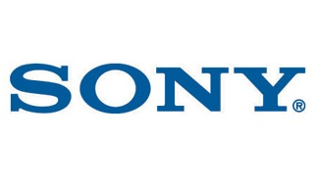cisco.png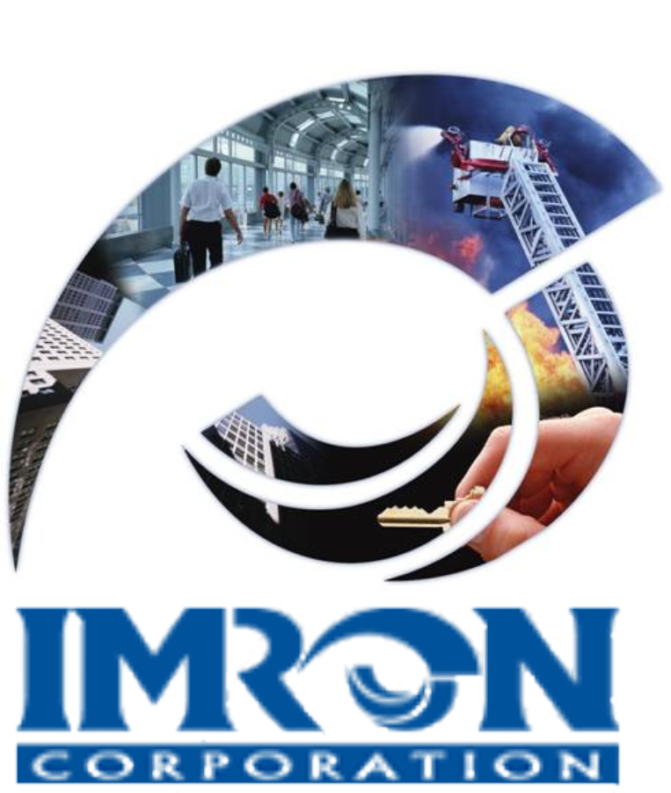IR-Schlage_Logo.gif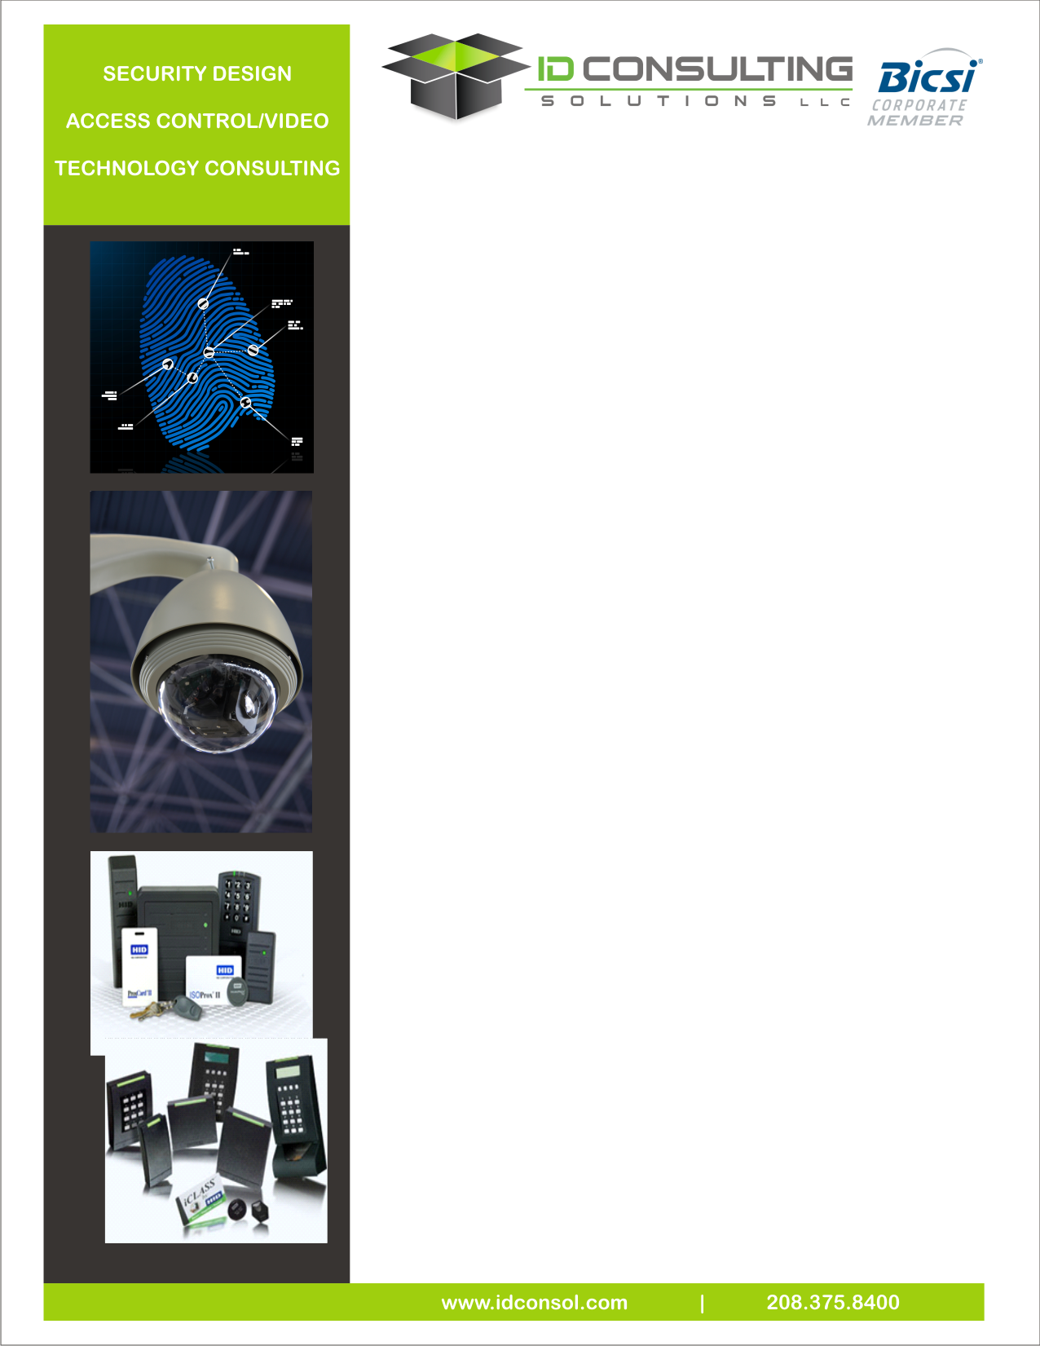

**Security and Access Controls**

Technology has created a dynamic and changing security industry. Internet Protocol (IP) devices, standard network compatible components and open access software solutions have had an enormous impact in security system selection and deployment. These innovations make installations more functional and simple, yet at the same time create new complexities. Our experienced team can partner with your organization to provide successful full turnkey project.

**Security and Technical Services**

IDCS has certified designers and technicians with numerous product vendors in the market place. We strive to stay educated and current with the latest developments in the security industry. It is critical that our clients receive a system design and installation that is tailored to their specific requirements. Our system planning, design and installation experience includes:

**Design and Planning:** IDCS has registered professional engineers and security designers and technicians possessing a knowledge base needed for implementation of today’s state of the art systems.

|  |  |
| --- | --- |
| * System selection | * Component layout |
| * System functionality | * Network design and components |
| * Drawings and specs | * Bill of materials |
| * Cost estimating * Risk Assissment | * Professional engineering |
| * Risk Assessment | * Standards Compliance |

**System Integration and Installation:** IDCS has certified IT personnel and security technicians with numerous product vendors in the market

|  |  |
| --- | --- |
| * CCTV – DVR & NVR | * Perimeter Detection |
| * IP Cameras | * Access Control |
| * Wireless/Mesh | * Security Systems |
| * Video Analytics | * Bio-Cards |
| * Biometrics | * RAID/SAN Storage |
| * Network Electronics | * Failover systems |
| * UPS power | * Wireless components |

Our team has design and integration experience in many industry sectors. These include:

|  |  |
| --- | --- |
| * Airports | * Higher Education |
| * Highways/Railroad | * Medical Campuses |
| * Commercial Business | * Utilities / Substations |
| * Data Centers | * Telecom Tower Sites |
| * K -12 Education | * Municipalities |
| * Metro Networks | * Radio Towers |

Security and Access Controls Systems