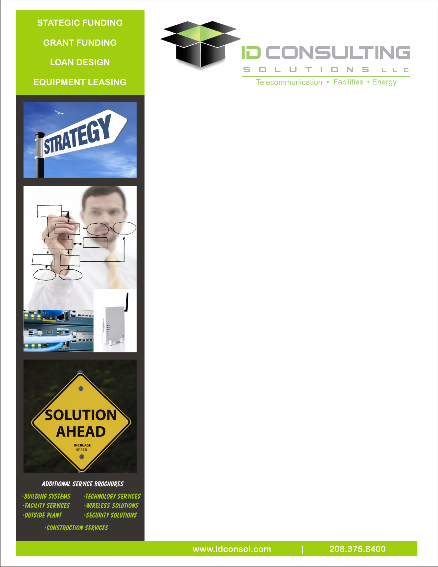

**Strategic Solutions**

IDCS realizes every next-generation network poses unique and individual characteristics. Thus, IDCS develops clear and specific initiatives, evaluates the market’s business potential for offering advanced broadband services on a sustainable basis, and understands what asset resources will be critical to a successful deployment. IDCS provides the experience and resources for a turn-key deployment that includes:

* Initiative Planning
* Business Structure & Governance
* Network Design & Engineering
* Facility Design & Engineering
* Technology Design & Engineering
* Financing Facilitation
* Construction & Project Management
* Network & Marketing Training
* Storage Area Networks (Off-site or On-site)

**Technical Solutions**

Technology agnostic, IDCS designs both active Ethernet and GPON next-generation networks.  These advanced networks provide the platform for existing applications, such as High-Definition videoconferencing, distance learning applications, Tele-medicine, and Virtual Private Networks.

IDCS also has extensive experience designing, deploying and integrating other technology solutions and systems into the broadband infrastructure, resulting in a cohesive platform for new, existing, and developing applications. As an example, the Next-Generation Network could serve as the single transport foundation for delivering a wireless overlay network, to offer mobility, public safety, traffic control and first responder applications. Utility organizations can also layer AMR/AMI technologies (electric, gas and water) over the Next-Generation network for “smart-grid” and “green energy” uses.

Our Technology Strategy considers the core applications, available resources, new equipment specifications, installation requirements, migration schedule and service offering schedule, resulting in a comprehensive, scalable solution.

**Funding Solutions**

To position your project with the greatest appeal to the current capital markets, ID Consulting Solutions (IDCS) offers industry-tested expertise for upgrading your Company’s business structure and corporate governance model. Our expertise has been especially helpful to clients seeking to qualify for the following financing mechanisms:

* Federal and State Grant and Loan Programs (including ARRA Funding)
* Municipal Bond Financing
* Municipal and Corporate Leasing Programs

Additional Financial Assistance Services include:

* Taxable Corporate Bond Financing
* Anchor Tenants
* Strategic Partners
* Private Security Markets
* Bank and Non-Bank Lending Methods

**Leasing Solutions**

With limited capital funds; due to economic relief to the market, specific projects continue to be critical where creative leasing maybe the choice for the next phase of deployment, help lower immediate asset expenditures with lower exposure and tax benefits. :

* Competitive Terms
* Flexible Funding Approaches
* Short Term Capital Options
* Emergency Solutions with Limited Capital