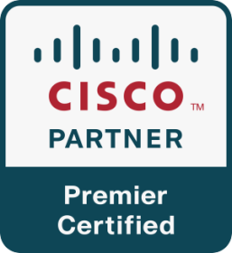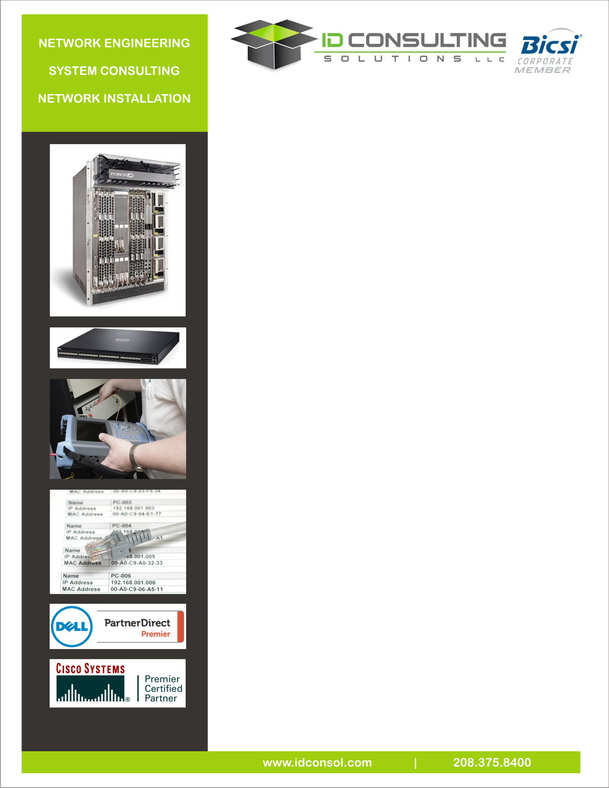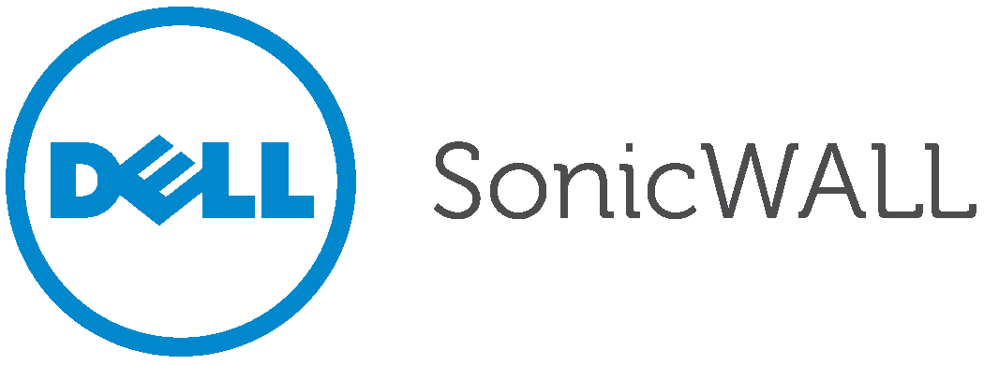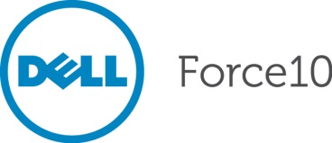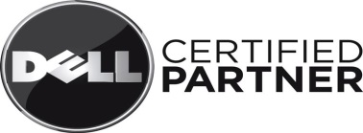MicroSoft.tifAlliedTelesis.gif

**Technology Systems**

The increasing complexities in managing and supporting large and diverse network infrastructures that power today’s network operations require efficient and cost-effective management solutions. With our proven expertise in managing hundreds of thousands of voice and data ports and network elements for wireless, wireline, optical, and enterprise networks around the world, ID Consulting Solutions delivers network operations services that are designed to manage complicated multi-vendor and multi-technology network environments.

The challenge of reducing operating costs while maintaining and improving existing service levels and overall customer satisfaction is fundamental to securing a competitive edge in today’s marketplace. To meet these challenges, ID Consulting Solutions provides reliable, end-to-end network management solutions aimed at reducing operating expenses, ensuring predictable service levels, and increasing revenues and customer satisfaction.

**Technology Systems Services include:**

|  |  |
| --- | --- |
| * Network Engineering | * Radio Frequency Engineering |
| * Virtualization | * Systems Audits and Diagnostic Testing |
| * Enterprise Server Solutions | * Data Center Design |
| * Microsoft Solution Integration | * Managed Operations |
| * IT Managed Services | * Storage Area Networks |
| * WiFi Integration * Desktop Virtualization (VDI) * Collaboration Solutions | * System Installation and Provisioning * Unified Communications * Penetration Testing |

**Network Engineering**

The network engineering team can analyze network traffic and data demand requirements to design the most viable electronic transport, distribution, and interface solutions. These solutions will be tailored to support the client’s goals and objectives while meeting both current and future demand requirements.

**Information Technology Services include:**

* Turnkey integration and system provisioning
* Analysis of existing systems and design requirements for current and future services
* Design of transport, interface, and network support systems
* Design and integration of Enterprise solutions
* Prepare budgetary pricing estimates as well as equipment and installation bids
* Equipment installation testing and turn-up

**Product Vendor Integration**

Our team has a large network of relationships and project experience that allows our team to review a large selection of equipment vendors for a project with a focus on warranties, operational experience, vendor stability, capital costs, and ongoing upgrades.