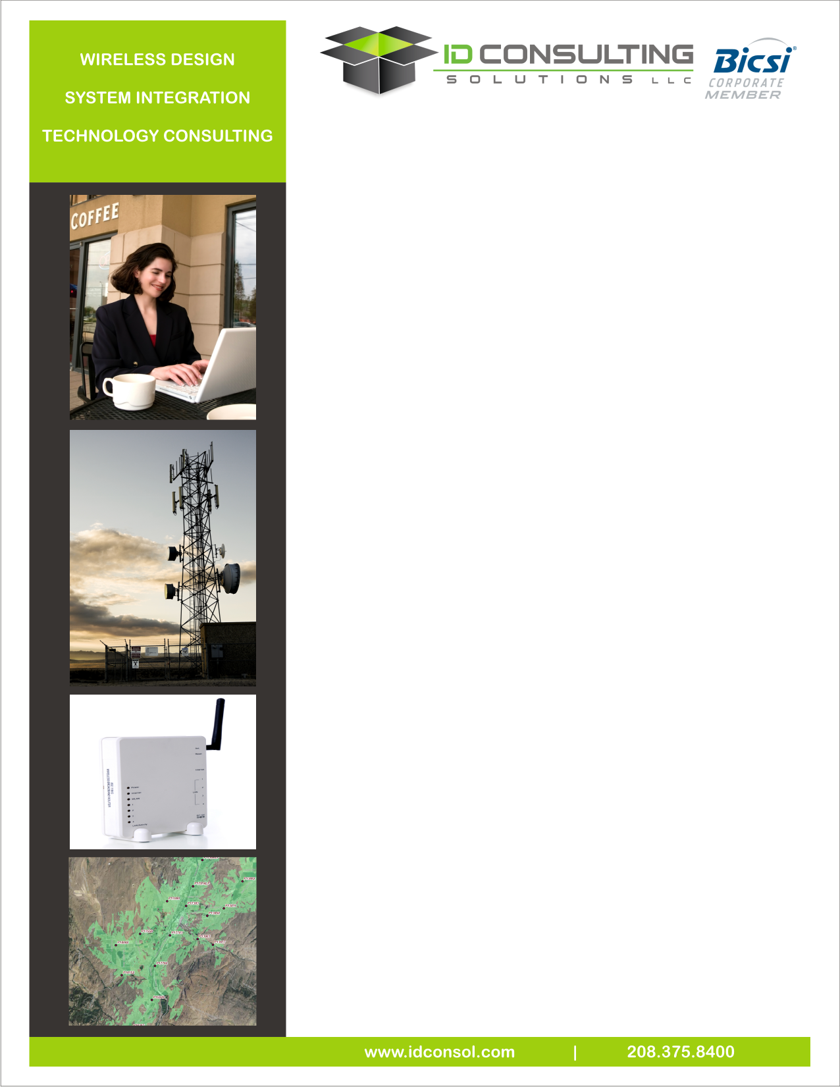

* Indoor Wi-Fi
* Indoor DAS
* Outdoor Parks
* Outdoor Rest Areas
* Outdoor City-wide
* Public and/or Private
* Open Access
* Closed System

We can help develop an approach, planning the system and integrate a solution that meets your needs!

**Wireless Systems**

ID Consulting Solutions’ offers a broad range of wireless communications services on wireless systems, including point-to-point backbone and distribution, point-to-multipoint, microwave, public safety emergency networks, cellular and special applications. Our team strives to stay current with all public and private applications, emerging solutions, FCC licensing, and new technology. The design team focuses on current and future service requirements, bandwidth requirements, frequency options, and review site location(s) requirements. Typical with most projects, our team will complete a thorough propagation study, review interference potentials, and examine FCC requirements.

The engineering team can analyze network traffic and data demand requirements to design the most viable electronic transports and interface solutions. These solutions are designed to handle both current and future demand requirements.

**Wireless Services include:**

* Turnkey engineering and design
* Turnkey site acquisition and construction
* Feasibility studies and path analysis
* Permitting, rights-of-way, and environmental acquisition
* Site design, survey, and facility layout
* Equipment selection and procurement
* System provisioning
* System audit development
* RFID network design and implementation
* Material development

**Radio Frequency Engineering**

* Microwave path profile and Fresnel analysis
* Radio interference mitigation
* RF heat mapping
* Radio frequency coordination
* 802.11x/802.16x network architecture and development
* FCC permitting and reports
* Analysis of existing systems
* Design requirements for current and future services
* Design broadband transport, interface, and network support systems
* Prepare budgetary pricing estimates
* Prepare equipment and installation bids
* Oversight and support of equipment installation testing and turn-up
* Ongoing support for additions, changes, and trouble shooting of existing broadband systems

**Public Safety & P25 Development**

The building of secure networks—especially in the case of public agencies that require interoperability for existing systems—demands a team of experts that can understand and prepare detailed and economical designs. Whenever necessary, IDCS never hesitates to supplement its core team of engineers with experts in those specific technology fields that will add valuable experience, including:

• Voice engineering • Interoperability engineering

• Equipment engineering • Software engineering

• Wireless engineering