Appendix A.
Materials and Guides
Pre-Screening Task
Pre-Screening Task (online):
In this study you will be asked to complete several tasks in different statistical software packages, including importing a dataset, creating a new column/variable, and taking the mean average of a variable. You will be given a guide (with screenshots) for each software.

- Novice (no experience; would rely heavily on the guide to complete the tasks, may need external support)
- Intermediate Beginner (some experience; would be able to complete the tasks using the guide)
- Advanced Beginner (some independence; would only need to use the guide for reference)
- Proficient (independent use; would likely be able to complete the tasks without the guide)
- Skilled (somewhat regular use; would be able to complete the tasks easily without the guide)

- Based on the listed tasks, how would you rank your ability with the following statistical software packages?
  - SPSS: _____
  - R/R Studio: _____
  - Jamovi: _____

Demographics and General Information
Demographic Information:
- Age:
- Date of Birth [MM/DD/YYYY]:
- Gender:
  - Male
  - Female
  - Non-Binary
  - Prefer not to answer

- Which of these groups would you say best describes your racial background?
  - American Indian/Alaska Native
  - Asian
  - Native Hawaiian or Other Pacific Islander
  - Black or African-American
  - White
  - More than one race (Specify: ___________________)
  - Other (Specify: ___________________)
  - Prefer not to answer

- Which of these groups would you say best describes your ethnicity?
  - Hispanic or Latino/a/e/x
  - Not Hispanic or Latino/a/e/x
  - Prefer not to answer

- What is your current college grade level?
  - Freshman
  - Sophomore
  - Junior
  - 4th-year Senior
  - 5+ year Senior

- What is your current major?
  - Psychology
  - Sociology
  - Political Science
  - Economics
  - Arts (specify: ___)
  - Humanities (specify: ___)
  - Other (specify: ___)

General Information:
- If you have previous SPSS experience, where did you gain that experience?
  - I do not have any previous SPSS experience
  - High School course
  - Undergraduate course at UCR
  - Undergraduate course elsewhere
  - Other (specify)

- Have you heard of R/RStudio before?
  - Yes
  - No

- Have you heard of Jamovi before?
  - Yes
  - No

- Are you taking any courses in the upcoming calendar year that teach or use [R/Jamovi]?
  - Yes
  - No
  - Unsure

- Do you have any experience with coding/programming?
  - Yes
  - No
If yes:
- What languages (Javascript, C++, python, etc.): ______
- How many years of experience? _____
- Where did you gain this experience? _____

- What is your level of experience with Microsoft Excel?
  - Novice (little to no experience)
  - Intermediate Beginner (some experience)
  - Advanced Beginner (some independence)
  - Proficient (independent use)
  - Skilled (somewhat regular use)

- Which computer operating system are you more familiar with?
  - Mac OS
  - Windows

Pre-Task Questionnaires
To be completed before the RStudio task:
Motivation Questionnaire [pre-test]:
- How motivated are you to complete the following task in RStudio? Please rate your motivation on a scale from 1-10.
1 = not at all motivated - - - - - - - - - - - - - - - - - - - - - - - - - - - 10 = extremely motivated

- How motivated are you to learn about and use RStudio in the future? Please rate your motivation on a scale from 1-10.
1 = not at all motivated - - - - - - - - - - - - - - - - - - - - - - - - - - - 10 = extremely motivated

To be completed before the Jamovi task:
Motivation Questionnaire [pre-test]:
- How motivated are you to complete the following task in Jamovi? Please rate your motivation on a scale from 1-10.
1 = not at all motivated - - - - - - - - - - - - - - - - - - - - - - - - - - - 10 = extremely motivated

- How motivated are you to learn about and use Jamovi in the future? Please rate your motivation on a scale from 1-10.
1 = not at all motivated - - - - - - - - - - - - - - - - - - - - - - - - - - - 10 = extremely motivated

Post-Task Questionnaires
To be completed after the RStudio task:
Motivation/Effort Questionnaire:
- What degree of effort did this task require of you?
Please rate the level of effort on a scale from 1-10.
1 = small amount of effort - - - - - - - - - - - - - -- - - - - 10 = large amount of effort

- How motivated are you to learn about and use RStudio in the future? Please rate your motivation on a scale from 1-10.
1 = not at all motivated - - - - - - - - - - - - - - - - - - - - - - - - - - - 10 = extremely motivated

To be completed after the Jamovi task:
Motivation/Effort Questionnaire:
- What degree of effort did this task require of you?
Please rate the level of effort on a scale from 1-10.
1 = small amount of effort - - - - - - - - - - - - - -- - - - - 10 = large amount of effort

- How motivated are you to learn about and use Jamovi in the future? Please rate your motivation on a scale from 1-10.
1 = not at all motivated - - - - - - - - - - - - - - - - - - - - - - - - - - - 10 = extremely motivated

Task Guide for SPSS:

Please complete the following three tasks in SPSS. You may complete them through any method you choose. See attached guide for further detailed instructions for each task.

Task 1: Import the dataset titled “data_test_scores_SPSS.csv”
Task 2: Add a new variable (in a column) titled “diff” that takes the difference of the two
other columns (test scores).
Task 3: Calculate the mean (average) of the “diff” variable.

This data is a set of 20 people whose scores were recorded on two different tests. The data has three columns, showing their subject number, score on test 1, and score on test 2.

Your final answer should be: 6.25
If you do not get this answer, you can continue to make attempts for the remainder of the allotted time.

Task 1: How to import a dataset
- Click on “File”, select “Import Data” then select “CSV Data”.
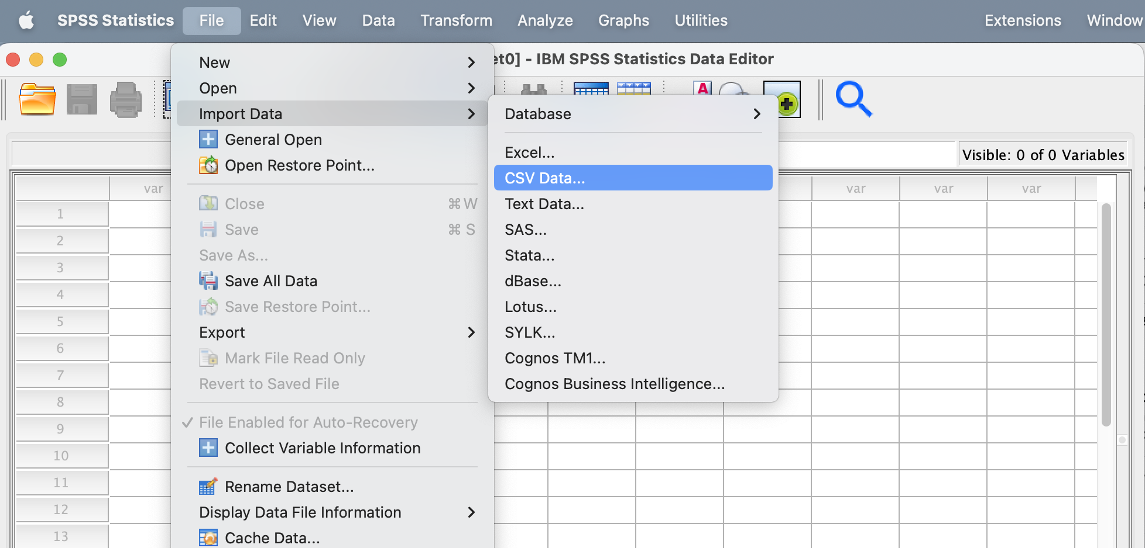

- Select the file titled “data_test_scores_SPSS.csv” and click “Open”.
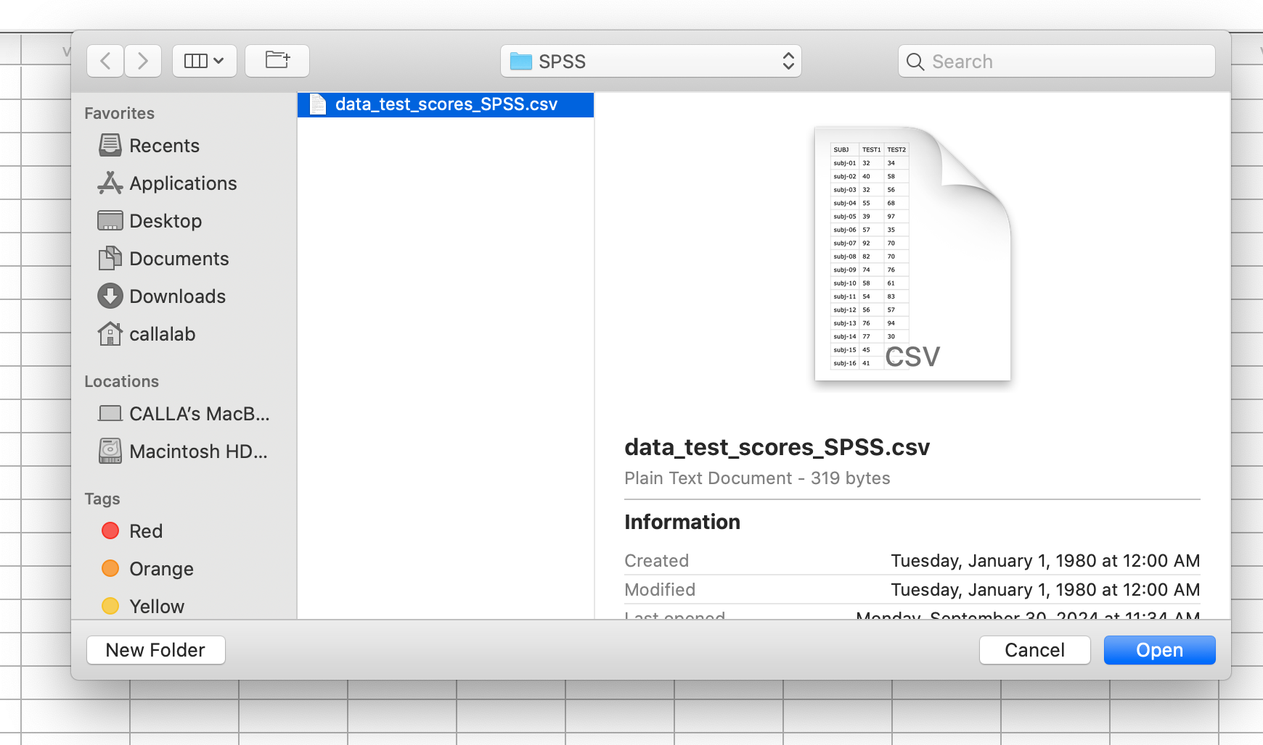

[continued on the next page]

- A new window will open called “Read CSV File”. Hit “OK” to close the window.
[It may take a moment for SPSS to pull up this new window]
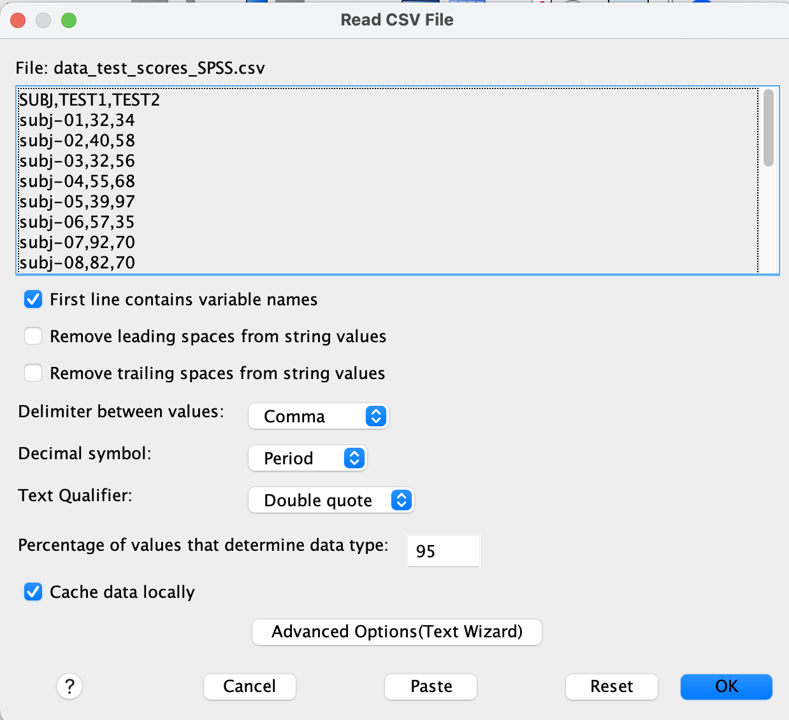

- Minimize (yellow button) or move the “IBM SPSS Statistics Viewer” window.
[If this window does not appear, simply continue to the next step]
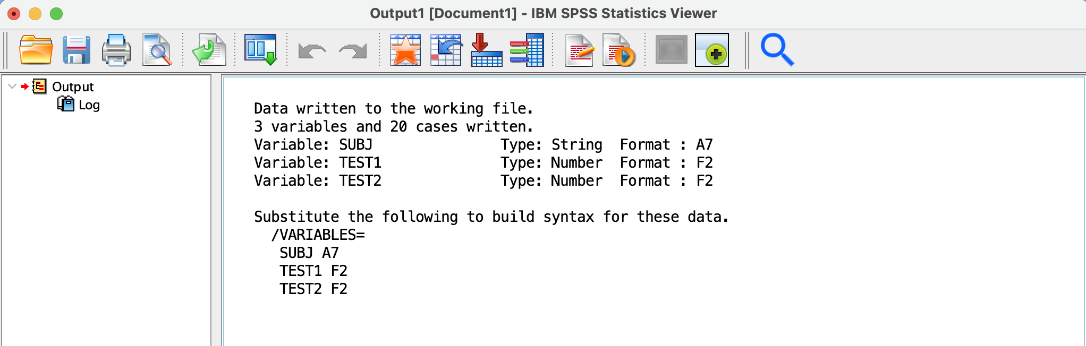

- You will then see the data open in another window.
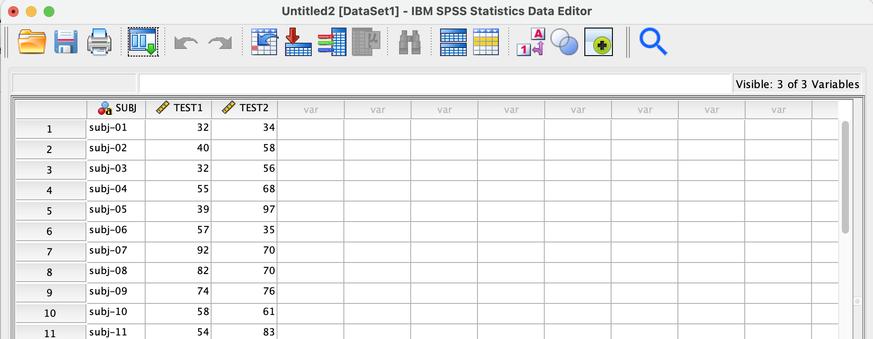
Task 2: How to add a new column variable to an existing data frame and calculate the new values within that variable:
- Select the “Transform” tab. Then select “Compute Variable”. A new window will pop up.
[It may take a moment for SPSS to pull up this new window]

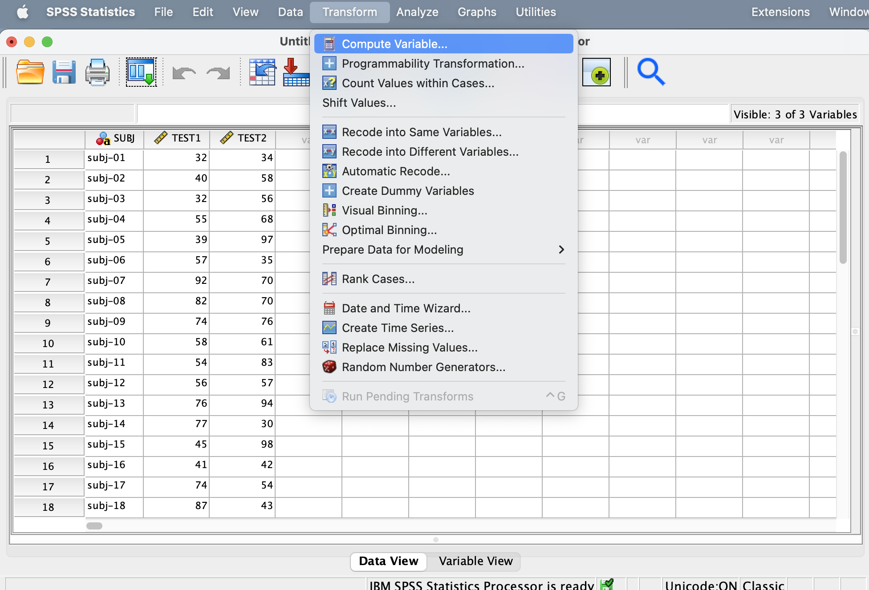

[continued on the next page]
- On the “Compute Variable” window there is a box labeled “Target Variable” (upper left corner). In the “Target Variable” section, type “diff”.

- The “Computer Variable” window also has a “Numeric Expression” section. In the “Numeric Expression” type “TEST2 - TEST1”. Once all information has been inputted, select “OK”.
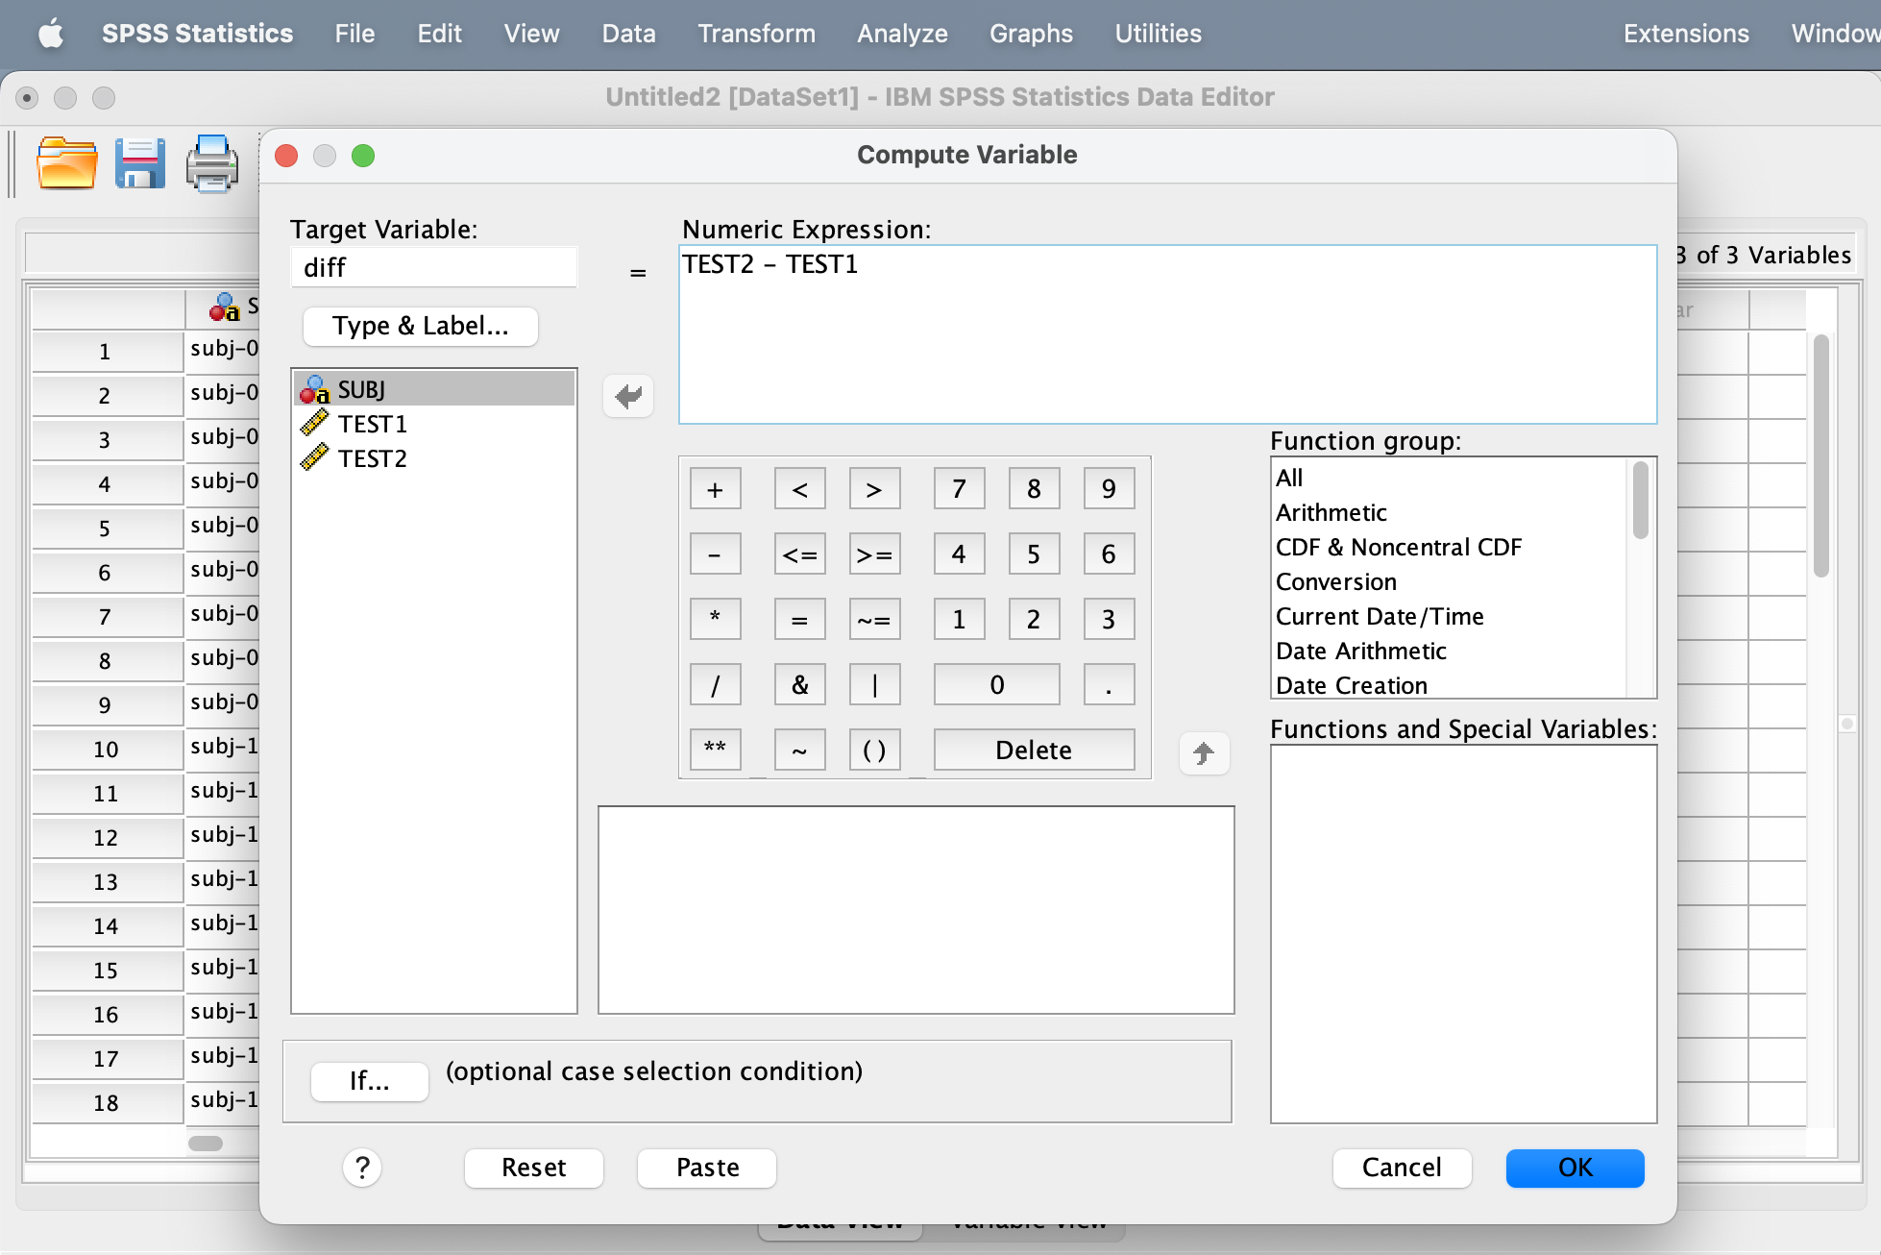

- Select “OK” to minimize the window. The new column “diff” should appear.

Task 3: How to calculate the mean (average) of a variable (column):

- Select the “Analyze” tab. From the menu, select “Descriptive Statistics” then select “Descriptives”, which will allow a new window (“Descriptives”) to appear.

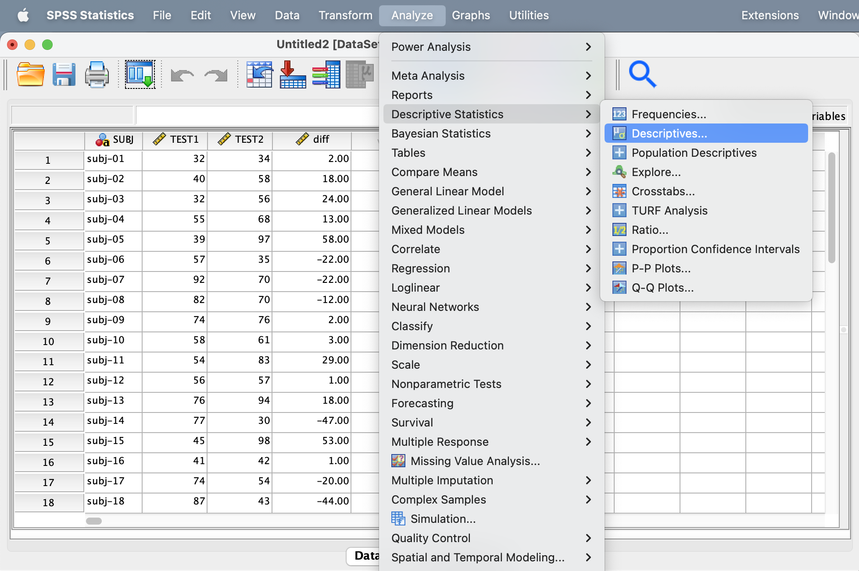

[continued on the next page]

- On the “Descriptives” window, click on the “diff” text to highlight it. Once highlighted, hit the blue arrow icon. This will transfer “diff” into the “Variables” text box. Hit “OK” to close the window.
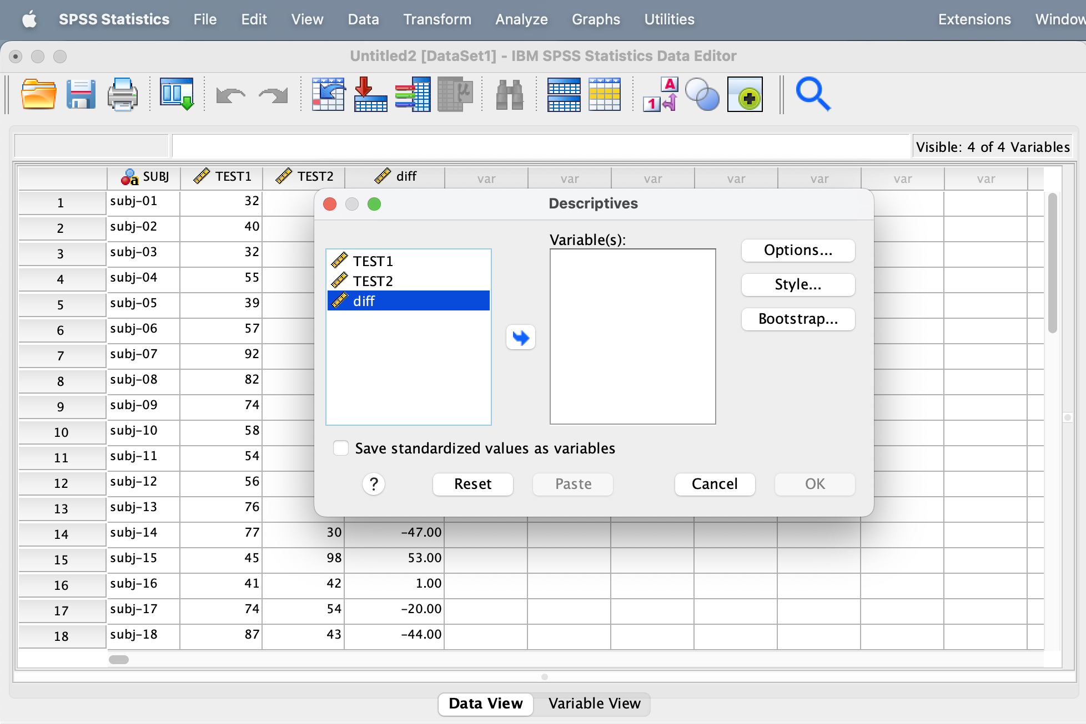

- A new window will appear with a table labeled “Descriptive Statistics”. You will now see the value that corresponds to the “Mean” of the data.
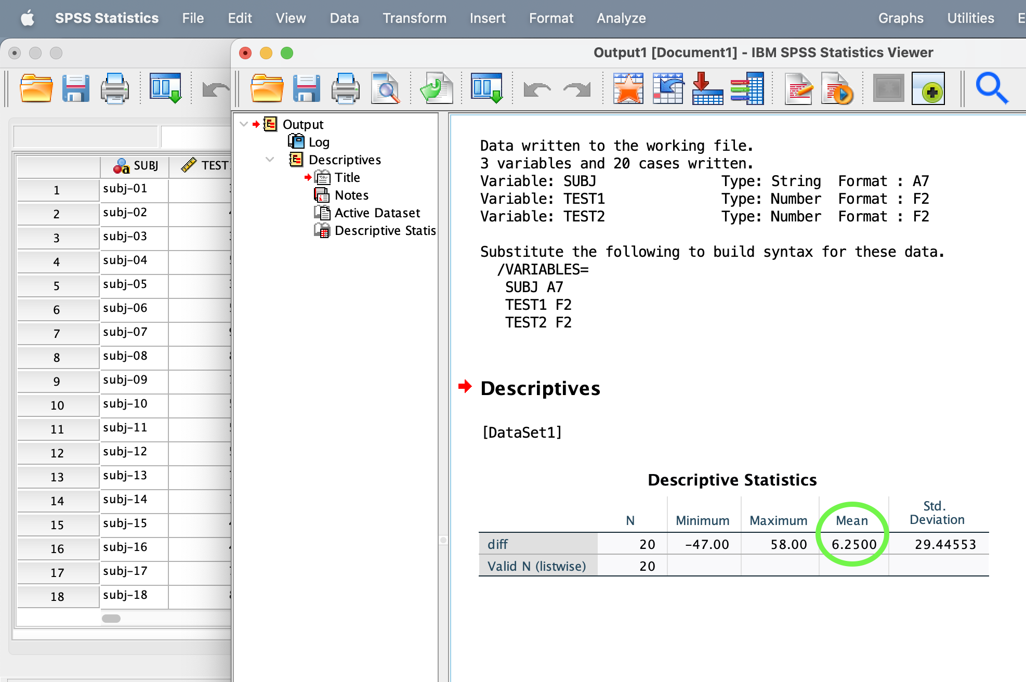

Task Guide for RStudio:

Please complete the following three tasks in RStudio. You may complete them through any method you choose. See attached guide for further detailed instructions for each task.

Task 1: Import the dataset titled “data_test_scores_R.csv”
Task 2: Add a new variable (in a column) titled “diff” that takes the difference of the two
other columns (test scores).
Task 3: Calculate the mean (average) of the “diff” variable.

This data is a set of 20 people whose scores were recorded on two different tests. The data has three columns, showing their subject number, score on test 1, and score on test 2.

Your final answer should be: 0.35
If you do not get this answer, you can continue to make attempts for the remainder of the allotted time.

In RStudio, you write lines of code and then run these lines of code.

Task 1: How to import a dataset (from .csv):

- In the “WorkPage1” window, type the line of code that is shown below.

data <- read.csv("data_test_scores_R.csv")

This line of code will import the .csv file:

Additional information about each element of the line of code:
- data is the name of the new data frame (you can give your data frame any name you want)
  - A data frame is the structure R uses to store data values
- the <- arrow symbol “assigns” whatever is on the right side of the arrow to the left side of the arrow.
  - For example, if you wrote “value_x <- 5” the number 5 would be assigned to a new variable called “value_x”
- read.csv is the name of the function that reads a .csv file
- ("data_test_scores_R.csv"): The name of the file you are trying to read is written out within parentheses and double quotation marks.

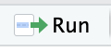
- Run this new line of code that you have written, by highlighting it and clicking

- After you click run, a new object will show up in the “Environment” window (top right) of the screen.

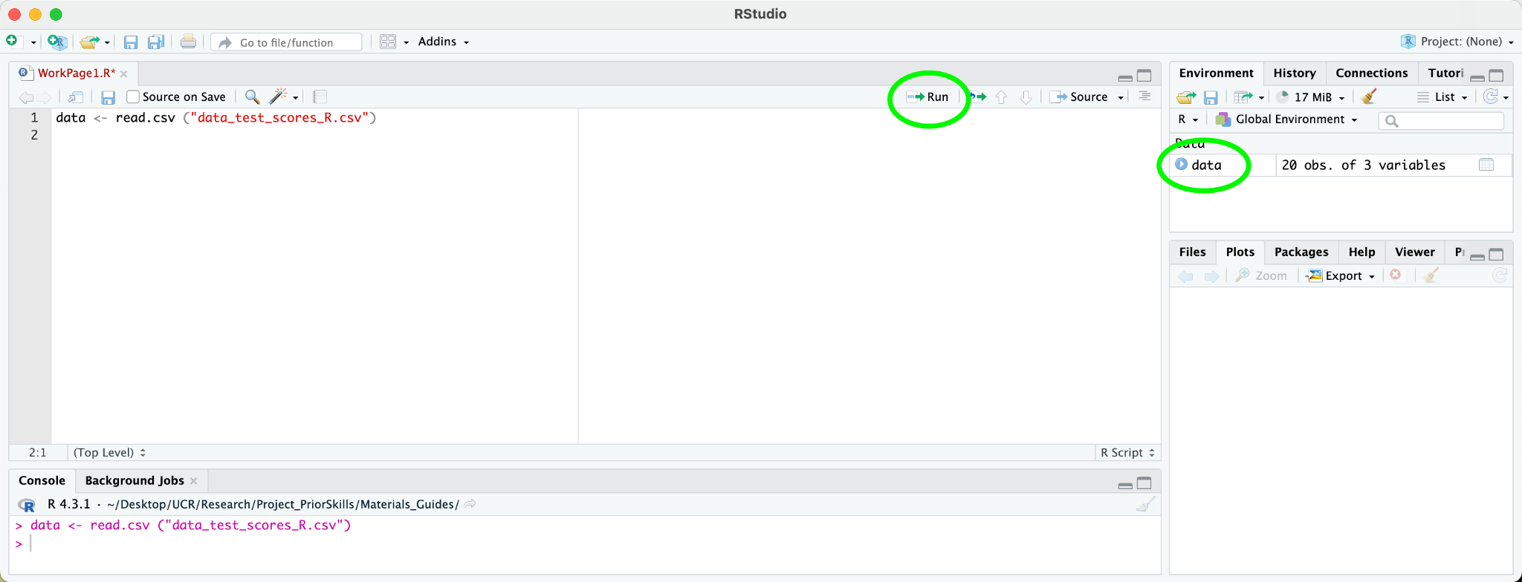

[continued on the next page]
- Click on “data” in the Environment window to view the data frame, which will show up in a new tab.

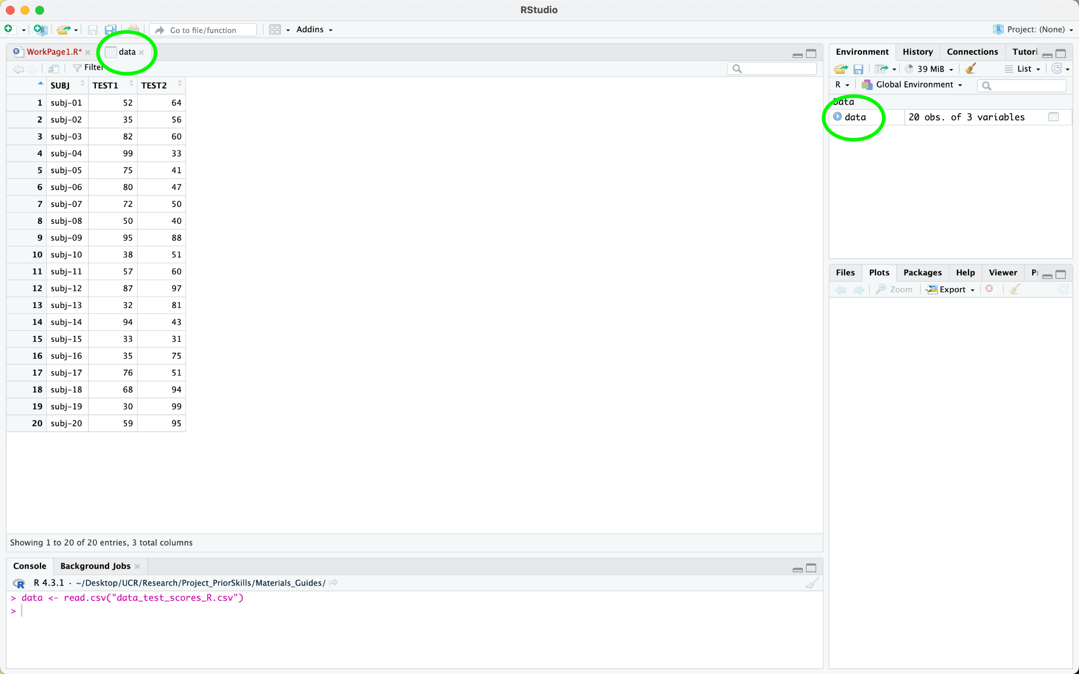
Task 2: How to add a new column variable to an existing data frame and calculate new values within that variable.

- Click back onto the “WorkPage1” tab.
- In the next line, type the new line of code as shown below:

data$diff <- data$TEST2 - data$TEST1

This line of code creates a new column called “diff” that takes the difference (subtraction) of two other columns.

Additional information about each element of the line of code:
- data is the name of our data frame
- data$diff selects the column called “diff” from the data frame “data”. Because this column doesn’t exist yet, it is automatically created.
- the <- arrow symbol “assigns” whatever is on the right side of the arrow to the left side of the arrow.
- data$TEST1 selects the column “TEST1” from the data frame “data”
- data$TEST2 selects the column “TEST2” from the data frame “data”


- Run this new line of code that you have written, by highlighting it and clicking

- The data sheet should now have a new column labeled “diff” as shown below:

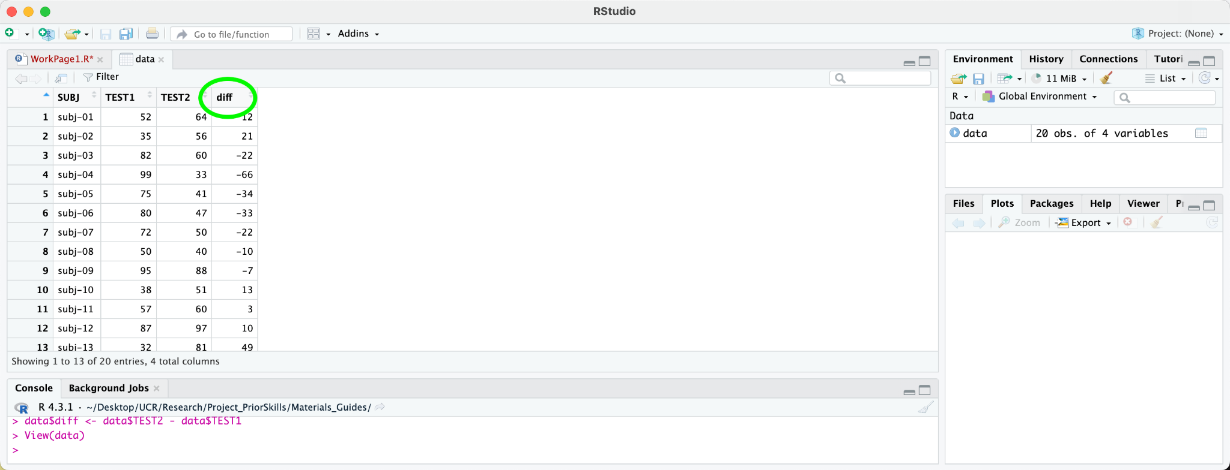

Task 3: How to calculate the mean (average) of a variable (column)

- Click back onto the “WorkPage1” tab.
- In the next line, type the new line of code as shown below:

mean(data$diff)

Additional information about each element of the line of code:
- mean is the name of the function that calculates mean
- data$diff selects the column called “diff” from the data frame “data”

- Run this new line of code that you have written by highlighting it and clicking

- When you run this line of code, the output will show up in the “Console” window (bottom left) of the screen.

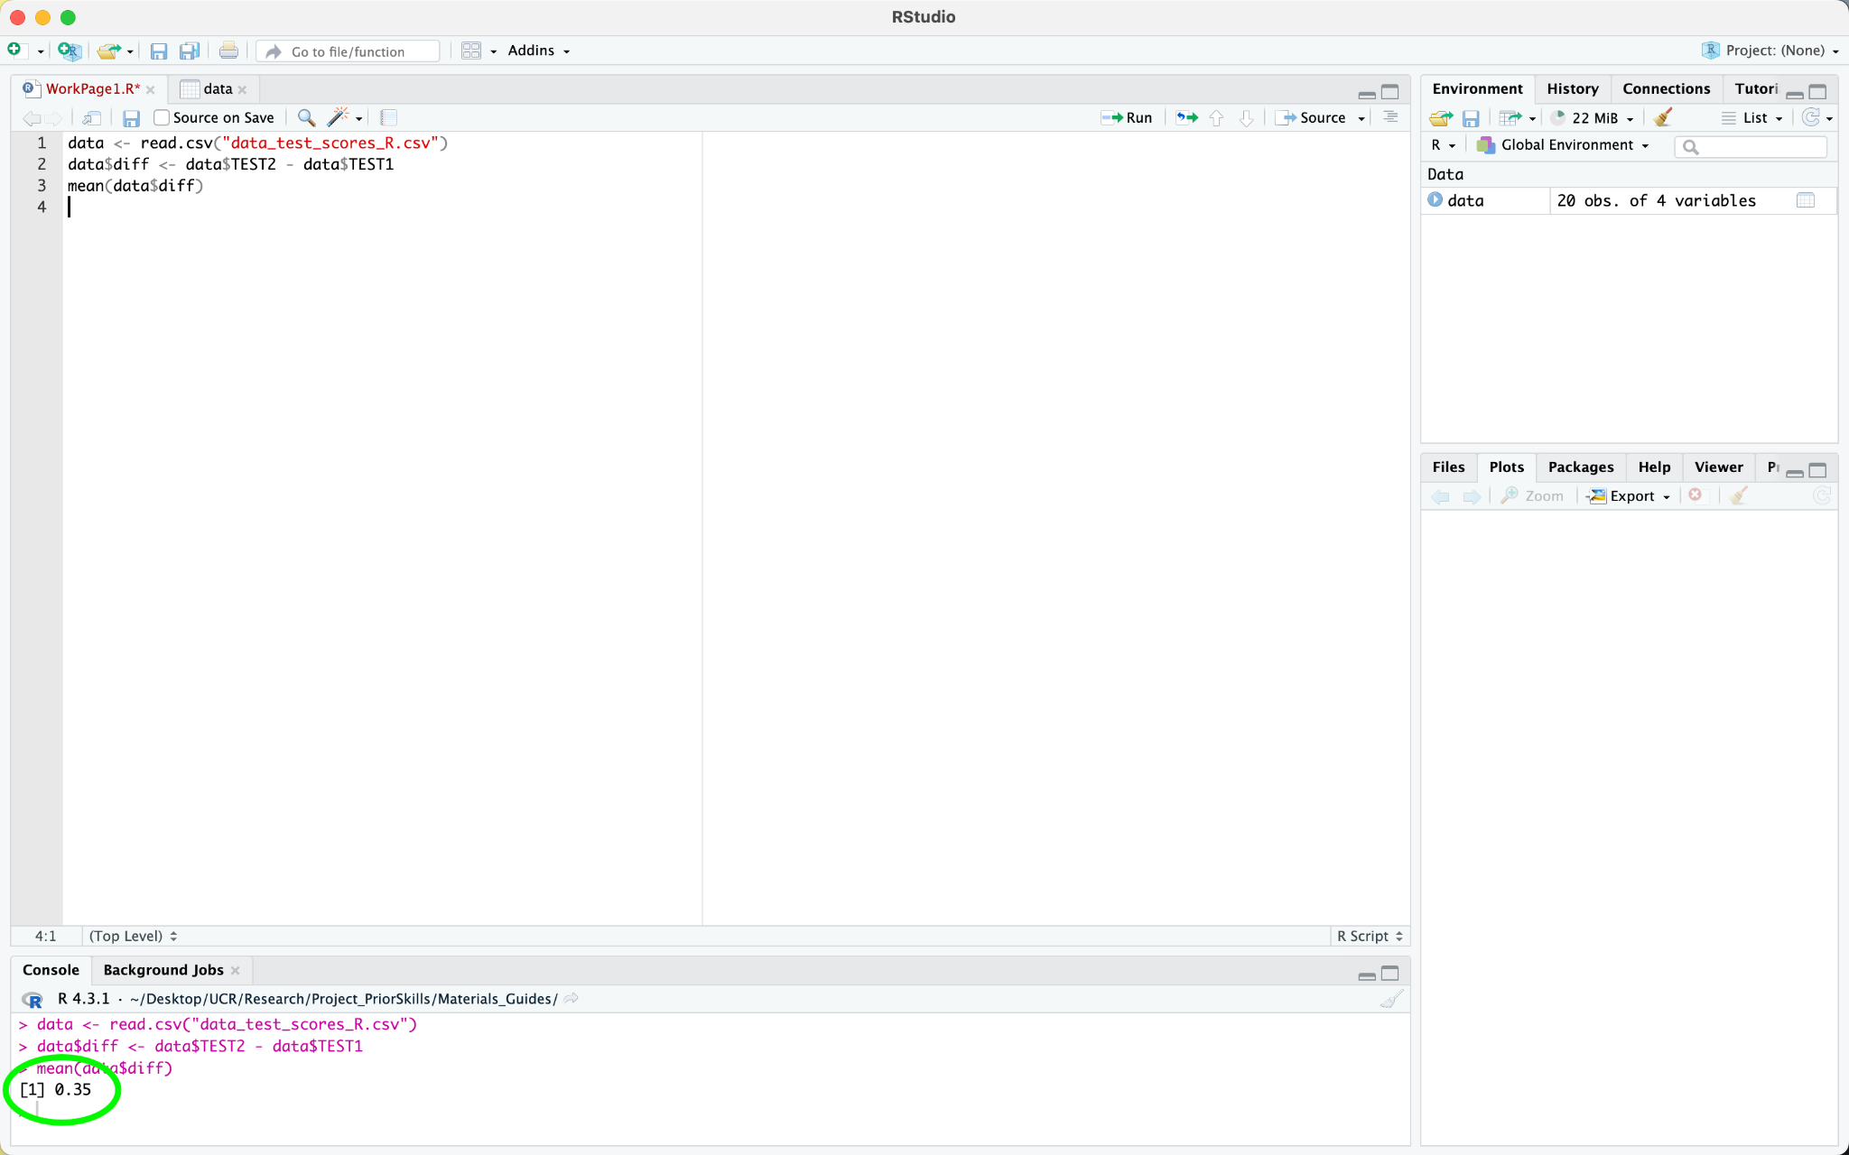

Task Guide for Jamovi:

Please complete the following three tasks in Jamovi. You may complete them through any method you choose. See attached guide for further detailed instructions for each task.

Task 1: Import the dataset titled “data_test_scores_Jamovi.csv”
Task 2: Add a new variable (in a column) titled “diff” that takes the difference of the two
other columns (test scores).
Task 3: Calculate the mean (average) of the “diff” variable.

This data is a set of 20 people whose scores were recorded on two different tests. The data has three columns, showing their subject number, score on test 1, and score on test 2.

Your final answer should be: -7.9
If you do not get this answer, you can continue to make attempts for the remainder of the allotted time.

Task 1: How to import a dataset
- Upon initial opening of software, a spreadsheet will be presented.

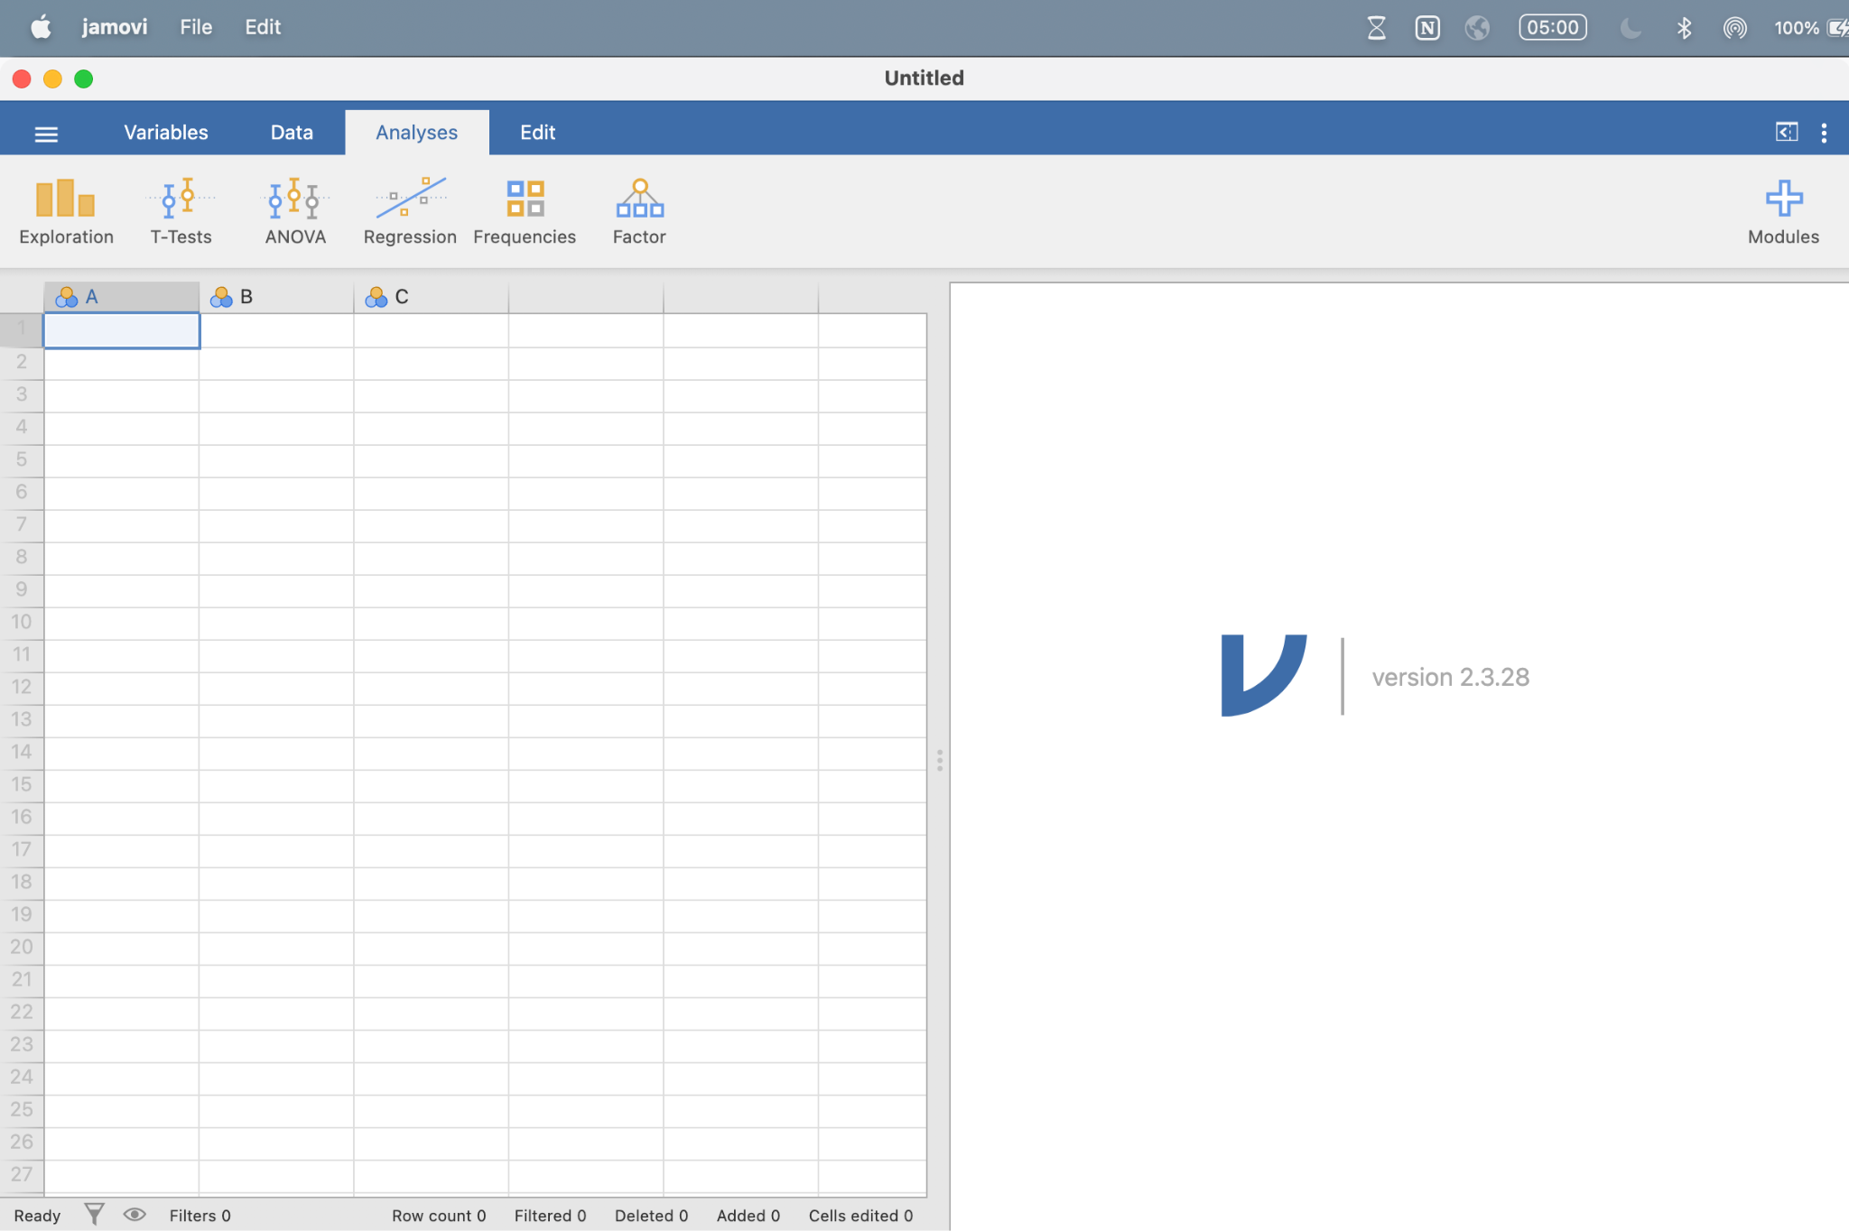

- Click on the Sidebar (upper left corner) and select “Open” then select “This PC”. Under this section, select the file titled “data_test_scores_Jamovi.csv”. The data will appear.
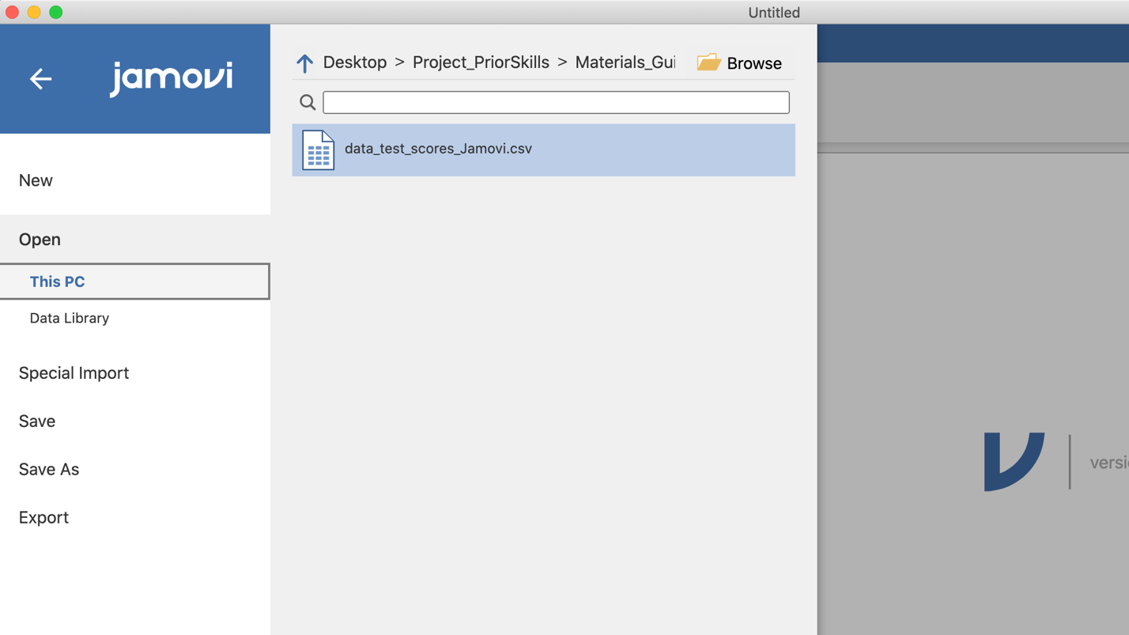

Task 2: How to add a new column variable to an existing data frame and calculate new values within that variable.
- Click on the “Variables” tab, then click on “Compute” (underneath the “Variables” tab). The screen will show several text boxes.
- In the “Computed Variable” box, type “diff’
- In the formula equation box type “TEST2 - TEST1”

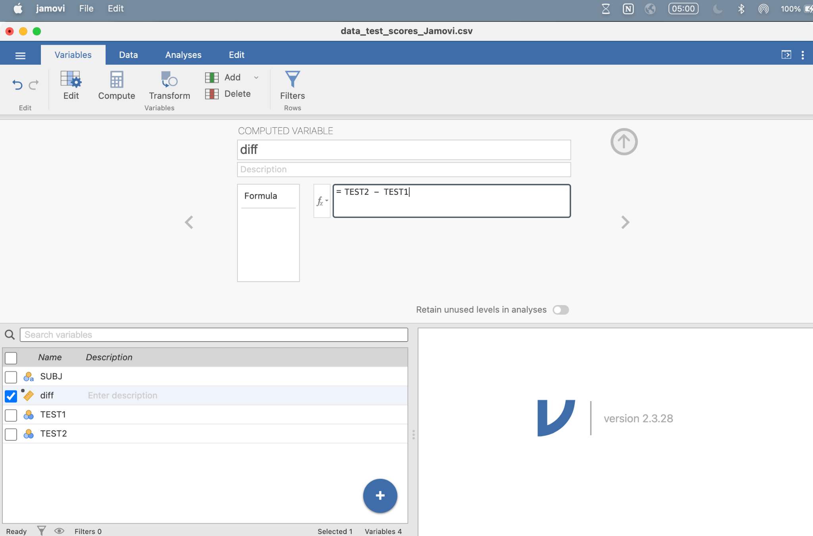

- Select the “Data” tab. A column labeled “diff” on the data sheet should now be present.

Task 3: How to calculate the mean (average) of a variable (column)
- Click on the “Analyses” tab, then select “Exploration”, then select “Descriptives”
- Highlight the “diff” text (located under the “Descriptives” section) by clicking on the text.
- Click the arrow on the left side of the “Variables” textbox. Doing so will transfer “diff” into the “Variables” textbox.
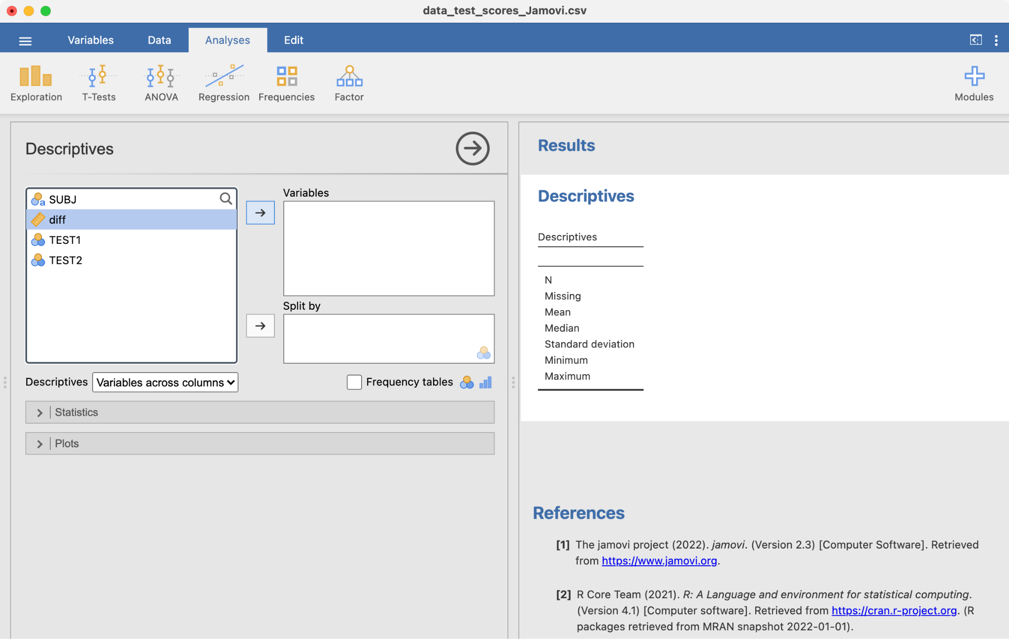

- A data table should appear under the “Results” section (right side of screen). You will now see the value that corresponds to the “Mean” of the data.

