**Question 1: Take a screenshot to show that the folder is created and you copied the file into this folder (3 Points).**

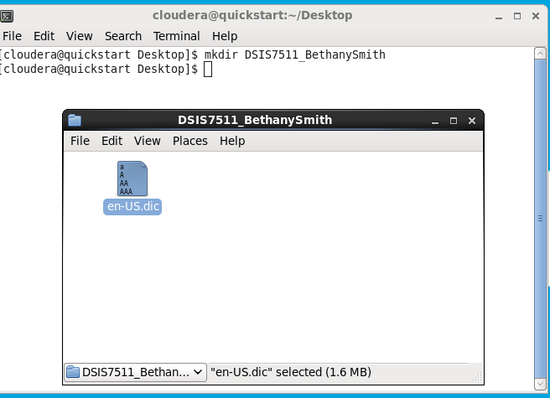

**Question 2: Take a screenshot to show you have this file copied to your HDFS system (3 Points)**

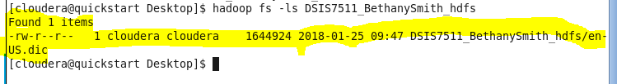

**Question 4-1: Take a screenshot to show that you are in the Anagram_bigdata folder. (2 Points)**

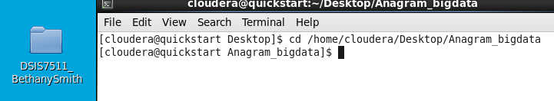

**Question 4-2: Take a screenshot to show that you have switched to root user. (1 Point)**

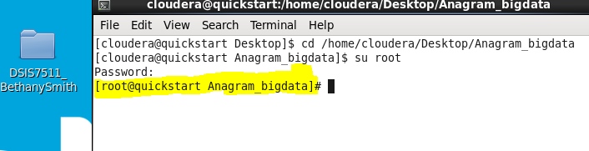

**Question 5: Take a screenshot to show that you have the class files created (3 Points).**

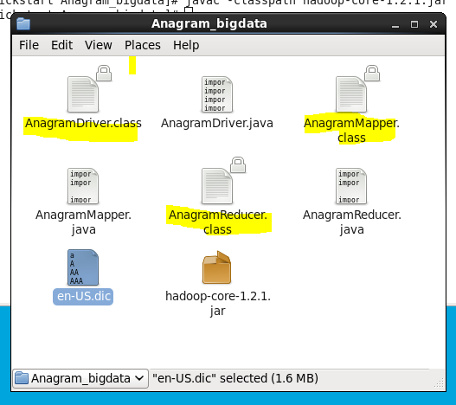

**Question 6: Take a screenshot to show that you have the jar file created. (3 Points)**

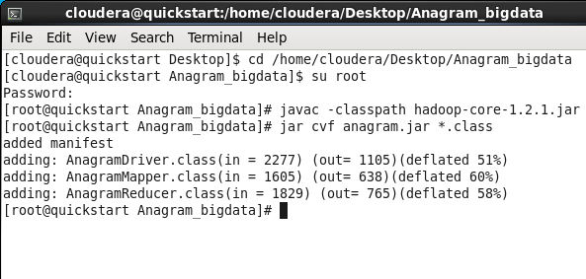

**Question 7: Take a screenshot to see the map-reduce job is completed successfully (3 Points).**

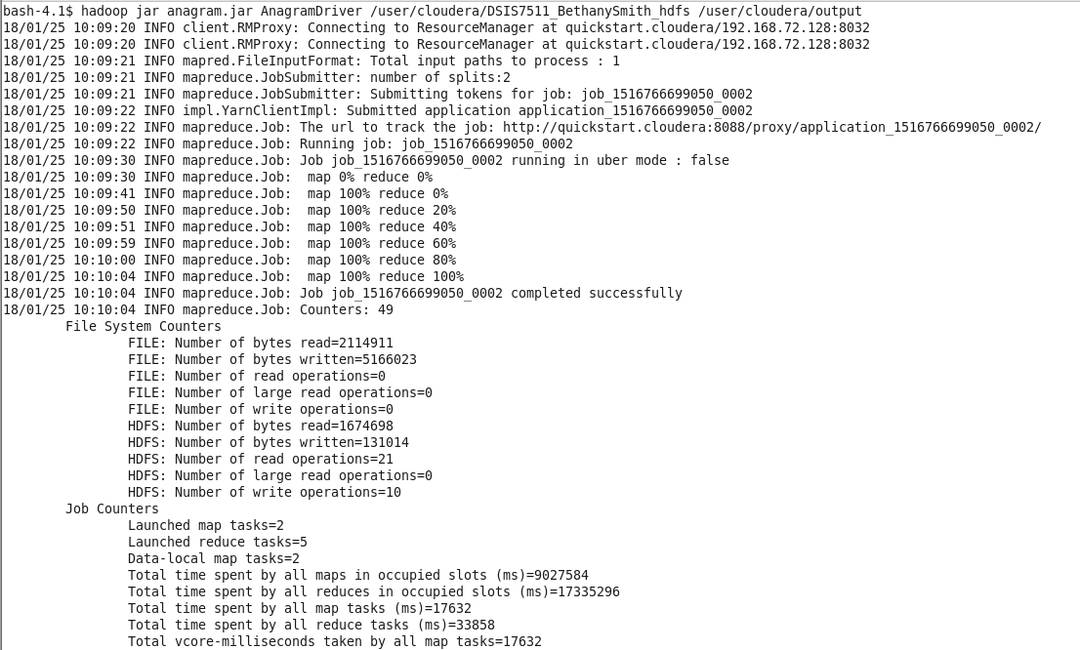

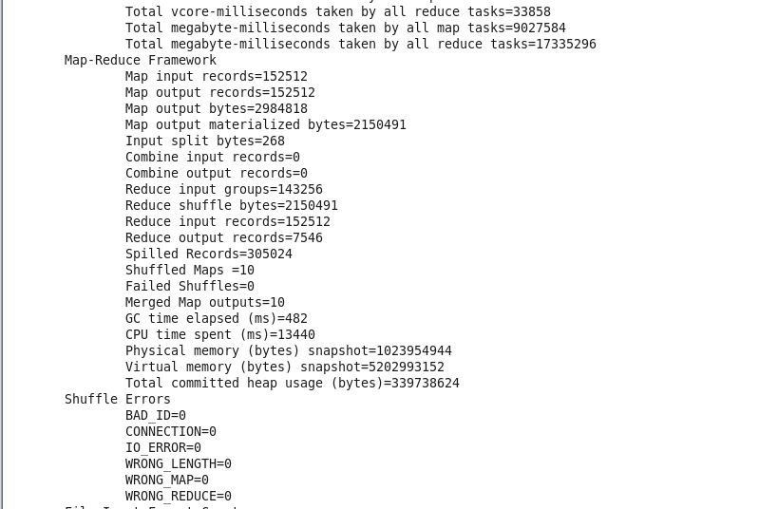



**Question 8: How many records have been input to Map? How many records have been output by Reduce? Answer both questions and take screenshots to support your answer (3 Points).**

Input records to Map : 152512

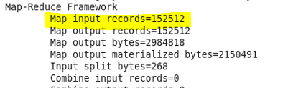

Records output by reduce: 7546

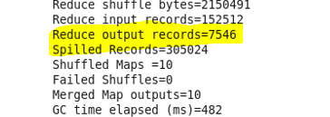

**Question 9: Take a screenshot to show all your output files (3 Points).**

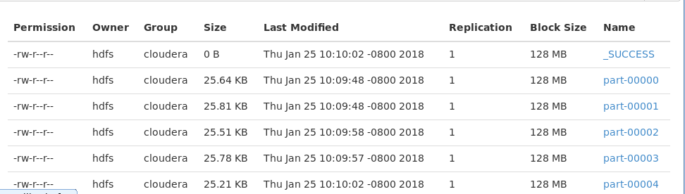

**Question 10: Take a screenshots to show one of the output files (3 Points).**

