**Question 1: log in to your KAFKA cluster, and take a screenshot (3 Points).**

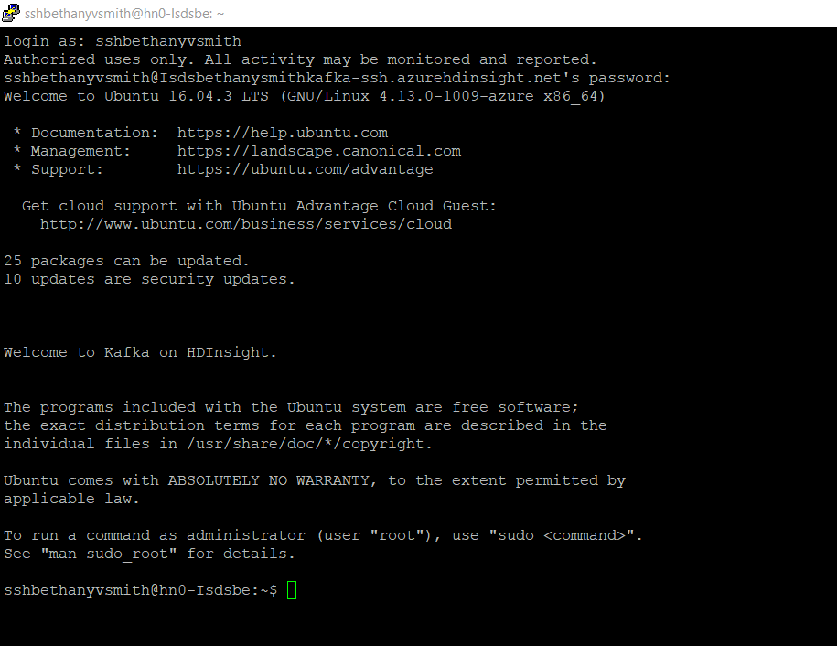

**Question 2: Use the proper command to show that you set up these two variables( KAFKAZKHOSTS and KAFKABROKERS) correctly (3 Points).**

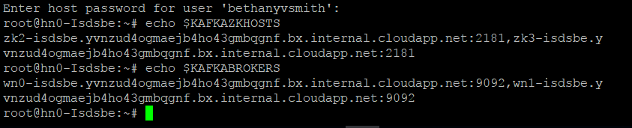

**Question 3: Create a topic with “isdsyourname” and take a screenshot. (3 Points)**

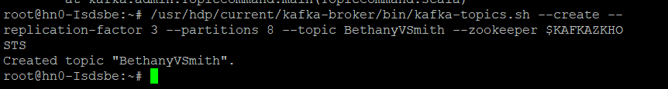

**Question 4: Create a producer to push message into your topic created in step 2-3. Take a screenshot of what you push into the topic (3 Points).**

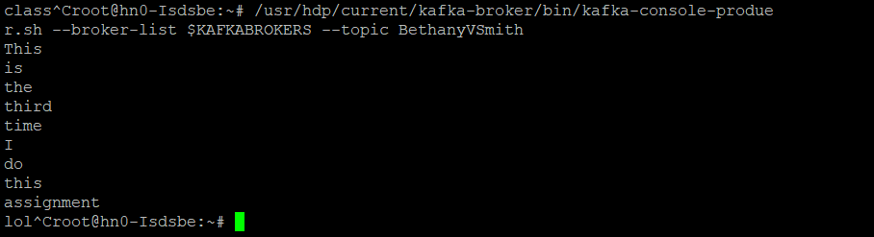

**Question 5-1: Describe the function of each part of the command (3 Points):**

|  |  |
| --- | --- |
| **Command** | **Function** |
| **/usr/hdp/current/kafka-broker/bin/kafka-console-consumer.sh** | “I am going to run the kafka-console-consumer.sh file in this directory” |
| **--bootstrap-server $KAFKABROKERS** | **Saying where the broker list is** |
| **--topic test** | **Here is where to look to pull the message from. We will pull the message from the topic test** |
| **--from-beginning** | **Start at the beginning to pul the entire message, from beginning to end, that is within the topic test** |

**Question 5-2: Take a screen shot of your consumer output(3 Points).**

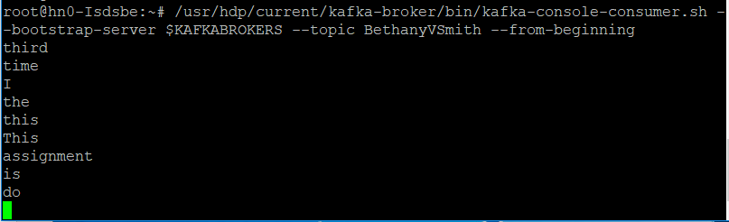

**Question 6: Input some message in session A, describe what happened in session B. Take a screen shot of both Session A and session B (12) Points.**

Session A bellow with producer: Session B bellow with consumer

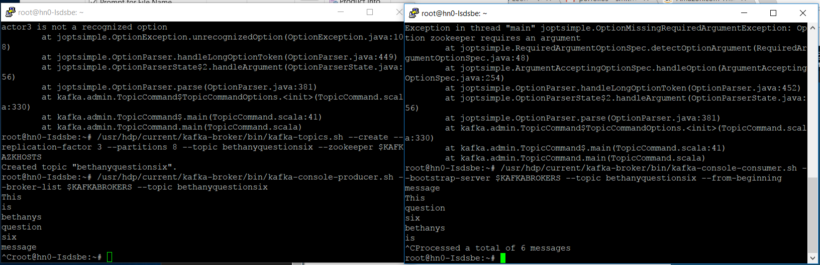

Better image of session A code with producer :

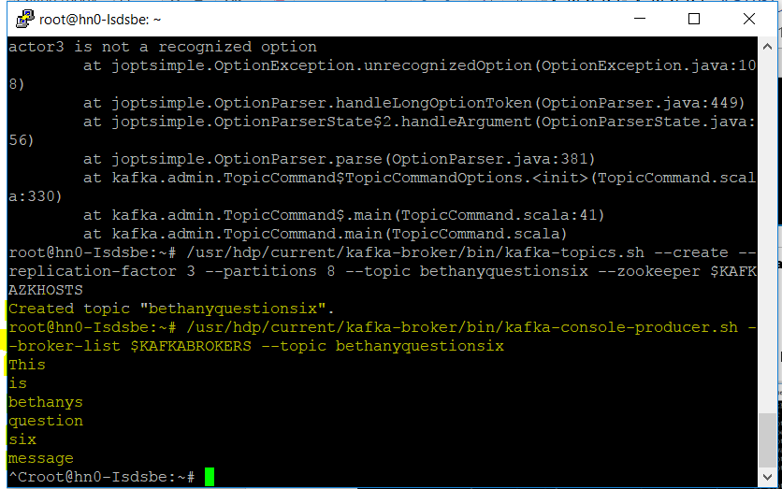

Better image of Session B code with consumer:

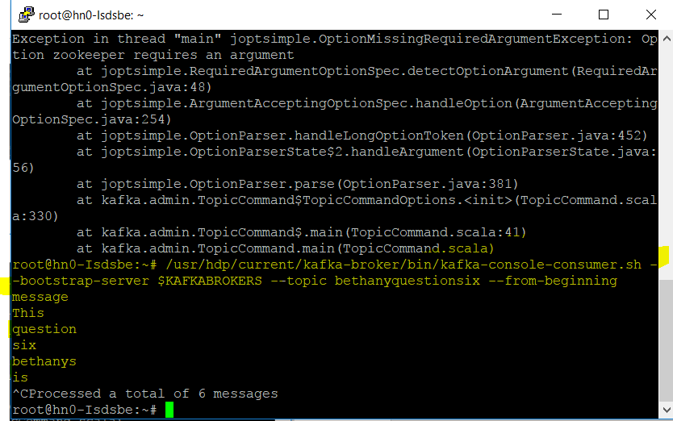

The producer in session A was used to input the message “This is bethanys question six” into the topic created for question six “bethanyquestionsix”. A separate session was opened, in which we re logged into the cluster, and started the consumer to pull the message out of the topic “Bethanyquestionsix”.