**Question 1: Take a screenshot to show the folder your created.**

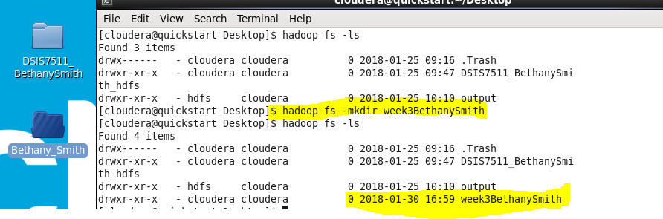

**Question 2: Take a screenshot of the folder as well as the “car.csv” file.**

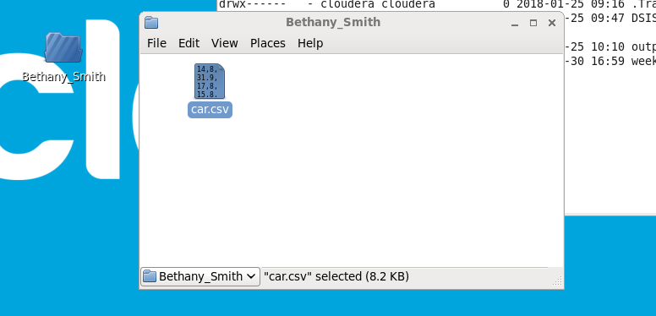

**Question 3: Take a screenshot to show you have the car.csv file in “week3yourname” directory.**

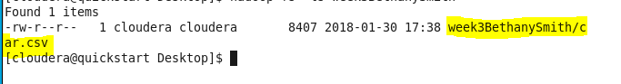

**Question 4: Take a screenshot of the “dump A;” result.**

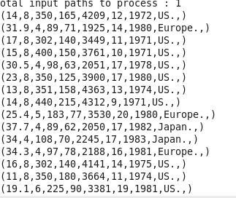

**Question 5: Take a screenshot of the grouped dataset.**

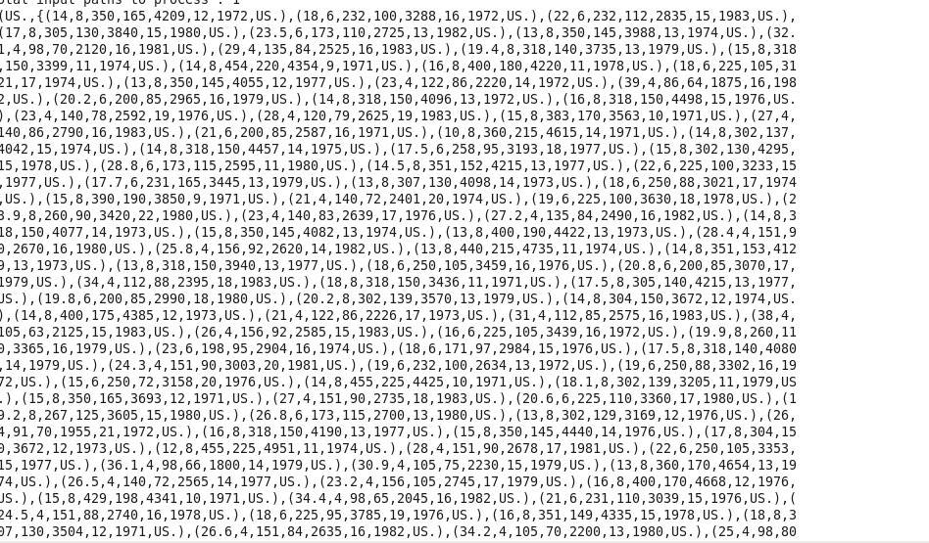

**Question 6: Take a screenshot of the result, replace my name with your name.**

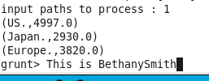

**Question 7: Store D as “max_yourname”. Take a screenshot to show max_yourname is now on the HDFS.**

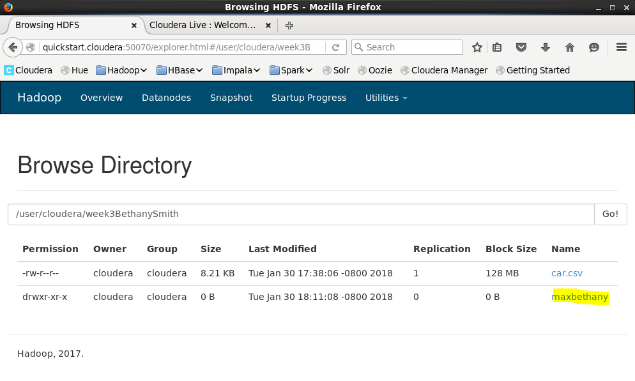

**PART II HIVE**

**Question 8: Take a screenshot of your code, showing table is created. Name the table as “car_yourname”**

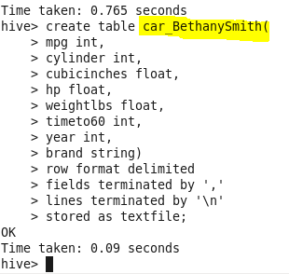

**Question 9: Take a screenshot showing the data is loaded correctly.**

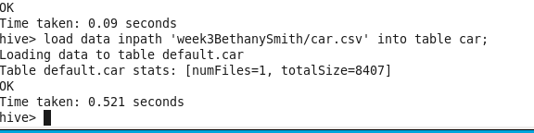

**Question 10: Take a screenshot showing your query and the result of the query.**

