Correlation

Write a program to calculate the correlation between two arrays of numbers x and y.

Thoroughly test the program. For one test, use the data in the Table 1. Calculate both the 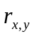 and 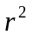values. Expected results are provided in Table 2.

 |  | Item Number | Actual Added and Modified Size | Development Hours
 |  | n | x | y
 |  | 1 | 186 | 15.0
 |  | 2 | 699 | 69.9
 |  | 3 | 132 | 6.5
 |  | 4 | 272 | 22.4
 |  | 5 | 291 | 28.4
 |  | 6 | 331 | 65.9
 |  | 7 | 199 | 19.4
 |  | 8 | 1890 | 198.7
 |  | 9 | 788 | 38.8
 |  | 10 | 1601 | 138.2
Table 1
As two additional tests, determine the correlation between actual added and modified size and actual development time for your assignments to date. Then determine the correlation between plan added and modified size and actual development time for your assignments to date. Be sure to include data from this assignment in the second and third tests.

Test | Expected Value |  | Actual Value
Table 1 | 0.9543 | 0.9107
Actual A&M Size vs. Dev. Time
Plan A&M Size vs. Dev. Time
Table 2

Correlation

Overview | The correlation calculation determines the relationship between two sets of numerical data.  The correlation can range from +1 to -1.  • Results near +1 imply a strong positive relationship; when x increases, so does y.  • Results near -1 imply a strong negative relationship; when x increases, y decreases.  • Results near 0 imply no relationship.

Using correlation | Correlation is used judge the quality of the linear relation in various historical process data that are used for planning.  For this purpose, we examine the value of the relation r_{xy} squared, or .
 |  | If is | the relationship is
 |  | .9 ≤ | predictive; use it with high confidence
 |  | .7 ≤ < .9 | strong and can be used for planning
 |  | .5 ≤ < .7 | adequate for planning but use with caution
 |  | < .5 | not reliable for planning purposes

Limitations of correlation | Correlation doesn’t imply cause and effect.  A strong correlation may be coincidental.  From 1840 to 1960, no U.S. president elected in a year ending in 0 survived his presidency. Coincidence or Correlation?  Many coincidental correlations may be found in historical process data.  To use a correlation, you must understand the cause-and-effect relationship in the process.
Continued on next page
Correlation, Continued

Calculating correlation | The formula for calculating the correlation coefficient is  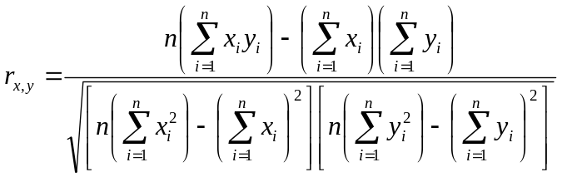  where  • Σ is the symbol for summation  • i is an index to the n numbers  • x and y are the two paired sets of data  • n is the number of items in each set x and y

A correlation example

A correlation example | In this example, we will calculate the correlation ( and values) of the data in the Table 3.

x | y
83 | 11.2
116 | 9.3
186 | 21.6
81 | 6.9
114 | 10.2
Table 3

- In this example there are 5 items in each dataset and therefore we set n = 5.
- We can now solve the summation items in the regression formula.

n | x | y | x² | x*y | y²
1 | 83 | 11.2 | 6889 | 929.6 | 125.44
2 | 116 | 9.3 | 13456 | 1078.8 | 86.49
3 | 186 | 21.6 | 34596 | 4017.6 | 466.56
4 | 81 | 6.9 | 6561 | 558.9 | 47.61
5 | 114 | 10.2 | 12996 | 1162.8 | 104.04
Total | 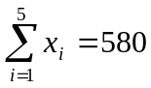 | 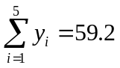 | 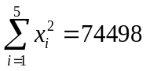 | 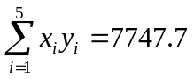 | 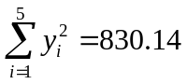

- We can then substitute the values into the formula
