Part 1

Find all movies that are longer than 2 hours

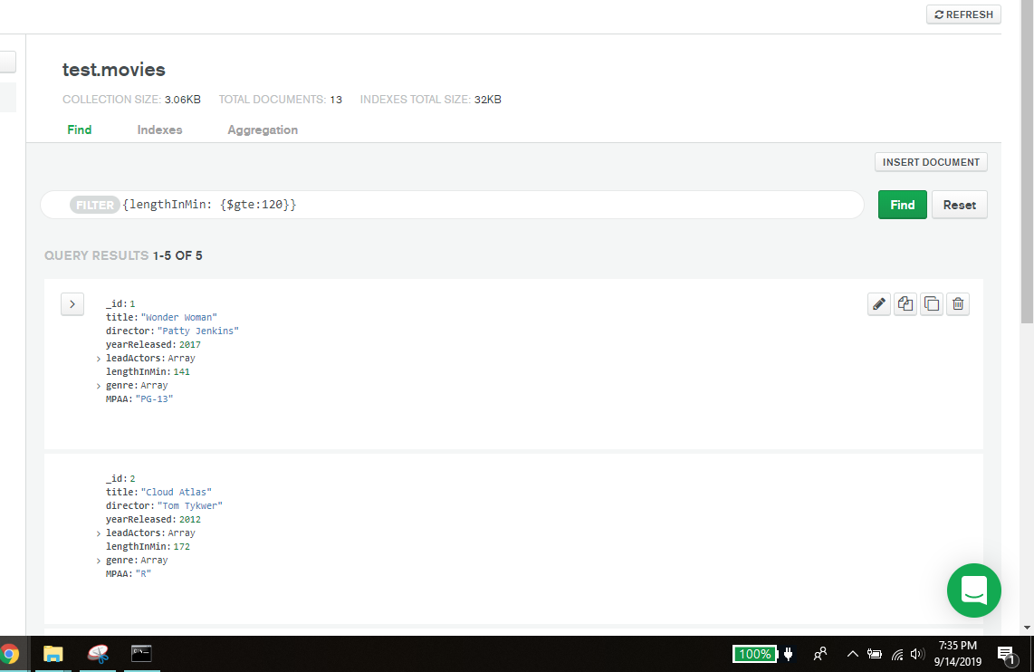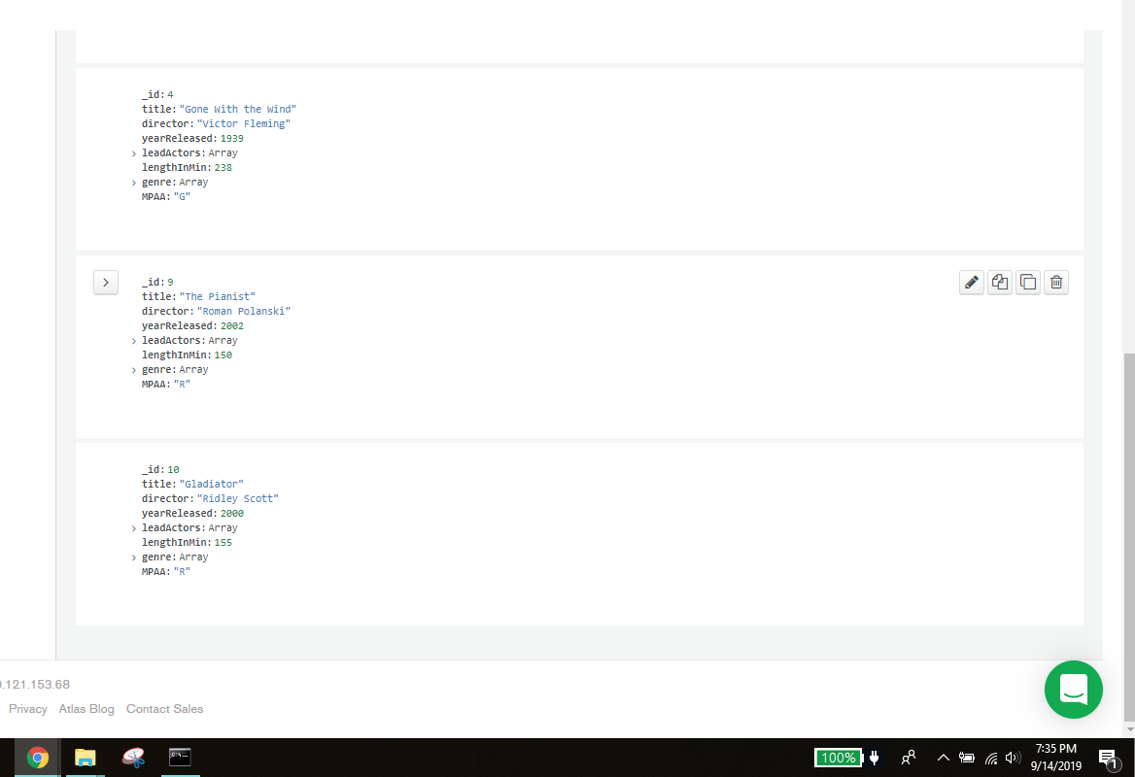

Find all movies that do not have Tom Hanks as a lead actor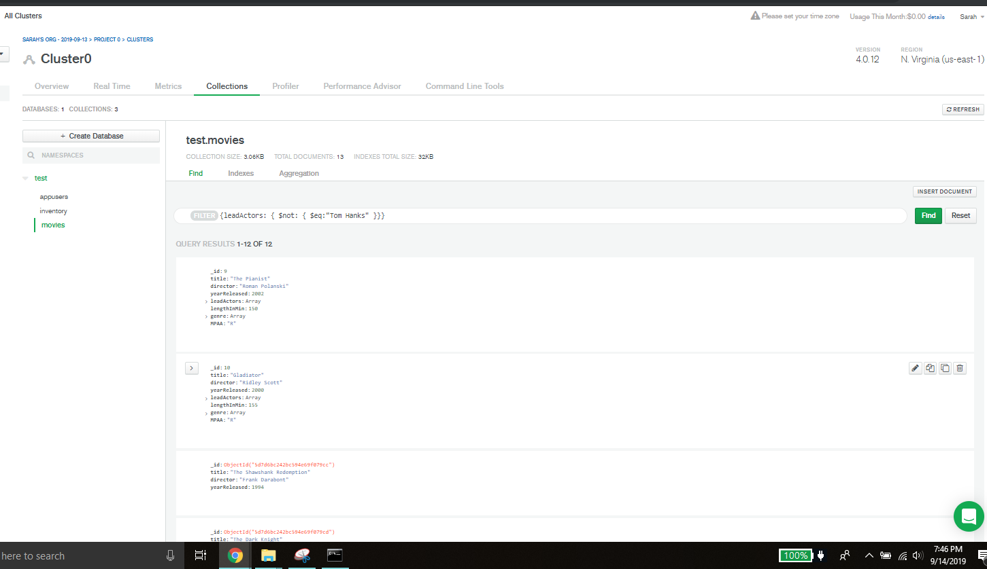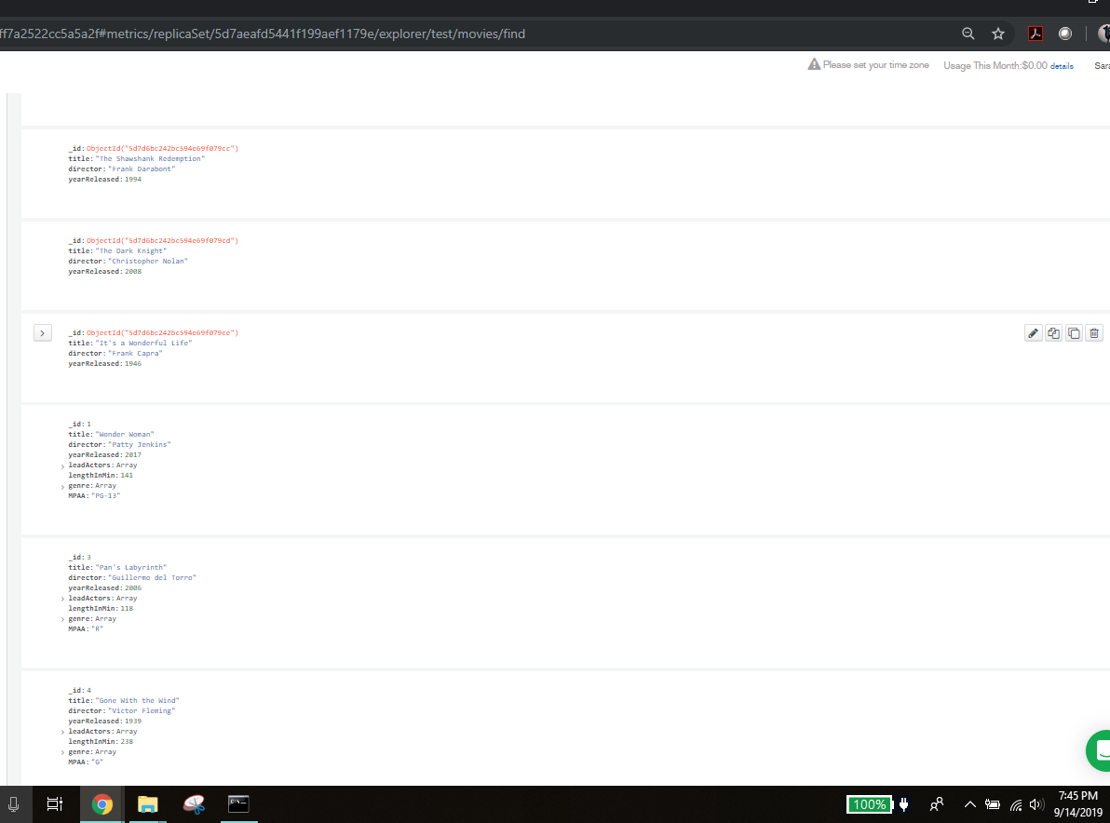
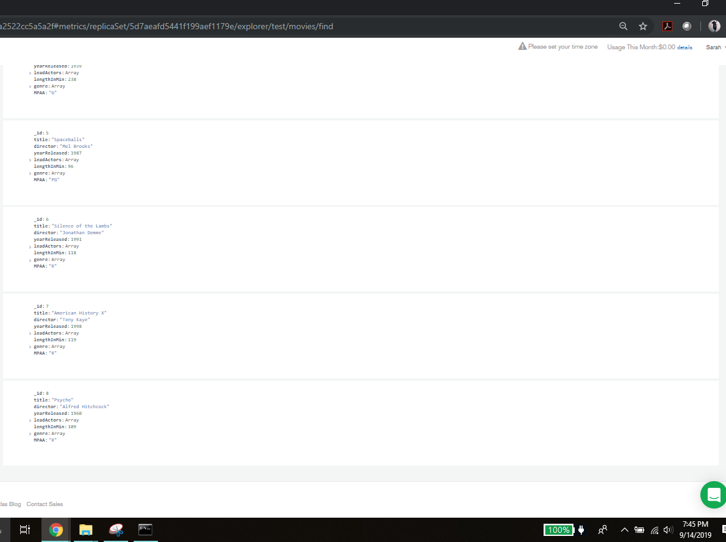

Find all movies that were directed by Mel Brooks

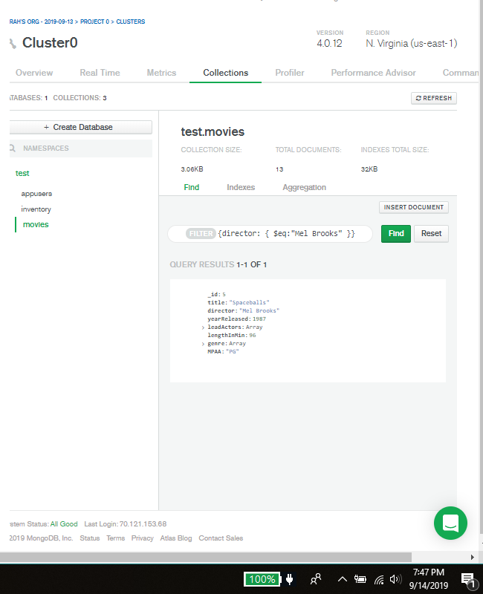

Find all movies that are not considered Drama
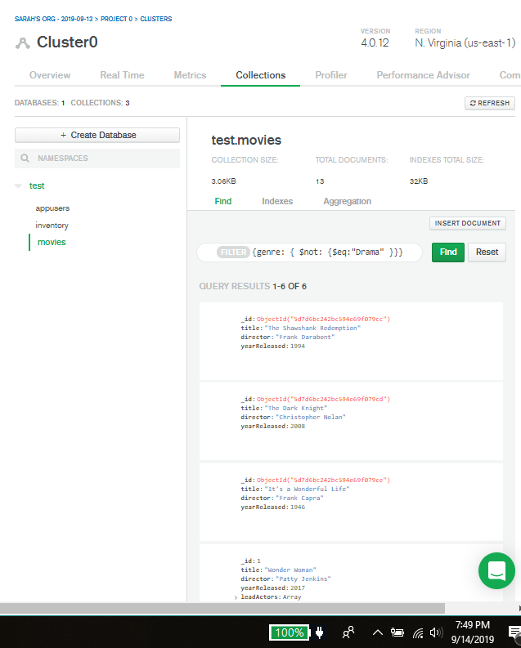
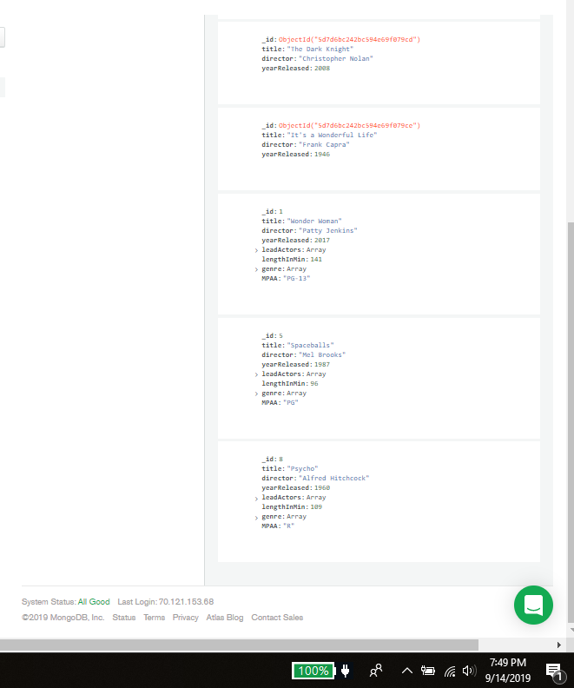

Find all movies that are longer than 90 minutes but less than 2 hours
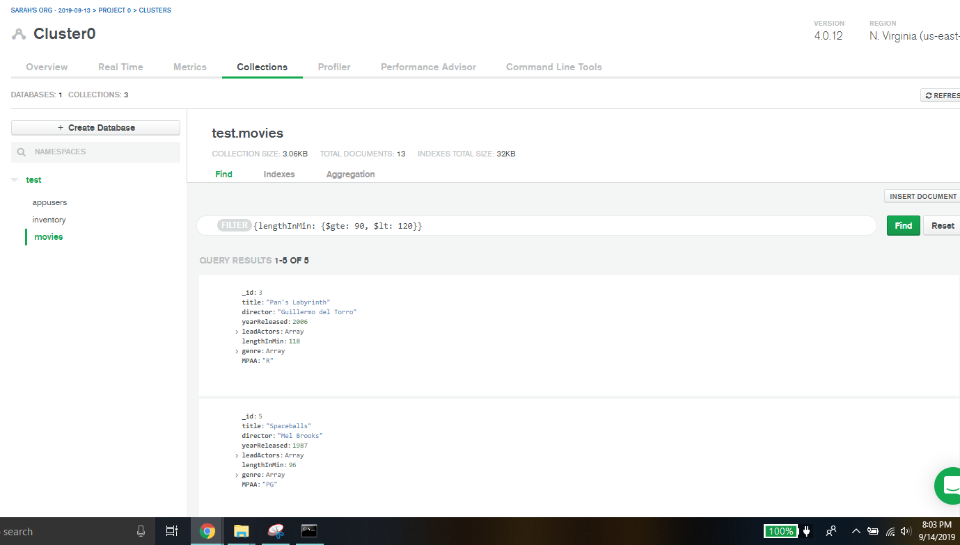
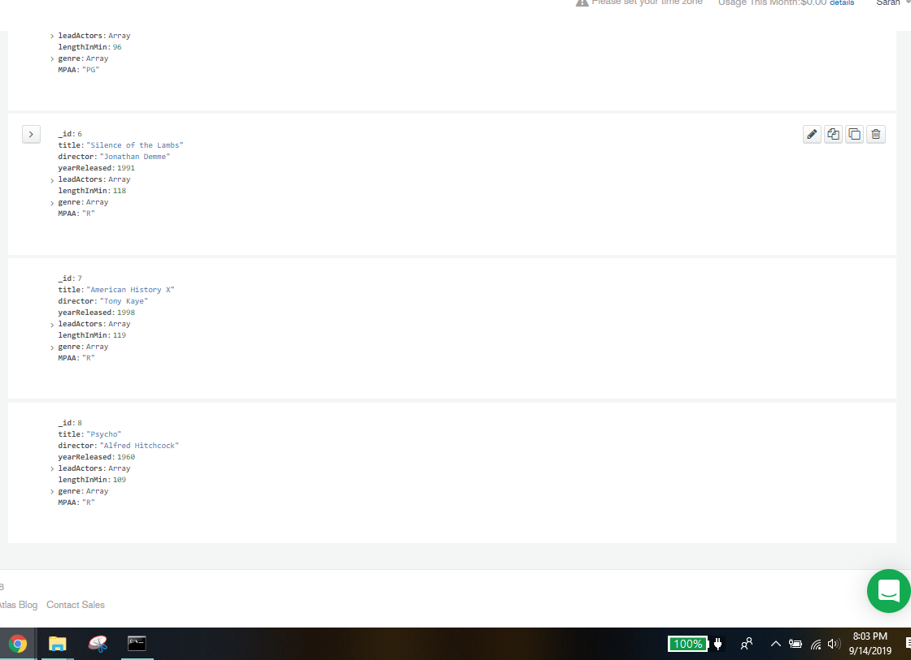Find all movies that are considered Action or Adventure and return only the title of the movie

The company you work for is having a movie night for all employees, and they are trying to find the perfect movie for movie night. The problem is, so many people have different opinions, and they want to make everyone happy.

Sally has very poor eyesight so cannot watch any foreign films but likes comedies and dramas.

Robert hates Jodie Foster and refuses to watch any movies with her in it, but likes comedies and horror films.

Stewart has somewhere to be after movie night, so he can't watch a movie longer than 2 hours; he prefers thrillers and comedies.

No foreign(no search option), No Foster, Not longer than 120 min.

Must be a Comedy,
<this is the 8th attempt...all to no avail>
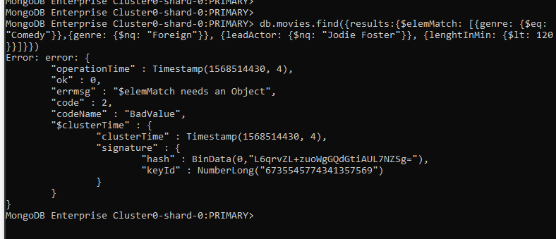

Working with mentor:
what I want is db.movies.find({{genre: {$eq: “Comedy”}}, {leadActor: {$nq: “Jodie Foster”}}, {lengthInMin: {$lt:120}}})

Should get spaceballs

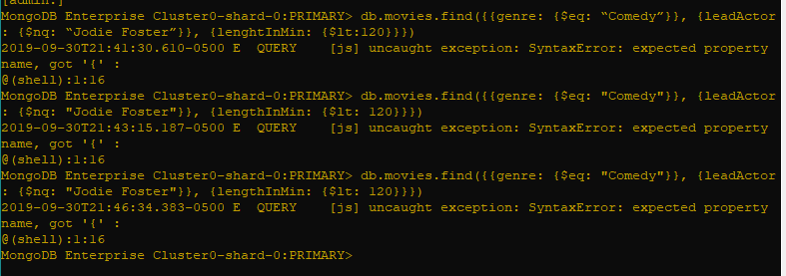
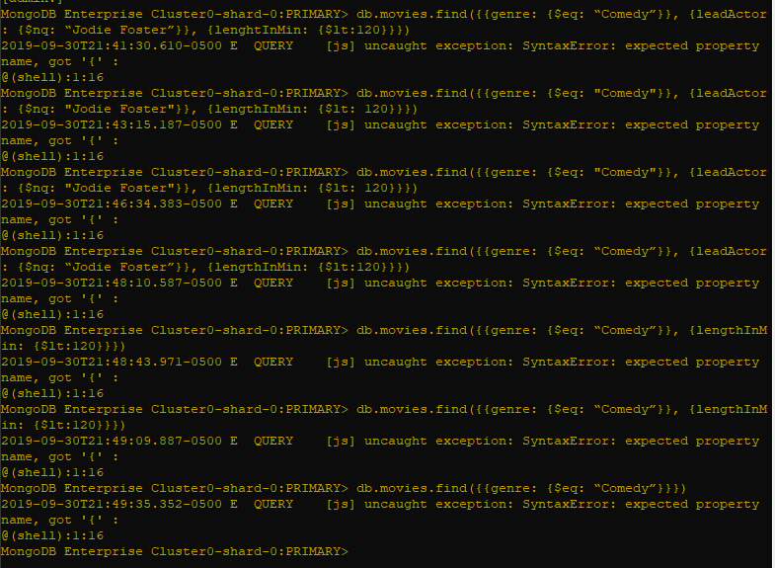
Not working :(

