

## ADDIS ABABA UNIVERSITY

## ADDIS ABABA INSTITUTE OF TECHNOLOGY

## SCHOOL OF CHEMICAL AND BIO ENGINEERING

**Chemical and Bio-engineering Department**

General and Inorganic Chemistry (ChEg2202)

Title: Extraction of cellulose from Jack fruit for the application in food and pharmaceutical industrial

Section A

Prepared by:-

* Biftu Lencho……………………..…………UGR/9410/15
* Desta Gezmu………………………………..UGR/6535/15
* Edna Assefa…………………………………UGR/0587/15
* Ephrata Melaku……………….…………….UGR/4013/15
* Kalkidan Alemu…………………..………...UGR/1208/15
* Kena Magarsa………………….…………...UGR/2629/15
* Khulud Osman………………………….…..UGR/8824/15
* Liza Avo…………………………………….UGR/9016/15
* Nathnael Ephrem…………………….……...UGR/7231/15
* Selam Daniel……………………………..…UGR/0982/15
* Solome Yihub…………………………….…UGR/9629/15

## Submitted to: Dr. Sendeku Takele

## Submission date: May 29-2024

**Abstract**

The project underscore the extraction of cellulose from jack fruit peel (Artocarpus heterophyllus) for applications in the food and pharmaceutical industry. Jack fruit, a tropical fruit native to Asia, Africa, and South America, is rich in nutritional components but often generates waste in the form of peels. These peels, containing significant amounts of cellulose (27.75%), represent a valuable, underutilized resource. This research aims to extract cellulose from jack fruit peels through a series of physical, chemical, and biological treatments, and to explore its potential applications in food and pharmaceutical industry.

The extraction process involves pre-treatment methods such as grinding, steam explosion, alkaline and acid treatments, and biological treatments to break down the peel's complex structure, which is then followed by enzymatic hydrolysis, pulping and bleaching steps to isolate and purify the cellulose.

The cellulose extracted from jack fruit peel has promising applications in the pharmaceutical industry. It can be used to produce bio active compounds with antiviral, anti platelet, anticancer, and provide an efficient medium for drug delivery. Additionally, jack fruit peel cellulose can be utilized in food industry which used as a thickening and stabilizing agent, fiber enhancer, fat re-placer, and biodegradable packaging material. These applications not only improve the nutritional profile of food products but also offer environmentally sustainable alternatives to conventional materials.

This research demonstrate the importance of jack fruit peel as a renewable source for cellulose extraction, with significant implications for food and pharmaceutical applications. Further multidisciplinary research integrating traditional and modern technologies can enhance the utilization of jack fruit in sustainable industrial materials.

Table of Contents Page

1. Introduction ……………………………………………………………….

1.1. Problem Statement ………………………………………………  
1.2. Objective ………………………………………………………...  
1.3. Scope and Significance of the Study …………………….………

1. Materials and Methods ……………………………………………………

2.1. Experiment ……………………………………………………………

2.2. Results and Discussion …………………………………………………….

1. Food Applications ……... ……………………...………………………….
2. Pharmaceutical Applications ………………... …………………………….
3. Conclusion …………………………………………………………………
4. Contribution of each member…………..…………………………………..
5. References …………………………………………………………………

**Acknowledgment**

We would like to express our sincere gratitude to our teacher, Dr. Sendeku Takele, for guiding us on how to approach and write this project. Your instructions and assignment have provided us with invaluable experience in conducting research, which will greatly benefit us in our future academic performance.

We also wish to thank our families for their understanding and giving the time and space to focus on this project. Your support has been essential in helping us complete this project.

A special thanks to our friends and classmates for providing a positive environment for discussion and idea sharing.

We are grateful for the wealth of information available on various online platforms, academic journals, and research publications. These resources were instrumental in helping us explore and understand the topic in depth. The accessibility of previous research findings significantly contribute to the credibility of our work. We appreciate the efforts of researchers and contributors who have made their work available to the public, helping students like us in our academic projects.

Thank you all, who helped us in completing this project work. Your support, guidance, and understanding have been invaluable, and we are truly grateful for your assistance.

**1. Introduction**

Jackfruit (Artocarpus heterophyllus) is a tropical fruit that is widely grown in Asia, Africa, and South America. While the fruit itself has various applications, the jackfruit peel is often considered a waste product. However, recent research has shown that the jackfruit peel contains significant amounts of valuable cellulosic components that can be extracted and utilized for various applications, particularly in the food industry.

This study focuses on the extraction of cellulose from jackfruit peel and its potential applications in food products. Cellulose is an abundant and versatile polysaccharide that can be used as a thickening and stabilizing agent, a fiber enhancer, a fat replacer, and in the development of edible films and biodegradable packaging materials. By extracting and characterizing the cellulose from jackfruit peel, this research aims to explore the feasibility of using this underutilized waste material as an industrial ingredient for improving the sensory and nutritional qualities of various food products.

1.1 Problem Statement:

The global food industry faces the challenge of addressing growing consumer demands for sustainable, nutritious, and functional food products. Simultaneously, the need to manage the substantial volumes of agricultural waste and byproducts has become increasingly pressing. Jackfruit (Artocarpus heterophyllus), a widely cultivated tropical fruit, presents an untapped opportunity in this regard. While the pulp and seeds of jackfruit are widely utilized, the peel, which accounts for up to 60% of the fruit's total biomass, is often discarded as an agricultural waste, leading to environmental concerns and missed opportunities for value addition.

1.2 Objective:

This study aims to extract and characterize cellulose from jackfruit peel, a largely underutilized component of the fruit, and explore its potential applications in the food industry. The research focuses on developing sustainable methods for the extraction and utilization of this valuable biopolymer, which can contribute to the development of innovative food products and promote the circular economy.

1.3 Scope and Significance of the Study**:**

The scope of this study encompasses the following key aspects:

1. Extraction and characterization of cellulose from jackfruit peel: The research will focus on optimizing the pretreatment and extraction processes to isolate the cellulosic components from the peel matrix, and analyze their physicochemical, thermal, and structural properties.
2. Evaluation of food applications of jackfruit peel cellulose: The study will investigate the potential use of the extracted cellulose as a thickening and stabilizing agent, fiber enhancer, fat replacer, and for the development of edible films and biodegradable food packaging materials.
3. Exploration of ongoing research efforts and future prospects: The study will review the current state of research on the utilization of jackfruit peel cellulose and identify areas for further investigation to expand its applications in the food industry.

The significance of this study lies in its contribution to the sustainable valorization of agricultural waste, specifically jackfruit peel, by unlocking its cellulosic potential. The findings can facilitate the development of innovative food products with enhanced nutritional, functional, and environmental attributes, thereby addressing the evolving demands of the food industry and consumers. Moreover, this research endeavor can promote the circular economy and reduce the environmental burden associated with the disposal of jackfruit peel, a largely underutilized byproduct.

**2. Materials and Methods**

2.1 Experiment

In the recent times, cellulosic derivatives have become important materials in various industries. One of the sources, the Jackfruit peel, remains one of the lesser explored renewable alternatives to extract cellulose and lignin constituents. Jackfruit peels are usually discarded off as waste, which can be utilised to produce valuable entities. Hence it is substantial to find out the approximate content of cellulosic constituents in the jackfruit peel and to isolate them.

The composition of jackfruit peel can be summarized as below.

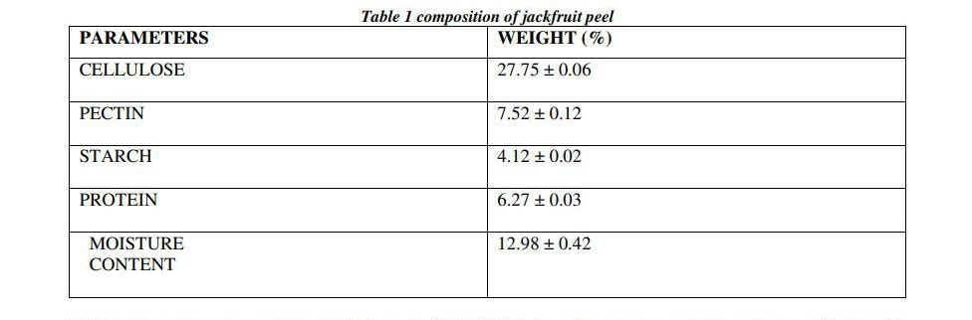

The most significant one is cellulose from those constituents listed above. Cellulose is an organic compound with formula (C6H10O5)n& is an important structural component of cell walls present in green plants. It is the most abundant organic polymer on earth. It is a linear polymer composed of single sugar molecule unit adjoined by β-1-4 glycosidic oxygen linkages. This polymer has versatile uses in textile cosmetic and pharmaceuticals industries.

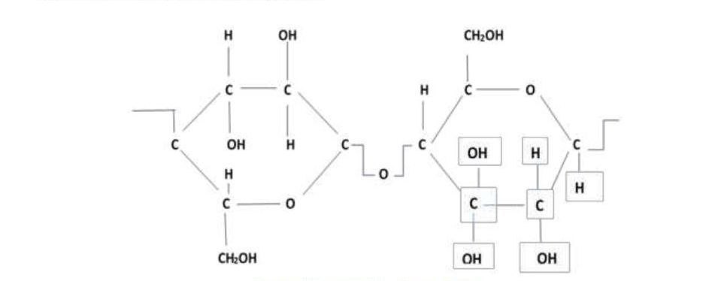

The jackfruit peel was studied. Proximate analysis of its peel showed high presence of cellulose (27.75%), pectin (7.52 ± 0.12 %), protein (6.27 ± 0.03%) and starch (4%). The outcome of the work from proximate analysis and FTIR spectroscopy shows that the jackfruit peel is immensely productive as a major alternative source of cellulosic and pectin materials that can be further utilized for food ingredient applications. We should also remember that the peel is not the only part that is useful but also its seeds and flesh as well.

**Objective of the research**

Jackfruit peels by isolation of cellulosic components.

**Chemicals and materials**

Jackfruit Peels, DM water, NaOH pallets, conc.H2SO4, Hydrogen peroxide solution.

**Experimental Procedure**

The Important process steps are described as follows:

• Peels were chemically treated, cleaned, oven dried and stored.

• Some of the dry pieces were further cut into smaller sizes.

• Peel pieces were subjected to alkaline conditions in a reflux setup at 90 ͦC to 110 ͦC for around 4 hours.

• The content o still were filtered out.

• The cake was bleached with H2O2 solution.

• Cake was further oven dried at controlled temperature conditions.

• The samples of lignin and cellulosic constituents are analyzed for functional group presence

using FTIR.

**Observations**

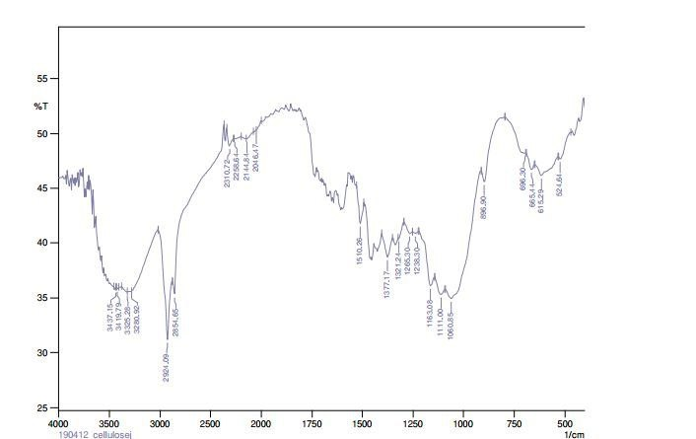

Spectrogram for celluloic sample one

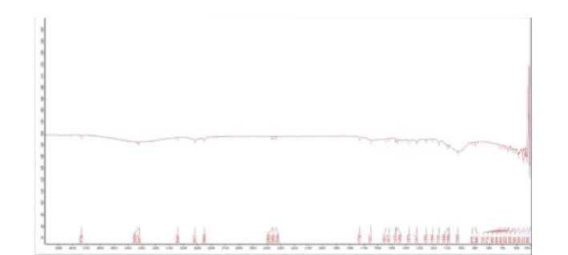

Spectrogram for cellulosic sample 2

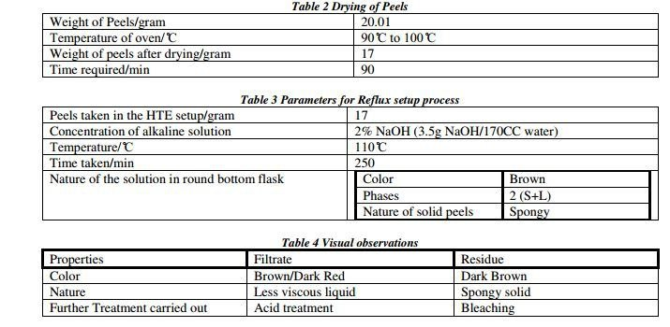

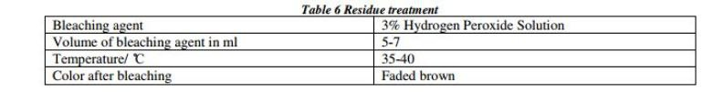

2.2 Result and Discussion

The dried sample of cellulosic constituents are subjected to FTIR analysis for establishing the

presence of functional groups.

The graph is plotted with infrared spectrum on x-axis and absorbance/ frequency on y-axis.

The peaks in the spectrogram, called as absorbance band that correspond to various vibrations of atoms present in the sample. Table 8 constitutes the comparison of the wave numbers of samples 1 and 2 for cellulose with purified cellulose reported in the literature.

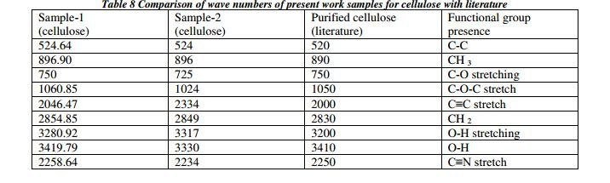

The yield of cellulosic constituents obtained after oven drying of spongy cake after bleaching is

3.57/10g of dry peel.

Conclusion and recommendation:

Jackfruit is a seasonal fruit abundantly found and grown in India during March to June. After consumption of jackfruit, a lot of waste in the form of peels is generated which is rich in ingredients like pectin, cellulose, lignin etc. The present work addresses to the isolation of cellulose from jackfruit peel using the novel alkaline reflux method. The obtained samples of cellulosic constituents are analyzed using FTIR for functional group presence. The comparison between the wavenumbers of the spectrogram of the present work samples have been carried out with that of cellulose samples reported in literature. Based on the comparison it can be concluded that the present work has successfully isolated the cellulosic constituents from the jackfruit peel. The average yield of cellulosic constituent are 2.89 g and 3.57 g respectively per 10 g of oven dried jackfruit peel powder.

**3. Extraction of Cellulose from Jackfruit Peel for Food Applications**

What is Jackfruit?

The scientific name for jackfruit is Artocarpus heterophyllus. Jackfruit is a tropical tree fruit grown in Asia, Africa and South America. It belongs to the same plant family as figs and mulberries.

Under its thick, bumpy green rind is a stringy yellow flesh that you can eat raw or cooked in a variety of dishes. It is seeds are also edible. Like many fruits, jackfruit contains some [fiber](https://health.clevelandclinic.org/11-best-high-fiber-foods/) for healthy digestion and very little fat. A 100-gram portion of jackfruit has:

* 95 calories.
* 2 grams of protein.
* 0.6 grams of fat.
* 3 grams of fiber.

Jackfruit also contains vitamins, minerals and phytochemicals that have health benefits. It’s a good source of:

* Vitamin C.
* Pyridoxine (vitamin B6).
* Niacin (vitamin B3).
* Riboflavin (vitamin B2).
* Folic acid (vitamin B9).
* Calcium.
* [Magnesium](https://health.clevelandclinic.org/foods-that-are-high-in-magnesium/).
* Potassium.
* Phosphorus.

Our main focus is to develop an innovative food products using jackfruit concentrate as industrial ingredients for the food industry, as current commercial applications for jackfruit nutrition are limited. The process involved preparing jackfruit concentrate through the boiling and evaporation of pulp until reached at 40 %TSS (sugar content) (20 % added sugar). Organoleptic evaluations determined this concentrate to be the most suitable product. Afterwards, various food items, including jackfruit jam, jackfruit leather, jackfruit pitha, and jackfruit candy, were produced using this concentrate. Organoleptic assessments were conducted for these food products, followed by an examination of their physicochemical, nutritional properties and microbial load.

The chemical composition of the products revealed a range of characteristics, including 30 to 80 %TSS, 4.9–17.25 mg 100 g −1 vitamin C, 17.01–79.83 % total sugars, 9.67–51.98 % reducing sugars, 6.80–30.04 % non-reducing sugar, and a pH range of 4.2–5.7.

The research highlights the potential of jackfruit concentrate as a valuable ingredient in the food industry, providing better taste and nutritional value in various products. The study contributes valuable insights into the processing and utilization of jackfruit concentrate, paving the way for its broader adoption in the food industry.

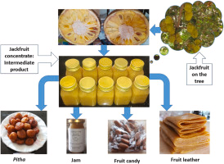

**1.** Pretreatment:

* Physical: This step aims to break down the complex structure of the peel, making it easier to access and extract the cellulose. Methods include:
* Grinding/Milling: Reduces particle size, increasing surface area for subsequent treatments.
* Steam Explosion: Uses high-pressure steam to disrupt the lignin and hemicellulose structure, making cellulose more accessible.
* Chemical: these step further breaks down lignin and hemicellulose, isolating cellulose. Methods include:
* Alkaline Treatment: Uses NaOH or KOH to remove lignin and hemicellulose.
* Acid Treatment: Uses dilute acids like HCl or H2SO4 to hydrolyze hemicellulose.
* Biological: This method utilizes enzymes to selectively degrade lignin and hemicellulose.
* Ligninolytic Enzymes: Break down lignin, increasing cellulose accessibility.
* Hemicellulases: Hydrolyze hemicellulose, separating it from cellulose.

**2.** Cellulose Extraction:

* Pulping: This step separates cellulose fibers from the remaining components. Methods include:
* Kraft Pulping: Uses NaOH and Na2S to dissolve lignin and hemicellulose, leaving behind cellulose fibers.
* Sulfite Pulping: Uses acidic sulfite solutions to dissolve lignin and hemicellulose.
* Bleaching: This step removes residual lignin and other impurities, resulting in a purer cellulose product.
* Chlorine-based Bleaching: Uses chlorine compounds to bleach the cellulose.
* Oxygen Delignification: Uses oxygen and alkaline conditions to remove lignin.

**3.** Cellulose Characterization:

* Degree of Polymerization (DP): Measures the average chain length of cellulose molecules, influencing its properties.
* Crystallinity: Describes the arrangement of cellulose molecules, impacting its strength and reactivity.
* Surface Area: Influences the accessibility of cellulose for chemical modifications and interactions.

**4.** Food Applications of Jackfruit Peel Cellulose:

* Thickening and Stabilizing Agent: Cellulose can be used to thicken sauces, soups, and desserts, providing a smooth texture and consistency.
* Fiber Enhancer: Adding cellulose to food products increases dietary fiber content, promoting digestive health.
* Fat Replacement: Cellulose can be used as a fat replacer in processed foods, reducing fat content and calories.
* Film Formation: Cellulose can be used to create edible films for food packaging, offering a sustainable alternative to plastic.
* Biodegradable Packaging: Cellulose-based materials can be used to create biodegradable packaging for food products, reducing environmental impact.

*Example: Extraction using Alkaline Treatment and Kraft Pulping:*

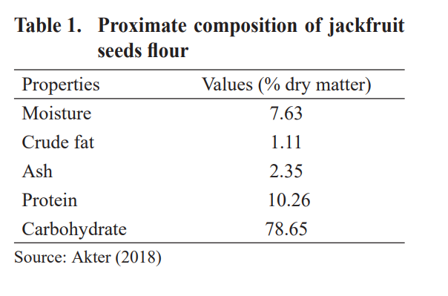

**Advantages of using Jackfruit Peel Cellulose:**

* Possesses desirable properties for various food applications, including thickening, stabilizing, and fiber enhancement.

There are ongoing research efforts to improve the properties and applications of jackfruit peel cellulose in the food industry.

1. Enhancing Cellulose Properties:

* Increased Degree of Polymerization (DP): Researchers are investigating methods to increase the DP of jackfruit peel cellulose, improving its strength, viscosity, and film-forming properties. This can be achieved through optimizing extraction processes, using specific enzymes, or applying chemical modifications.
* Controlled Crystallinity: Controlling the crystallinity of cellulose can influence its functional properties. Researchers are exploring ways to modify the crystalline structure to achieve desired properties for specific applications, such as improved film formation or increased water-holding capacity.
* Surface Modification: Modifying the surface of cellulose with functional groups can enhance its interactions with other food components, improving its performance as a thickener, stabilizer, or emulsifier. This can be achieved through grafting or crosslinking reactions.

2. Expanding Food Applications:

* Fat Replacers: Researchers are investigating the use of jackfruit peel cellulose as a fat replacer in processed foods. This can reduce the calorie content and improve the nutritional profile of food products.
* Edible Films and Coatings: Jackfruit peel cellulose is being explored as a biodegradable and edible film-forming material for food packaging. This can offer a sustainable alternative to plastic packaging and enhance food preservation.
* Novel Food Ingredients: Researchers are exploring the use of jackfruit peel cellulose in novel food formulations, such as plant-based meat alternatives or dairy-free products.

3. Optimizing Extraction Processes:

* Green Extraction Methods: Researchers are developing environmentally friendly and cost-effective methods for extracting cellulose from jackfruit peel, such as using enzymatic treatments or ionic liquids.
* Scale-Up and Industrialization: Efforts are underway to scale up the extraction process to meet the demands of the food industry and develop cost-effective industrial production methods.

4. Consumer Acceptance and Market Development:

* Sensory Evaluation: Research is being conducted to assess the sensory properties of food products containing jackfruit peel cellulose, ensuring consumer acceptance.
* Market Analysis: Studies are being conducted to identify potential markets for jackfruit peel cellulose and develop strategies for its commercialization.

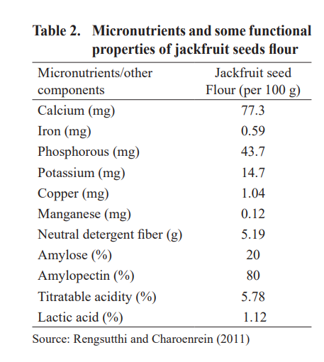

Examples of Ongoing Research:

* National Institute of Food Science and Technology (NIFST), India: Research on the extraction and characterization of cellulose from jackfruit peel and its application as a thickener and stabilizer in food products.
* University of the Philippines Los Baños: Research on the development of biodegradable films from jackfruit peel cellulose for food packaging applications.
* International Journal of Biological Macromolecules: Publication of research articles on the pro

**4. Extraction of Cellulose from Jackfruit Peel for pharmaceutical industries**

The use of jackfruit in ethnopharmacology focuses on treating inflammation, diarrhea, and diabetes. Integrating traditional and modern technology is crucial for expanding the potential of jackfruit as a source of therapeutic compounds. This review highlights the identification, production, and bioactivity of metabolites in jackfruit, with a focus on its role in controlling and preventing diseases.

1) Jackfruit species contain flavonoids, stilbenoids, aryl benzofurans, and lectin jacalin. Jacalin can evaluate the immunological state of HIV-1 patients and inhibit 24 bacterial species. It also inhibits DNA viruses like herpes simplex virus type-2, varicella–zoster virus, and cytomegalovirus.

2) Jackfruit peel contains bioactive compounds that have been used in various activities such as antiviral, antiplatelet, anticancer, antiatherosclerotic effects, and formulation of fast-dissolving tablets.

3) Jackfruit can provide pills for managing diabetes mellitus and can provide about 1370 kJ of total energy.

4) High levels of total cholesterol and LDL-C increase the risk of cardiovascular disease and atherosclerosis. Jackfruit extracts have cytoprotective properties and can protect human cells from oxidative damage.

5) Jackfruit latex has antibacterial and antifungal properties, making it useful in dental applications. The emulsion derived from the latex can be used in dental problems, such as preparing affusion solutions and dental implantation substances.

6) Jackfruit plant contains amino acids and carbohydrates. Jackfruit peel's cellulose is used in the pharmaceutical sector to create fast-dissolving tablets. In summary, jackfruit has potential in managing inflammation, diarrhea, and diabetes. Its bioactive compounds and metabolites have various therapeutic benefits, such as antiviral, anticancer, and cytoprotective effects. Jackfruit latex and peel also have dental applications, while its cellulose is used in the pharmaceutical sector.

**5. Conclusion**

The extraction and characterization of cellulose from jack fruit peel demonstrated its potential as a valuable source of cellulose. The proximate analysis revealed that jack fruit peel contains a significant amount of cellulose (27.75%), as well as other useful components like pectin, protein, and starch.

The extraction process utilizing physical, chemical and biological treatment was able to successfully isolate the cellulose constituents from the jack fruit peel. FTIR spectroscopy analysis confirmed the presence of characteristic cellulose functional groups in the extracted samples, verifying the successful isolation of cellulose.

These findings highlight the untapped potential of jackfruit peel as a renewable source of cellulose that can be leveraged for various food and other industrial applications. The extracted cellulose can be further explored for its use as a thickening and stabilizing agent, fiber enhancer, drug delivery system, formation of fast dissolving tablets and for developing biodegradable food packaging materials.

Ongoing research efforts aim to continue optimizing the extraction processes, enhancing the properties of jackfruit peel cellulose, and expanding its applications in the food industry, pharmaceutical industry and beyond. Utilizing this agricultural waste stream can contribute to the development of more sustainable and value-added products, reducing environmental impact and promoting the circular economy.

**6. Contribution of Each member:**

Biftu Lencho:- wrote the major draft on the extraction of cellulose and the application on Pharmaceutical industry

Desta Gezmu: Template (Abstract, Acknowledgment, table of content, Conclusion)

Edna Assefa:- wrote the major draft on the extraction of cellulose and the application on food industry

Ephrata Melaku:- wrote the major draft on the extraction of cellulose and the application on food industry

Kalkidan Alemu:- made the power point

Kena Magarsa:- wrote the final draft on the extraction of cellulose and the application on food industry

Khlud Osman:- wrote the final draft on the extraction of cellulose and the application on pharmaceutical industry

Liza Avo:- wrote the first draft on the extraction of cellulose and the application on Pharmaceutical industry

Nathnael Ephrem:- made the power point and found research papers.

Selam Daniel:- wrote the final draft on the extraction of cellulose and the application on pharmaceutical industry

Solome Yihub:- wrote the final draft on the extraction of cellulose and the application on food industry

**References**

1.[https://health.clevelandclinic.org/what-is-jackfruit-and-is-it-healthy](https://health.clevelandclinic.org/what-is-jackfruit-and-is-it-healthy#_blank)

2.[https://www.sciencedirect.com/science/article/pii/S2666154324002217#bib20](https://www.sciencedirect.com/science/article/pii/S2666154324002217#_blank)

3.Sundarraj, A. (2018). EXTRACTION AND CHARACTERIZATION OF CELLULOSE FROM JACKFRUIT(Artocrapus integer) PEEL.

[https://www.academia.edu/36804599/EXTRACTION_AND_CHARACTERIZATION_OF_CELLULOSE_FROM_JACKFRUIT_Artocarpus_integer_PEEL](https://www.academia.edu/36804599/EXTRACTION_AND_CHARACTERIZATION_OF_CELLULOSE_FROM_JACKFRUIT_Artocarpus_integer_PEEL#_blank)

4.Extraction of cellulose jackfruit peel.(n.d). ResearchGate

[https://www.researchgate.net/figure/Extraction-of-cellulose-from-jackfruit-peel_fig1_324017693](https://www.researchgate.net/figure/Extraction-of-cellulose-from-jackfruit-peel_fig1_324017693#_blank)

5.[https://www.sciencedirect.com/science/article/pii/S2772753X22001071](https://www.sciencedirect.com/science/article/pii/S2772753X22001071#_blank)

6.[https://www.ncbi.nlm.nih.gov/pmc/articles/PMC10743863/](https://www.ncbi.nlm.nih.gov/pmc/articles/PMC10743863/#_blank)

7.[https://fppn.biomedcentral.com/articles/10.1186/s43014-023-00170-z](https://fppn.biomedcentral.com/articles/10.1186/s43014-023-00170-z#_blank)

8.[https://www.phcogrev.com/sites/default/files/PhcogRev-3-6-353.pdf](https://www.phcogrev.com/sites/default/files/PhcogRev-3-6-353.pdf#_blank)