[xiahuang@xpszlogin1 vegfa3trial]$ nohup bash template-surm.sh &

[1] 3333402

[xiahuang@xpszlogin1 vegfa3trial]$ nohup: ignoring input and appending output to 'nohup.out'

^C

[1]+ Exit 1 nohup bash template-surm.sh

[xiahuang@xpszlogin1 vegfa3trial]$ mmlsquota --block-size auto gpfs:root

Block Limits | File Limits

Filesystem Fileset type blocks quota limit in_doubt grace | files quota limit in_doubt grace Remarks

gpfs root USR 3.789G 200G 200G 319.9M none | 25977 0 0 109 none

错误展示

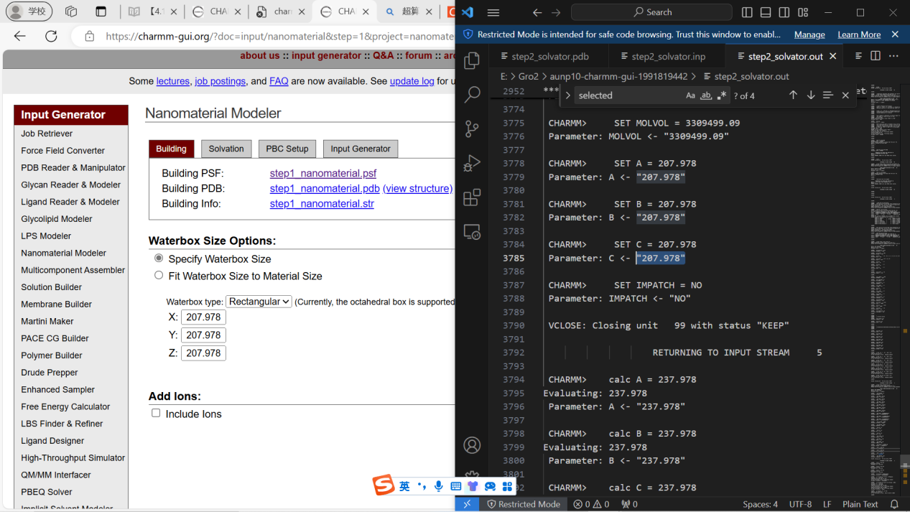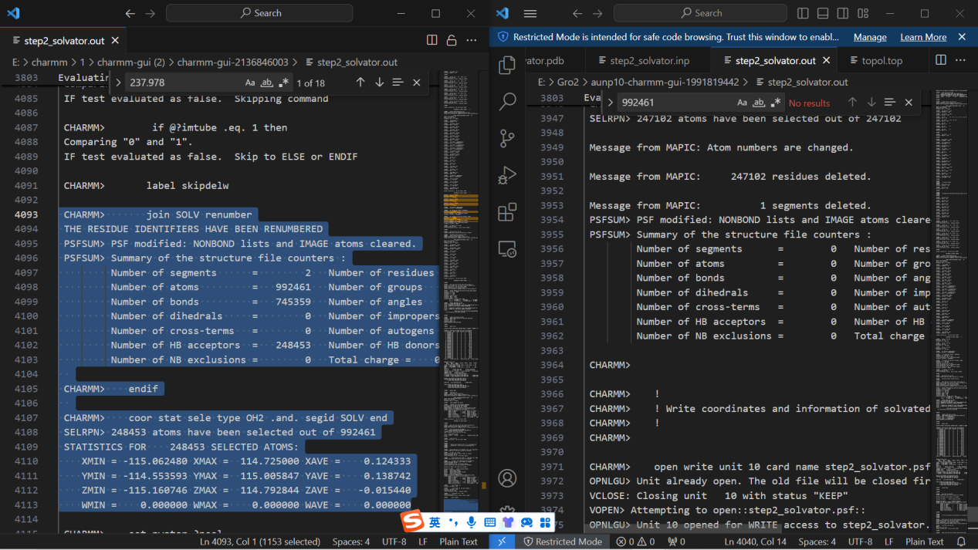

Step1 选择vacuum不要选solvated

后面一页 无add ions

其他默认选项

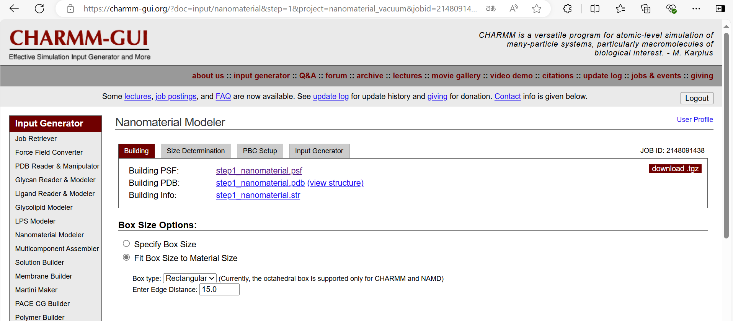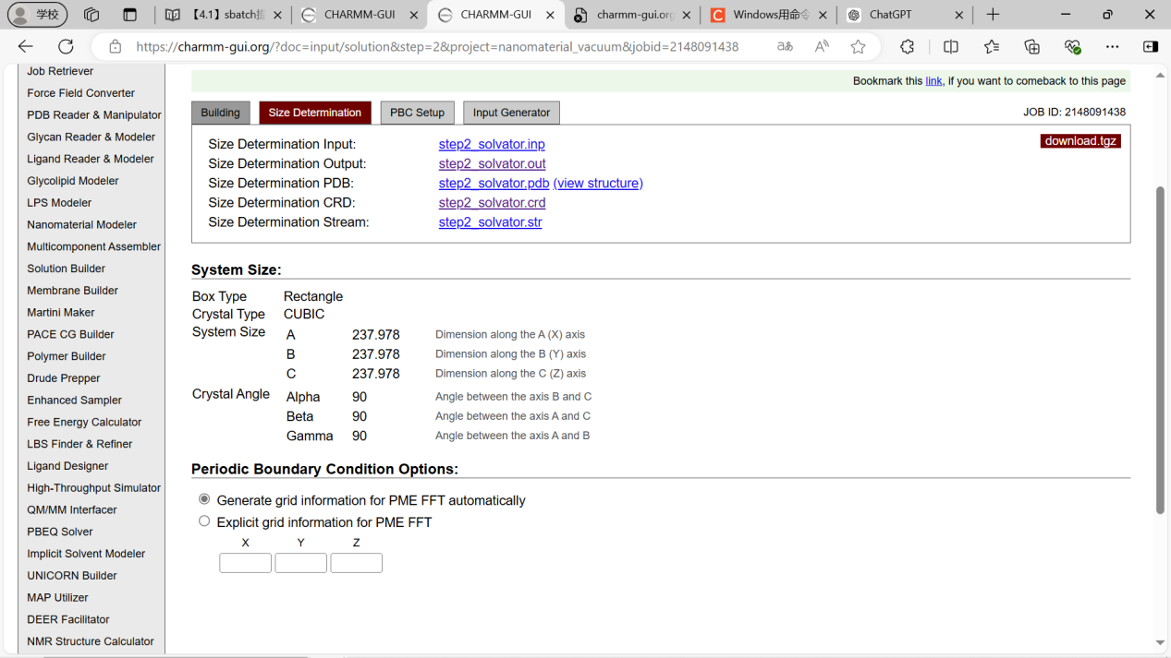

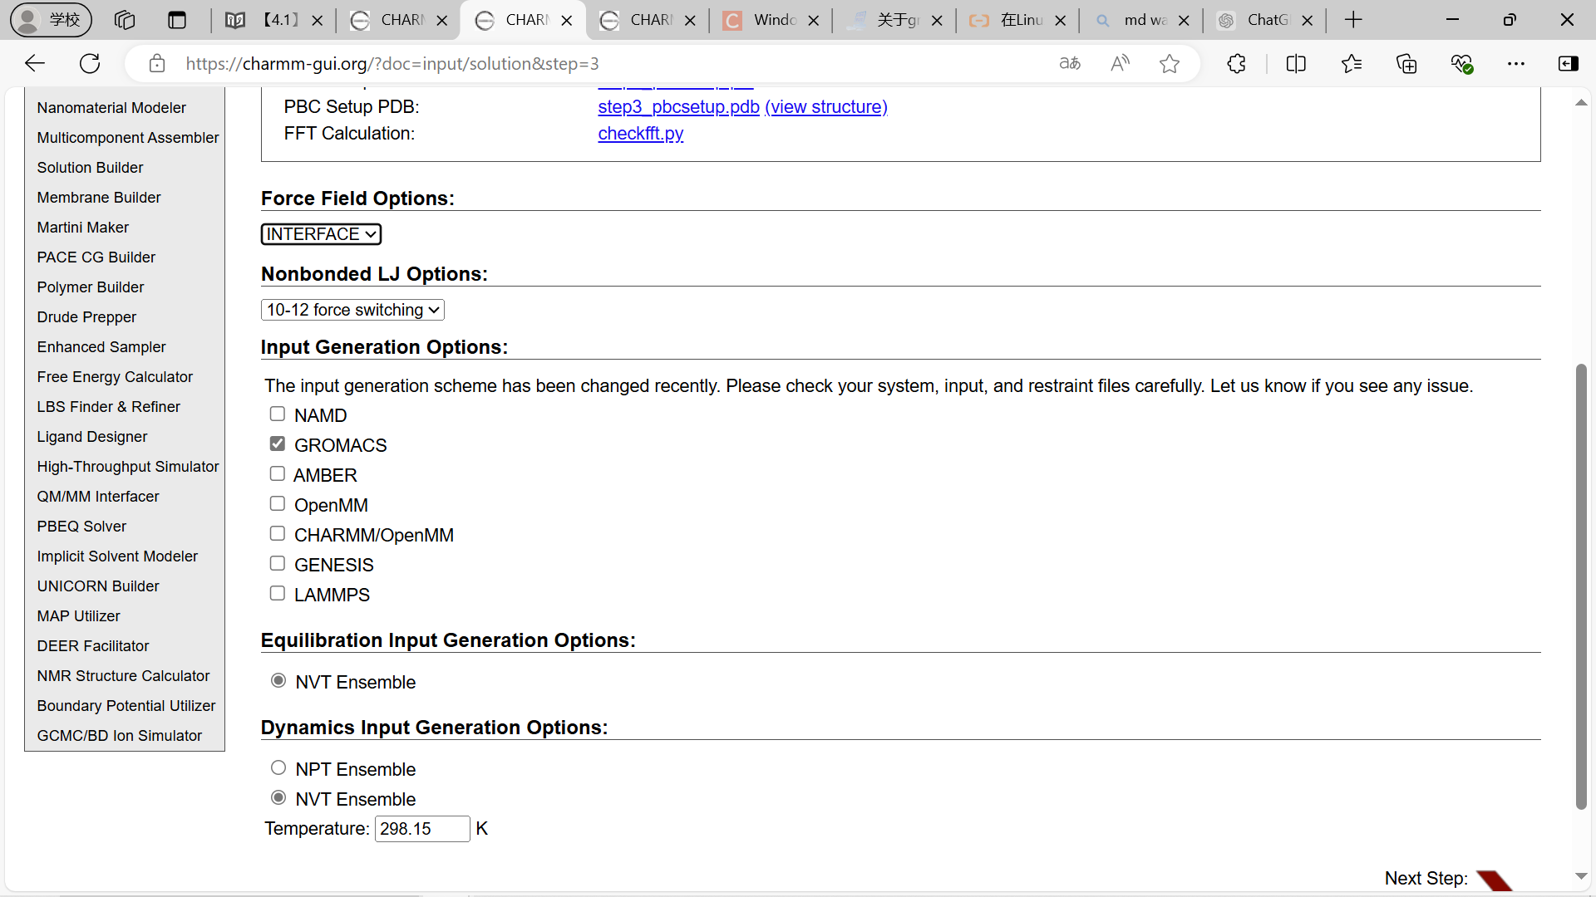

[Nanomaterial Modeler Tutorial 6 - Modeling Nanoparticle and Surfaces of Silica (youtube.com)](https://www.youtube.com/watch?v=dUYozHW_4mQ&t=226s)

