**Project Milestone 1**

**Group 3**

*Elizabeth Billings*

*Romal Patel*

*Simi Maithani*

*Pranav Vella*

**Finalized project proposal:**

Our app is “FlashQuiz.” It is a flashcard app. This app will help the user learn or memorize information, similar to how they might use physical flashcards. It will help students score better on exams while also allowing them to cut back on paper used. The repository for the project is located here: <https://github.com/bethfbillings/AndroidDevelopment_Afternoon_Group3>.

The cards will be pairs of data including a question or image and an answer or image (a front and a back) and will be stored in our app as a stack of the Flashcard class. There will be five pages: a home page, the “front” of the flashcard page, the “back” of the flashcard page, a statistics page, and an edit flashcard page. The home page will have buttons to go to the front of flashcard page, the statistics page, and the edit flashcards page.

* The front of flashcard page will display the question or what would be on the front of the flashcard, and buttons to return to home and to see the back of the flashcard. The flashcard can also display an image, either with or without text.

* The back (the next page, where the answer is displayed) will have the answer, and buttons to indicate if the user was correct or incorrect, and a button to return home. Once the user selects if it was correct or incorrect, the “card” will be moved to back of the stack of cards, and the front of the new top “card” will be displayed. When a user chooses correct or incorrect, a corresponding celebratory or not sound clip will play.
* The statistics page will display the percent of incorrect and correct answer and a button and the total questions a user has done to return to home page.
* The edit card page will display all the cards as text edits and will give user option to add more questions. The flashcards, sets of questions and answers, and the percentages and total cards seen will be stored data. There will be not data shared online or with other users.

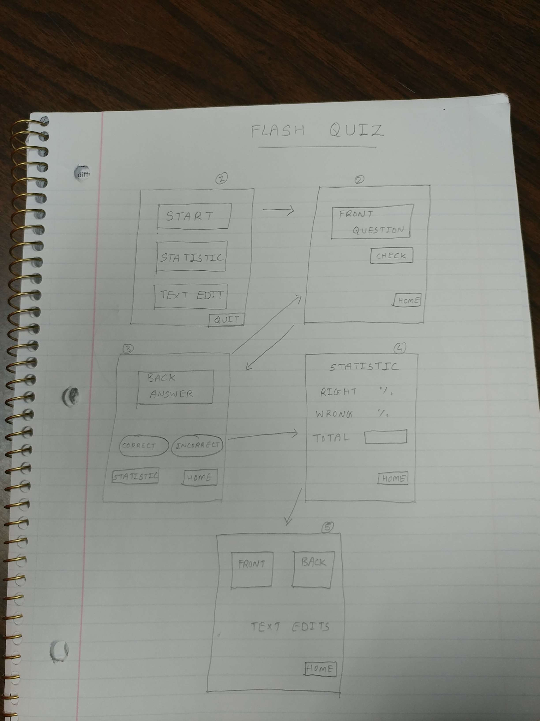

**Risky components:**

We will include the option for users to upload their own images from elsewhere on the phone (like the gallery), which isn’t something we’ve discussed in class yet. We will also include audio, which is something none of us have used before.

**Create an online repository:** *Created*

**Add your GA and me (HOOT@nwmissouri.edu) to your repo. :** *Completed*

**Create all layouts for your application with all the features. (features doesn't have to be fully functional, they can be just widget with no functionality assigned to them.) :** *Created*

**We should be able to navigate through all the layouts created. :** *Completed*