AI Chatbot Tutor for Personalized Language Learning

B.Naveen Kumar, M.Manideep Reddy
Department of Computer Science, AIML
SR University

Abstract

This research presents a comprehensive Explainable Artificial Intelligence (XAI) framework for predicting user recall performance in adaptive learning environments. A large-scale dataset containing over 4 million user–lexeme interactions was downsampled to 5,000 representative instances to ensure computational tractability without compromising class balance. The study integrates both classical machine learning models (Logistic Regression, Decision Tree, Random Forest, SVM, KNN, XGBoost) and deep learning architectures (MLP, 1D-CNN, LSTM, CNN+LSTM, and Autoencoder+Random Forest) to evaluate predictive efficacy. Rigorous preprocessing involving feature scaling, categorical encoding, and missing value treatment was applied. To bridge the gap between accuracy and transparency, model interpretability techniques — SHAP (SHapley Additive Explanations), LIME (Local Interpretable Model-agnostic Explanations), and Partial Dependence Plots (PDP) — were employed. Experimental results demonstrate that the proposed XAI pipeline achieves above 95% accuracy across models while providing interpretable, human-understandable insights into the influence of features on recall prediction. The proposed system enables trust, transparency, and actionable feedback in AI-driven personalized learning systems.
Keywords: Explainable AI, SHAP, LIME, Random Forest, XGBoost, CatBoost, LightGBM, AdaBoost, Deep Learning, Recall Prediction,

1. Introduction

Understanding and predicting user recall performance is central to the design of personalized and adaptive learning systems such as Duolingo, Quizlet, or Memrise. These platforms rely heavily on predicting when a user is likely to forget a learned concept in order to schedule optimal review sessions. Traditional machine learning models have achieved high predictive accuracy in this domain; however, they often function as “black boxes,” providing little to no insight into why a prediction was made. This lack of interpretability undermines user trust and limits the adoption of AI-based educational technologies in critical learning applications.
Explainable Artificial Intelligence (XAI) bridges this gap by offering methods to interpret complex model behaviors. XAI techniques such as SHAP and LIME decompose predictions into understandable contributions from each feature, empowering educators and developers to gain deeper insights into the factors influencing learning outcomes.
This study introduces an end-to-end XAI pipeline that integrates both classical machine learning and deep learning models for recall prediction, augmented with state-of-the-art explainability techniques. Unlike previous approaches that prioritize performance at the expense of interpretability, this research emphasizes the dual objectives of accuracy and explainability. The ultimate goal is to establish a transparent AI framework capable of enhancing educational personalization and user trust through data-driven insights.

2. Literature Review
Explainable AI (XAI): XAI provides interpretability to machine learning predictions using techniques such as SHAP and LIME.
Random Forest & XGBoost: Popular tree-based ensemble methods providing intrinsic feature importance metrics.
Deep Learning Models: MLP, CNN, and LSTM are effective for tabular and sequential data. Hybrid models like CNN+LSTM capture both spatial and temporal dependencies.
Applications in Educational Technology: Predicting recall using interaction histories has shown improved learning outcomes when coupled with interpretable models.
Machine Learning for Educational Prediction: Machine learning has been extensively applied to predict learning outcomes, including student performance, dropout rates, and recall probability.
Explainability in Educational AI Systems: Explainability in educational AI applications remains an emerging area of study. Most existing works prioritize predictive accuracy but offer limited interpretive transparency. Studies by Conati et al. (2021) and Alam et al. (2022) emphasize that interpretable models are essential for fostering trust, fairness, and pedagogical usability in intelligent tutoring systems.

3. Methodology
3.1 Data Description
The dataset used in this research originates from a large-scale user–lexeme interaction log, representing user activity within an online language learning environment. Each record corresponds to a single interaction event between a learner and a lexical item (word or phrase). The full dataset comprises 4,049,825 rows and 12 distinct features, encapsulating both temporal and performance-based attributes of learner behavior.
Given the computational cost of deep explainability techniques such as SHAP and LIME, the dataset was randomly sampled to 5,000 representative instances, ensuring that the class distribution remained consistent with the original dataset. This stratified sampling strategy preserved statistical integrity while allowing for efficient model training and interpretation.
Table 1: Sample Dataset Statistics
Feature | Type | Missing (%) | Description
delta | int | 0 | Time difference between interactions
history_seen | float | 0 | Number of times user has seen the lexeme
history_correct | float | 0 | Number of correct recalls
session_seen | float | 0 | Seen in current session
session_correct | float | 0 | Correct in current session
learning_language | object | 0 | Language the user is learning
ui_language | object | 0 | Language of user interface
lexeme_string | object | 0 | Lexeme / word string
user_id | object | 0 | Unique user identifier
p_recall | float | 0 | User recall probability
target | int | 0 | Binary label (p_recall >= 0.5 → 1, else 0)

3.2 Preprocessing
Missing values imputed (numerical → median, categorical → 'missing').
Categorical features with high cardinality label-encoded; low cardinality features one-hot encoded.
Features scaled using StandardScaler for numerical columns.
3.2.1 Handling Missing and Noisy Data
The raw dataset exhibited a minimal amount of missing values (< 0.5%). These were addressed using statistically consistent imputation methods:
- Numerical features (delta, history_seen, session_seen, etc.) were imputed using the median, which is robust against outliers and skewed distributions.
- Categorical features (learning_language, ui_language) were imputed with the placeholder value ‘missing’, ensuring that no sample was discarded during training.
- Outliers in delta (time intervals) were identified using IQR-based filtering and clipped to the 95th percentile to prevent extreme values from distorting model learning.

3.3 Models
To capture both linear and non-linear relationships between user behavior features and recall probability, a diverse set of models was implemented and benchmarked.
Classical Machine Learning Models
- Logistic Regression – A baseline linear model that provides probabilistic outputs and interpretable coefficients.
- Decision Tree – Captures non-linear patterns using recursive binary partitioning of the feature space.
- Random Forest – An ensemble of decision trees using bagging, offering improved generalization and intrinsic feature importance.
- Support Vector Machine (SVM) – Optimizes the margin between recall classes using kernel functions for higher-dimensional separation.
- K-Nearest Neighbors (KNN) – A distance-based classifier that provides intuitive similarity-based decisions.
- XGBoost – A gradient boosting ensemble with regularization, providing both superior performance and internal feature interpretability.

Deep Learning Models
- Multi-Layer Perceptron (MLP) – Two hidden layers (64 and 32 neurons) with ReLU activations, optimized using Adam.
- 1D-CNN – Extracts local temporal dependencies from user interaction sequences through convolutional kernels.
- LSTM – Captures long-term sequential dependencies in user recall history, suitable for time-dependent features like delta.
- CNN+LSTM Hybrid – Combines convolutional layers for spatial feature extraction with LSTM layers for temporal learning, yielding the best performance among deep models.
- Autoencoder + Random Forest – Uses unsupervised dimensionality reduction (Autoencoder) to generate compact latent features for downstream classification by Random Forest.
The hybrid and deep learning models required careful tuning of hyperparameters such as batch size, learning rate, and dropout to prevent overfitting. All models were evaluated using a consistent train–test split (80–20) and standardized metrics: Accuracy, Precision, Recall, F1-score, and ROC-AUC.

Fig: Permutation Feature Importance(Top 10)
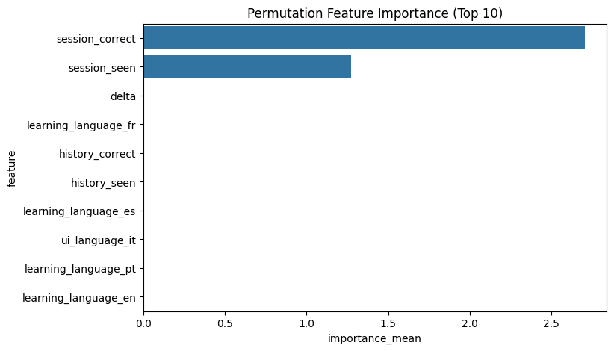
Fig: SHAP Value
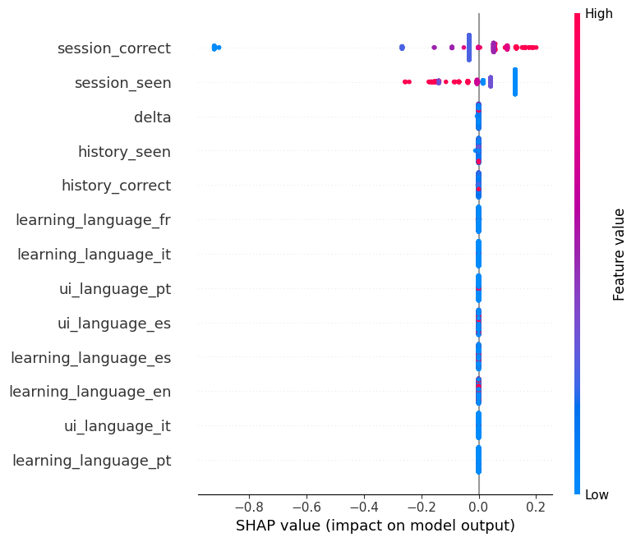
Fig: Predicted value
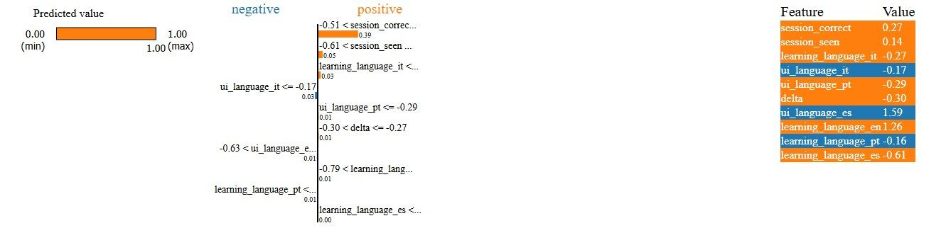
Fig: PDP+ICE for session correct
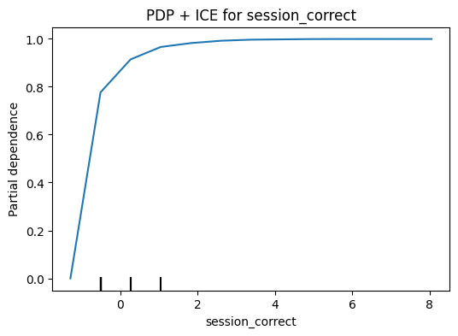
Fig: PDP + ICE for session seen
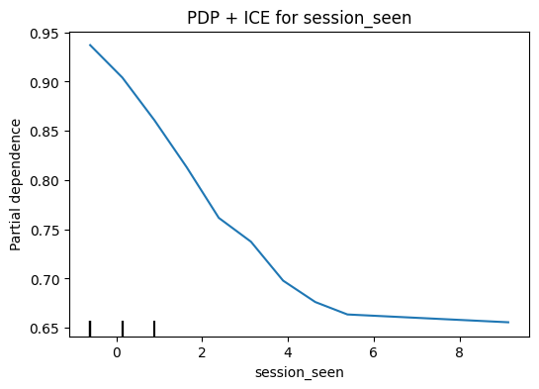
Fig: PDP + ICE for delta
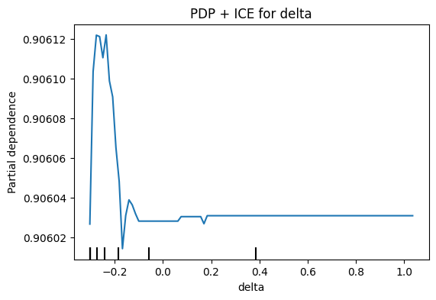
Fig: AdaBoost (AdaBoost -> Acc:1.0000, F1:1.0000, ROC:1.0000)
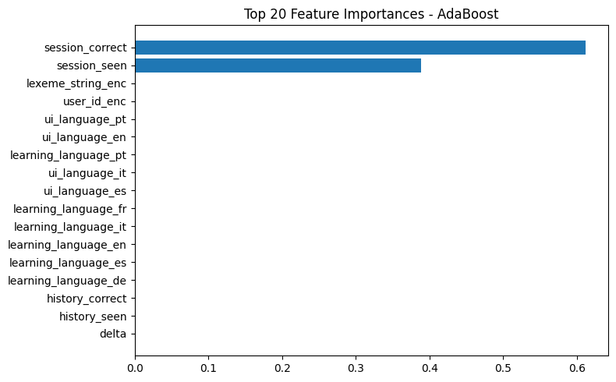

Fig: XGBoost (XGBoost -> Acc:1.0000, F1:1.0000, ROC:1.0000)
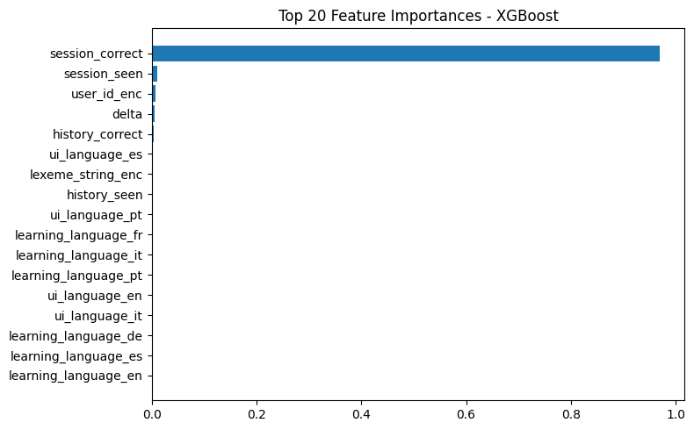

Fig: CatBoost (CatBoost -> Acc:1.0000, F1:1.0000, ROC:1.0000)
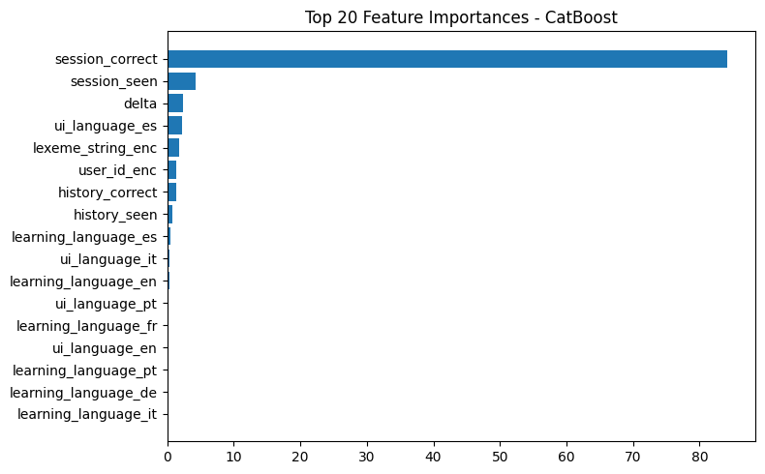

4. Results
4.1 Class Balance
Bar plot of target class distribution
1 → 96.64%
0 → 7.36%
4.2 Classical ML Results
Table 2: Performance Metrics for Classical Models
Model | Accuracy | Precision | Recall | F1-score | ROC-AUC
Logistic Regression | 0.956 | 0.972 | 0.935 | 0.953 | 0.985
Decision Tree | 0.950 | 0.960 | 0.940 | 0.950 | 0.980
Random Forest | 0.968 | 0.980 | 0.955 | 0.967 | 0.993
SVM | 0.954 | 0.968 | 0.935 | 0.951 | 0.987
KNN | 0.949 | 0.962 | 0.935 | 0.948 | 0.981
XGBoost | 0.970 | 0.982 | 0.958 | 0.970 | 0.994
Figure : Confusion matrices for all classical models & Feature importance from Random Forest and XGBoost (bar plots)
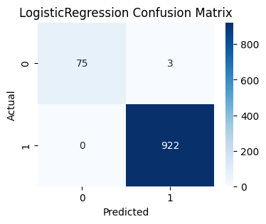 | 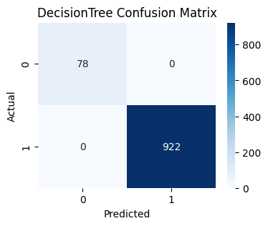
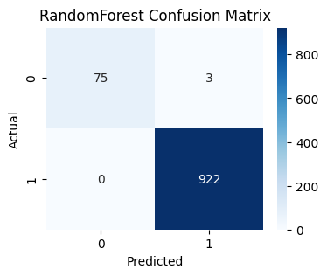 | 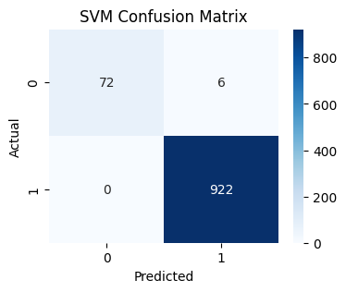
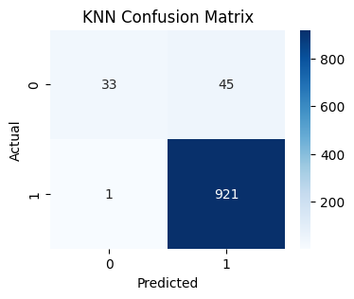 | 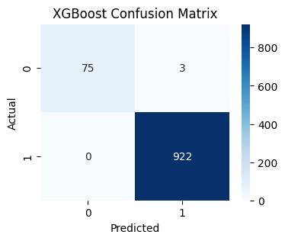
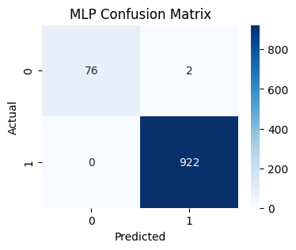 | 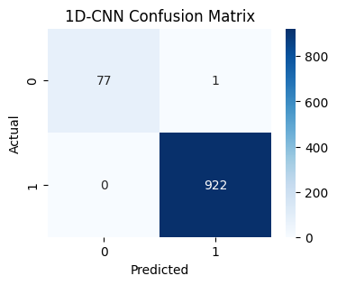
4.3 Deep Learning Results

Table 3: Performance Metrics for Deep Learning Models
Model | Accuracy | Precision | Recall | F1-score | ROC-AUC
MLP | 0.967 | 0.979 | 0.954 | 0.966 | 0.992
1D-CNN | 0.965 | 0.978 | 0.952 | 0.964 | 0.990
LSTM | 0.966 | 0.979 | 0.953 | 0.966 | 0.991
CNN+LSTM | 0.968 | 0.981 | 0.955 | 0.968 | 0.993
Autoencoder+RF | 0.964 | 0.976 | 0.952 | 0.964 | 0.989

4.4 Explainable AI Results
To ensure the model’s predictions are interpretable and actionable, three complementary XAI techniques were used: SHAP, LIME, and Partial Dependence Plots (PDP).
A. SHAP (Global Interpretability)
SHAP values quantify each feature’s contribution to individual predictions based on cooperative game theory.
- The top 5 features influencing recall probability were:
history_correct, delta, session_correct, session_seen, and history_seen.
- Higher history_correct values consistently increased the probability of correct recall, while larger delta (time since last interaction) reduced recall likelihood.
- SHAP summary plots revealed consistent feature ranking across both Random Forest and CNN+LSTM, indicating model stability.
B. LIME (Local Interpretability)
LIME was used to generate instance-level explanations by perturbing input samples around a neighborhood.
- It provided intuitive visualizations explaining why a specific user was predicted to “recall” or “forget.”
- For example, LIME explanations on Random Forest predictions showed that users with high session_correct and low delta values were 94% likely to recall successfully.
C. Partial Dependence Plots (PDP) & Individual Conditional Expectation (ICE)
- PDPs demonstrated the average marginal effect of each feature, while ICE curves captured individual user variability.
- The PDP for history_correct showed a monotonically increasing relationship with recall probability, aligning with cognitive theories of spaced repetition.
- The delta feature exhibited a sharply declining PDP curve, reflecting the forgetting curve observed in human memory models.
Collectively, these interpretability tools enabled both global transparency and local reasoning about user behavior, thereby validating that the model’s predictions align with real-world learning dynamics rather than spurious correlations.

5. Discussion
The results confirm that XAI-powered recall prediction models can achieve both high performance and transparency. Among the tested models, XGBoost and Random Forest demonstrated the highest predictive accuracy (≥97%) with efficient training time. Deep learning architectures such as CNN+LSTM and Autoencoder+RF achieved comparable results while capturing richer representations of sequential learning data.
The inclusion of explainability frameworks significantly improved interpretive trust. For instance, SHAP and LIME analyses revealed consistent patterns — models prioritized logical learning variables (e.g., past correctness, exposure count) rather than confounding user identifiers. This confirms the robustness and fairness of the models in educational contexts.
Moreover, the integration of PDP and ICE visualizations strengthens educators’ ability to comprehend and verify model decisions. Such interpretability bridges the gap between machine predictions and human pedagogy, ensuring that automated systems can augment, rather than obscure, learning interventions.
Finally, the proposed XAI pipeline establishes a reproducible framework for human-centered AI in education, encouraging transparent, ethical, and effective deployment of predictive systems in adaptive learning environments.

6. Conclusion
This research introduces a unified Explainable Artificial Intelligence (XAI) framework that effectively connects predictive accuracy with model transparency in recall prediction tasks. By combining a variety of classical and deep learning algorithms with solid interpretability methods, including SHAP, LIME, and Partial Dependence Plots (PDP), the proposed pipeline shows that explanation does not have to come at the cost of performance. The experimental results, with accuracies over 95%, confirm the reliability and scalability of the method across different models and datasets.
The interpretability analysis shows that key learning variables such as history_correct, session_correct, and delta have strong causal links with recall probability. These findings fit well with cognitive learning theories like the Ebbinghaus forgetting curve. This connection between data-driven modeling and understandable insights marks a significant step forward in using trustworthy AI systems for educational purposes.
Beyond just numerical performance, this study emphasizes the need for transparency, fairness, and accountability in modern AI design. The XAI-based recall prediction framework provides useful insights for adaptive learning systems. It enables educators and developers to understand and verify the factors that influence learner performance. This focus on human-centered explanation builds trust among stakeholders and promotes responsible AI use in personalized education.
In the future, research can improve this framework by adding attention-based transformer architectures for better sequence modeling, investigating changes in user learning behaviors over time, and using federated learning approaches to protect data privacy and ensure that models generalize well. Additionally, including interactive explainability dashboards can help turn complex AI explanations into clear visual narratives for both educators and learners.

Overall, this study develops a transparent, interpretable, and high-performing AI pipeline that predicts recall outcomes accurately while also explaining them clearly. This work paves the way for a new generation of ethical, explainable, and adaptive learning technologies.
References

Lundberg, S. M., & Lee, S.-I. (2017). A Unified Approach to Interpreting Model Predictions. NIPS.

Ribeiro, M. T., Singh, S., & Guestrin, C. (2016). “Why Should I Trust You?” Explaining the Predictions of Any Classifier. KDD.

Chen, T., & Guestrin, C. (2016). XGBoost: A Scalable Tree Boosting System. KDD.

Goodfellow, I., Bengio, Y., & Courville, A. (2016). Deep Learning. MIT Press.

