ZENNY
The Braid Trading System
Complete System Specification
April 2026 — Confidential

This document contains four integrated specifications for the Zenny trading system. It is written for the development team and assumes the existing codebase — including the auto-research framework, Coinglass integration, panel scaffolding, and scoring logic — as the foundation. Nothing is thrown away. The developer decides what maps to the new specification and what is reworked.

Doc | Title | Purpose
Doc 1 | The Why | Philosophy, intent, and what makes Zenny categorically different
Doc 2 | Functional Spec | Every function — rules, inputs, outputs, call relationships
Doc 3 | UI Specification | Every UI component — rules, inputs, visual behaviour
Doc 4 | Test Specification | How correct implementation of every function and component is verified

Document 1
The Why
Philosophy, intent, and what makes Zenny categorically different

1.1 The problem with every existing bot
Every existing trading bot is built on a common architectural assumption: that price action expressed as OHLCV candles is the primary input. Indicators are derived from that price action. RSI measures the speed of recent price movement. MACD measures the relationship between moving averages of price. Even the most advanced algorithmic systems are applying increasingly complex transformations to historical price data and waiting for signals to emerge.
This has a structural problem. Price is a lagging record of what already happened. Every indicator built on price inherits that lag. By the time the signal appears, the best entry is already behind you.
Zenny is built on a different premise entirely. Price does not move randomly. Price moves toward liquidity. Liquidity — clusters of resting orders, stop losses, liquidation thresholds — is the cause of price movement. Price action is the effect. Zenny reads the cause directly and positions itself at the destination before the journey begins.

1.2 The Braid — a completely new visual object
The Braid is not a better candlestick chart. It is a different kind of visual object built for a specific purpose: verifying that a bot is behaving with strategic integrity. A candlestick chart is optimised for human analysts making real-time decisions. The Braid is optimised for answering one question — did the bot do what it was designed to do.
The Braid has three temporal zones. The left section is history: the price wire moving through the pool landscape with all past interactions visible. The now line is the present moment. The right section splits into two panels — one for the pool above, one for the pool below — each showing what Zenny expects to happen when price arrives.
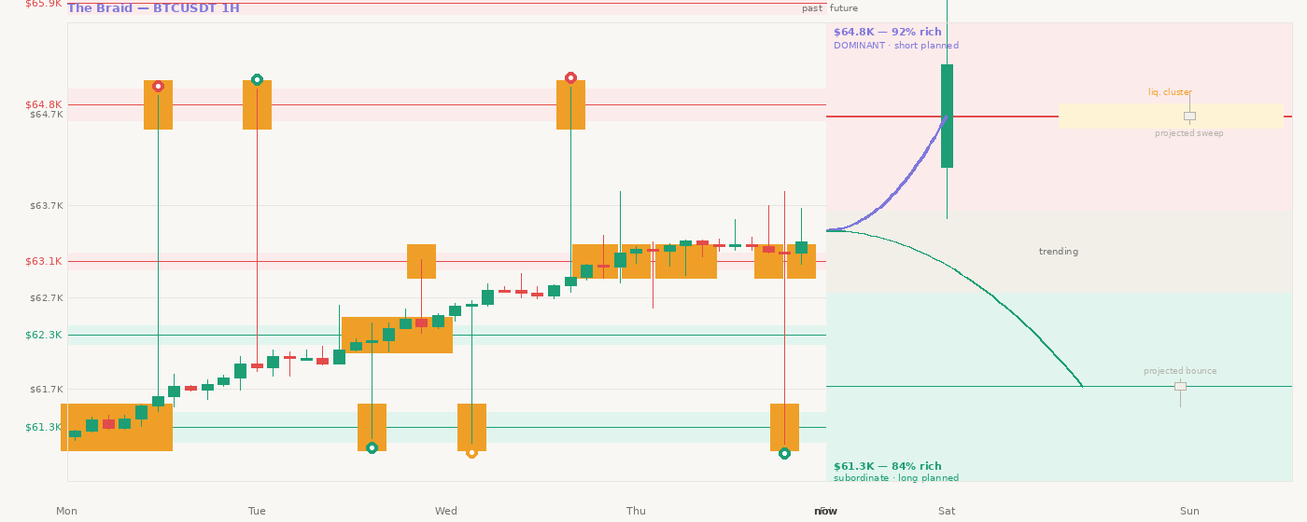
Figure 1: The Braid — price wire on left, now line dividing present, two tendency panels on right. Last real candle on dominant arm. Ghost candle shows projected sweep.

1.3 Why the rectangle and not the line
Technical analysis has drawn support and resistance as horizontal lines for a century. A line implies a precise price at which the market will reverse. Zenny draws rectangles. Each rectangle is constructed from actual wick extremes: the ceiling is the highest wick that touched and rejected the level. The floor is the lowest wick. The centre line is the body cluster.
The rectangle also has a lifecycle — born on first tick cluster detection, active while scoring above 60/100, weakening as wick rejections tighten, dead when a candle engulfs it. When it dies it flips polarity. Resistance becomes support. The level persists with a new role.
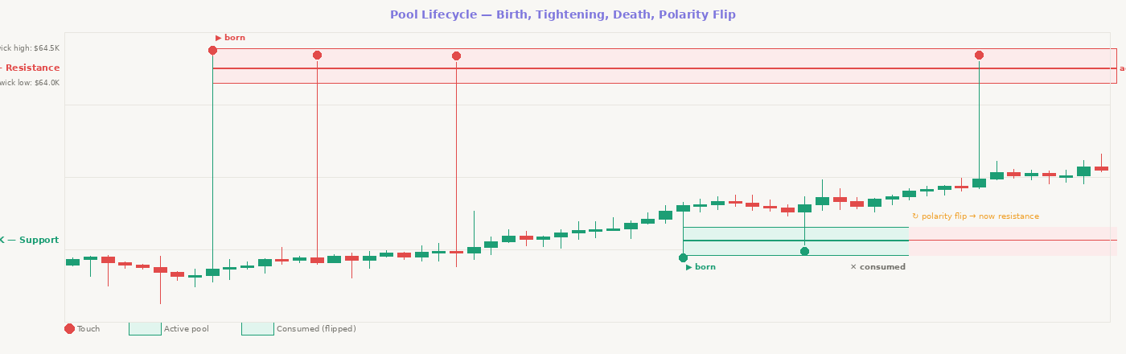
Figure 2: Pool lifecycle — birth marker, wick boundaries, touch interactions, death marker, polarity flip from support to resistance.

1.4 Why the angle and not a regime declaration
Zenny reads regime from the geometry of the wire itself. The angle of the price wire over the last 14 candles is the regime. It updates with every new candle close. Gann identified the meaningful thresholds in 1935: below 14 degrees is noise — no trade. 14 to 26.25 is accumulation. 26.25 to 45 is ranging. 45 to 63.75 is trending. Above 63.75 is breakout or unsustainable.
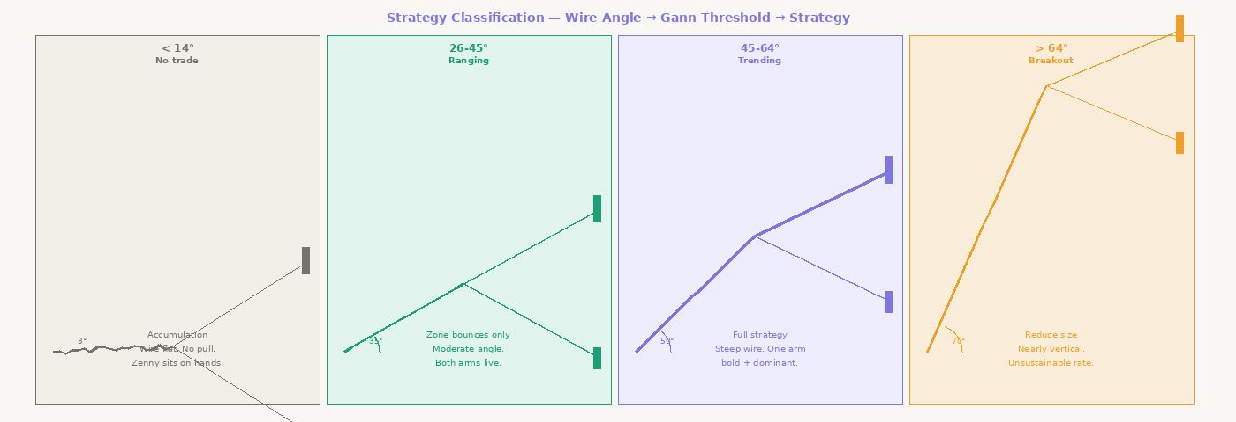
Figure 3: Four strategy scenarios derived from wire angle. Gap between arms represents velocity toward dominant pool — wide gap = trending, narrow gap = accumulation.

1.5 Intelligence map — all inputs to the Braid
Zenny monitors and weights dozens of signals simultaneously. No human can do this in real time. The intelligence map shows how every data source flows through the system to produce the Braid visual and trade decisions.
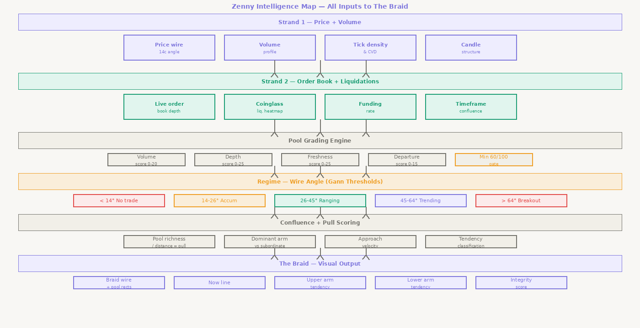
Figure 4: Zenny intelligence map — all signals flowing from raw data through pool grading, regime classification, and pull scoring to visual output.

1.6 Three-layer architecture
Every pool on the trading timeframe exists within a higher timeframe context. The daily and 4H establish the permanent backdrop. The 1H is the active layer where trades are planned. The 15m is the execution layer where entry candles form. These are not three separate analyses — they are three lenses on the same underlying reality.
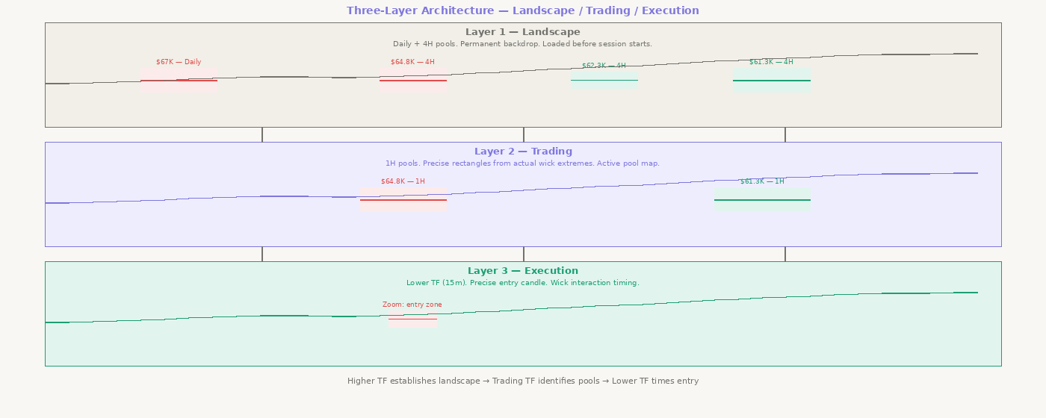
Figure 5: Three-layer architecture — landscape (daily/4H), trading (1H), execution (15m). Higher timeframes establish context; lower timeframes time entry.

1.7 Why integrity score and not P&L
P&L is deeply misleading. A bot gambling randomly in a bull market shows positive P&L. A bot executing a sound strategy in adverse conditions shows negative P&L. Neither number tells you whether the bot is doing what it was designed to do.
The integrity score measures something different: of all valid setups that existed on a given day, what fraction did Zenny correctly identify and act on — either by taking the trade or by intentionally skipping it with a logged reason. This was the exact diagnostic that caught the original bot's failure. P&L masked the problem completely. The integrity score would have caught it in minutes.

1.8 The relationship to the existing codebase
Zenny is a rework, not a rebuild. The following components are explicitly preserved:
- The auto-research framework based on Karpathy's self-testing methodology — this is the fundamental verification backbone
- The Coinglass liquidation heatmap integration — feeds ScoreLiquidationCluster directly
- The panel and dashboard scaffolding — the Braid renders within this
- The existing scoring and grading logic — reworked to match specification, not replaced

Document 2
Functional Specification
Every function — rules, inputs, outputs, call relationships

2.1 Architecture overview
Zenny's functional architecture is a pipeline with eight layers: data ingestion, tick processing, candle analysis, pool identification, pool scoring, strategy classification, pull calculation, and trade and visual output. Every function has defined inputs and defined outputs. RegimeGuard runs as a gate before any trade output — no exceptions.

2.2 Data ingestion
Function | Rule / Logic | Test Criteria
FetchCandles | Inputs: symbol, timeframe, lookback. Calls Binance klines endpoint. Returns [{timestamp,open,high,low,close,volume}]. Validates: no gaps, timestamps ordered, all values non-null. Caches on symbol+timeframe+last_timestamp. | Output matches TradingView for same symbol/timeframe within 0.01%. No missing candles. No duplicates. Updates cache correctly on new candle close.
FetchOrderBook | Inputs: symbol, depth_limit (default 500). Calls Binance /api/v3/depth. Returns {bids:[[price,qty]], asks:[[price,qty]]}. Updates via WebSocket. Bids sorted descending, asks ascending. | Spread matches Binance live feed within 100ms. Depth at each price matches raw API. Updates within 1 second of order book change.
FetchTicks | Inputs: symbol, start_timestamp. Subscribes to Binance trade stream WebSocket. Returns stream of {timestamp,price,qty,side}. Side=BUY if market order lifted ask, SELL if hit bid. | Every trade in raw stream appears in output. No duplicates. Timestamps ordered. Volume matches trade size exactly.
FetchLiquidationData | Inputs: symbol, timeframe. Calls Coinglass API. Returns {price_level: liquidation_usd} map. Caches 5 minutes. | Values match manual Coinglass query for same symbol/window within 5% tolerance. Cache invalidates correctly after 5 minutes.
FetchFundingRate | Inputs: symbol. Calls Binance futures /fapi/v1/fundingRate. Returns {rate, next_funding_time}. Caches 1 minute. | Matches Binance futures funding rate endpoint for same timestamp exactly.
NormaliseTimeframe | Inputs: candles_1H array. Aggregates every 4 candles: open=first.open, high=max(highs), low=min(lows), close=last.close, volume=sum. Output length = floor(input/4). | Synthetic 4H candle matches native 4H from exchange within 0.01%.
CacheHistoricalData | Inputs: key(symbol+timeframe+timestamp), data. TTL = one candle period. Second call with same key returns cached data without API hit. | No API hit on second call. Cache invalidates on new candle close. Stale cache never returned after TTL.
DetectDataGaps | Inputs: candles array, expected_interval. Checks consecutive timestamps differ by interval. Returns [{gap_start, gap_end, duration}]. Empty array if no gaps. | Injected missing candle flagged. Two consecutive missing candles both flagged. No gaps produces empty array.

2.3 Tick processing
Function | Rule / Logic | Test Criteria
AggregateTicksByPrice | Inputs: ticks array, bucket_size (0.1% of price). Groups ticks into buckets. Returns {bucket_centre: {count, volume, buy_volume, sell_volume}}. | Sum of all tick volumes in bucket equals raw tick volume at that price. Total volume across buckets equals total input volume.
CalculateTickDensity | Inputs: aggregated_ticks, window_seconds. Returns {price_level: density_score}. Density = count/window_seconds. Normalised 0-1 across all levels. | Level with 100 ticks scores higher than level with 10 ticks. Density decays to zero outside window. Max score = 1.
DetectTickCluster | Inputs: tick_density, threshold (0.7). Returns [{price_centre, density_score, width}] for all levels above threshold. | Synthetic cluster at known price detected. Random ticks spread across prices at same volume = no cluster. Threshold boundary tested.
CalculateVolumeDelta | Inputs: ticks array, price_bucket. Returns {delta: buy-sell, total_volume, delta_ratio}. Positive = more aggressive buying. | Manual buy minus sell sum matches output. Positive delta in known uptrend. Negative in known downtrend.
DetectAbsorption | Inputs: volume_delta, price_movement_pct. Returns {absorbed: bool, side, strength}. Absorbed when delta > threshold AND price_movement < 0.1%. | Large volume + minimal price movement = absorbed. Large volume + significant price movement = not absorbed.
MeasureBidAskSpread | Inputs: order_book. Returns {spread_absolute, spread_pct, mid_price}. Monitors 60-second rolling window for tightening signal. | Spread matches manual top-of-book calculation. Tightening signal fires when spread narrows >20% over 60 seconds.
CalculateCumulativeVolumeDelta | Inputs: volume_delta stream, window. Returns running sum. Resets on session open. Divergence flag fires when CVD makes new high/low but price does not. | CVD rises in known uptrend. Divergence flag fires correctly on historical examples.

2.4 Candle analysis
Function | Rule / Logic | Test Criteria
FindLocalExtrema | Inputs: candles, lookback (5). Returns {highs:[{index,price}], lows:[{index,price}]}. High = candle high > all surrounding N candles. Minimum separation = lookback. | Known BTC swing highs and lows all detected. No false extrema on flat sections. Minimum separation enforced.
ClassifyCandle | Inputs: candle {open,high,low,close}. Returns {type:ERC|NRC|DOJI}. ERC=body>=75% range. NRC=body<=50%. DOJI=body<=5%. | Body 80% of range = ERC. 40% = NRC. 3% = DOJI. All boundary values tested.
MeasureWickExtreme | Inputs: candles array touching a price band. Returns {wick_high:max(highs), wick_low:min(lows)}. | Wick high matches candle high exactly. Wick low matches candle low exactly. Tested against raw OHLCV.
MeasureBodyCluster | Inputs: candles array. Returns {cluster_centre, cluster_width}. Centre = median of (open+close)/2. Width = 90th percentile body range. | Cluster centre falls between open and close. Width covers 90% of body extremes.
CountTouches | Inputs: candles, pool_rectangle. Returns {touch_count, body_touches, wick_touches}. Touch = candle high>=pool.low AND candle low<=pool.high. | Manual count matches output. Candles entirely outside zone do not increment. Body vs wick classified correctly.
MeasureTouchQuality | Inputs: candle, pool, subsequent_candles(5). Returns {quality_score 0-100}. Scored on rejection_speed, rejection_distance, candle_type. | Strong rejection scores 80+. Weak touch below 30. Score monotonically related to rejection speed and distance.
DetectEngulfingCandle | Inputs: candle, pool_rectangle. Returns {engulfed:bool}. Engulfed = body crosses BOTH pool ceiling and floor. | Body crosses both boundaries = true. Partial overlap = false. Tested on historical BTC breakout candles.
DetectWickPierce | Inputs: candle, pool_rectangle, boundary. Returns {pierced:bool, depth_pct}. Pierced = wick crosses boundary but body stays inside. | Wick crossing boundary with body inside = true. Body crossing = false. Depth pct matches manual calculation.
MeasureDepartureStrength | Inputs: departure_candle, prior_base_candles. Returns {strength_score 0-100}. Gap-away=100. ERC=60. NRC=25. DOJI=5. | Historical departure events classified correctly vs manual review.
DetectTightening | Inputs: recent_wicks(last 5), pool. Returns {tightening:bool, trend}. Tightening = each successive wick less deep into zone. | Three successive tightening wicks detected. Same-depth wicks not detected. Two wicks insufficient.

2.5 Pool identification
Function | Rule / Logic | Test Criteria
ClusterPriceLevels | Inputs: local_extrema, tick_clusters, tolerance(0.5%). Groups items within tolerance. Returns {candidate_pools:[{centre_price, extrema_count, tick_density}]}. | Known BTC S/R levels appear as clusters. Random prices do not. Tolerance boundary tested.
ValidateCandidatePool | Inputs: candidate_pool, candles. Checks: touch_count>=3, volume>=threshold, departure_strength>0. Returns {valid:bool, failure_reason}. | 2 touches = invalid. 3 touches + sufficient volume = valid. Each failure reason testable in isolation.
SetPoolBoundaries | Inputs: validated_pool, candles. Returns {wick_high, wick_low, centre_line, zone_width_pct}. Width must be 0.5%-1.5% of price. | Wick high matches highest wick at level. Centre matches body cluster. Width validated against 0.5-1.5% rule.
ClassifyPoolType | Inputs: pool, approach_direction. Returns {type:RESISTANCE|SUPPORT}. From below = RESISTANCE. From above = SUPPORT. | Historical levels classified correctly. Polarity-flipped pools classified correctly after flip.
DetectPoolBirth | Inputs: tick_cluster, existing_pools. Fires when density Z-score>2.0 at level with no existing active pool. Returns {born:bool, pool_id, timestamp}. | Birth fires exactly once per new level. Second cluster at same level within tolerance does not fire second birth.
DetectPoolDeath | Inputs: pool, recent_candles. Fires when engulfing candle detected OR 3 consecutive closes outside boundary. Returns {dead:bool, death_candle_index, cause}. | Engulfing = immediate death. Three consecutive closes = death on third. One close outside = no death.
DetectPoolWeakening | Inputs: pool, recent_wick_interactions. Returns {weakening:bool, degrade_factor 0-1}. Three successive tightening wicks. | Three tightening wicks fires weakening. Two insufficient. Degrade_factor reduces pool score proportionally.
ApplyFibonacciExtensions | Inputs: swing_low, swing_high, current_price. Called when price > all-time-high. Returns {synthetic_pools:[{price,level_name}]} at 1.618, 2.618, 3.618, 4.236 extensions. | Extensions match manually calculated values. Only called above all-time-high. Updates on new swing.
ApplyPolarityFlip | Inputs: dead_pool. Returns pool with type flipped (RES->SUP or SUP->RES), status=FLIPPED, score reset to 40. | Type changes. Boundaries unchanged. Score reduced to 40. Downstream functions treat correctly.
FilterPoolByMinimumScore | Inputs: pool, score. Returns {passes:bool}. Score>=60 = passes. Below 60 = suppressed, no rectangle, no trade, logged. | Score 60 = passes. Score 59 = fails. Failure logged. No visual or trade output for failed pools.

2.6 Pool scoring
Function | Rule / Logic | Test Criteria
ScoreVolume | Inputs: pool_price, volume_profile. Returns {score 0-20}. Top 10%=20, top 20%=15, top 40%=10, below 40th=0. | Top 10% volume node scores 20. Adjacent low-volume level scores 0. Updates when volume profile recalculates.
ScoreOrderBookDepth | Inputs: pool_price, order_book. Returns {score 0-25}. >=500 BTC=25, 250-500=18, 100-250=10, <100=0. | 600 BTC in book scores 25. 200 BTC scores 10. Updates when order book changes >10% at level.
ScoreFreshness | Inputs: pool, touch_history. Returns {score 0-25}. Untouched=25, 1 touch=20, 2=14, 3=8, 4+=3. | Untouched scores 25. Each touch degrades monotonically. Historical touch count verified.
ScoreDepartureStrength | Inputs: pool_birth_candle, departure_type. Returns {score 0-15}. Gap-away=15, ERC=9, NRC=4, DOJI=1. Set at birth, immutable. | Historical birth candles classified correctly. Score does not change after birth.
ScoreTimeframeConfluence | Inputs: pool_price, all_timeframe_pools. Returns {score 0-10}. 1 TF=3, 2 TF=7, 3+ TF=10. | 4 timeframes scores 10. 1 timeframe scores 3. Alignment within 0.5% price tolerance.
ScoreTouchQuality | Inputs: touch_history. Returns {adjustment -10 to +5}. Strong rejections(>70) add, weak touches(<30) reduce. | Pool with 3 strong rejections has positive adjustment. Weak touches have negative adjustment.
ScoreLiquidationCluster | Inputs: pool_price, liquidation_data. Returns {score 0-5}. Within 1%=5, within 2%=2, beyond 2%=0. | Cluster within 1% scores 5. No cluster scores 0. Distance verified against manual Coinglass data.
AggregatePoolScore | Inputs: all sub-scores. Returns {total_score, breakdown{volume,depth,freshness,departure,confluence,touch_quality,liquidation}}. Max=105. | Sum matches total. No sub-score exceeds stated max. All 7 components in breakdown. Recalculates on every candle close.
ValidatePoolThreshold | Inputs: pool, score. Returns {valid:bool}. Valid if score>=60. Invalid = no rectangle, no trade, logged. | Score 60 = valid. Score 59 = invalid. Both cases logged with pool_id, score, timestamp.

2.7 Timeframe management
Function | Rule / Logic | Test Criteria
DetermineActiveTimeframe | Inputs: config. Returns {active_tf, higher_tf_1 (4x), higher_tf_2 (16x)}. All three preloaded before trading. | Correct timeframe from config. Higher TFs calculated as 4x and 16x. Data available before first trade attempt.
LoadHigherTimeframePools | Inputs: symbol, higher_tf_1, higher_tf_2. Loads and scores pools on both. Returns {landscape_pools}. Refreshes on higher_tf candle close. | Daily loads before 4H. 4H loads before 1H analysis. Order of operations verified by timestamp.
CheckPoolVisibilityAcrossTimeframes | Inputs: pool_price, all_tf_pools, tolerance(0.5%). Returns {visible_on:[tf_list], confluence_count}. | Within 0.5% on two TFs = visible on both. 0.6% away = not visible. Confluence count matches visible TF count.
AlignPoolsAcrossTimeframes | Inputs: trading_tf_pool, landscape_pools. Returns {aligned:bool, aligned_pools, alignment_strength}. | Within 0.5% = aligned. 0.6% apart = not aligned. Alignment strength sums aligned pool scores correctly.
ClassifyTradeType | Inputs: trade_direction, higher_tf_bias. Returns {type:TYPE1|TYPE2, size_modifier}. TYPE1=aligned(1.0x). TYPE2=against(0.5x). | Long with bullish higher TF = TYPE1. Long with bearish higher TF = TYPE2. Size modifier applied correctly.

2.8 Wire and angle
Function | Rule / Logic | Test Criteria
BuildPriceWire | Inputs: candles, lookback(100). Returns {wire:[close_prices], timestamps}. Updates on each candle close. | Wire closes match candle closes exactly. Length always equals lookback. Updates within 100ms of candle close.
SmoothWire | Inputs: raw_wire, periods(3). Returns {smooth_wire}. 3-period SMA. End points unchanged. | Smoothed values between adjacent raw values. Single spike dampened. End points equal raw values.
MeasureWireAngle | Inputs: smooth_wire, lookback(14), price_scale_factor. Returns {angle_degrees, slope_normalised}. | Flat price = angle near 0. Known 45° trend = angle within 2° of 45. Negative angles for downtrends.
MapAngleToGann | Inputs: angle_degrees. Returns {gann_bracket, strategy_label}. <14=NO_TRADE, 14-26.25=ACCUMULATION, 26.25-45=RANGING, 45-63.75=TRENDING, >63.75=BREAKOUT. | All five bracket boundaries tested explicitly. Angle exactly at boundary goes to correct bracket.
ClassifyStrategy | Inputs: gann_bracket. Returns {strategy, trade_permitted:bool}. NO_TRADE+ACCUMULATION=false. RANGING/TRENDING/BREAKOUT=true. | All five brackets return correct strategy and trade_permitted value.
DetectAngleShift | Inputs: current_bracket, previous_bracket. Returns {shifted:bool, from, to}. Debounce: 3 candles before shift confirmed. | Bracket change fires exactly once. Oscillation at boundary prevented by debounce.
DetectAngleWidening | Inputs: angle_history(last 5). Returns {widening:bool, rate}. Widening = angle increasing >10° over 3 candles. | 12° increase over 3 candles = widening. <10° change = no widening.
MeasureWireVelocity | Inputs: angle_history(last 5). Returns {velocity, direction:ACCELERATING|DECELERATING|STABLE}. | Increasing angle = ACCELERATING+positive. Decreasing = DECELERATING+negative. Constant = STABLE+near-zero.

2.9 RegimeGuard — architectural gate
RegimeGuard is not just a function. It is an architectural gate enforced at the pipeline level. Every trade attempt must pass through RegimeGuard before any downstream function executes. No exceptions. Any trade in the log without a corresponding RegimeGuard pass record is a critical integrity failure.
Function | Rule / Logic | Test Criteria
RegimeGuard | Inputs: wire_angle, gann_bracket. Returns {permitted:bool, reason}. Permitted=false if bracket is NO_TRADE or ACCUMULATION (angle<26.25). Permitted=true if RANGING/TRENDING/BREAKOUT. Reason logged for all decisions. | Angle 13° = not permitted. Angle 26° = not permitted. Angle 27° = permitted. Every trade in log has RegimeGuard pass record. Zero exceptions.

2.10 Pull calculation
Function | Rule / Logic | Test Criteria
MeasureDistanceToPool | Inputs: current_price, pool. Returns {distance_pct, distance_abs, direction:UP|DOWN}. Updates each candle close. | Distance to pool 1% above = 1.0%. Direction correct for pools above and below.
CalculatePullScore | Inputs: pool_score, distance_pct. Returns {pull: pool_score/distance_pct}. Normalised 0-100 across all active pools. | Score 90 at 1% = higher pull than score 90 at 3%. Inverse relationship confirmed. Normalisation: highest pull=100.
RankPoolsByPull | Inputs: active_pools with pull scores. Returns {ranked_pools} sorted by pull descending. | Highest pull ranked first. Ties broken by pool score, then freshness.
DetermineArmDominance | Inputs: pool_above, pool_below with pull scores. Returns {dominant:pool_id, subordinate:pool_id, dominance_ratio}. | Higher pull = dominant. Equal pull = neither dominant, both arms equal. Ratio = dominant/subordinate.
CheckArmExists | Inputs: pool, pull_score, min_threshold. Returns {exists:bool}. Below threshold = arm suppressed entirely. | Above threshold = arm exists. Below = absent from all outputs. Threshold boundary tested. Suppression logged.
DecayPullWithTime | Inputs: pool, last_interaction_candles_ago. Pull decays 5% per candle price moves away. Stops when price reverses. | Pull lower today than yesterday if price moved away. 5% decay rate verified. No decay when stationary.
SuppressPhantomArm | Inputs: arm, pull_score, threshold. If suppressed: removed from render queue, trade plans cancelled, logged. | Suppressed arm absent from all render output. No faint line rendered. Cancellation logged.

2.11 Tendency wire
Function | Rule / Logic | Test Criteria
MeasureApproachVelocity | Inputs: current_price, pool_price, candles_elapsed. Returns {velocity_pct_per_candle, direction:TOWARD|AWAY}. | 2% toward pool over 5 candles = 0.4%/candle. Moving away = negative+AWAY. Stationary = near-zero.
ClassifyApproach | Inputs: approach_velocity. Returns {approach_type:STEEP|MODERATE|FLAT}. STEEP>=0.3%/candle, MODERATE 0.1-0.3%, FLAT<0.1%. | 0.35%/candle=STEEP, 0.2%=MODERATE, 0.05%=FLAT. Boundary values tested.
EstimateSweepDepth | Inputs: pool, approach_velocity, approach_type. Returns {sweep_depth_pct}. STEEP+rich=80%, MODERATE+rich=50%, FLAT=25%. Low volume cap 30%. | Rich+STEEP=80%. Thin pool=30% cap regardless of approach.
EstimateRejectionSpeed | Inputs: pool_score, volume_score. Returns {rejection_speed:FAST|MEDIUM|SLOW}. Volume>15=FAST, 8-15=MEDIUM, <8=SLOW. | High volume pool = FAST. Historical sweep events classified correctly vs observed rejection speed.
ClassifyTendency | Inputs: pool_score, approach_type, volume_score. Returns {tendency:REVERSAL|CONTINUATION|BREAKOUT}. REVERSAL=score>75+STEEP. CONTINUATION=volume<8. BREAKOUT=score>75+angle>45+STEEP. | 15 historical sweep events classified correctly. All three tendency types testable.
ClassifyLiquidityGrabType | Inputs: sweep_candle, subsequent_candles(3). Returns {grab_type:GRAB|SWEEP}. GRAB=fast spike+immediate return+volume spike. SWEEP=methodical multi-candle move. | Single candle spike with return = GRAB. Multi-candle move through 3+ levels = SWEEP.
EstimateGhostCandleShape | Inputs: pool, sweep_depth, rejection_speed, tendency. Returns {ghost:{open,high,low,close,type}}. REVERSAL=wick into zone+close back inside. CONTINUATION=body through zone. | Ghost candle within pool wick bounds. Shape matches tendency. Clearly distinct from real candles visually.
DrawUpperTendencyWire | Inputs: pool_above, sweep_depth, ghost_candle, tendency. Returns {wire_coordinates}. All coordinates within pool wick bounds. | Wire starts at pool lower boundary. Wick to sweep_depth. Close inside pool. All points within zone bounds.
DrawLowerTendencyWire | Mirror of upper for pool below. Starts at pool upper boundary, extends downward. | Wire starts at pool upper boundary. Wick downward to sweep_depth. Close inside pool. Within zone bounds.

2.12 Trade management
Function | Rule / Logic | Test Criteria
ValidateEntryLocation | Inputs: entry_price, pool_rectangle. Valid only if entry_price between pool.wick_low and pool.wick_high. Rejection logged with distance_from_boundary. | Entry inside pool = valid. Entry outside = rejected. Zero tolerance. All rejections logged.
CalculatePositionSize | Inputs: account_balance, risk_pct, pool_score, trade_type, confluence_score. Base_risk=balance*risk_pct. Modified by score/100 and type modifier. Cap and floor enforced. | Size scales with pool_score. TYPE2 halves size. Cap and floor enforced regardless of score.
SetStopLoss | Inputs: pool_rectangle, trade_direction, atr_14. Long: stop=wick_low-(atr*0.5). Short: stop=wick_high+(atr*0.5). Always outside pool. | Stop outside pool rectangle always. ATR buffer applied consistently. Never inside pool.
SetTarget | Inputs: trade_direction, active_pools, current_price. Returns next pool centre in direction with pull>minimum. Null if none qualifying. | Long target = next pool above with sufficient pull. Returns null if no qualifying pool. Pool_id logged.
ClassifyTradeRisk | Inputs: entry_price, pool_rectangle. Returns {risk_class:ZONE|SWEEP}. ZONE=entry within 20% of boundary. SWEEP=beyond boundary after sweep detection. | Entry at pool edge=ZONE. Sweep-triggered entry=SWEEP. Risk class logged and affects sizing.
LogTradeDecision | Every trade produces: timestamp, pool_id, pool_score, wire_angle, gann_bracket, pull_score, strategy_type, position_size, stop, target, trade_type, risk_class. All fields required. | Every trade has complete log record. No null fields. Written before order submitted to exchange.
LogMissedSetup | Inputs: pool_id, timestamp, valid_setup_params, miss_reason. Called by auto-research. Miss_reason: DETECTION_FAILURE|SCORE_BELOW_THRESHOLD|REGIME_BLOCKED. | Every miss produces log record. Reason categorised correctly. Integrity score reduced.
LogSkippedSetup | Inputs: pool_id, timestamp, valid_setup_params, skip_reason. Called when valid setup intentionally filtered. Integrity score NOT reduced. | Every skip produces log record. Reason categorised. Does not reduce integrity score.
DetectSessionFilter | Inputs: current_utc_time, configured_sessions. Returns {session_active:bool}. Trades blocked outside sessions. | Valid session = active. Low liquidity window = blocked. Boundary at exactly session open tested.
CheckFundingRateBias | Inputs: funding_rate. Returns {bias:LONG|SHORT|NEUTRAL}. >0.05%=SHORT, <-0.05%=LONG, between=NEUTRAL. | Rate 0.06%=SHORT. Rate -0.06%=LONG. Rate 0.03%=NEUTRAL. Adjusts confidence, does not block trade.
ManageOpenPosition | Inputs: open_trade, current_pool_status. If pool dies while trade open: move stop to pool death price. Log adjustment. | Pool death while long = stop moves to death price. Log entry created for adjustment.

2.13 Integrity and oversight
Function | Rule / Logic | Test Criteria
VerifyTradeInsidePool | Inputs: trade_log, pool_at_trade_time. Every logged trade entry must fall within pool rectangle at trade time. | All inside = pass. Any outside = integrity breach requiring investigation. Zero tolerance.
CalculateIntegrityScore | Inputs: taken, skipped, missed. Score=(taken+skipped)/(taken+skipped+missed)*100. | Manual count for known historical window matches output. 100%=all setups detected. 0%=all missed.
FlagMissedSetup | Inputs: valid_setup detected retrospectively. Reduces integrity score. Appears in daily report. | Injected valid setup not traded = flagged. Score reduces by 1/total_setups fraction.
ClassifySetupOutcome | Inputs: completed_trade, tendency_wire_prediction. Returns {outcome:MATCH|MISMATCH|PARTIAL}. | Historical sweep that reversed = MATCH for REVERSAL. Continued = MISMATCH. Match rate logged as learning signal.
GenerateDailyIntegrityReport | Inputs: trade_log, setup_log, pool_map. Returns complete report: score, counts, pool_map, trade_list, missed_analysis. No null fields. | All fields populated. Score matches live display. Pool map includes all pools active during day.
UpdateBraidLive | Inputs: new_candle, current_state. Updates wire, pool scores, pull scores, tendency wires on each candle close. Latency <500ms. | Wire extends 1 point on close. All updates within 500ms. Pipeline measured under load.

Document 3
UI Specification
Every component — rules, inputs, visual behaviour, test criteria

3.1 Design principles
The Braid UI has one purpose: let a human verify in 10 seconds whether Zenny is behaving with strategic integrity. Every visual decision serves this purpose. Colour encodes meaning. Size encodes importance. Position encodes time and price simultaneously.
- Colour: Red = resistance. Green = support. Purple = dominant arm. Amber = warning or liquidation cluster. Grey = consumed/inactive.
- Size: Rectangle height = zone width. Opacity = pool score. Arm wire thickness = pull score. Ghost candle size = estimated sweep depth.
- Time axis: Left = past. Now line = present. Right = future. Pools drawn from birth to death on left, continue as destinations on right.

3.2 Braid canvas
Component | Rule | Inputs | Test Criteria
BraidCanvas | Full-width canvas. Updates on each candle close. Never full-redraws — incremental updates only. | Active pools, wire data, trade markers, tendency data, now line position | Full redraw <500ms. Partial update (single score change) <50ms. No flicker on update.
PriceAxis | Vertical axis. Labels only at active pool centre lines and wick boundaries. Format: $XX.XK. No intermediate labels. | Active pool list with wick_high, wick_low, centre_line | Labels at correct Y coordinate. No overlapping labels. Updates when new pool added.
TimeAxis | Horizontal axis. Past section shows historical timestamps. Right section shows projected candle times. | Candle timestamps, active timeframe | Labels match actual candle timestamps. Right section labels correct for timeframe. Now line aligns with current candle.
NowLine | Vertical line at current candle position. Heavier than pool lines. Moves on each close. Label reads "NOW" with current timestamp. | Current candle timestamp | At correct X always. Moves exactly one candle width on close. Label updates each candle.

3.3 Pool rectangle components
Component | Rule | Inputs | Test Criteria
PoolRectangle | Rectangle from birth to death timestamp (or now line if active). Height = wick_high to wick_low. Fill opacity = score/100. Red = resistance. Green = support. | Pool {wick_high, wick_low, birth_candle, death_candle, type, score} | Y coordinates match wicks exactly. Opacity matches score/100. Birth X matches birth candle. Death X matches death candle or now line.
PoolCentreLine | Dashed horizontal line at pool.centre_line. Spans same X as parent rectangle. Line weight = score/25 (max 4px). | Pool centre_line, score, type | Centre line at correct Y. Dashed pattern consistent. Weight proportional to score.
BirthMarker | Triangle at birth candle X, at pool boundary Y. Tooltip: birth timestamp, initial score, departure strength. | Pool birth_candle, type, initial_score | Marker at exact birth candle. Correct Y boundary. Tooltip shows all three fields.
DeathMarker | X mark at death candle X, at pool centre Y. Grey always. Tooltip: death timestamp, death cause, final score. | Pool death_candle, death_cause, final_score | At exact death candle. Grey regardless of pool type. Never shown on active pools.
WeakeningIndicator | Amber overlay on pool rectangle when weakening. Opacity increases with degrade_factor. Pulsing animation. | Pool weakening status, degrade_factor | Appears only when weakening detected. Pulsing complies with prefers-reduced-motion.
PolarityFlipIndicator | Rectangle colour transitions red-to-green (or reverse) over 3 seconds on pool flip. Tooltip: flip timestamp, original type, new type. | Pool flip event, new_type | Transition completes in 3 seconds. New colour matches new type. Tooltip correct.
LiquidationClusterOverlay | Amber-tinted band within pool rectangle where Coinglass cluster detected. Dashed amber border. | Coinglass cluster data for pool price | Within pool bounds only. Dashed border distinct from solid pool border. Tooltip shows liquidation USD estimate.

3.4 Wire components
Component | Rule | Inputs | Test Criteria
PriceWire | Line connecting candle closes over lookback. Thin (1.5px). Colour darker in trending sections, lighter in flat based on wire_velocity. Behind pool rectangles in Z order. | Smooth wire, wire_velocity per candle | Wire closes match candle closes exactly. Z order: wire behind rectangles, behind trade markers.
AngleIndicator | Top-right display: current angle in degrees, Gann bracket name, strategy label. Background colour = bracket (red=no trade, amber=accumulation, green=trending/breakout). | MeasureWireAngle output, gann_bracket | Updates each candle close. Background colour correct for bracket. No decimal places on angle.
RegimeGuardIndicator | Prominent banner below angle indicator. trade_permitted=false: red "NO TRADE — [reason]". true: green "ACTIVE — [strategy_label]". Never absent. | RegimeGuard output | Red when angle<26.25°. Green when >=26.25°. Reason text matches RegimeGuard output exactly. Always visible.

3.5 Right panel — tendency wires
Component | Rule | Inputs | Test Criteria
UpperPanelContainer | Right section above gap. Purple-tinted background. Pool rectangle continues from left at same Y coordinates. Contains: tendency wire, ghost candle, pool labels, planned trade marker. | Pool above data, tendency wire data | Pool Y coordinates continuous from left. Updates when pool above changes. Background tint visible but not obscuring.
LowerPanelContainer | Right section below gap. Green-tinted background at lower opacity than upper. Pool rectangle continues. | Pool below data, tendency wire data | Same rules as upper. Background lighter opacity. Y coordinates continuous.
GapIndicator | Empty space between panels. Width proportional to wire velocity. Label in gap centre: regime name and velocity description. | Gap width from wire_velocity, regime | Gap proportional to velocity. Narrow="Ranging — low velocity". Wide="Trending — high velocity". Min 5% canvas height. Max 40%.
TendencyWireUpper | Wire showing expected price action on pool arrival. REVERSAL: enters from below, wick up, closes back near entry. CONTINUATION: enters and continues. BREAKOUT: enters and extends. | DrawUpperTendencyWire output, tendency_classification | Wire starts at pool lower boundary. Shape matches tendency. All coordinates within pool wick bounds. Visually distinct from real candles.
TendencyWireLower | Mirror of upper for pool below. REVERSAL: enters from above, wick down, closes back. | DrawLowerTendencyWire output, tendency_classification | Wire starts at pool upper boundary. All rules mirrored.
GhostCandle | Semi-transparent candle within pool. Dashed border. Wick = estimated sweep depth. Label: "Projected entry". | EstimateGhostCandleShape output | Within pool wick bounds always. Dashed border distinct. Label visible. Wick matches EstimateSweepDepth.
PlannedTradeMarker | Diamond at planned entry price. Arrow indicating direction. Label: entry, stop, target pool, R:R ratio. Purple=dominant, green=subordinate. | Planned trade parameters | Diamond at correct entry Y. Arrow correct direction. R:R calculated correctly. Colour matches arm dominance.
PoolLabel | Price label at pool centre line in right panel. Shows: price, richness score %, pool type. Bold for dominant. | Pool centre_line, score, type, dominance | At correct Y. Score as percentage. Bold for dominant, normal for subordinate.

3.6 Trade markers and integrity display
Component | Rule | Inputs | Test Criteria
TakenTradeMarker | Filled circle on wire at entry candle. Green=long, red=short. Size proportional to position size. White inner circle. Tooltip: entry, stop, target, R:R, size, pool_id. | Trade log entry | Circle at correct wire position. Size proportional. Tooltip has all six fields. Only within pool rectangle.
MissedSetupMarker | Hollow red circle with X through it at missed candle. Tooltip: pool_id, miss_reason, estimated R:R, time. | Missed setup log entry | Hollow+X. Red always. Tooltip shows miss_reason category. Reduces integrity score display.
SkippedSetupMarker | Hollow amber circle with centre dot at skipped candle. Tooltip: pool_id, skip_reason, confluence_score. | Skipped setup log entry | Distinct from missed (amber vs red, dot vs X). Tooltip correct. Does NOT reduce integrity score.
IntegrityScoreDisplay | Persistent top-left: score %, taken, skipped, missed. Green>=80%, amber 50-79%, red<50%. Real-time updates. | CalculateIntegrityScore output, counts | Score matches output. Colour thresholds correct. All four counts displayed. Updates within 100ms of event.

3.7 Daily report panel
Component | Rule | Inputs | Test Criteria
DailyReportTrigger | Button or scheduled display. Overlays on main canvas without leaving view. Does not disrupt live Braid. | User trigger or scheduled time | Accessible from main canvas. Loads <1 second. Closes without data loss.
IntegritySummary | Date, integrity score, taken/skipped/missed breakdown, top 3 missed setup analysis. Colour coded by score. | GenerateDailyIntegrityReport output | All fields populated. Score matches live display. Top 3 misses shown with reason.
PoolMapView | Visual timeline of all pools active during day. Birth/death events, score changes, polarity flips. Colour by type. | Full day pool history | All pools shown. Birth and death events marked. Polarity flips shown as colour transitions.
TradeListView | Table: time, pool, direction, entry, stop, target, result, R:R, integrity_pass. Sortable by any column. Export to CSV. | Trade log for the day | All trades shown. All columns populated. integrity_pass for each trade. Sortable.

Document 4
Test Specification
How correct implementation is verified for every function and component

4.1 Testing philosophy
Three tiers: unit tests verify individual function outputs against known inputs. Integration tests verify functions call each other correctly. System tests verify the complete pipeline against real historical BTC data where correct outputs are known from manual analysis.
The auto-research framework (Karpathy methodology) is the execution environment for all three tiers. A function that passes unit tests but fails the system test has a specification gap. A function that passes the system test but fails unit tests has an implementation that is accidentally correct and will break.
The integrity score is the ultimate system test. If Zenny achieves >= 80% integrity on a known historical day where setups are manually identified and verified, the system is working. Below 80% on a known-good day = a function is broken.

4.2 Unit test requirements
Every function in Document 2 must have unit tests covering: happy path with standard inputs, boundary conditions at exact threshold values (60 not 59, 14 not 13.9), edge cases (empty arrays, null inputs, zero values, max values), and failure cases with correct failure reasons. All unit tests deterministic — no randomness, no network calls, all dependencies mocked. Suite completes in < 30 seconds.

4.3 Integration test call chains
- FetchCandles → BuildPriceWire → SmoothWire → MeasureWireAngle → MapAngleToGann → ClassifyStrategy → RegimeGuard. Output: correct strategy classification for known historical candle sequences.
- FetchTicks → AggregateTicksByPrice → CalculateTickDensity → DetectTickCluster → DetectPoolBirth. Output: birth event at correct timestamp for known tick cluster injection.
- ValidateCandidatePool → SetPoolBoundaries → all Score* functions → AggregatePoolScore → ValidatePoolThreshold. Output: correct score and pass/fail for three known historical pools.
- DetectPoolWeakening → DetectPoolDeath → ApplyPolarityFlip → FilterPoolByMinimumScore. Output: correct lifecycle events for pool that weakens and dies on known historical data.
- CalculatePullScore → RankPoolsByPull → DetermineArmDominance → CheckArmExists. Output: correct dominance assignment for known pool pairs.
- MeasureApproachVelocity → ClassifyApproach → EstimateSweepDepth → EstimateRejectionSpeed → ClassifyTendency → EstimateGhostCandleShape → DrawUpperTendencyWire. Output: correct tendency wire for three known approach scenarios.

4.4 System test — known historical day
Select a historical BTC day with at least 5 manually-identified valid setups. This is ground truth. Run full Zenny pipeline and verify:
- Every manually identified pool appears in pool list with score >= 60
- Every pool's wick_high and wick_low within 0.1% of manually measured values
- Pool birth timestamps within 2 candles of manually identified birth points
- Pool death timestamps match manually identified death candles exactly
- Wire angle matches manually measured angle within 3 degrees
- Gann bracket correct for that day's market behaviour
- Integrity score >= 80% compared to manually identified setups
- All trade markers inside pool rectangles — zero exceptions
- Tendency wire classification matches what actually happened for each pool interaction

4.5 Performance requirements
- Full pipeline update on candle close: < 500ms end-to-end
- Pool score recalculation: < 100ms per pool
- Order book depth fetch and parse: < 200ms
- Tick stream processing: < 50ms per tick
- Full unit test suite: < 30 seconds
- Daily report generation: < 1 second
- Braid canvas full render: < 200ms
- Braid canvas incremental update: < 50ms

4.6 Auto-research framework — per-cycle checks
- Retrospective setup detection: scan last 24 hours for valid setups not flagged. Any found = missed setup logged, integrity score updated.
- Tendency wire accuracy: compare previous pool interaction prediction to actual. Log MATCH/MISMATCH/PARTIAL. Update match rate.
- Pool score drift: flag any pool whose score changed >30 points without corresponding touch or order book event.
- RegimeGuard audit: verify every trade in last 24 hours has RegimeGuard pass record. Any trade without = critical integrity failure.
- Entry location audit: verify every trade entry inside its pool rectangle. Any outside = critical integrity failure.

4.7 UI component tests
Every UI component in Document 3 must pass: correct data (displays exactly specified inputs), correct position (X and Y match time and price), correct colour (encoding rules respected), correct interaction (tooltips within 100ms, all fields present, no nulls), dark mode (all components correct in both modes), responsive (correct at 320px to 2560px width), reduced motion (animations stopped), and performance (no frame drops below 60fps under full load).

4.8 Regression requirements
After any code change, all five must pass before deployment: full unit test suite, all six integration call chains, system test >= 80%, performance benchmarks within limits, UI visual tests. No deployment without all five passing. CI/CD enforces this automatically.

End of Zenny System Specification — v1.0 — April 2026

