**RISC-V Reference SOC Tapeout Program VSD**

Tools Installation

Oracle Virtual machine link

<https://www.virtualbox.org/wiki/Downloads>

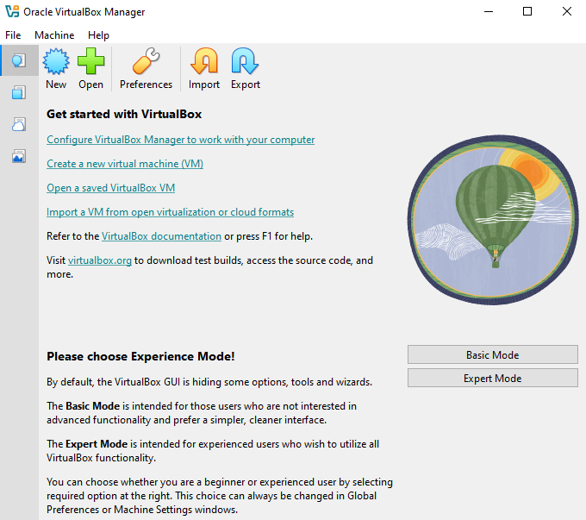

System Requirements

6GB RAM

50 GB HDD

Ubuntu 20.04+

4vCPU

Tool Check

Yosys

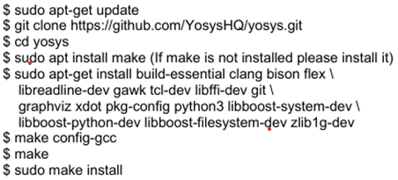

Iverilog



gtkwave

