Republic of the Philippines
BAGO CITY COLLEGE
Bago City, Negros Occidental

PULSE: Real-Time Syndromic Surveillance and Risk Forecasting using Isolation Forest Algorithms and Geospatial Data Fusion

A Capstone Project Presented to the Faculty of
Bachelor of Science in Information System Department
Bago City College
Bago City, Negros Occidental
Philippines

In Partial Fulfillment of the Requirements for the
Degree of Bachelor of Science in Information System

Programmer/Developer

Banez, Hernani J.
Betita, Jaykirt M.
Sarcia, Earl Adrian M.

April 2026

Republic of the Philippines
BAGO CITY COLLEGE
Bago City, Negros Occidental

PROJECT COORDINATOR AND PROGRAM HEAD’S ACCEPTANCE SHEET

The Project Entitled:

PULSE: Real-Time Syndromic Surveillance and Risk Forecasting using Isolation Forest Algorithms and Geospatial Data Fusion

After having been recommended and approved and hereby accepted by the Bachelor of Science in Information System Department od Bago City College, Bago City, Negros Occidental

ANTHONY S. MALABANAN, MIT, MAT-Math
BSIS Program Head/Project Coordinator

April 2026

Republic of the Philippines
BAGO CITY COLLEGE
Bago City, Negros Occidental

PANELS’ APPROVAL SHEET

The Project Entitled

PULSE: Real-Time Syndromic Surveillance and Risk Forecasting using Isolation Forest Algorithms and Geospatial Data Fusion

Developers:

Banez, Hernani J.
Betita, Jaykirt M.
Sarcia, Earl Adrian M.

After having been presented in hereby approved
by the following members of the Panel

XXXXXX XXXXXX
Panel Panel

ANTHONY S. MALABANAN MIT, MAT-Math
Panel

April 2026

Abstract

Title of the Study “PULSE: Real-Time Syndromic Surveillance and Risk Forecasting using Isolation Forest Algorithms and Geospatial Data Fusion”

PULSE is a centralized, role-based web application for near-real-time syndromic surveillance and public-health risk assessment in Bago City. Authorized barangay personnel encode PIDSR-aligned patient demographics, symptoms, exposure history, onset dates, and geospatial coordinates. The Django system links every submission to a Patient record, prevents duplicate open cases using normalized name, birthdate, and barangay identity, and applies two complementary machine-learning methods: Random Forest suggests the most likely monitored disease, while Isolation Forest contributes anomaly detection for unusual case activity. APTAS (Alerts, Patterns, and Thresholds Analysis System) combines anomaly, temporal, environmental, and spatial indicators with PIDSR threshold rules to produce risk levels, alerts, analytics, and geospatial displays. Laboratory confirmation is assisted by OCR with patient-name matching and positive/negative result gates. PULSE supports decision-making but does not replace clinical diagnosis, laboratory interpretation, or official outbreak declaration.

Table of Contents
TITLE PAGES
Acceptance Sheet
Approval Sheet
Acknowledgement i
Abstract ii

CHAPTER I: INTRODUCTION
Context of the Study 2
Historical Background 3
Statement of the Problem 4
Objectives of the Study 5
Significance of the Study 6
Scope of the Study 7
Limitations of the Study 9
Definition of Terms 10
Conceptual Framework 12
CHAPTER II: LITERATURE REVIEW
Related Concepts 15
Related Works 18
Related Tools 21
Synthesis 24
CHAPTER III: METHODOLOGY
Model Base 28
Model Phase 31
CHAPTER IV: ENVIRONMENTAL CONTEXT
Organization 35
Processes 39
Data 41
Technology 45
Information 47

CHAPTER V: REQUIREMENTS ANALYSIS AND SPECIFICATION
Technical Requirements 50
System Facilities and Features 53
Data Requirements 56
Information Requirements 58
Functional Requirements 59
Management and Support Requirements 63

CHAPTER VI: DESIGN
Architectural Design 65
Process Design 66
Use Case Diagram 67
Data Flow Diagram 68
Entity-Relationship Diagram 69
Database Design 70
Normalization 74
Physical Structure 78
Prototype Design
CHAPTER I
INTRODUCTION
Communicable diseases remain a serious threat to public health, requiring timely detection and rapid response systems. In Bago City, Negros Occidental, disease surveillance is primarily based on manual and delayed reports from Barangay Health Stations, leading to late detection of outbreaks, inconsistent data, and limited situational awareness. The current system mainly presents numerical case counts without automated analysis, geographic visualization, or early warning capabilities, making it difficult for health authorities to identify emerging health risks.
To address these challenges, the researchers developed PULSE as a centralized Django-based surveillance platform. Authorized Barangay Health Workers, encoders, catchment nurses, and CHO personnel submit structured PIDSR-aligned case information. On submission, the system links the Patient, checks duplicates, suggests a disease through Random Forest, screens unusual activity through Isolation Forest, evaluates APTAS and PIDSR thresholds, and stores controlled case and location information.
PULSE generates in-application APTAS and PIDSR threshold alerts and displays barangay risk shading, heat layers, same-disease clusters, and patient case pins on a Leaflet map. Analytics and bilingual recommendations help authorized personnel prioritize investigation and field response.
Context of the Study
Barangay Health Stations (BHS) monitor community health and report notifiable diseases and unusual health events to the City Health Office (CHO). However, in practice, information flowing from Barangays to the city is often delayed, inconsistent, and incomplete. Reports are submitted at different times, in various formats, making data consolidation difficult and error prone.
The current system mainly provides raw numerical data, such as patient counts for specific symptoms or diseases. While useful, these numbers do not show trends, spatial distribution, or emerging risks. Health officers must manually interpret large volumes of data, which are time-consuming and delays decision-making.
PULSE addresses these gaps through a centralized workflow that consolidates barangay submissions, Patient records, environmental context, machine-learning outputs, laboratory confirmation, PIDSR thresholds, and geospatial information. Updates occur when reports are submitted and dashboards refresh; the implementation is near-real-time rather than continuous sensor streaming.

Historical Background
The Bago City Health Office (CHO) is the primary agency responsible for delivering health services in Bago City, Negros Occidental, under the Local Government Code of 1991. Its mandate includes preventive, promotive, curative, and rehabilitative health programs tailored to community needs.
To strengthen local disease surveillance, the CHO established the Community-Based Disease Surveillance System (CDSS) in 2001, enabling barangay health workers to monitor priority infectious diseases, detect unusual patterns, and report them promptly to the city level. The CDSS facilitated early warning, trend analysis, and informed response to outbreaks across the city’s barangays.
The system aligns with the Philippine Integrated Disease Surveillance and Response (PIDSR) framework, which standardizes case definitions, reporting flows, and data use nationwide. By integrating CDSS with PIDSR guidelines, the Bago City Health Office has improved outbreak detection, data-driven decision-making, and overall community health resilience.
In September 2025, the Bago City Health Office was officially licensed as a Primary Care Facility (PCF), further enhancing its capacity to provide comprehensive health services, expanding preventive programs, and strengthening its role in community-based disease surveillance.

Statement of the Problem
During our interview with the head of the Community-Based Disease Surveillance Unit, the public health reporting and monitoring system in Bago City faces several challenges that limit its effectiveness:
1. Inefficient and slow data consolidation for disease detection.
2. Limited capabilities of tools for real-time analysis, visualization, and prediction of health risks.
3. Absence of an automated alert system delays early detection of potential outbreak and response.

Objectives of the Study
To design and develop PULSE: Real-Time Syndromic Surveillance and Risk Forecasting using Isolation Forest Algorithms and Geospatial Data Fusion for the City Health Office of Bago City to strengthen disease surveillance, improve health data consolidation and analysis, support early outbreak detection, and enable timely public health response:
- To develop a system that has a digital reporting and automated consolidation interface to ensure timely and consistent recording of syndromic health data.
- To develop a system that uses Random Forest disease suggestion, Isolation Forest anomaly screening, APTAS composite risk analysis, PIDSR thresholds, and geospatial mapping to track disease activity and support evidence-based decisions.
- To develop an authenticated in-application alerting system that informs authorized CHO personnel of elevated risk and PIDSR threshold events, records acknowledgements, and supports auditable response coordination.
- Evaluate critical functions through automated tests and stakeholder review, and conduct ISO/IEC 25010:2011 quality evaluation when validated respondent data and instruments are available.

Significance of the Study
This capstone project aims to be beneficial for the following:
1. Barangay Health Workers, by improving reporting efficiency and early detection of disease risks.
2. City Health Office and LGUs, by enhancing outbreak preparedness and decision-making through real-time analytics.
3. Communities, by enabling faster public health response and improved protection against disease outbreaks.
4. Future Researchers, by providing a foundation for further studies on AI-based disease surveillance systems.

Scope of the Study
The scope of the study sets the boundaries and objectives, outlining what will be included and excluded in the research.
1. The collection and centralization of syndromic health data, recorded patient information, and relevant environmental data submitted from barangays into a single disease surveillance platform.
2. The analysis of real-time and historical data using machine learning and geospatial data fusion to detect anomalies, identify abnormal symptom patterns, assess disease risk levels, and locate possible hotspot areas with potential outbreak activity.
3. The provision of a web-based dashboard and visualization interface that displays disease trends, hotspot maps, risk levels, and other surveillance outputs for monitoring and decision-making.
4. The generation of automated alerts and notifications to concerned users when abnormal symptom patterns or predefined risk thresholds are detected, serving as early warning signals for possible outbreaks.
5. The generation of surveillance reports to support documentation, monitoring, and timely public health response at the barangay and City Health Office levels.
6. The use of secure cloud-based storage and backup mechanisms to support data availability, system continuity, and protection against data loss.

Limitations of the Study
The limitations of the study outline factors that may impact research findings or restrict their scope.
1. The system performs syndromic surveillance based on reported symptoms and patterns; it does not provide clinical diagnosis.

Definition of Terms
Syndromic Surveillance
Conceptual: Monitoring symptoms and symptom patterns to detect possible outbreaks.
Operational: The method used by PULSE to analyze reported symptoms and related data for early warning of possible outbreak activity.
Anomaly Detection
Conceptual: Identifying unusual patterns in data.
Operational: The process PULSE uses to detect abnormal symptom increases.
Isolation Forest Algorithm
Conceptual: A machine learning method for detecting anomalies.
Operational: The anomaly-detection method used to identify unusual activity; it operates alongside Random Forest disease classification and does not establish a diagnosis.
Hotspot Mapping
Conceptual: Identifying high-risk areas.
Operational: The map feature of PULSE showing areas with elevated disease risk or possible outbreak activity.
APTAS (Alerts, Patterns, and Thresholds Analysis System)
Conceptual: A structured framework combining patterns, thresholds, and multiple risk indicators.
Operational: The service that combines anomaly, temporal, environmental, and spatial scores with PIDSR thresholds, stores barangay risk logs, and presents eligible alerts.
Real-Time Monitoring
Conceptual: Continuous tracking and reporting of system data.
Operational: PULSE processes reports on submission and refreshes map, analytics, and alert information on request, providing near-real-time surveillance rather than continuous streaming.
Risk Score
Conceptual: A value indicating outbreak risk.
Operational: A Low, Moderate, High, or Critical APTAS level derived from anomaly, temporal, environmental, and spatial indicators.
Geospatial Data
Conceptual: Location-based information.
Operational: Data used by PULSE to generate hotspot maps.
Outbreak
Conceptual: An unusual increase in disease cases.
Operational: An unusual increase in disease cases identified and officially validated by health authorities
Risk Threshold
Conceptual: A predefined level that indicates danger.
Operational: The value used by PULSE to trigger potential outbreak alerts for investigation

Conceptual Framework
A conceptual framework is a structured plan that outlines key concepts and their relationships within a system or study. It helps organize and clarify how different elements interact, guiding the design, analysis, and understanding of the system.
Input Process Output Outcome
Improved Early Disease Detection
Enhanced Outbreak Preparedness
Faster Public Health Response
Strengthened Community Surveillance
Automated Alerts (APTAS)
Geospatial Hotspot Maps
Standardized Incident Reports
Real-Time Analytics Dashboard
Syndromic Health Data
Geospatial Data
System Parameters
Historical Data
Real-Time Data Ingestion
AI-Assisted Analysis
Anomaly Detection
Risk Scoring & Evaluation
Geospatial Data Fusion

Figure 1. Conceptual Framework

Under the IPO-O model, PULSE receives authorized staff submissions containing patient identity, demographics, symptoms, exposures, onset date, barangay, and coordinates, together with historical cases and available environmental data.
Processing consists of Patient linking and duplicate checks, Random Forest disease suggestion, Isolation Forest anomaly screening, APTAS scoring, PIDSR threshold evaluation, and same-disease spatial-temporal clustering. Outputs include scoped dashboards, case records, analytics, alerts, bilingual recommendations, laboratory-confirmation records, and a layered map.
As an outcome, the system improves early disease detection, enhances outbreak preparedness, and strengthens community-based public health surveillance, ultimately supporting a faster, evidence-based response to protect community well-being.

CHAPTER II
LITERATURE REVIEW
This chapter presents a review of related literature and studies that provide the theoretical and technical foundation for the development of PULSE, a centralized, AI-assisted digital health surveillance system. The discussion focuses on key concepts, technologies, and frameworks relevant to public health monitoring, disease surveillance, data integration, predictive analytics, and automated alert systems. By synthesizing insights from existing research and real-world implementations, this chapter establishes the basis for designing a system that enhances early outbreak detection and supports evidence-based public health decision-making.
Furthermore, this chapter examines existing disease surveillance systems and digital health platforms implemented at local and national levels. The strengths, limitations, and challenges encountered in these systems are analyzed to identify best practices and gaps that PULSE aims to address. Emerging trends in health informatics, artificial intelligence, and real-time data analytics are also discussed to ensure that the proposed system aligns with current advancements in public health technology.

Related Concepts

Modern public health practice increasingly relies on digital surveillance platforms to ensure timely and accurate disease monitoring. Manual and paper-based reporting systems often result in fragmented data and delayed analysis, limiting effective response. Digital surveillance systems support continuous data collection and automated analytics, allowing health authorities to identify emerging health threats and respond more efficiently (Bansal et al., 2021).
Early identification of disease outbreaks has been enhanced through surveillance approaches that focus on symptom patterns rather than confirmed diagnoses. By analyzing clusters of non-specific symptoms, health officials can detect abnormal health events at an earlier stage. Studies show that this method is particularly effective when applied at the community and primary care levels, where early signals of outbreaks typically emerge (Mandl et al., 2020).
The transition from manual reporting to electronic and web-based systems has improved the consistency and reliability of disease data. Standardized digital reporting minimizes repeated encoding and reduces human error, leading to more complete and timely health information. Evidence suggests that electronic surveillance platforms significantly strengthen local-level data accuracy and accelerate public health response (Dixon et al., 2021).
Spatial analysis has become a critical tool in understanding disease distribution and transmission. By visualizing health data geographically, health authorities can identify clusters, hotspots, and high-risk areas that require immediate intervention. Geospatial technologies have been shown to enhance situational awareness and support more targeted and efficient public health strategies (Kamel Boulos & Geraghty, 2020).
Proactive disease control is supported by systems that automatically detect unusual health patterns and trigger alerts when risk thresholds are exceeded. These mechanisms enable health officials to investigate potential outbreaks earlier and reduce reliance on delayed, reactive responses. The World Health Organization (2021) emphasized that automated early warning systems are essential for effective outbreak preparedness and containment.
Recent advancements in artificial intelligence have enabled health surveillance systems to process large volumes of data and identify patterns that may not be immediately visible through manual analysis. Machine learning models are particularly effective in detecting anomalies and forecasting public health risks. Research demonstrates that AI-assisted surveillance improves detection accuracy and supports data-driven public health decisions (Rahman et al., 2022).
Effective disease surveillance depends on the integration of data from multiple health units into a unified platform. Centralized information systems improve coordination between community health centers and local government offices by providing a single source of reliable health data. Such systems enhance real-time monitoring, reporting efficiency, and decision-making at the city level (Silva et al., 2020).
Reliable public health analysis requires health information systems that can seamlessly exchange and interpret data across different platforms. Interoperable and standardized data systems reduce inconsistencies caused by varying reporting formats and schedules. Studies highlight that data interoperability is essential for integrated surveillance, accurate analytics, and efficient public health planning (Lehne et al., 2021).
Syndromic surveillance has emerged as an important component of public health planning in the United States, particularly in the light of global health concerns such as COVID-19, influenza, and emerging zoonotic illnesses (Sharan et al., 2023). Modern syndromic surveillance systems improve the ability of the nation to detect outbreaks before they turn into major public health problems by combining AI, machine learning, and big data analytics (Jiao et al., 2022). Therefore, the capacity to analyze large amounts of real-time health data provides an advantage in identifying disease trends and implementing timely interventions.

Related Works
SmartHealth-Track: AI-Based Real-Time Infectious Disease Monitoring
Alwakeel (2025) proposed a real-time infectious disease monitoring framework that integrates AI with IoT-enabled health tracking, wearable sensors, and machine learning models to enhance early outbreak detection and predictive forecasting. The framework demonstrated high accuracy in detecting outbreaks and highlights the effectiveness of AI-driven real-time surveillance for proactive public health interventions.
DHIS2 (District Health Information Software 2)
DHIS2 is an open-source, web-based health information system widely used by national and local health agencies for disease surveillance and health data management. Developed by the University of Oslo, DHIS2 enables centralized data collection, reporting, and visualization across multiple health facilities. The platform supports real-time dashboards, standardized reporting, and basic analytics, making it a core surveillance tool in many developing countries, including the Philippines. However, DHIS2 relies primarily on manual data entry and lacks advanced AI-driven anomaly detection, which PULSE aims to address.
EpiWatch – AI-Based Early Outbreak Detection System
EpiWatch is an AI-powered disease surveillance system that monitors open-source data such as news reports, health bulletins, and online publications to detect early signals of disease outbreaks. The system applies machine learning and natural language processing to identify emerging health threats before official confirmation. EpiWatch has been used to detect respiratory disease outbreaks and pandemic signals, demonstrating the effectiveness of automated early warning systems.
HealthMap Disease Surveillance Platform
HealthMap is a real-time global disease monitoring system developed by researchers at Boston Children’s Hospital. It aggregates data from online news, official reports, and surveillance feeds to track infectious disease outbreaks worldwide. The system provides geographic visualization and public dashboards to display disease spread patterns.
ESSENCE (Electronic Surveillance System for the Early Notification of Community-Based Epidemics)
ESSENCE is an electronic disease surveillance system developed by the U.S. Department of Defense and public health agencies to support syndromic surveillance. It analyzes health data to detect unusual patterns and generates alerts for potential outbreaks.
Philippine Integrated Disease Surveillance and Response (PIDSR) Digital Reporting Initiatives
The PIDSR framework serves as the national disease surveillance system in the Philippines, guiding the reporting of notifiable diseases from local health units to higher authorities. Recent digital initiatives under PIDSR aim to improve reporting timeliness and data consolidation. While PIDSR establishes standardized reporting protocols, challenges remain in real-time analytics, visualization, and automated risk detection.
SORMAS (Surveillance, Outbreak Response Management and Analysis System)
SORMAS is an open-source digital surveillance platform developed to support real-time disease surveillance, outbreak detection, and response management. It is widely used in several countries for monitoring infectious diseases such as COVID-19, Ebola, and measles. The system integrates case reporting, contact tracing, laboratory data, and automated alerts into a centralized dashboard. SORMAS demonstrates how real-time data ingestion and digital workflows can enhance outbreak preparedness and coordinated response, aligning closely with the objectives of the PULSE system.
FluNet and FluID Digital Surveillance Systems
FluNet and FluID are global web-based surveillance platforms managed by the World Health Organization to monitor influenza activity and respiratory disease trends. These systems collect standardized reports from national health authorities and provide geographic and temporal analysis of disease spread.

Related Tools
In software development, the effectiveness of the PULSE system relies on the careful selection of tools and technologies. These tools support all aspects of the system, including coding, data collection, storage, geospatial mapping, machine learning–based risk analysis, and automated alerting, ensuring timely and accurate public health surveillance.
Backend Development
Django (Python) – Provides routing, session authentication, authorization, ORM access, reporting services, dashboards, APIs, and server-rendered templates in one application.
Python – Implements the application services and machine-learning pipeline using Django, scikit-learn, pandas, and NumPy.
API Integration – OCR.Space Engine 3 assists laboratory extraction, while environmental/weather services provide contextual data when available. Public self-reporting is outside the implemented scope.
Database Management
MySQL – Stores syndromic reports, patient records, environmental data, and historical health records for real-time and historical analysis.
Deployment Environment – Hosted WSGI deployment, HTTPS, environment-managed secrets, WhiteNoise static delivery, and managed MySQL; the application is not tied to AWS or Google Cloud.
Frontend Development
Django Templates – Render role-specific dashboards and forms; static JavaScript provides asynchronous controls, modals, charts, and map behavior.
Leaflet.js – Displays OpenStreetMap-compatible tiles, GeoJSON boundaries, risk shading, heat layers, patient pins, and same-disease clusters.
HTML & CSS – Structures and styles the web dashboard interface for clarity and usability.
JavaScript – Powers dynamic updates, interactive components, and real-time visualization of health data.
AI / Machine Learning
Isolation Forest and Random Forest – Isolation Forest screens unusual activity; Random Forest ranks monitored diseases from clinical and contextual features.
Python Libraries (scikit-learn, pandas, NumPy) – Support classification, anomaly detection, data preparation, and analytics. TensorFlow and PyTorch are not used.
Alerting System
APTAS (Alerts, Patterns, and Thresholds Analysis System) – Computes composite barangay risk signals and merges eligible ML and PIDSR threshold alerts.
In-Application Alerts – Deliver risk and threshold information through authenticated dashboards and notification records. SMS delivery is not currently implemented.
Reporting & Analytics
Django Analytics and Reports – Provide in-application KPIs, epidemiological curves, disease distributions, and hotspot summaries without Tableau.

Development Tools
Visual Studio Code (VS Code) – The primary IDE for writing, testing, and debugging system components, including backend, frontend, and AI modules.
CURSOR
Cursor is an AI-enhanced code editor designed to streamline software development by integrating powerful AI assistance directly into the workflow. It supports many programming languages and provides features such as intelligent code generation, inline refactoring, semantic search, and built-in Git integration. Cursor was used as a development environment to help write, analyze, and modify code more efficiently through natural-language instructions.

Synthesis
The development of PULSE: Real-Time Syndromic Surveillance and Risk Forecasting using Isolation Forest Algorithms and Geospatial Data Fusion is grounded in research on digital health surveillance, community-based disease monitoring, and real-time outbreak detection. Studies emphasize the effectiveness of AI-assisted anomaly detection, such as the Isolation Forest algorithm, in identifying abnormal symptom patterns and predicting potential disease clusters. Research on geospatial data integration highlights its role in visualizing high-risk areas, supporting timely and targeted public health interventions. Furthermore, literature on syndromic surveillance and historical disease trends demonstrates how pattern recognition and risk scoring enhance early detection and minimize delayed responses.
Ensuring system reliability, studies underscore the importance of centralized data platforms and cloud-based storage to maintain continuous access to accurate health information from multiple sources, including Barangay Health Workers, patient records, and environmental data. The integration of web-based dashboards strengthens situational awareness, allowing health officials to monitor trends, generate automated alerts through the APTAS, and access standardized health incident reports for informed decision-making.
Research on early warning and automated alert systems supports proactive public health measures, enabling rapid response to emerging outbreaks and reducing reliance on reactive interventions. By synthesizing these insights, this study establishes a strong technical and conceptual foundation for PULSE, a system that enhances disease surveillance, improves outbreak preparedness, and strengthens evidence-based public health responses to protect community well-being.

CHAPTER III
METHODOLOGY
This chapter outlines the Agile methodology for developing PULSE: Real-Time Syndromic Surveillance and Risk Forecasting using Isolation Forest Algorithms and Geospatial Data Fusion. Agile promotes an iterative and incremental development process that enables the research team to deliver functional components of the system in short development cycles, adapt to evolving public health requirements, and incorporate continuous stakeholder feedback. This approach ensures flexibility, collaboration, and early delivery of high-priority surveillance features, allowing the system to evolve efficiently over time.
The chapter further discusses the system development process, evaluation procedures, and deployment strategies, ensuring alignment with the functional and operational requirements of the Bago City Health Office (CHO) and Barangay Health Stations. Evaluation includes functionality testing, artificial intelligence model validation, performance assessment, and system quality evaluation based on ISO/IEC 25010:2011 standards to ensure accuracy, reliability, security, and efficiency in disease risk detection and automated alert generation. Deployment strategies consider data privacy compliance, environmental readiness, cloud scalability, and real-world implementation within community-based health surveillance settings.
Additionally, the study recognizes the scope limitations of the system while emphasizing its contribution to early disease detection, outbreak preparedness, and strengthened community health monitoring. This methodological framework ensures a technologically robust and systematically developed digital surveillance solution founded on continuous improvement and stakeholder collaboration.
Model Base
The Model Base section of this chapter defines the methodological foundation for developing the PULSE system. The study adopts the Agile methodology, which emphasizes iterative development, continuous enhancement, stakeholder collaboration, and incremental delivery of working system components through adaptive planning and execution. This approach is suitable for public health surveillance systems where rapid response, evolving symptom patterns, and data-driven decision-making are critical. Agile ensures that the system remains adaptable to emerging health concerns while maintaining technical stability and operational reliability.
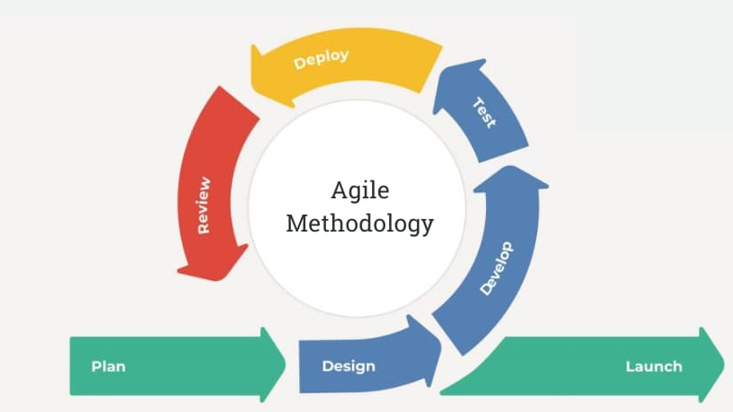
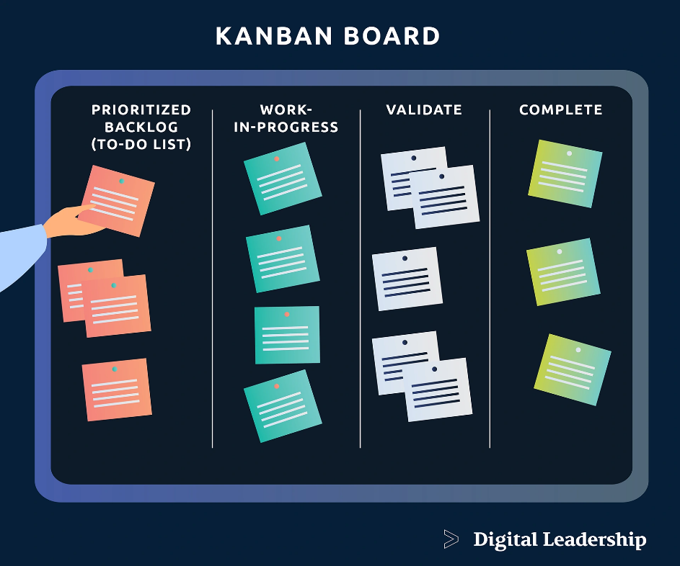
Agile Methodology Model
Figure 2. Agile Methodology Model
The project adopts an Agile methodology that emphasizes iterative system enhancement, continuous collaboration with the City Health Office and Barangay Health Workers, and incremental delivery of system modules. This ensures that the system remains flexible and responsive to changes in reporting requirements, disease trends, and stakeholder feedback throughout the project lifecycle.
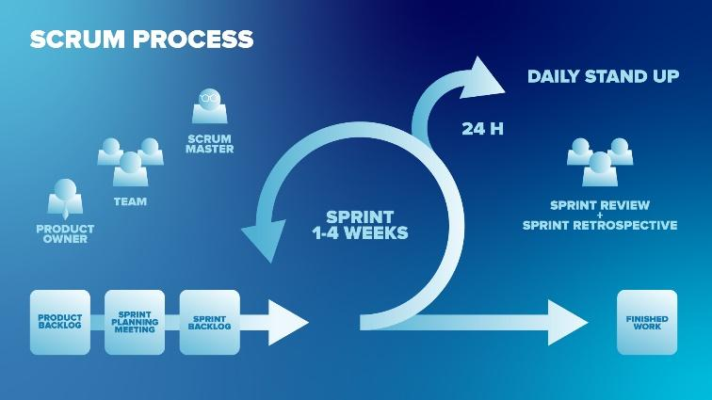

Figure 3. Scrum Process Framework

Within the Agile methodology, the Scrum framework was specifically chosen for the development of PULSE due to its structured yet flexible approach to project management and iterative delivery. Public health surveillance systems require frequent updates and refinements in response to incoming epidemiological data, changing disease patterns, and stakeholder needs. Scrum supports these requirements by organizing development into short, time-boxed sprints, allowing for rapid implementation, testing, and refinement of each system module.
Additionally, Scrum facilitates active stakeholder engagement through sprint reviews, daily stand-up meetings, and feedback sessions. This ensures that system components — including syndromic data ingestion, risk forecasting, geospatial data analysis, and reporting dashboards — are closely aligned with the workflows and operational needs of the City Health Office. By integrating feedback continuously, the framework helps minimize misalignment between system functionality and user expectations, enhancing both usability and reliability. The iterative nature of Scrum makes it ideal for adaptive planning, early detection of issues, and continuous improvement, all of which are essential for a dynamic public health surveillance system like PULSE.

Model Phase
The foundational methodology for this project is Agile, which emphasizes iterative development, continuous improvement, stakeholder collaboration, and incremental delivery of functional system features through adaptive planning. This approach ensures flexibility and responsiveness to evolving public health surveillance requirements throughout the project lifecycle.
Phase 1: Plan Phase
The Plan Phase defined requirements with CHO, surveillance, catchment, encoder, and barangay stakeholders. Priorities included structured intake, Patient deduplication, dual-model analysis, APTAS/PIDSR alerts, OCR confirmation, analytics, recommendation protocols, and geospatial mapping.
Phase 2: Design Phase
The Design Phase established a Django/MySQL architecture, role- and barangay-scoped workflows, PIDSR-aligned structures, ML and APTAS services, OCR confirmation, and server-rendered interfaces. Security includes bcrypt hashing, CSRF, hardened sessions, HTTPS settings, login lockout, audit logs, and environment-managed secrets.
Phase 3: Develop Phase
Iterative development implemented authentication, batch submission, Patient deduplication, Random Forest classification, Isolation Forest screening, APTAS, PIDSR thresholds, analytics, alerts, laboratory OCR, bilingual recommendations, and Leaflet visualization.
Phase 4: Test Phase
The Test Phase uses focused Django tests for patient deduplication, OCR parsing and confirmation gates, disease identity, anomaly defaults, map confidence, date/status scope, recommendation contracts, clustering, alert permissions, and production command safety. ISO/UAT scores are not inferred from automated tests.
Phase 5: Deploy Phase
Deployment supports hosted WSGI, managed MySQL, WhiteNoise, HTTPS proxy settings, secure cookies, HSTS, and environment-provided credentials. Backup, availability, and training remain operational responsibilities of the hosting provider and CHO.
Phase 6: Review Phase
Review uses issue reports, code review, automated checks, and stakeholder feedback. Recent iterations strengthened secrets, Patient deduplication, date/status consistency, alert authorization, anomaly defaults, OCR, clustering, and recommendations.
Phase 7: Launch Phase
Launch provides controlled staff access to the deployed application. Continued operation requires CHO ownership of accounts, thresholds, clinical protocols, backup, credential rotation, monitoring, and ML reassessment.

CHAPTER IV
ENVIRONMENTAL CONTEXT
The PULSE: Real-Time Syndromic Surveillance and Risk Forecasting using Isolation Forest Algorithms and Geospatial Data Fusion system operates within a structured public health surveillance environment. Various external factors, such as organizational structure, reporting workflows, technology infrastructure, and data management practices, influence its effectiveness.
With the increasing risk of communicable diseases, timely monitoring and rapid response are essential. Real-time data ingestion, AI-based anomaly detection, and geospatial mapping enable early identification of abnormal symptom patterns and high-risk areas, improving outbreak preparedness and response. The system must align with the operational processes of Barangay Health Workers and the City Health Office to ensure accurate reporting and efficient decision-making.
This chapter examines how organizational roles, surveillance workflows, data processing, and technological integration support the system’s functionality, ensuring improved early disease detection and strengthened community-based public health surveillance.

Organization
The City Health Office (CHO) responsible for implementing the Community-Based Disease Surveillance System (CDSS) operates under the Local Government Unit (LGU) in coordination with the Department of Health (DOH) and is structured to ensure efficient disease monitoring, reporting, investigation, and public health response. The organizational hierarchy defines the division of roles, responsibilities, and operational functions necessary for effective disease surveillance and outbreak management. A structured organization enhances communication, decision-making, and coordination among health personnel at the barangay and city levels.
The CHO consists of several key units and personnel, each playing a critical role in surveillance data collection, validation, encoding, epidemiological analysis, and public health intervention. The CDSS Unit analyzes the collected data to identify trends, detect potential outbreaks, and generate morbidity and mortality reports for decision-making and policy implementation.
In conclusion, a well-defined organizational structure strengthens the implementation and operation of the Community-Based Disease Surveillance System. It streamlines reporting processes, improves inter-departmental coordination, and ensures that health personnel can respond promptly and effectively to emerging public health concerns. Below is a breakdown of key roles within the City Health Office that contribute to the success of the CDSS.

Organizational Chart
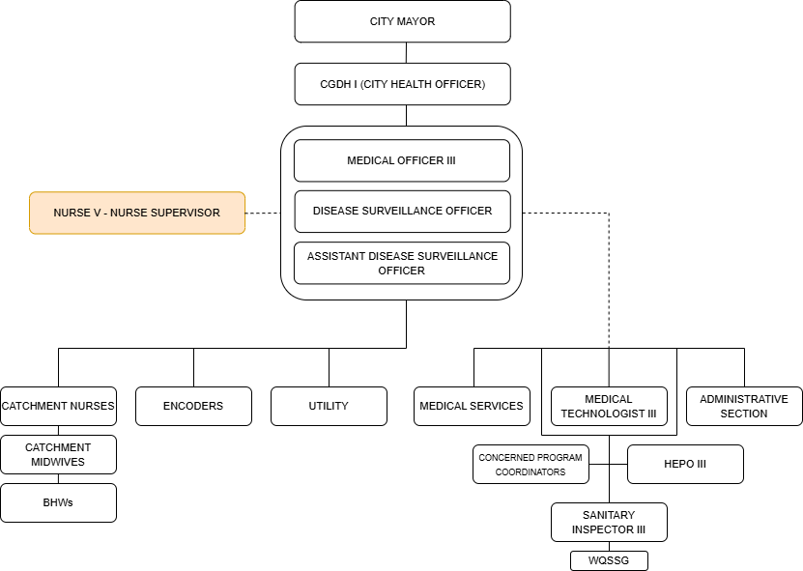
Figure 4. Organizational Chart
CDSS Unit Organizational Chart: Key Roles
CGDH I (City Health Officer)
The department head who oversees all health operations, approves official morbidity and mortality reports, and directs the city’s overall epidemiological strategy.
Medical Officer III
Acts as the clinical lead who provides expert medical assessment, validates the classification of cases (Suspected, Probable, or Confirmed), and oversees clinical protocols.
Disease Surveillance Officer
Responsible for managing the surveillance database, analyzing disease trends, and triggering alerts for potential outbreaks.
Assistant Disease Surveillance Officer
Supports the DSO in data consolidation, field investigations, and ensures the timely submission of reports to the regional office.
Nurse V (Nurse Supervisor)
Provides administrative and technical supervision over the nursing staff, ensuring that surveillance standards are integrated into daily nursing services.
Catchment Nurses
Coordinate surveillance activities within specific geographical clusters and serve as the secondary validators of data coming from the barangay level.
Catchment Midwives
Directly supervise BHWs, validate the initial CDSS Worksheets, and ensure that all suspected cases in their assigned barangays are documented.
BHWs (Barangay Health Workers)
The primary frontliners who conduct active case finding, household monitoring, and initial data gathering in the community.

Encoders
Technical personnel responsible for the accurate and timely entry of manual data from the CDSS Worksheets and Investigation Forms into the digital system.
Medical Technologist III
Provides laboratory support by performing diagnostic tests required to officially confirm a case.
HEPO III (Health Education and Promotion Officer)
Translates surveillance data into public health advisories and leads community education campaigns to prevent further disease transmission.
Sanitary Inspector III & WQSSG
Handle the environmental aspect of surveillance, such as vector control (fogging/larviciding) and water quality testing in areas with high infection rates.

Processes (transactional documents)
Transactional documents within the Community-Based Disease Surveillance System (CDSS) are essential for early detection, validation, reporting, and epidemiological analysis of notifiable diseases. These structured procedures ensure proper data flow from Barangay Health Workers (BHWs) to the City Health Office (CHO) and the CDSS Unit.
Community-Based Disease Surveillance System (CDSS) Worksheet Process
- Case Identification
- Initial Interview & Data Gathering
- CDSS Worksheet Completion
- Barangay Validation
- Submission to City Health Office
Disease Investigation Form Process
- Case Trigger
- Form Issuance
- Field Investigation
- Investigation Form Completion
- Review & Validation
- Submission to CDSS Unit for encoding and analysis
Case Report Form (CRF) Process
- Case Confirmation
- CRF Preparation
- Detailed Data Encoding in Form
- Medical Officer Validation
- Submission to Higher Reporting Level
Data Encoding Process
- Receipt of Approved Forms
- Data Entry into PIDSR System
- Data Verification
- Database Storage
CDSS Unit Analysis Process
- Data Aggregation
- Trend Analysis
- Outbreak Detection
- Report Generation
- Decision & Response Recommendation
Feedback & Response Process
- Report Dissemination
- Implementation of Control Measures
- Monitoring & Re-evaluation

Data
Manual disease reporting, case investigation, and epidemiological documentation are integral to the workflows of the City Health Office (CHO) and the Community-Based Disease Surveillance System (CDSS) Unit. These processes are essential in identifying suspected and confirmed cases, monitoring disease trends, validating clinical findings, and ensuring compliance with national surveillance requirements. Strengthening these procedures enhances early detection of outbreaks, improves data accuracy, supports evidence-based decision-making, and reinforces public health response strategies.
1. CDSS Worksheet

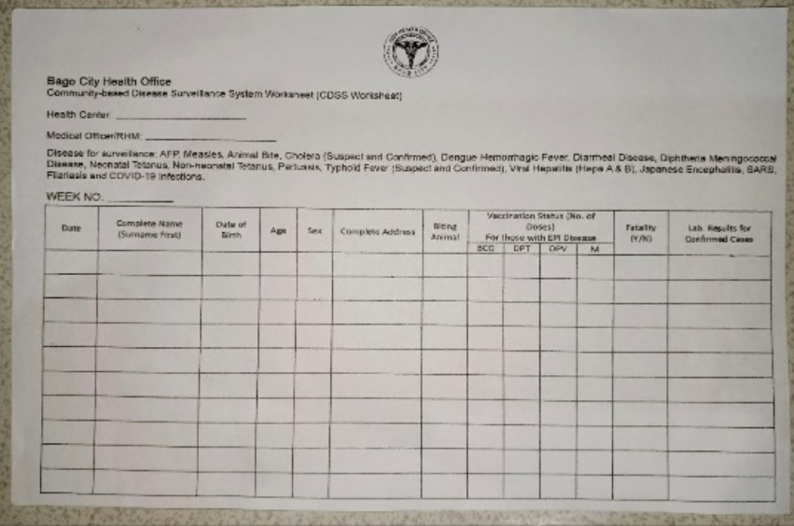

Figure 5. CDSS Worksheet
The Community-Based Disease Surveillance System (CDSS) Worksheet is a primary data collection document used by Barangay Health Workers (BHWs) to record suspected and confirmed cases within their respective areas of responsibility. This worksheet serves as the initial surveillance tool for monitoring notifiable diseases at the barangay level. It captures essential demographic and clinical information such as the patient’s complete name, date of birth, age, sex, address, disease classification, vaccination status (if applicable), fatality status, and laboratory results for confirmed cases.
The accomplished worksheet is reviewed by the Catchment Nurses or the Catchment Midwives before submission to the City Health Office/CDSS Unit. It is typically submitted on a weekly basis, or immediately in cases of urgent or outbreak-prone diseases. The CDSS Worksheet provides the foundation for municipal-level disease monitoring and serves as the primary source document for encoding into the surveillance system.

2. Disease Investigation Form
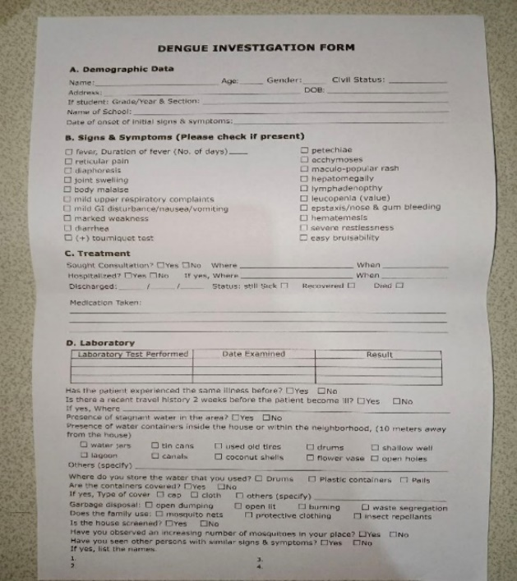
Figure 6. Dengue Investigation Form
The Disease Investigation Form is a detailed documentation tool used when a reported case meets the criteria for further epidemiological investigation. This form is commonly utilized for priority diseases such as dengue and other notifiable infections. It expands upon the initial data recorded in the CDSS Worksheet by collecting comprehensive clinical, environmental, and exposure-related information.
The form includes detailed demographic data, date of onset of symptoms, complete list of signs and symptoms, hospitalization details, laboratory test results, treatment information, and possible environmental risk factors. It may also document exposure history, travel history, and the presence of similar cases in the community. The investigation is conducted by authorized health personnel and reviewed by the CHO or Surveillance Officer for validation. This document supports outbreak detection, cluster identification, and implementation of control measures.

3. Case Report Form (CRF)
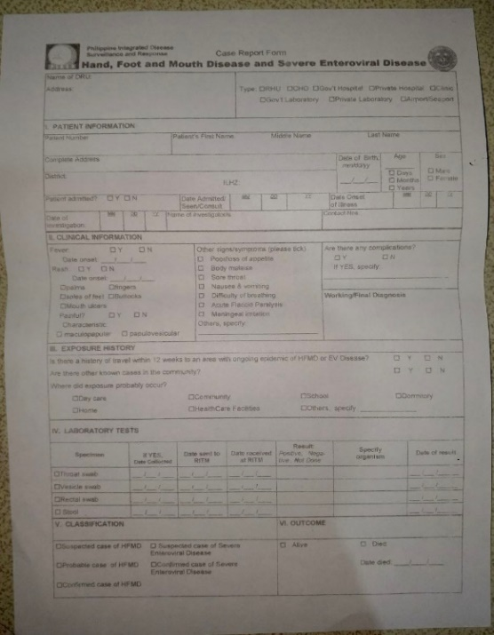
Figure 7. CRF
The Case Report Form (CRF) is an official reporting document used for suspected, probable, and confirmed cases of notifiable diseases under national surveillance guidelines. This form ensures standardized reporting to higher levels of the public health system, such as the Regional Epidemiology and Surveillance Unit (RESU) and the Department of Health (DOH).
The CRF contains comprehensive patient information, clinical presentation, laboratory findings, exposure history, case classification, and final outcome (alive or deceased). It also includes sections for vaccination history, specimen collection details, and final diagnosis validated by the attending physician or Medical Officer. This document serves as the official basis for case confirmation, national reporting, and epidemiological analysis. Proper completion and timely submission of the Case Report Form are essential for maintaining accurate disease surveillance data and ensuring compliance with national health reporting standards.
Technology
Public health surveillance relies on both traditional and digital tools to collect, record, transmit, and analyze disease-related data. Although technological innovations support faster communication and data processing, the City Health Office (CHO) and Barangay Health Workers (BHWs) still depend largely on manual documentation combined with basic digital tools. These technologies support case reporting, investigation, encoding, and communication within the Community-Based Disease Surveillance System (CDSS).
Technologies Utilized by CDSS Unit:
- Pen – A writing instrument used by Barangay Health Workers (BHWs), midwives, and health personnel to manually accomplish surveillance forms such as the CDSS Worksheet, Disease Investigation Form, and Case Report Form.
- Paper – A material used for printing and completing official surveillance documents. It serves as the primary medium for recording patient information, clinical findings, and laboratory results before digital encoding.
- Forms – Structured paper-based documents (CDSS Worksheet, Disease Investigation Form, Case Report Form) used to systematically gather demographic, clinical, and epidemiological data necessary for disease monitoring and reporting.
- Printer – A device used to produce hard copies of surveillance forms, reports, and official documents required for submission, filing, and compliance with reporting standards.
- Computer – A desktop electronic device used at the City Health Office for encoding collected data into the CDSS database, storing surveillance records, generating reports, and performing basic data analysis.
- Laptop – A portable computing device used by surveillance officers or health personnel for data entry, report preparation, presentations, and coordination during field investigations or meetings.
- Mobile Phone – A communication device used by BHWs and CHO personnel to report urgent cases, coordinate investigations, send updates, and facilitate rapid communication during potential outbreak situations.
- Wi-Fi / Internet Connection – A wireless network technology that enables transmission of encoded data, submission of reports to higher health authorities (e.g., regional or national level), and communication through email or online reporting platforms.

Information
The system manages essential public health surveillance data such as morbidity and mortality records, age-group distribution, sex classification, and barangay-level case counts. By consolidating and summarizing reported cases, the CDSS supports trend monitoring, outbreak detection, and evidence-based decision-making for disease prevention and control.
CDSS Monthly Morbidity and Mortality Report
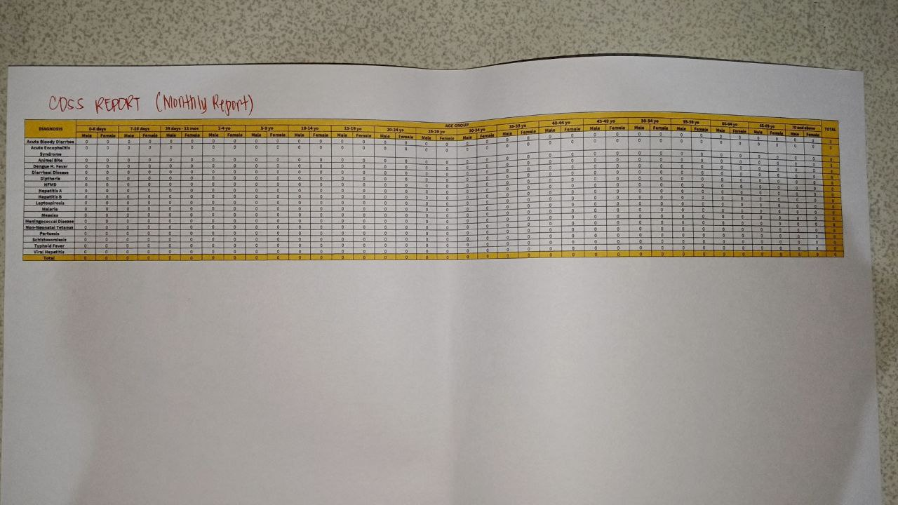
Figure 8. Monthly Morbidity and Mortality Report
This report presents the consolidated monthly summary of reported diseases categorized by diagnosis, age group, and sex. It provides an overview of total morbidity and mortality cases within the reporting period, enabling the City Health Office (CHO) to monitor disease patterns, identify high-risk age groups, and evaluate overall public health status.
CDSS Weekly Morbidity Report
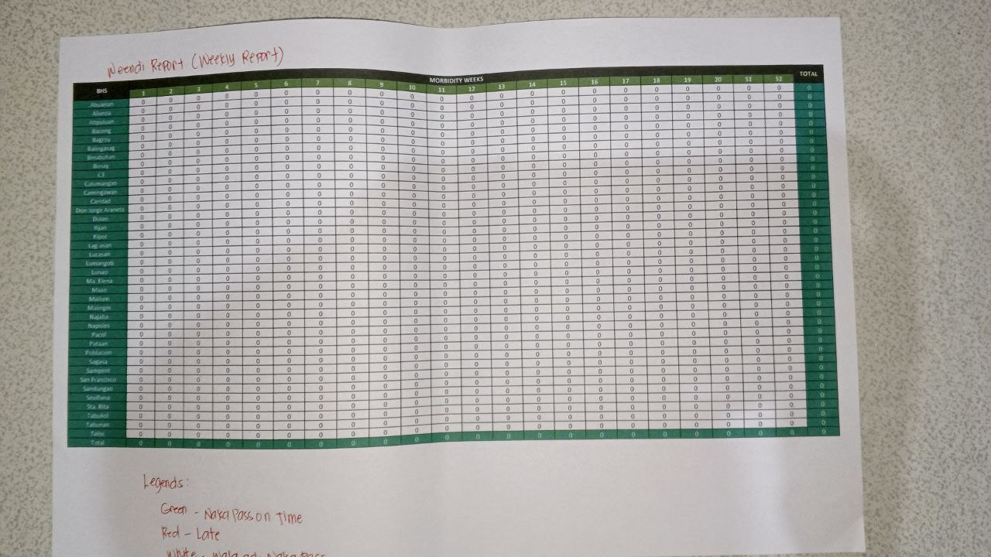
Figure 9. Weekly Morbidity Report
This report displays the weekly distribution of reported cases across barangays within the city. It tracks the occurrence of diseases per morbidity week, allowing the CHO and CDSS Unit to detect unusual increases, monitor clusters, and implement timely intervention and control measures.

CHAPTER V
REQUIREMENTS ANALYSIS AND SPECIFICATION
This chapter outlines the functional, non-functional, and technical requirements of PULSE: Real-Time Syndromic Surveillance and Risk Forecasting using Isolation Forest Algorithms and Geospatial Data Fusion, developed to address the current limitations in manual disease reporting, delayed outbreak detection, and lack of predictive analytics within the City Health Office (CHO) and Community-Based Disease Surveillance System (CDSS) Unit of Bago City. These requirements were derived from stakeholder interviews, field observations, review of existing CDSS worksheets, investigation forms, case report forms, and analysis of current morbidity and mortality reports. The objective is to guide system development and ensure alignment with user needs, epidemiological standards, and public health operational objectives.

Technical Requirements
The technical requirements outline the essential hardware and software components necessary for the development and deployment of the proposed PULSE system.
Server Hardware Specification
Components | Requirements | Justifications
Processor (CPU) | Intel Xeon E5-2630 v4 (10 Cores / 20 Threads) | Provides strong multi-core processing capability for concurrent case reporting, multi-user dashboard access, database transactions, geospatial mapping, and background anomaly-detection analytics. It also supports stable server operation and future scalability for increasing surveillance workloads.
RAM | 192 GB DDR4 ECC (expandable to 256 GB) | Provides very large memory capacity for high-volume database operations, simultaneous users, geospatial processing, analytics workloads, and future system expansion. ECC memory also improves reliability by reducing memory-related errors during long server uptime.
Storage Device | 2 × 500 GB SSD + 2 × 2 TB HDD | The SSDs support faster operating system, application, and database performance, while the HDDs provide larger-capacity storage for historical health records, reports, logs, and backups.
Network Connection | Gigabit Ethernet (1Gbps) or higher | Ensures stable and fast real-time data transmission.
Power Supply | Redundant Power Supply | Prevents downtime during power interruptions.
Operating System | Managed cloud runtime or Ubuntu Server 24.04 institutional deployment | Supports hosted WSGI deployment and a controlled institutional alternative.

Table 1. Server Hardware Specifications

Technical Requirements for Admin / Encoder / Surveillance Officer / BHW
Components | Minimum Requirements
Processor | Intel Core i3, AMD Ryzen 3 or higher
RAM | 8GB or higher
Storage Device | SSD, 512GB or higher
Hardware Architecture | 64-bit
Browser | Chrome, Firefox, Edge

Table 2. Technical Requirements for Users

Server Software Specification
Components | Requirements | Justifications
Operating System | Hosted WSGI runtime or equivalent Linux environment | Runs Django in a maintained HTTPS environment.
Cloud Hosting | Vercel-compatible hosting and managed MySQL | Provides centralized access without binding PULSE to AWS, Azure, or Google Cloud.
Web Server | Django WSGI and WhiteNoise | Serves requests and static assets through the implemented Python stack.
Database Server | MySQL | Stores patients, reports, users, risks, thresholds, OCR, alerts, and audits.
Programming Language | Python 3, Django 4.2, scikit-learn, pandas, NumPy | Implements the web app and both ML methods.
GIS Integration | Leaflet.js, OpenStreetMap-compatible tiles, GeoJSON | Displays boundaries, risk shading, heat layers, pins, and clusters.
Browser | Microsoft Edge, Google Chrome, Mozilla Firefox, Opera, Safari | Supports modern web technologies across platforms.

Table 3. Server Software Specifications

System Facilities and Features

Implemented capabilities include role-scoped submission and monitoring, Patient linkage, duplicate protection, ML classification, APTAS/PIDSR alerts, laboratory confirmation, analytics, geospatial visualization, recommendations, audits, and user management.

SUPER ADMIN
- System Configuration
a. Initialize Disease Categories
b. Configure Anomaly Threshold
- User Role Management
a. Assign System Roles
b. Manage Permissions
- Model and Threshold Governance
a. Configure PIDSR outbreak thresholds through authorized administration functions
b. Maintain training CSV data and retrain models through controlled offline technical procedures; no end-user training screen is implemented
- Profile
a. Edit Profile
- Logout

ADMIN (CHO / CDSS Unit)
- Admin Dashboard
a. Overview of morbidity and mortality trends
b. Real-time anomaly alerts
- Real-Time Case Monitoring
a. Live case updates
b. Status indicators per barangay
- Anomaly Detection Panel
a. View flagged unusual case increases
b. Risk Level Classification (Low, Moderate, High, Critical)
- Geospatial Risk Mapping
a. View Heat Map
b. Highlight high-risk barangays with coordinates
c. Zoom and filter by disease type
- Report Generation
a. Weekly Morbidity Report
b. Monthly Morbidity and Mortality Report
c. Export (PDF / Excel)
- Case Records
a. Filter
b. Search
c. Update
- System Logs
a. View
b. Filter
c. Print
- Profile
a. Edit Profile
- Logout

ENCODER
- Encode CDSS Worksheet Data
- Encode Investigation Form Data
- Encode Case Report Form Data
- Validate and Update Records
- Search Case Records
- Logout

Data Requirements
This section outlines the specific data requirements of PULSE. The data listed below ensures accurate syndromic monitoring, anomaly detection, risk forecasting, and geospatial visualization.

Patient Data
- Patient ID – Unique identifier assigned to each recorded case.
- Full Name – Complete name of the patient.
- Age – Patient’s age at time of diagnosis.
- Sex – Male or Female classification.
- Address – Barangay and complete location details.
- Date of Onset – Date symptoms first appeared.
- Disease Type – Identified or suspected disease.
- Case Classification – Suspected, Probable, Confirmed.
- Outcome – Recovered, Ongoing, or Deceased.

Geospatial Data
- Barangay ID – Unique identifier of each barangay.
- Geographic Coordinates – Latitude and longitude for mapping.
- Case Count – Total reported cases per area.
- Risk Score – Composite APTAS score derived from anomaly, temporal, environmental, and spatial indicators; Isolation Forest is one component.
- Risk Level – Classification (Low, Moderate, High, Critical)
Forecasting Data
- Historical Case Records – Previous weeks/months case data.
- Weekly Growth Rate – Increase or decrease in cases.
- Anomaly Score – Model-generated abnormality indicator.
- Predicted Risk Level – Forecasted outbreak probability.

Information Requirements
The Information Requirements define the essential data elements needed by users and administrators to ensure the effective functionality of PULSE.
- Near-real-time alerts include disease identity, PIDSR category, location, active case count, trigger source, APTAS components, risk level, map link, and recommendations.
- Weekly Morbidity Summary – Consolidated case totals per week.
- Monthly Morbidity and Mortality Report – Aggregated monthly statistics.
- Geospatial Risk Map – Visual representation of disease distribution.
- High-Risk Barangay List – Areas flagged for possible outbreak.
- Forecasted Risk Report – Predicted disease trends and risk levels.
- System Activity Logs – User login and system usage records.

Functional Requirements
Functional requirements cover Super Administrator, Administrator, Health Officer, Surveillance Officer, Catchment Nurse, Encoder, and Barangay Health Worker. City-wide roles may acknowledge alerts; barangay roles are restricted to assigned data.

SUPER ADMIN
- User & System Management
a. Generate Admin/User IDs
b. Assign roles and access levels
- Access Restriction
a. Limit access to monitoring and data analytics features
b. Grant permission only for user registration and system configuration
- System Configuration
a. Initialize surveillance modules
b. Assign barangays or monitoring areas to authorized users
- Profile Management
a. Edit personal profile
- Logout
a. Securely exit the system

ADMIN
- Admin Dashboard
a. Overview of syndromic alerts, anomaly detections, and system health
- Real-Time Syndromic Monitoring
a. View live data streams from barangay-submitted reports and other surveillance data sources
b. Monitor anomaly scores and case activity indicators.
- Alert Logs
a. View historical syndromic alerts with filtering and search options
- User Management
a. List all users
i. Add new users
ii. Update existing users
iii. Delete users
- Data Module Configuration
a. Set detection thresholds for syndromic patterns
b. Calibrate anomaly detection parameters
- Geo-Spatial Mapping
a. Visualize alerts and high-risk zones on a map
b. Zoom and filter by barangay, disease type, or risk level
- Profile Management
a. Edit admin profile information
- Emergency Alert Activation
a. Monitor alert levels
b. Activate notifications for relevant health authorities
- System Logs
a. View user actions and system activity logs
b. Filter, search, and export logs
- Logout
a. Securely exit admin account

HEALTH OFFICER (CLIENT)
- Account Access
a. Receive assigned user credentials from the system administrator or City Health Office
- Login
a. Access system using registered credentials
- Dashboard
a. View assigned barangays, active alerts, and data summaries
- Profile Management
a. Edit personal information
- Alert Notifications
a. Receive SMS, email, or dashboard alerts about abnormal symptom patterns or high-risk events
- Data Access
a. View real-time and historical surveillance data
- Notification Logs
a. Review previously received alerts
- Historical Incident Records
a. Access previous outbreak reports and responses
- Logout
a. Securely exit account

SURVEILLANCE OFFICER
- Surveillance Officer Dashboard
a. Monitor ongoing syndromic alerts and risk scores in real-time
- Alert Acknowledgment
a. Confirm receipt of alerts and update investigation status
- Geo-Spatial Analysis Map
a. View alert locations, clusters, and suggested response routes
- Data Viewer
a. Access current and historical surveillance data for affected barangays
- Response Logs
a. Track investigation time, actions taken, and case updates
- Notification Monitoring
a. View sent and pending alerts related to outbreaks
- Profile Management
a. Edit epidemiologist profile details
- Logout
a. Securely exit account

BARANGAY HEALTH WORKER
- Registration / Account Access
a. Receive assigned user credentials from the system administrator or City Health Office
b. Log in securely using authorized account credentials
- Dashboard
a. View assigned barangay dashboard
b. View of recent submitted reports, active alerts, and barangay case summaries
- Case Identification and Data Gathering
a. Record suspected and confirmed cases within the assigned barangay
b. Enter patient demographic and initial symptom information
- CDSS Worksheet Submission
a. Encode and submit CDSS Worksheet data
b. Save draft reports before final submission
c. Update submitted reports when corrections are required before validation
- Patient Record Entry
a. Enter patient details such as full name, age, sex, address, and date of onset
- Alert Notification Access
a. Receive real-time alerts and notifications related to abnormal symptom patterns or high-risk events in the assigned barangay
b. View alert details and recommended response instructions
- Barangay Monitoring
a. View case summaries and health report status within the assigned barangay
b. Monitor reported symptoms and unusual increases in cases
- Report History
a. View previously submitted health reports
b. Search and review historical submissions for the assigned barangay
- Profile Management
a. Edit personal profile information
- Logout
a. Securely exit the system

Management and Support Requirements
Management and support requirements are crucial for the smooth operation and maintenance of PULSE after deployment.
Data Management – Involves secure collection, storage, and retrieval of surveillance data, ensuring data integrity and confidentiality through backups and access control.
Security Management – Implements authentication, encryption, and user access restrictions to protect sensitive health information.
System Maintenance – Includes routine updates, database optimization, and periodic retraining of the Isolation Forest model.
Technical Support – Provides system documentation, troubleshooting assistance, and user support for CHO personnel.
Training and Documentation – Conducts orientation sessions and provides user manuals to ensure effective system utilization.
Disaster Recovery Plan – Includes regular data backups and recovery procedures to ensure minimal downtime and continuity of surveillance operations.

CHAPTER VI
DESIGN
The design phase focuses on the detailed planning and organization of PULSE: Real-Time Syndromic Surveillance and Risk Forecasting using Isolation Forest Algorithms and Geospatial Data Fusion. This stage defines the system architecture, process models, database structure, and interface prototypes needed to support real-time syndromic surveillance, AI-assisted anomaly detection, geospatial hotspot mapping, and automated alert generation. Through systematic design, the functional and technical requirements identified in Chapters I to V are translated into implementable models that guide system development, integration, and deployment. This chapter serves as the blueprint of the PULSE system and ensures that its components work cohesively to improve early disease detection, risk forecasting, and evidence-based public health response.

Architectural Design
PULSE is a Django monolith composed of accounts, users, reports, dashboard, mapping, and shared domain modules. Views/templates serve interfaces and JSON endpoints; services implement Patient registry, ML, APTAS, thresholds, OCR, recommendations, analytics, and case-state transitions; ORM models connect to MySQL.

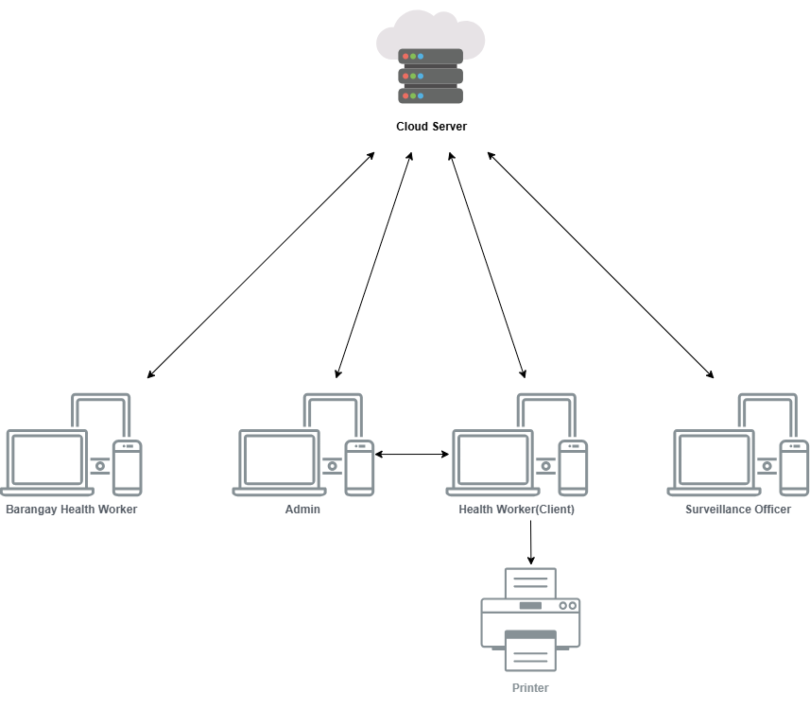
Figure 10. Architectural Design

Process Design
The implemented process begins with authenticated, scoped intake and ends with monitored case state, analytics, map display, alerts, recommendations, laboratory confirmation, or closure. Patient identity and duplicate checks precede persistence; confirmation and closure trigger threshold and alert recalculation.
PULSE uses modular Django services for authentication, users, Patient-linked submission, monitoring, dual-model analysis, PIDSR thresholds, APTAS, analytics, map APIs, OCR confirmation, recommendations, auditing, and lifecycle cleanup.

Use Case Diagram
The original use-case figure is retained as an early design artifact. The implemented roles additionally include Encoder and Catchment Nurse, with scoped intake, case monitoring, OCR confirmation for CHO roles, thresholds, city-wide alert acknowledgement, analytics, and map review.
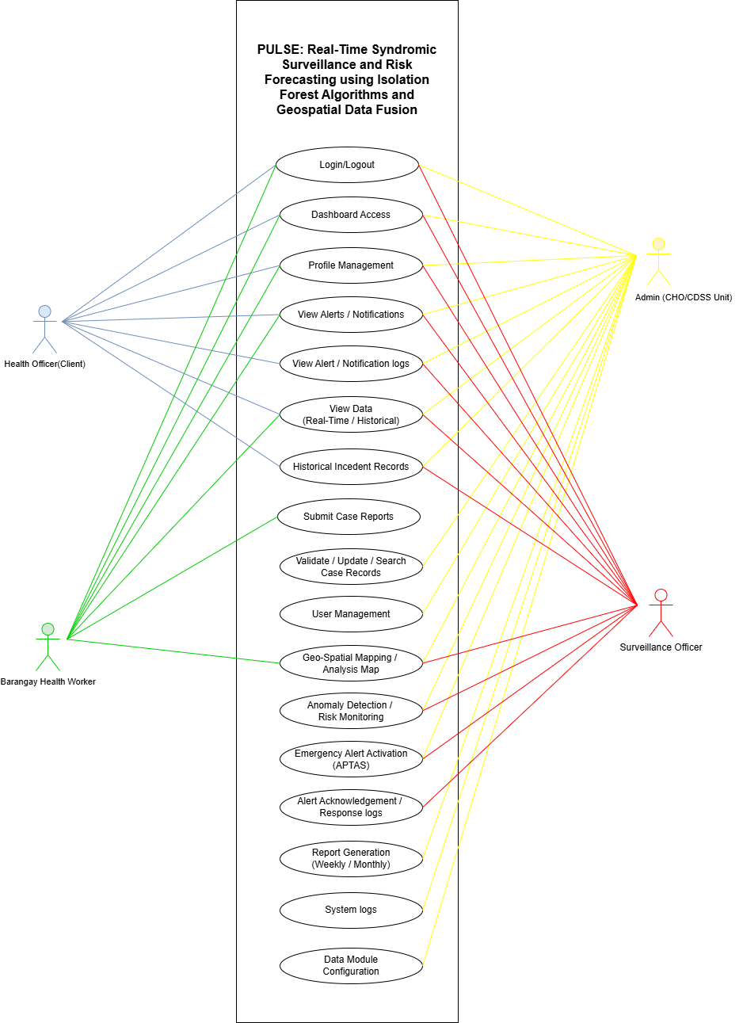
Figure 11. Use Case Diagram

Data Flow Diagram
Updated flow: authenticated submission → Patient match and duplicate check → SurveillanceReport/PatientCase persistence → Random Forest and Isolation Forest → APTAS/PIDSR evaluation → scoped dashboards, alerts, analytics, recommendations, and map APIs → OCR confirmation or closure → recalculation.
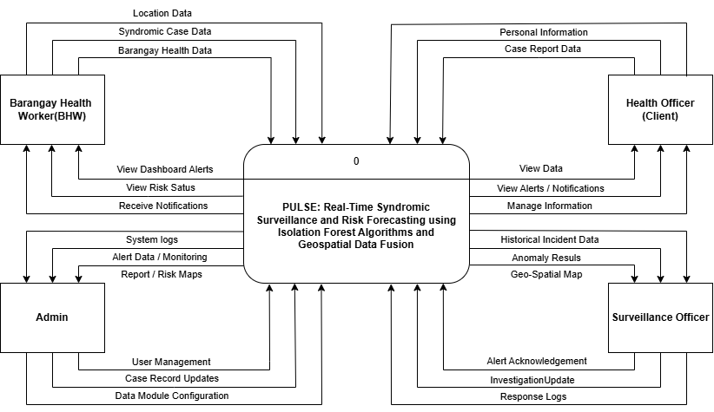

Figure 12. Data Flow Diagram

Entity-Relationship Diagram

The original ERD is retained as a conceptual artifact. The implemented core centers on Patient, SurveillanceReport, PatientCase, Symptom, Barangay, EnvironmentalData, RiskAssessment, BarangayRiskLog, BarangayEpidemicStatus, Alert, notifications, logs, and account records.
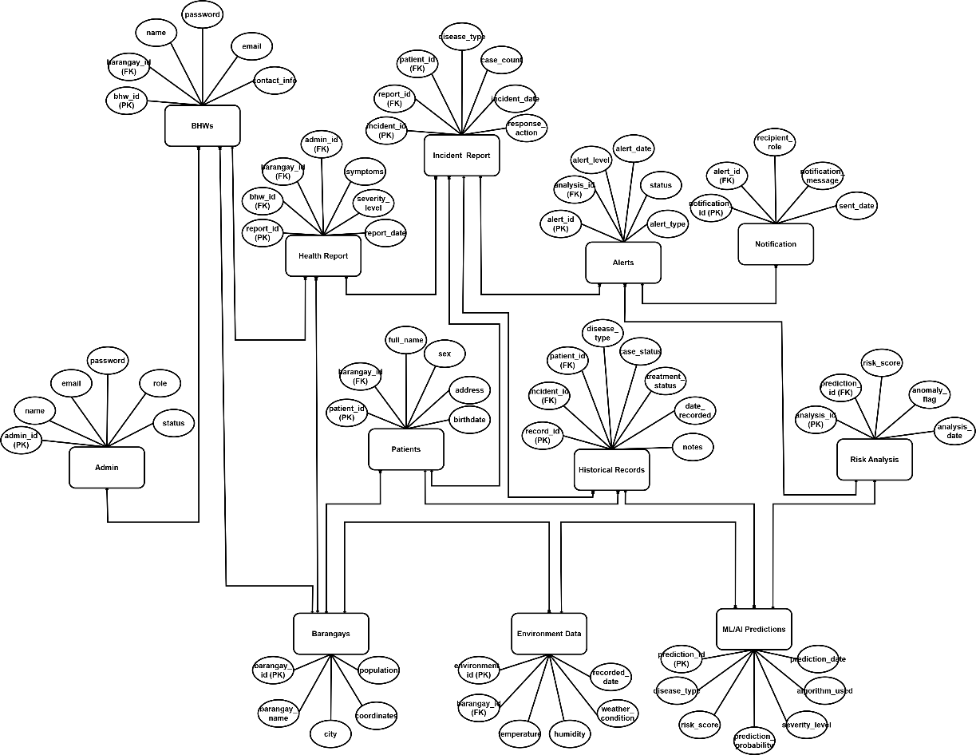

Figure 13. Entity Relationship Diagram

Database Design

Tables 4–29 document the earlier conceptual schema and examples. The physical implementation uses Patient-linked surveillance reports with ML, APTAS, threshold, OCR, notification, and audit entities. The implementation section below supersedes conflicting conceptual names.

Table 4. Admin Table
Name | Definition
admin_id | Primary key for the administrator account.
Name | Full name of the administrator or super administrator.
Email | Email address used for login and account recovery.
password | Encrypted password credential for secure access.
Role | Access level of the account such as Admin or Super Admin.
Status | Current account state such as active or inactive.
Table 5. Super Admin Table
Name | Definition
super_admin_id | Primary key for the super administrator account.
Name | Full name of the super administrator.
Email | Email address used for login and account recovery.
password | Encrypted password credential for secure access.
role | Access level of the account as Super Admin.
status | Current account state such as active or inactive.

Table 6. BHWs Table
Name | Definition
bhw_id | Primary key for the Barangay Health Worker account.
barangay_id | References the barangay assigned to the BHW.
name | Full name of the Barangay Health Worker.
password | Encrypted password for BHW login.
email | Email address of the BHW account.
contact_info | Contact number or other contact details of the BHW.

Table 7. Health Report Table
Name | Definition
report_id | Primary key for each submitted health report.
bhw_id | References the BHW who submitted the report.
barangay_id | References the barangay where the report originated.
admin_id | References the admin account that reviewed or managed the report.
symptoms | Reported symptoms or syndrome details.
severity_level | Recorded severity level for the reported case or cluster.
report_date | Date and time when the report was submitted.

Table 8. Patients Table
Name | Definition
patient_id | Primary key for the patient record.
barangay_id | References the barangay of residence of the patient.
full_name | Complete name of the patient.
sex | Recorded sex of the patient.
address | Home address of the patient.
birthdate | Date of birth of the patient.

Table 9. Incident Report Table
Name | Definition
incident_id | Primary key for the disease incident report.
report_id | References the originating health report.
patient_id | References the patient linked to the incident.
disease_type | Disease or syndrome category associated with the incident.
case_count | Number of cases represented by the incident report.
incident_date | Date when the incident was recorded or confirmed.
response_action | Action taken in response to the reported incident.

Table 10. Historical Records Table
Name | Definition
record_id | Primary key for the archived historical case record.
incident_id | References the related incident report.
patient_id | References the patient in the historical record.
disease_type | Disease classification stored for historical analysis.
case_status | Current or final status of the recorded case.
treatment_status | Treatment progress or disposition of the patient.
date_recorded | Date when the historical record was saved.
notes | Additional remarks or observations about the record.

Table 11. Barangays Table
Name | Definition
barangay_id | Primary key for the barangay master record.
barangay_name | Official barangay name.
city | City where the barangay belongs.
coordinates | Stored map coordinates for GIS plotting.
population | Estimated population count of the barangay.

Table 12. Environment Data Table
Name | Definition
environment_id | Primary key for each environmental data record.
barangay_id | References the barangay linked to the environmental reading.
temperature | Recorded temperature value for the area.
humidity | Recorded humidity value for the area.
weather_condition | General weather condition observed or imported.
recorded_date | Date and time when the environmental data was captured.

Table 13. ML/AI Predictions Table
Name | Definition
prediction_id | Primary key for the prediction output.
disease_type | Disease category used in the prediction output.
risk_score | Computed risk score generated by the model.
prediction_probability | Probability value produced by the predictive model.
severity_level | Predicted severity level derived from model output.
algorithm_used | Machine learning algorithm used to generate the prediction.
prediction_date | Date and time when the prediction was generated.

Table 14. Risk Analysis Table
Name | Definition
analysis_id | Primary key for the risk analysis record.
prediction_id | References the prediction result being analyzed.
risk_score | Final risk score used for interpretation and alerting.
anomaly_flag | Indicates whether the analyzed pattern is anomalous.
analysis_date | Date and time when the analysis was performed.

Table 15. Alerts Table
Name | Definition
alert_id | Primary key for the generated alert.
analysis_id | References the risk analysis that triggered the alert.
alert_level | Assigned severity level of the alert.
alert_date | Date and time when the alert was created.
status | Processing or response status of the alert.
alert_type | Type or category of the generated alert.

Table 16. Notification Table
Name | Definition
notification_id | Primary key for the sent notification record.
alert_id | References the alert associated with the notification.
recipient_role | Role of the target recipient such as Admin or Health Officer.
notification_message | Message content delivered by the system.
sent_date | Date and time when the notification was sent.

Normalization
Table 17. Admin Table
Name | Data
admin_id | 1
name | CHO Administrator
email | admin@pulse-bago.gov.ph
password | [bcrypt password hash — representative value omitted]
role | Admin
status | Active

Table 18. Super Admin Table
Name | Data
super_admin_id | 1
name | System Super Administrator
email | superadmin@pulse-bago.gov.ph
password | [bcrypt password hash — representative value omitted]
role | Super Admin
status | Active

Table 19. BHWs Table
Name | Data
bhw_id | 101
barangay_id | 3
name | Maria L. Santos
password | [bcrypt password hash — representative value omitted]
email | maria.santos@pulse.local
contact_info | 09171234567

Table 20. Health Report Table
Name | Data
report_id | 501
bhw_id | 101
barangay_id | 3
admin_id | 1
symptoms | Fever, cough, headache
severity_level | Moderate
report_date | 2026-03-22 08:30:00

Table 21. Patients Table
Name | Data
patient_id | 205
barangay_id | 3
full_name | Juan Carlo Dela Cruz
sex | Male
address | Purok 2, Barangay Ma-ao, Bago City
birthdate | 2004-03-22

Table 22. Incident Report Table
Name | Data
incident_id | 320
report_id | 501
patient_id | 205
disease_type | Influenza-like illness
case_count | 4
incident_date | 2026-03-22
response_action | Barangay follow-up and monitoring

Table 23. Historical Records Table
Name | Data
record_id | 9001
incident_id | 320
patient_id | 205
disease_type | Influenza-like illness
case_status | Confirmed
treatment_status | Under observation
date_recorded | 2026-03-22 09:15:00
notes | Cluster flagged for review

Table 24. Barangays Table
Name | Data
barangay_id | 3
barangay_name | Ma-ao
city | Bago City
coordinates | 10.5331, 122.8342
population | 12450

Table 25. Environment Data Table
Name | Data
environment_id | 700
barangay_id | 3
temperature | 31.4 C
humidity | 78%
weather_condition | Cloudy
recorded_date | 2026-03-22 07:00:00

Table 26. ML/AI Predictions Table
Name | Data
prediction_id | 880
disease_type | Influenza-like illness
risk_score | 0.82
prediction_probability | 86%
severity_level | High
algorithm_used | Isolation Forest
prediction_date | 2026-03-22 09:00:00

Table 27. Risk Analysis Table
Name | Data
analysis_id | 610
prediction_id | 880
risk_score | 0.82
anomaly_flag | True
analysis_date | 2026-03-22 09:05:00

Table 28. Alerts Table
Name | Data
alert_id | 450
analysis_id | 610
alert_level | High
alert_date | 2026-03-22 09:10:00
status | Sent
alert_type | Outbreak warning

Table 29. Notification Table
Name | Data
notification_id | 1200
alert_id | 450
recipient_role | Health Officer
notification_message | High-risk cluster detected in Barangay Ma-ao
sent_date | 2026-03-22 09:12:00

Physical Structure

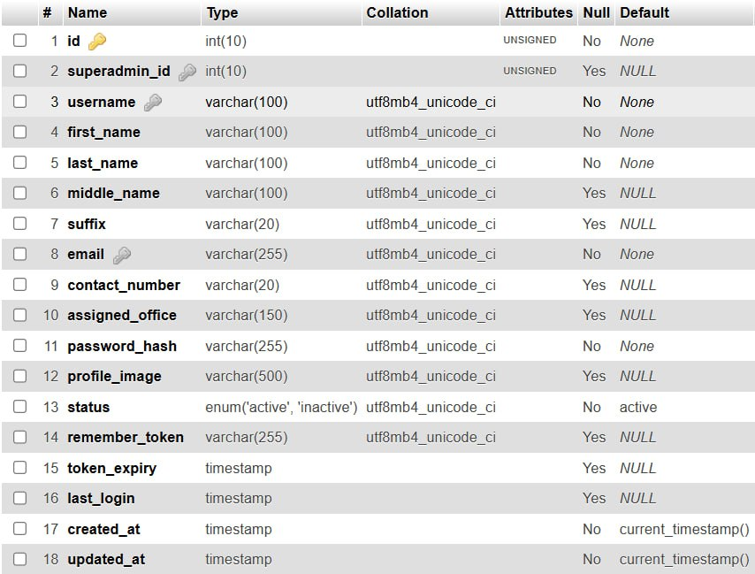

Figure 14. Admins Table

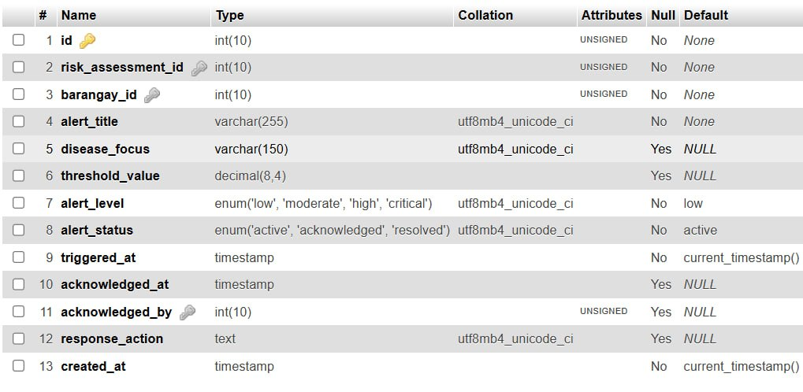

Figure 15. Alerts Table

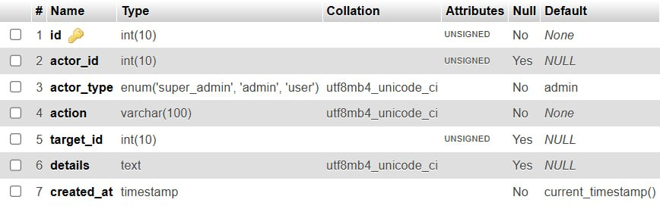

Figure 16. Audit Log Table

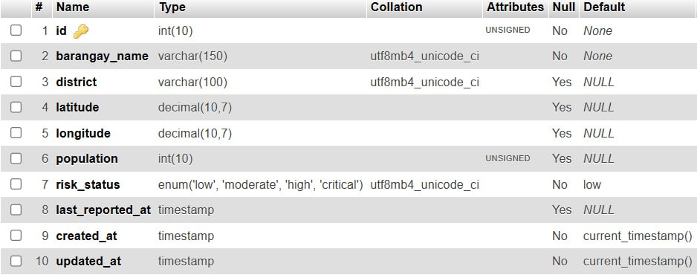

Figure 17. Barangay Table

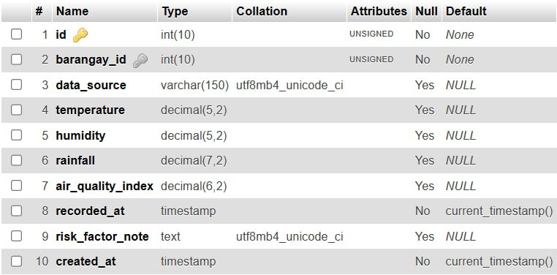

Figure 18. Environmental Data Table

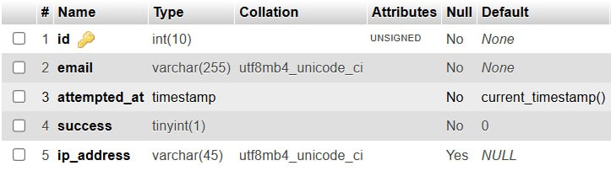

Figure 19. Log In Attempts Table

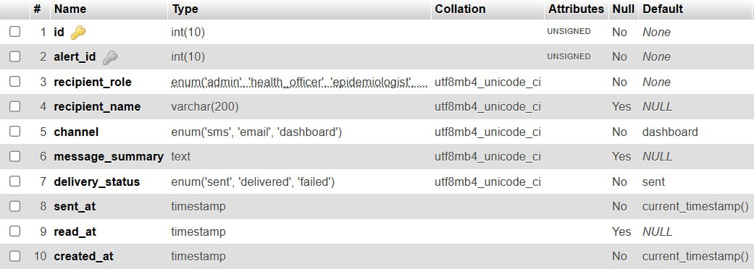

Figure 20. Notification Logs Table

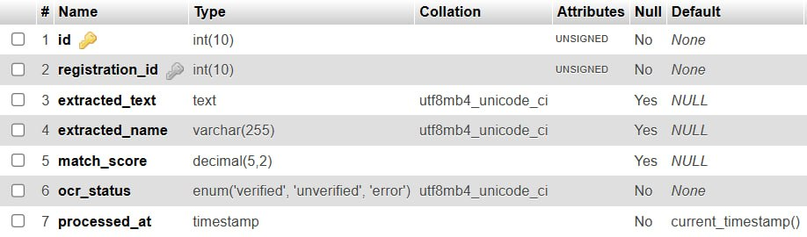

Figure 21. OCR Results Table

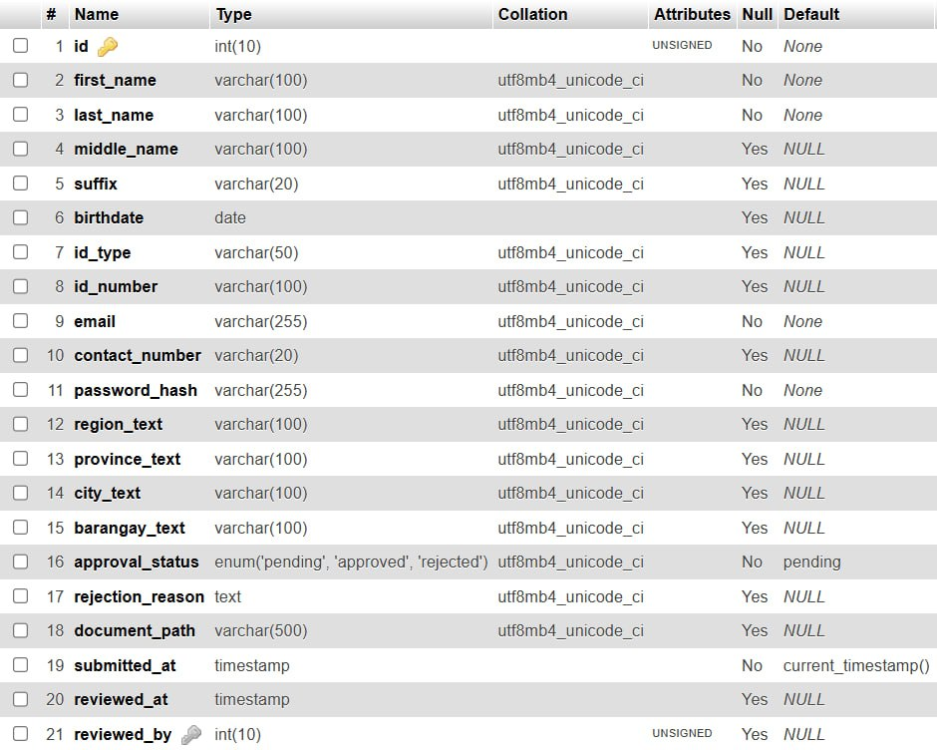

Figure 22. Registration Table

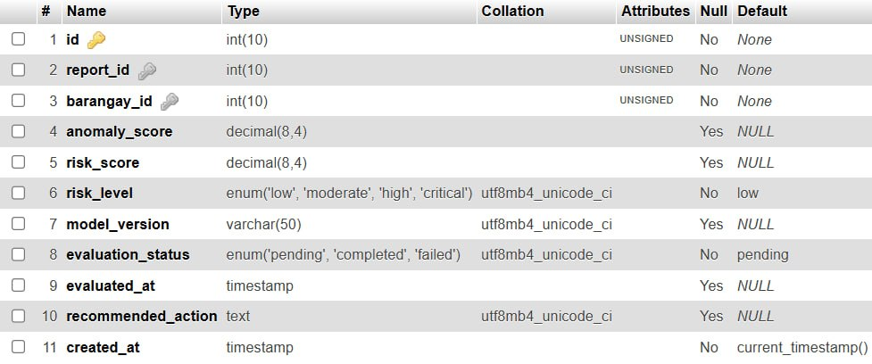

Figure 23. Risk Assessment Table

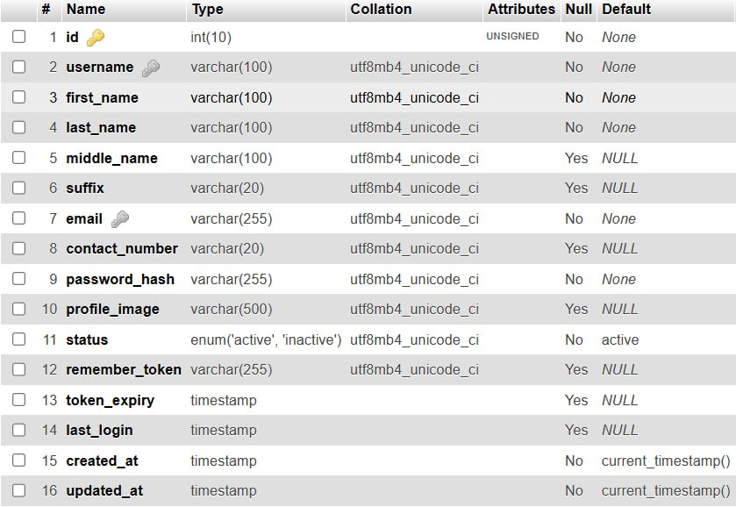

Figure 24. Superadmin Table
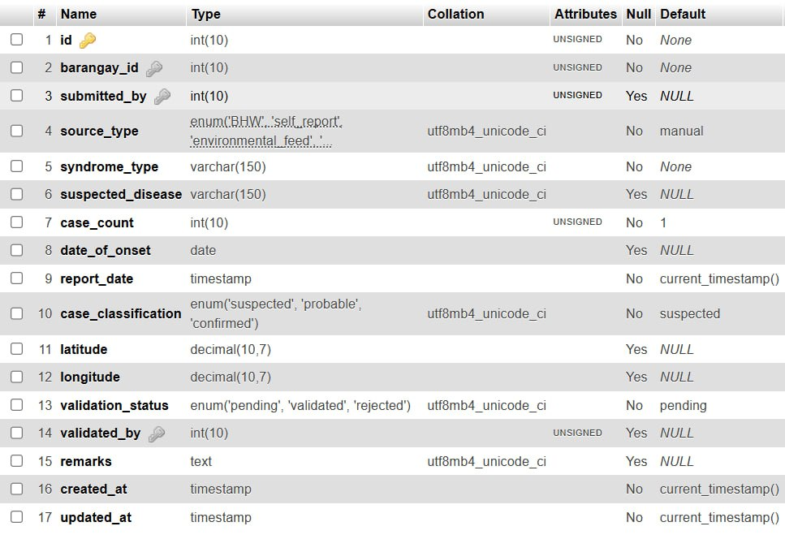

Figure 25. Surveillance Report Table

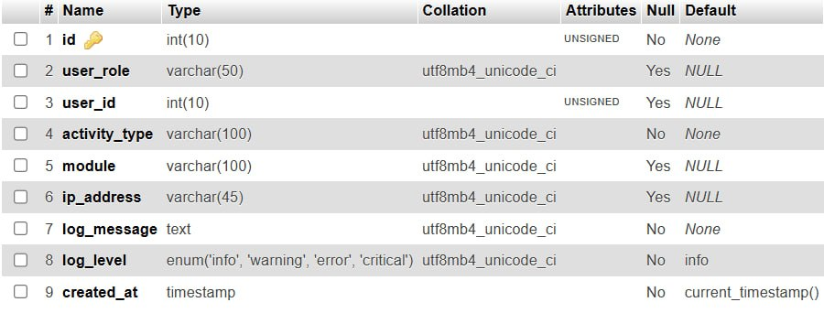

Figure 26. System Logs Table
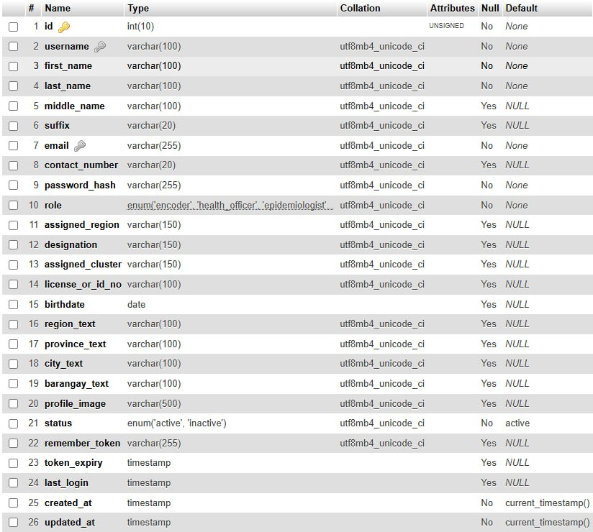

Figure 27. Users Table

Prototype Design
Figures 28–40 are early prototypes. The implemented interface uses role-specific Django dashboards with Submit Report, My Reports, Case Monitoring, Case Confirmation, Analytics, Alerts, Geospatial Map, users, logs, and thresholds. Accounts are administrator-provisioned.
Landing Page
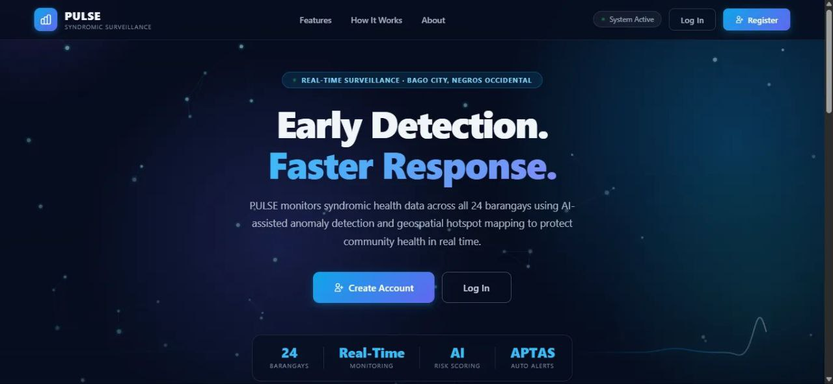

Figure 28. Landing Page

Log In
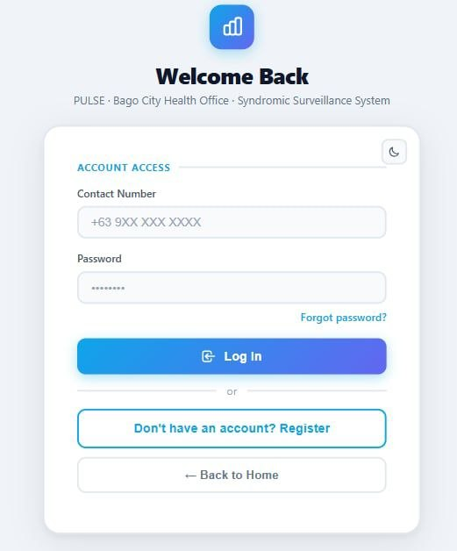

Figure 29. Log In

Create Account
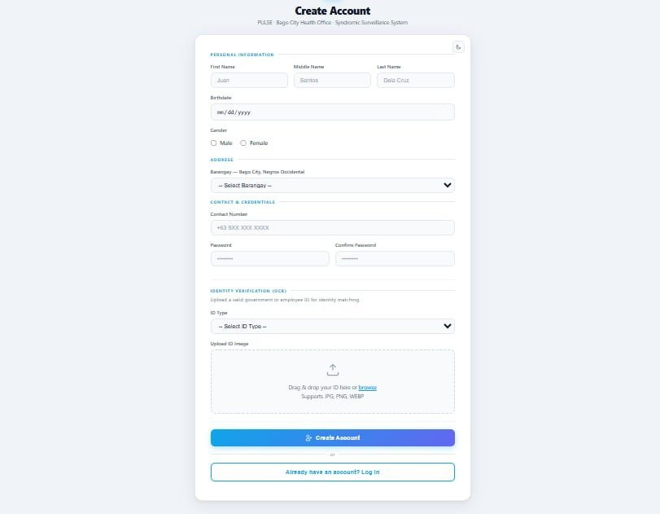

Figure 30. Legacy Account-Creation Prototype (current accounts are administrator-provisioned)

Dashboard
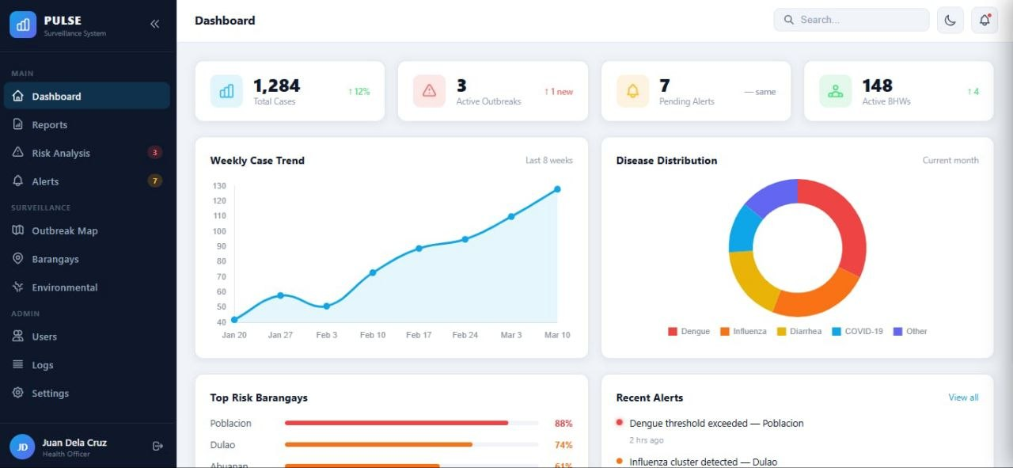

Figure 31. Dashboard

Incident Reports
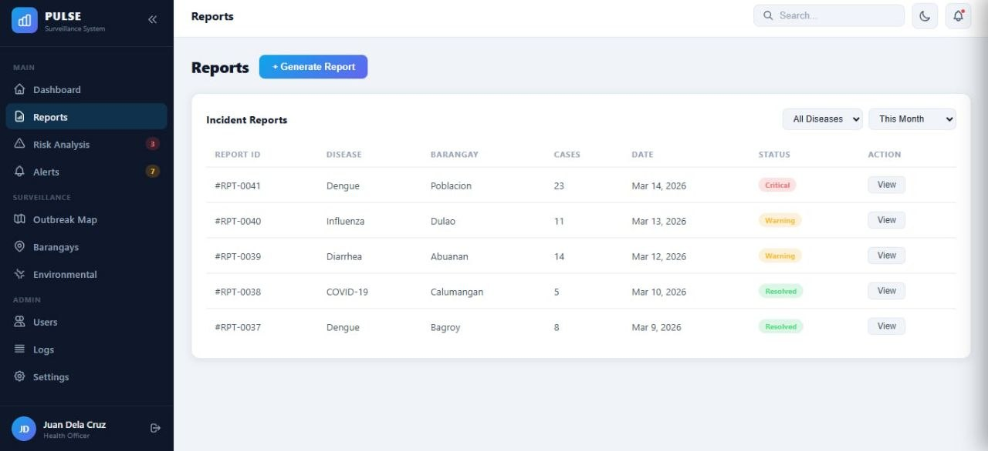

Figure 32. Legacy Incident-Report Prototype (current workflow uses Patient-linked Surveillance Reports)

Risk Analysis
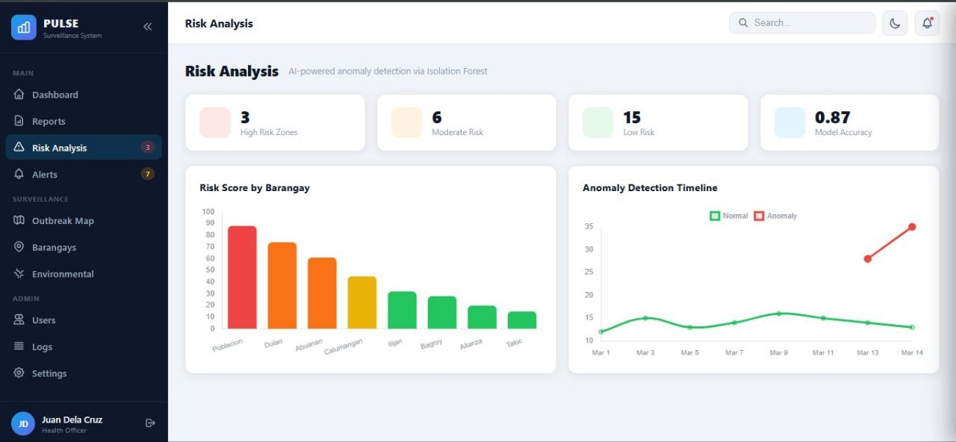

Figure 33. Risk Analysis

Alerts
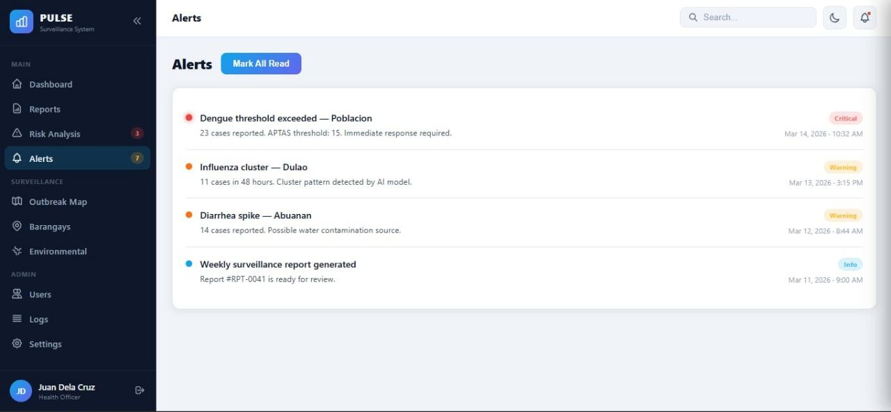

Figure 34. Alerts

Outbreak Map
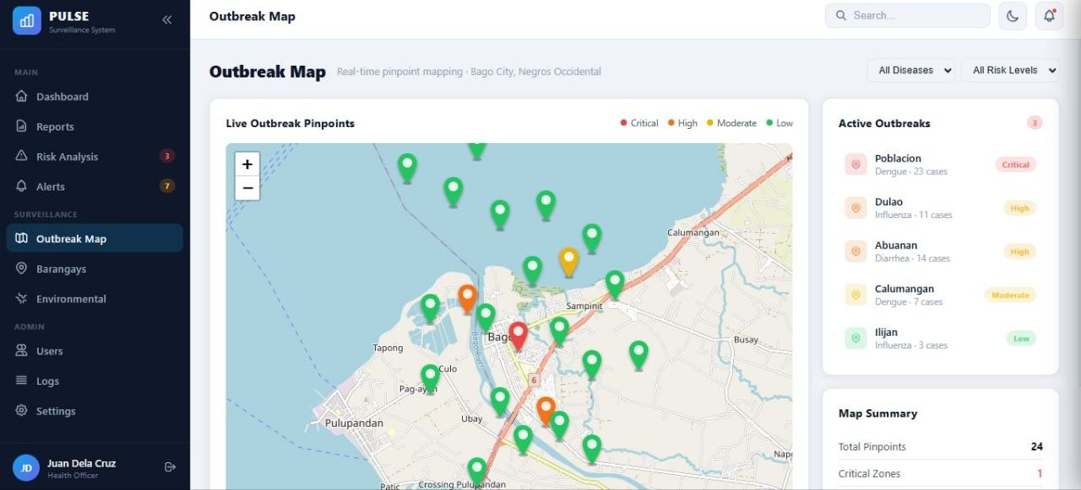

Figure 35. Early Outbreak-Map Prototype (current implementation uses the unified Geospatial Hotspot Map)

Hotspot Map
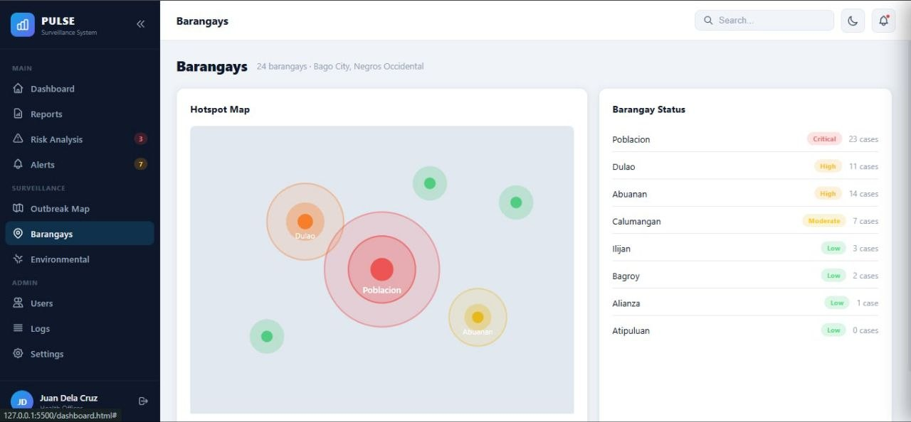

Figure 36. Early Hotspot Prototype (current map adds scoped filters, risk layers, pins, and same-disease clusters)

Environmental Data
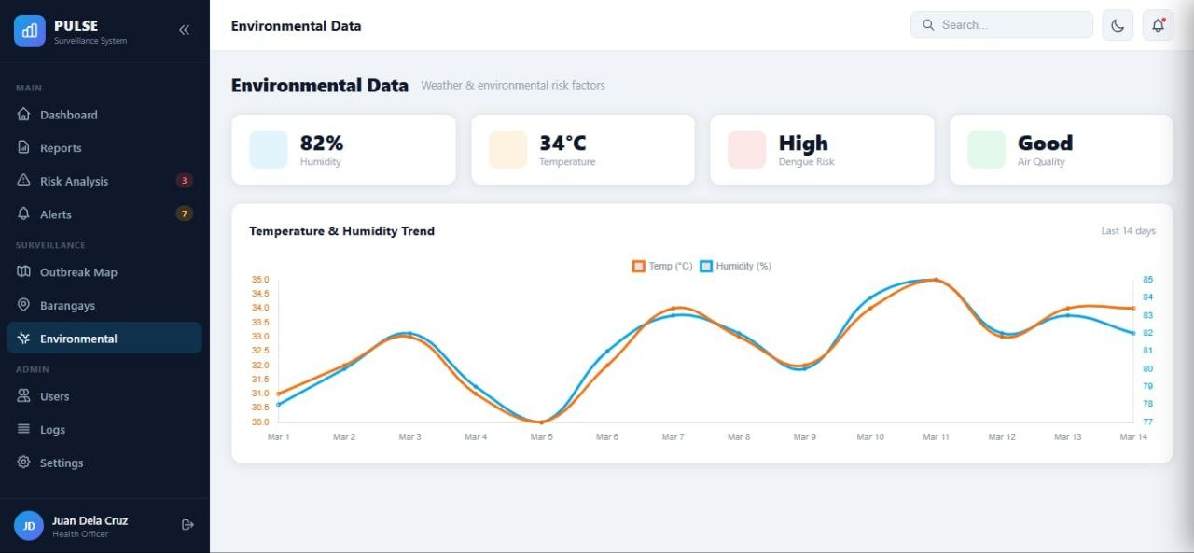

Figure 37. Environmental Data

Users
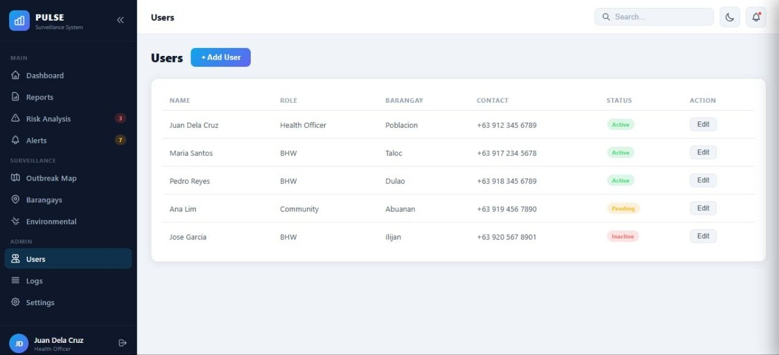

Figure 38. Users

System Logs
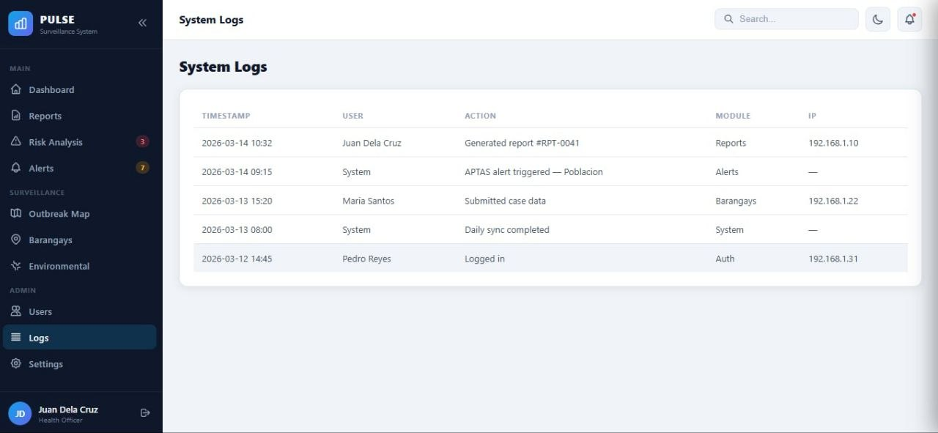

Figure 39. System Logs

Settings
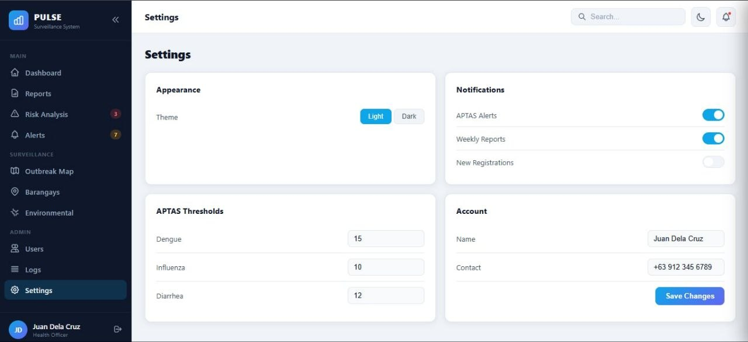

Figure 40. Early Settings Prototype (current configuration focuses on users, roles, PIDSR thresholds, and secure environment settings)

CHAPTER VII
CURRENT SYSTEM IMPLEMENTATION AND VERIFICATION
Revision note: This chapter records source-code-verified behavior as of September 2026. Yellow highlighting identifies revised or inserted content. Earlier conceptual diagrams and prototypes remain only where explicitly labeled.
Implemented Architecture
PULSE is implemented as a Django 4.2 web application backed by MySQL. Django templates and static JavaScript provide the interface; Leaflet renders map tiles and GeoJSON boundaries; WhiteNoise supports static delivery. Secrets and production settings come from environment variables.
Layer | Implemented components | Responsibility
Presentation | Django templates, CSS, JavaScript, Leaflet | Role dashboards, forms, alerts, analytics, maps, and recommendations
Application | accounts, users, reports, dashboard, mapping | Authentication, scope, submission, monitoring, confirmation, alerts, and APIs
Services | Patient registry, prediction, APTAS, thresholds, OCR, recommendations | Business rules and lifecycle transitions
Data | Django ORM and MySQL | Patients, reports, users, barangays, risks, thresholds, alerts, OCR, and audits
Implemented Users and Activities
Role | Scope | Principal activities
Super Administrator | City-wide | Administrative access, users, configuration, logs, and thresholds
Administrator | City-wide | Users, cases, alerts, analytics, maps, confirmation, and logs
Health Officer | City-wide | Case review, OCR confirmation, alert acknowledgement, closure/discard
Surveillance Officer | City-wide | Risk and threshold monitoring, acknowledgement, analytics, maps
Catchment Nurse | Assigned barangay | Barangay case review/submission, BHW supervision, catchment contact
Encoder | Assigned barangay | Structured case encoding and permitted record review
Barangay Health Worker | Assigned barangay | Patient/symptom submission and permitted monitoring
Alert acknowledgement is restricted to city-wide roles and is recorded in audit and system logs. Barangay-scoped users cannot acknowledge city-level alerts.
End-to-End Surveillance Workflow
1. Authorized staff sign in; session, lockout, role, and barangay scope are enforced server-side.
2. The submitter records patient identity, birthdate, demographics, location, onset, symptoms, and exposures using English clinical labels with local helper text.
3. PULSE links or creates a Patient and blocks duplicate open cases sharing normalized name, birthdate, and barangay unless staff deliberately override.
4. Random Forest ranks 27 PIDSR diseases. At least two symptoms are required, and confidence below 30 percent is classified as inconclusive.
5. Isolation Forest screens unusual activity; APTAS records composite barangay risk; PIDSR confirmed-case thresholds are evaluated separately.
6. Scoped case monitoring, analytics, alerts, recommendations, and map APIs present the results.
7. CHO roles upload lab documents for suspected/probable cases. OCR extracts fields and blocks confirmation unless patient identity and a clear positive/negative outcome match.
8. Positive results confirm; negative results discard. Thresholds, APTAS, alerts, and map state are recalculated.
9. City-wide personnel acknowledge alerts; field teams use bilingual action cards and target-unit tags.
Machine Learning, APTAS, and Map Rules
Random Forest suggests diseases; Isolation Forest detects anomalous activity. Neither confirms a diagnosis. APTAS means Alerts, Patterns, and Thresholds Analysis System. Final Risk = 100 × (0.50 × Anomaly + 0.20 × Temporal + 0.15 × Environmental + 0.15 × Spatial). Low is below 40, Moderate is 40–59.99, High is 60–74.99, and Critical is 75 or above. Ordinary APTAS activation requires final risk of at least 60 and anomaly of at least 0.50 unless forced by an authorized/PIDSR condition.
APTAS spatial analysis uses 500 meters. The map separately clusters only the same canonical disease within 300 meters and seven onset days. The 300-meter calculation stays hidden while a 50-meter response circle is displayed. The map defaults to the last 30 days and also offers 7-day, 90-day, and all-open filters. Closed and discarded cases are inactive. Unconfirmed ML-only pins below 30 percent confidence are hidden; confirmed or validated cases remain eligible.
PIDSR Disease Coverage and Recommendations
Category I — immediately reportable: Acute Flaccid Paralysis; Adverse Event Following Immunization; Anthrax; COVID-19; Hand, Foot, and Mouth Disease; Human Avian Influenza; Measles; Meningococcal Disease; Middle East Respiratory Syndrome; Neonatal Tetanus; Paralytic Shellfish Poisoning; Rabies; Severe Acute Respiratory Syndrome.
Category II — weekly reportable: Acute Bloody Diarrhea; Acute Encephalitis Syndrome; Acute Hemorrhagic Fever Syndrome; Acute Viral Hepatitis; Bacterial Meningitis; Cholera; Dengue Fever; Diphtheria; Influenza-Like Illness; Leptospirosis; Malaria; Non-Neonatal Tetanus; Pertussis; Typhoid and Paratyphoid Fever.
The bilingual recommendation matrix covers suspected, probable, confirmed, and cluster states for all 27 diseases. Cards include Category I priority banners, status and cluster badges, English and Hiligaynon/Taglish instructions, target units, and de-duplicated BHW field actions.
Laboratory Confirmation and OCR
OCR.Space Engine 3 extracts demographics, laboratory control and CHO/PORT specimen numbers, dates, markers, interpretations, test type, and disease. OCR-damaged characters such as a replacement symbol for Ñ are tolerated during matching and corrected from the Patient record. Scans are report- and session-bound. Missing/mismatched names, unclear outcomes, expired scans, wrong reports, and unauthorized roles block confirmation.
Security and Operational Safeguards
Control | Implemented behavior
Credentials | bcrypt password hashing; no plaintext operational passwords
Authorization | Role checks plus city-wide/barangay queryset scoping
Web security | CSRF, secure production cookies, SameSite, HTTPS proxy awareness, HSTS
Secrets | SECRET_KEY, database, and OCR credentials loaded from environment variables
Account protection | Failed-login recording and temporary lockout
Auditability | Audit/system logs for sensitive actions
Data integrity | Transactional submission, Patient linkage, duplicates, controlled states
Command safety | Production/shared DB blocks for destructive seed/import/wipe commands
Verification Evidence
Focused automated tests verify Patient deduplication, OCR parsing and confirmation gates, recommendation contracts and sorting, disease identity, missing anomaly defaults, case scope, map confidence policy, alert acknowledgement authorization/auditing, and destructive-command safety. Django checks support release verification. These tests are not clinical validation or ISO certification.
Current Limitations and Responsible Use
• PULSE does not diagnose, prescribe, or independently declare an outbreak.
• Low Random Forest confidence is expected when symptoms overlap across 27 diseases; top candidates below threshold remain inconclusive.
• Coordinates may overlap when patients share a household or reference point.
• OCR depends on image quality and external-service output; staff must compare fields with the source.
• Automated tests do not replace epidemiological validation, security assessment, recovery exercises, accessibility review, or ISO respondent evaluation.
• SMS, public self-reporting, continuous sensor streaming, end-user model training, Tableau, React, TensorFlow, PyTorch, and Mapbox are not verified current features.
Document Revision Summary
This highlighted revision aligns the capstone with the implemented Django architecture, current roles and activities, Patient-linked flow, dual-model ML, APTAS and PIDSR rules, map behavior, OCR confirmation, bilingual recommendations, security safeguards, and available tests. Legacy diagrams should be redrawn in a future layout revision if final-interface images are mandatory.

