Testing object: device-api

Let’s check our endpoints.
We have the following resources for our service:
- /api/v1/devices
- /api/v1/devices/{deviceID}

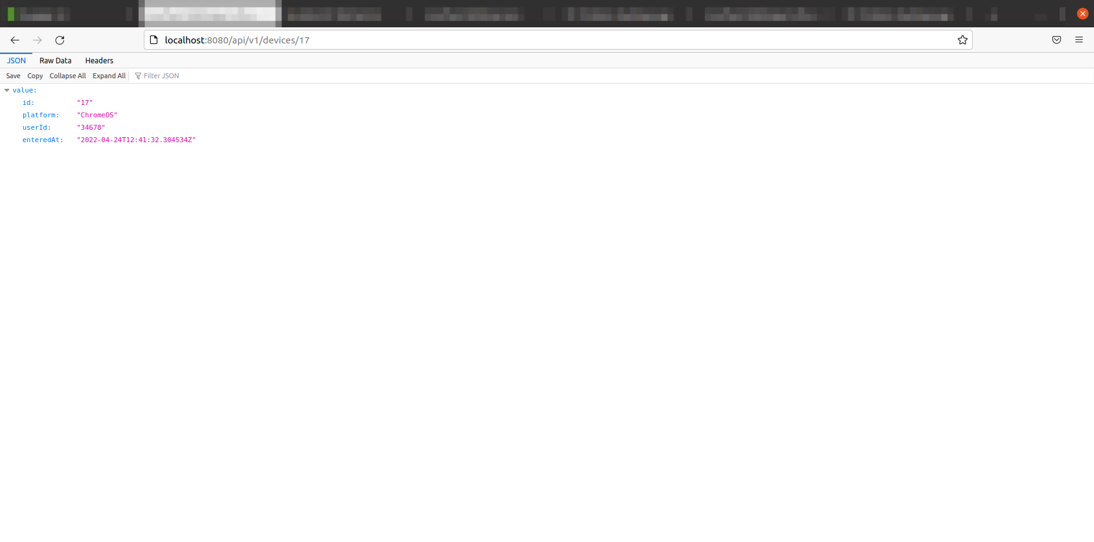

According to the Swagger UI spec we have the following requests:

GET ListDevicesV1 - List of devices

This request returns list of each devices in given pages

Code 200 - A successful response

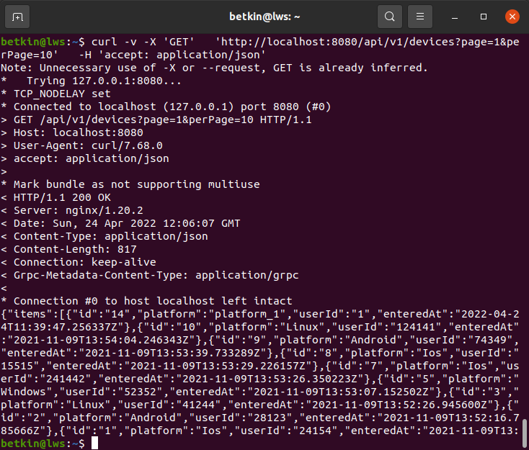
POST CreateDeviceV1 - Create a device

Input restriction
userId: [1 : 9223372036854775807]

Code 200 - A successful response
Code 400 - Bad Request

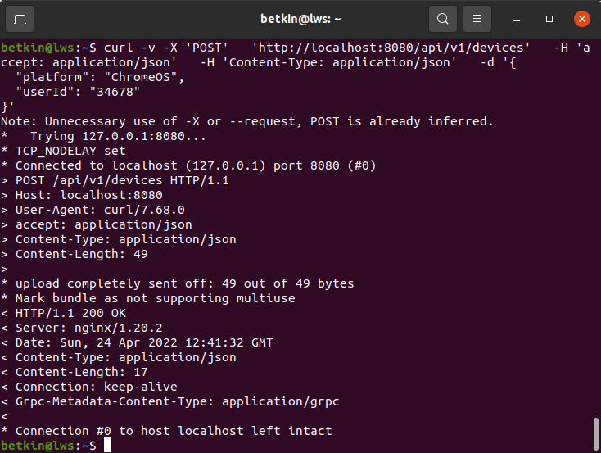
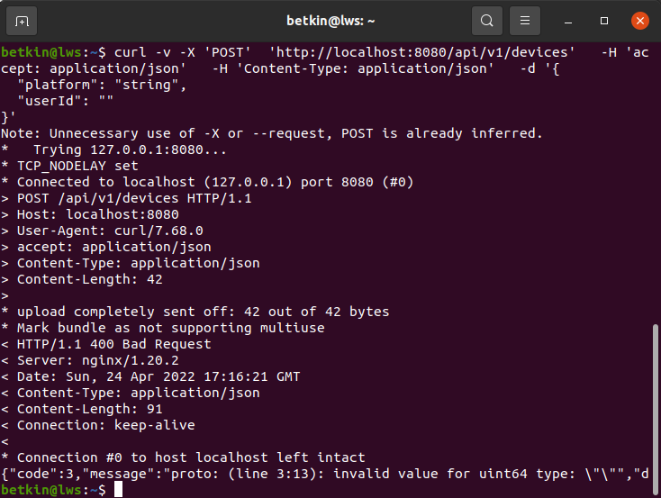

GET DescribeDeviceV1 - Describe a device

This request returns information about device{id}

Input restriction
id: [1 : 2147483647]

Code 200 - A successful response
Code 400 - Bad Request
Code 404 - Not Found
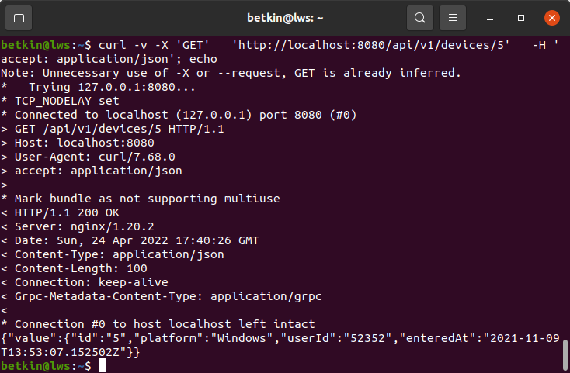
Code 500 - Internal server error

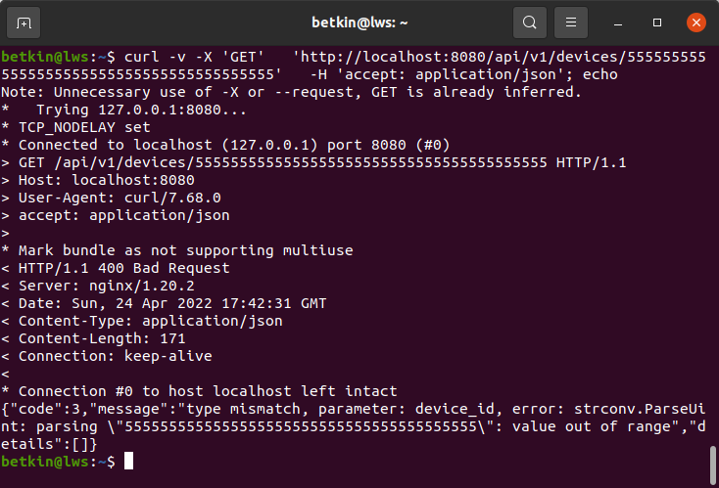
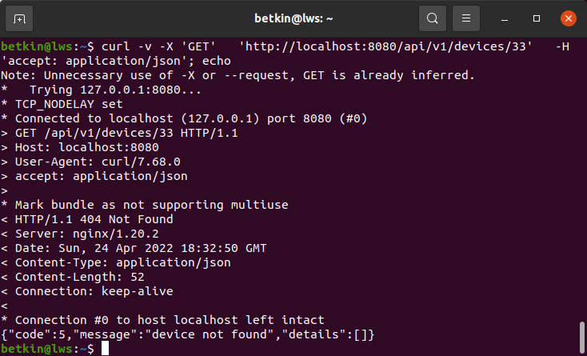
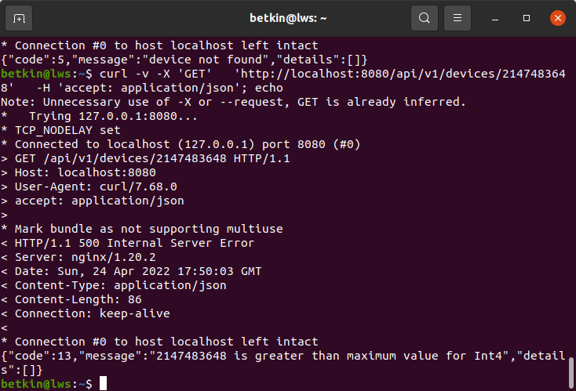

DELETE RemoveDeviceV1 - Remove a device

This request removes device{id}

Input restriction
id: [1 : 2147483647]

Code 200 - A successful response (if we have ““found”: true” in response’ body!!!)
Code 400 - Bad Request
Code 500 - Internal Server Error

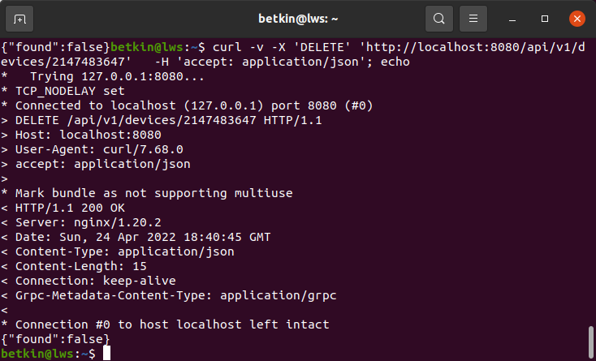
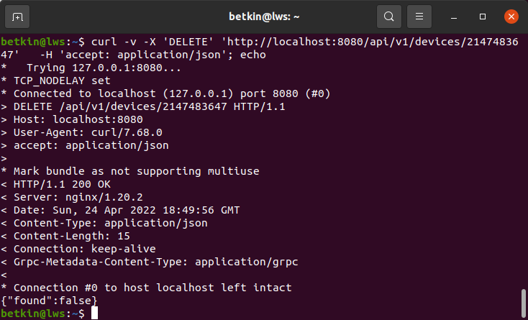

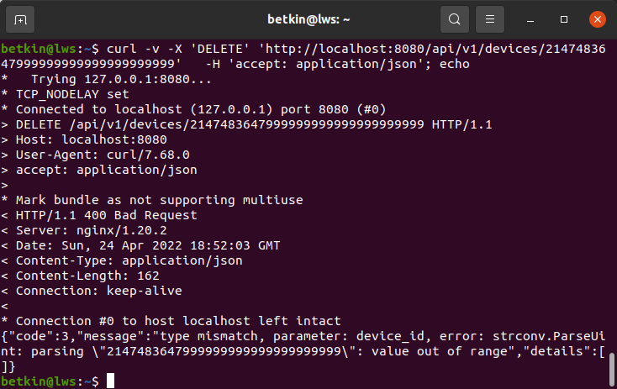
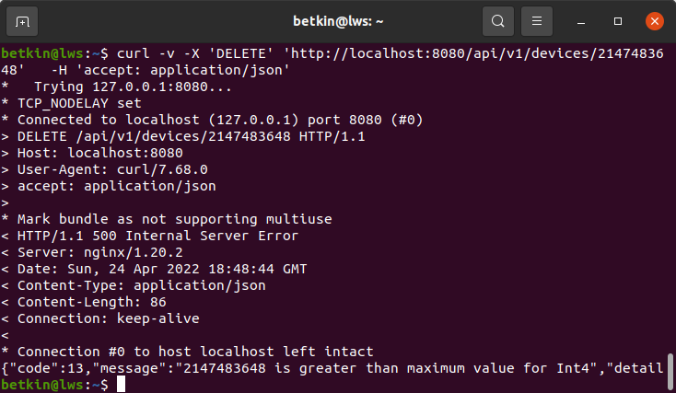

PUT UpdateDeviceV1 - Update a device

This request update device{id}

Input restriction
id: [1 : 2147483647]

Code 200 - A successful response (if we have ““found”: true” in response’ body!!!)
Code 400 - Bad Request
Code 500 - Internal Server Error

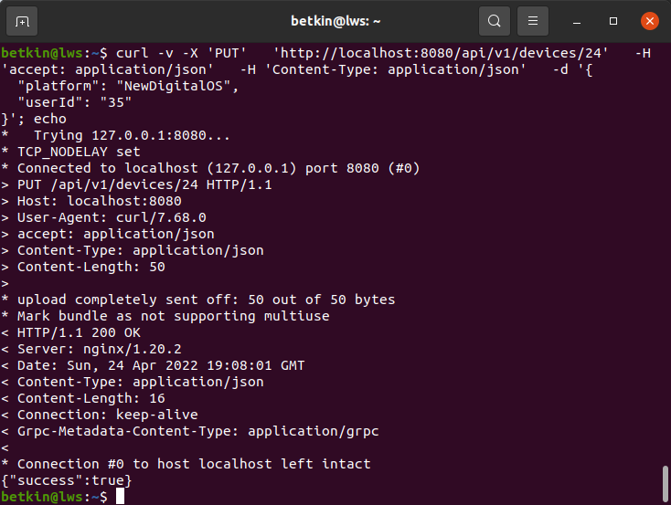

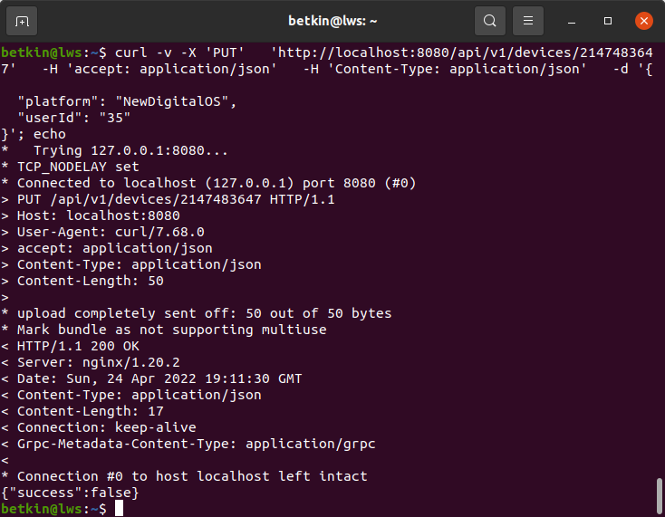

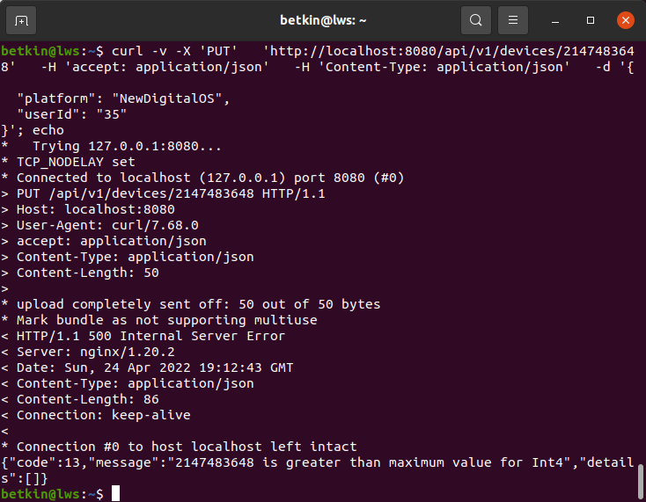
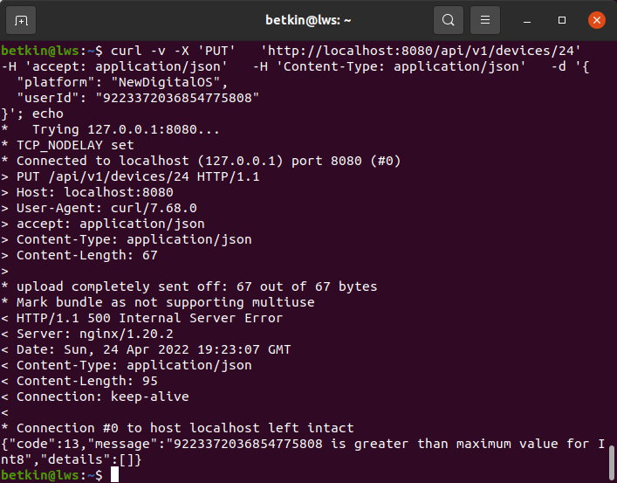

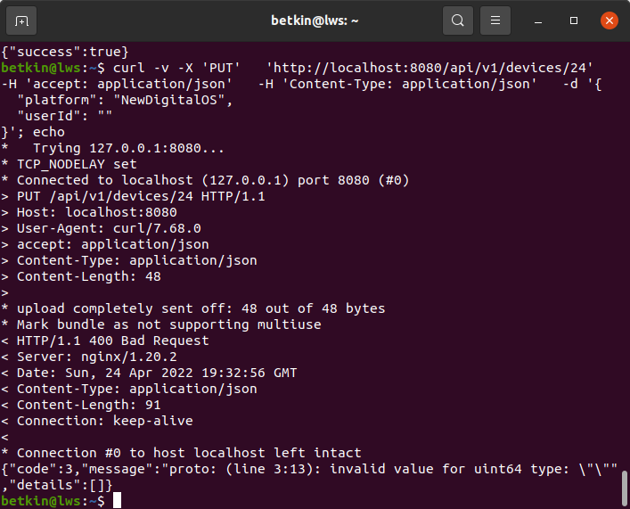

Results of the research tour

We have tested the basic functionality of the service. No critical or blocker bugs found.
There is a mismatch between the actual and declared data types for the id field. The range of valid values for this field is from 1 to 2147483647.

